

**ΝΕΑ** ΤΡΑΠΕΖΑ ΘΕΜΑΤΩΝ ΔΙΑΒΑΘΜΙΣΜΕΝΗΣ ΔΥΣΚΟΛΙΑΣ



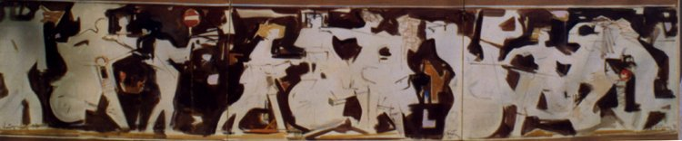

***Κώστας Κοντογιάννης****: “Σύνθεση με νέους και μηχανάκια”*

*ακρυλικά σε ύφασμα 70x300cm - έτος 2000*

**➤ 7969 / B2 😂** [****](https://drive.google.com/file/d/1VJmriz7_Jey78RHZel7jKGqMGaa6aejL/view?usp=sharing)

**➤ 7990 / B2 😂(ΙΔΙΑ!!!)** [****](https://drive.google.com/file/d/1hm-AyW2eOPT62_EUqX9Peduv_uKaYKQV/view?usp=sharing)

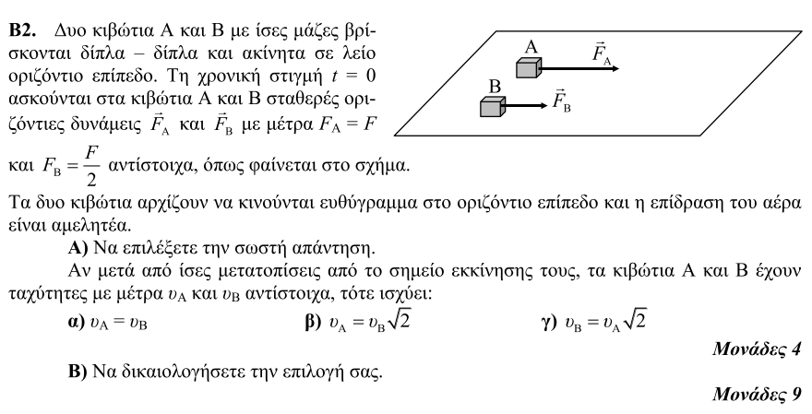

**➤ 7972 / B1** [****](https://drive.google.com/file/d/1UR4cbgcMYaoS-XzF6biqZXZo9dbJ2p7_/view?usp=sharing)

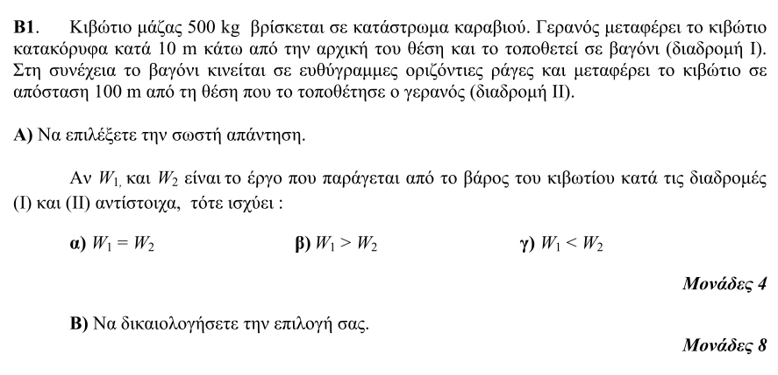

**➤ 7973 / B1** [****](https://drive.google.com/file/d/1kYmumnHOkb-ftB4gRp5XjSC7SqyEhrab/view?usp=sharing)

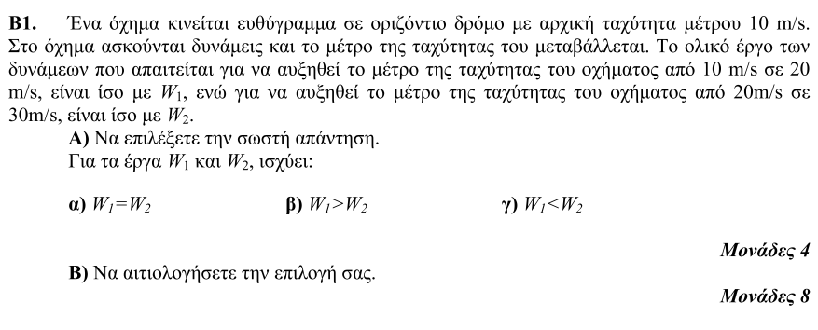

**➤ 7975 / B2** [****](https://drive.google.com/file/d/1FAFJiqhqGqUEaOa_U4vvKBvx5XEXfexC/view?usp=sharing)

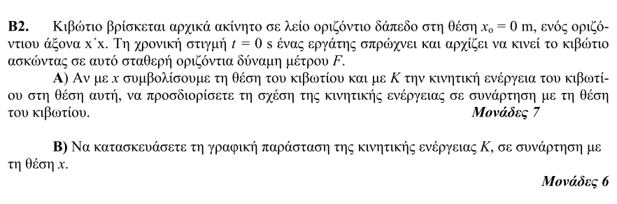

**➤ 7979 / B2** [****](https://drive.google.com/file/d/166DypaD2VLlQXgcuKdy9LBLJIngrftcg/view?usp=sharing)

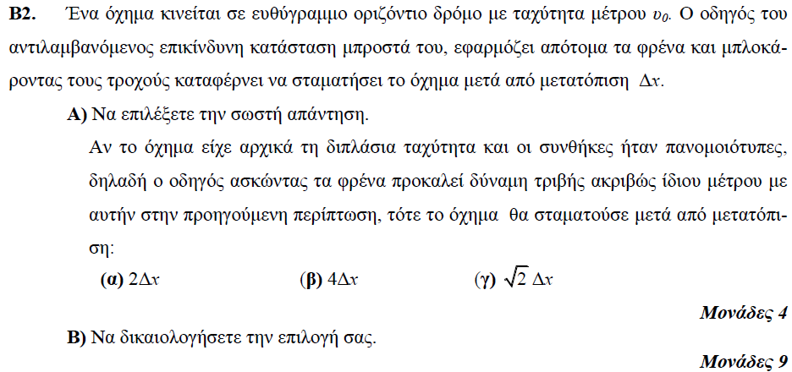

**➤ 7980 / B2** [****](https://drive.google.com/file/d/1DBqwD4k0owsXjNBc8QEKcDixdXkWVvUF/view?usp=sharing)

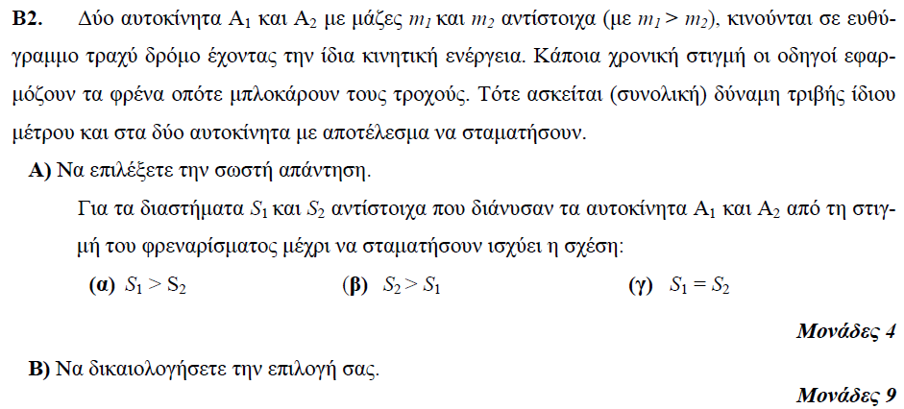

**➤ 7985 / B1** [****](https://drive.google.com/file/d/1OMO0Nanqy5oTTPTsDZdX501As-_RkPgn/view?usp=sharing)

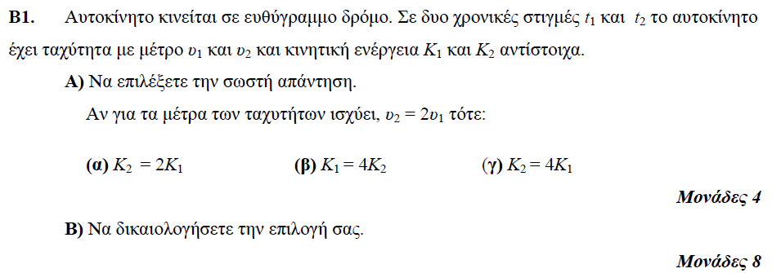

**➤ 7987 / B2** [****](https://drive.google.com/file/d/1UmWUWx2SSwXRN_233TSVz5-yI5UwI9WR/view?usp=sharing)

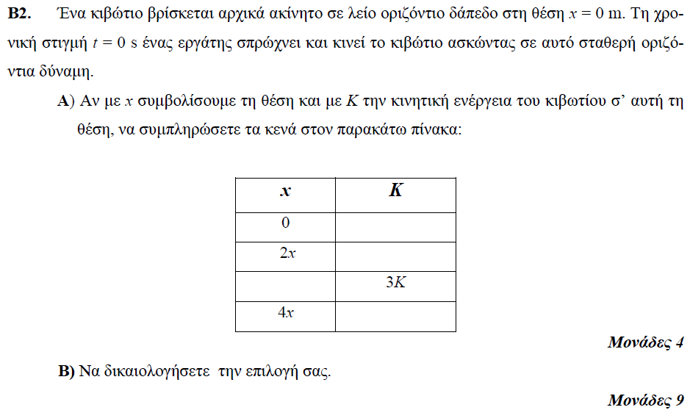

**➤ 7991 / B2** [****](https://drive.google.com/file/d/13pIpmRsdpgnMTjUA6FLDcc0vLKBUuT9-/view?usp=sharing)

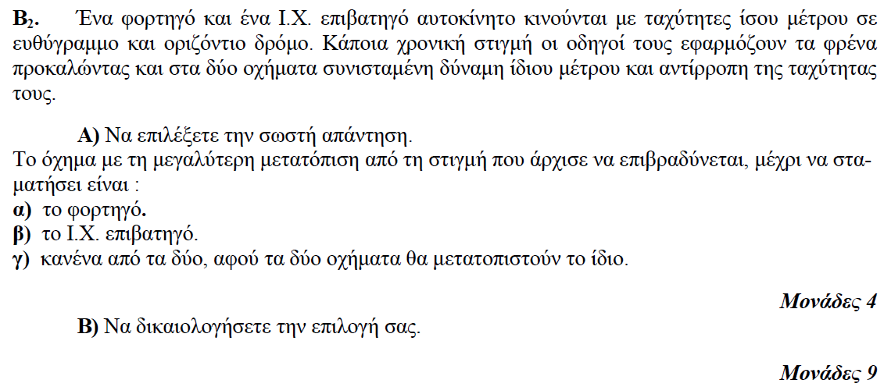

**➤ 7993 / B2** [****](https://drive.google.com/file/d/1YE_7THhvQUf85Lq26FJF4NGocPWeuT5n/view?usp=sharing)

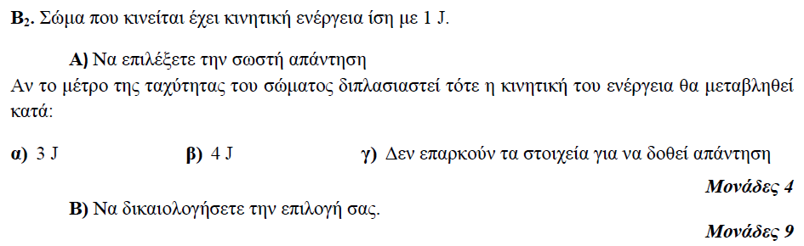

**➤ 7995 / B2** [****](https://drive.google.com/file/d/1q0pBFc1svGsY1BI5-0PSqONnKE-9nxZB/view?usp=sharing)

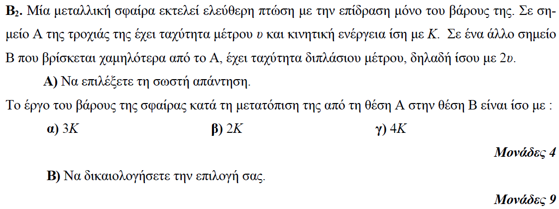

**➤ 7996 / B2** [****](https://drive.google.com/file/d/1GbgcaOzx_XeVKyItgskPJSxQn2kr9_2W/view?usp=sharing)

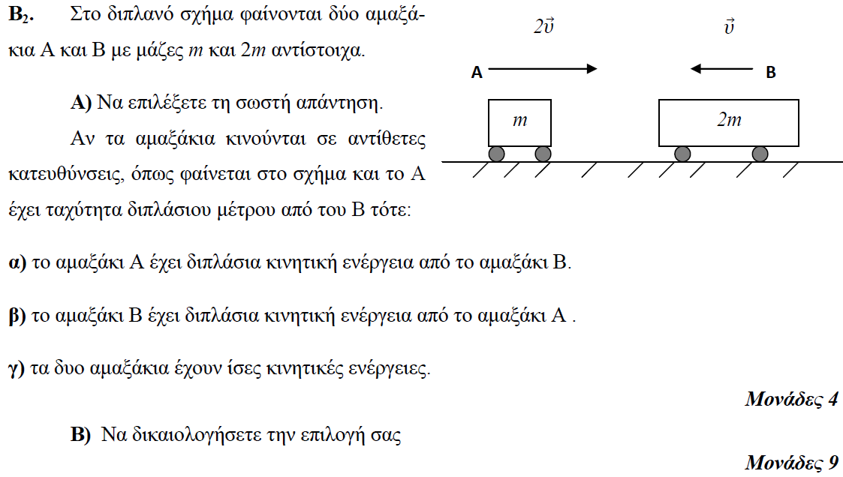

**➤ 7999 / B1** [****](https://drive.google.com/file/d/1QWQCMFOBCVEv-R42EUqbrBh5wgkBrTYh/view?usp=sharing)

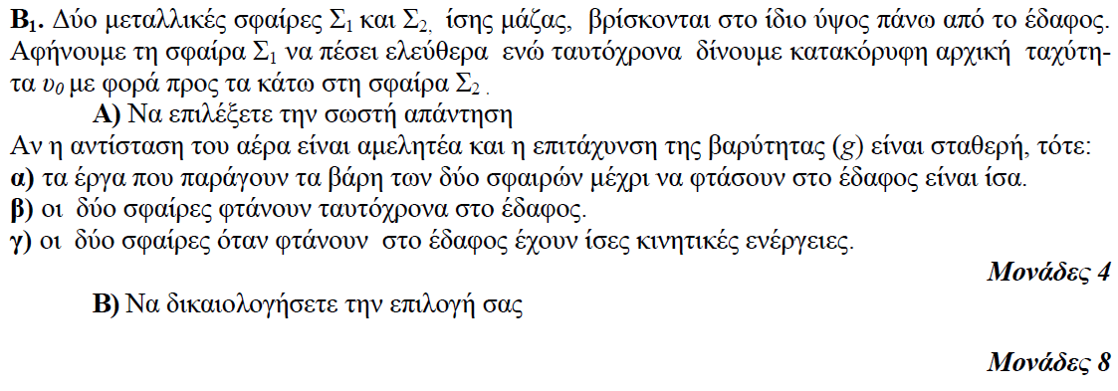

**➤ 8001 / B2** [****](https://drive.google.com/file/d/1hNhQ0vin0zUZPKEFrGtP0MFfjXyry-aU/view?usp=sharing)

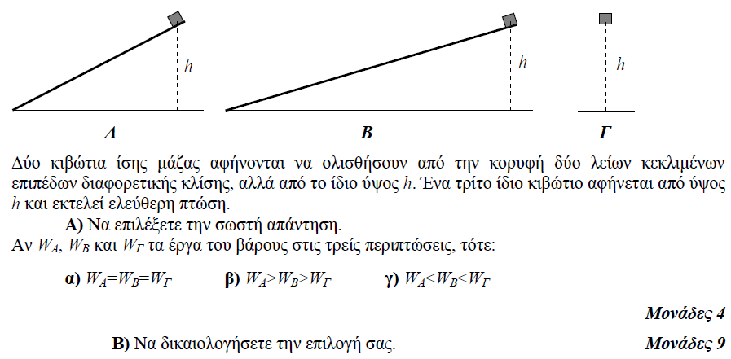

**➤ 8002 / B2** [****](https://drive.google.com/file/d/17vB2P2RpWJVbaat9nnGQx9v4c24g_DqK/view?usp=sharing)

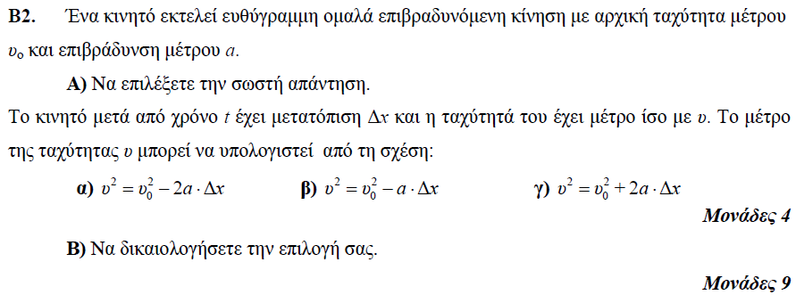

**➤ 8011 / B2** [****](https://drive.google.com/file/d/11iOVxKr1Kd5UxIJXv3XEEqqY0M97fMzT/view?usp=sharing)

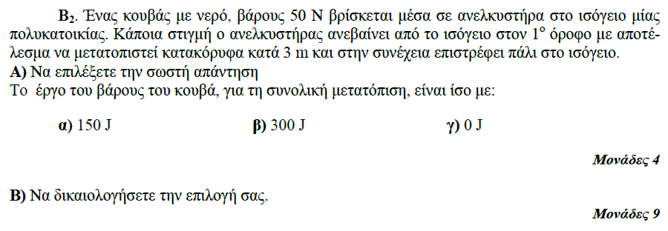

**➤ 8012 / B1** [****](https://drive.google.com/file/d/1ZgyjMKwl3-zQvSRPgfw70bUSxfghLHPW/view?usp=sharing)

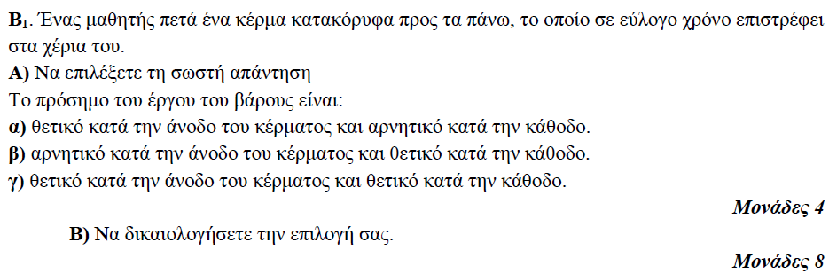

**➤ 8015 / B2** [****](https://drive.google.com/file/d/1JJONFcSa28TvkR100tVXPj-cg0-pDG-b/view?usp=sharing)

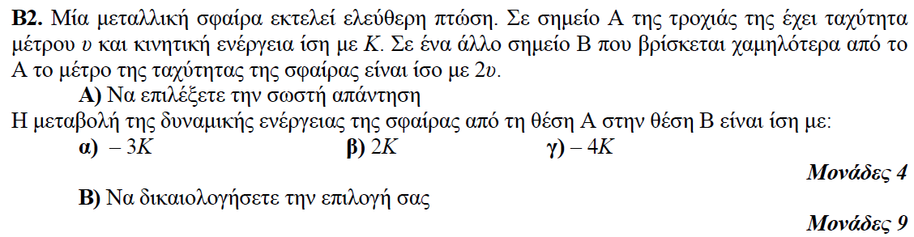

**➤ 8022 / B1** [****](https://drive.google.com/file/d/16c7b1gpH7RKri4Ns9elPadgY-yqO1ChF/view?usp=sharing)

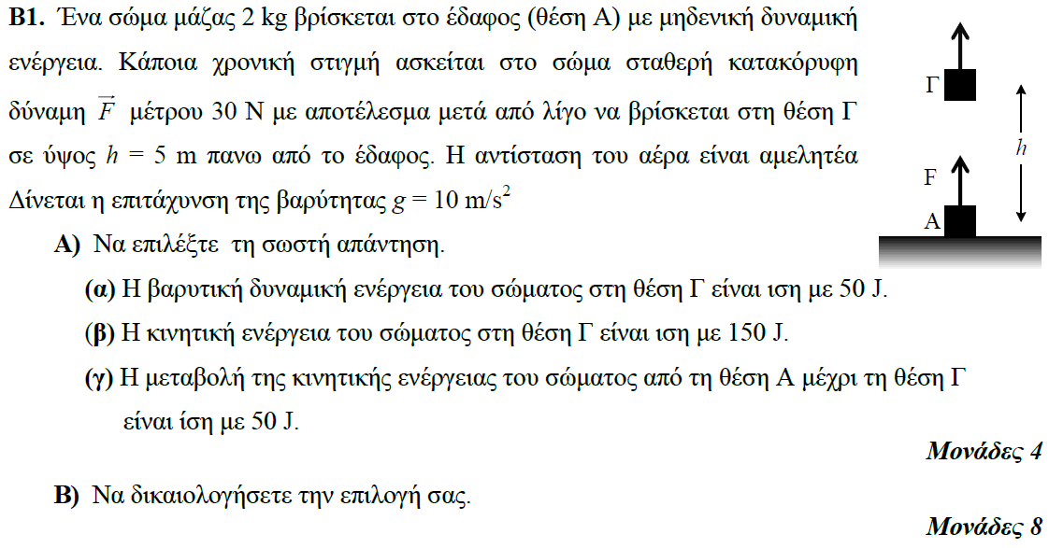

**➤ 8024 / B1** [****](https://drive.google.com/file/d/1qm9xuSm8rNH3jCzkodNKD7sxld1McDMu/view?usp=sharing)

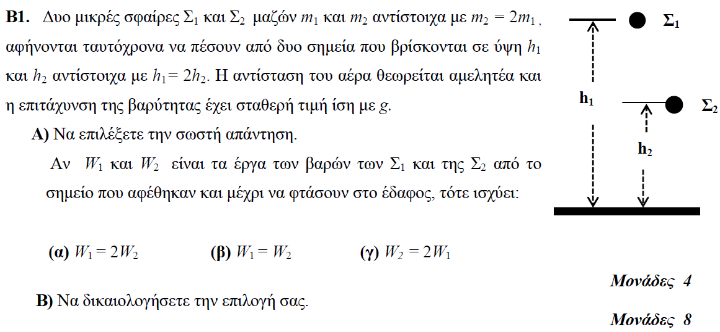

**➤ 8025 / B1** [****](https://drive.google.com/file/d/1JwCYCbXPCJvm22pdFtRNym4eI7FG7Vp3/view?usp=sharing)

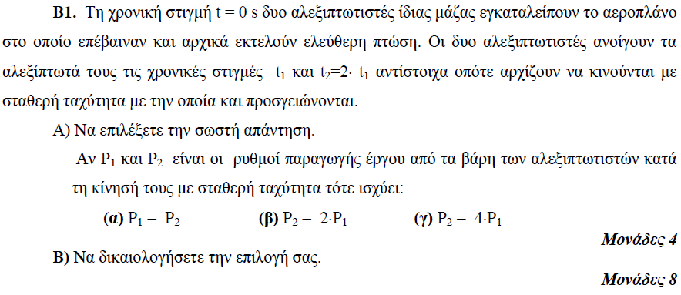

**➤ 8027 / B1** [****](https://drive.google.com/file/d/1NJjnwZN-_0uJXr4CzSdYp3Sx5rS_BzkB/view?usp=sharing)

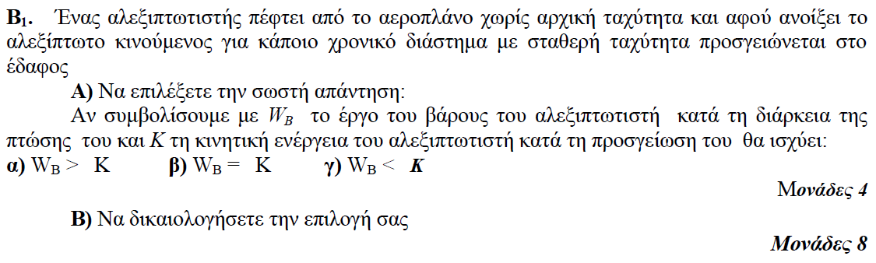

**➤ 8028 / B1** [****](https://drive.google.com/file/d/1i4RhMvxxsQwqzdhs2cF5n7rs8vPrJXcK/view?usp=sharing)

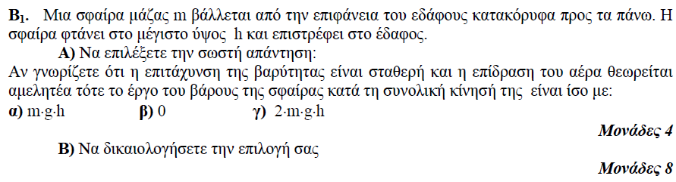

**➤ 8030 / B1** [****](https://drive.google.com/file/d/17LNn-GvIp1EzEGrf7_3O0t1tAcuxvhPj/view?usp=sharing)

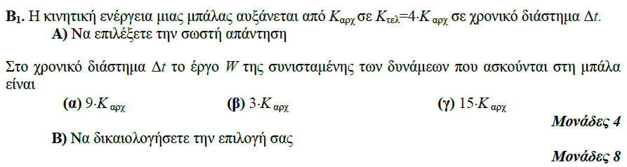

**➤ 8036 / B2** [****](https://drive.google.com/file/d/1GeV8ikiC7VWeRI_hwakITMTxVFqyjnG5/view?usp=sharing)

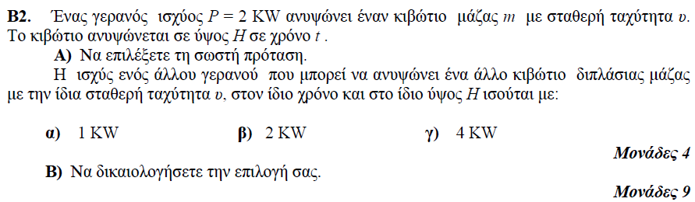

**➤ 8037 / B2** [****](https://drive.google.com/file/d/13R76d33qPznQ3ENCPZ5jwAuzSvLjELlj/view?usp=sharing)

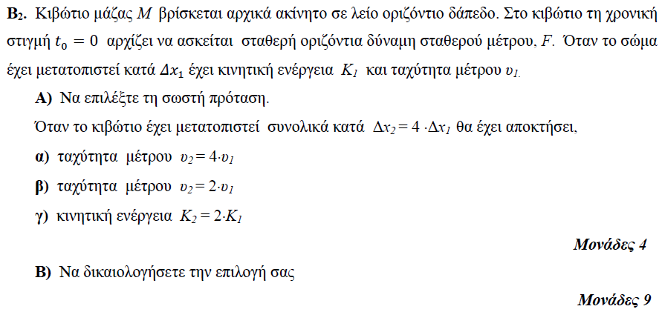

**➤ 8038 / B2** [****](https://drive.google.com/file/d/1gBfnNFUHe-F7UcKjThYeM2KyXcz3yFrG/view?usp=sharing)

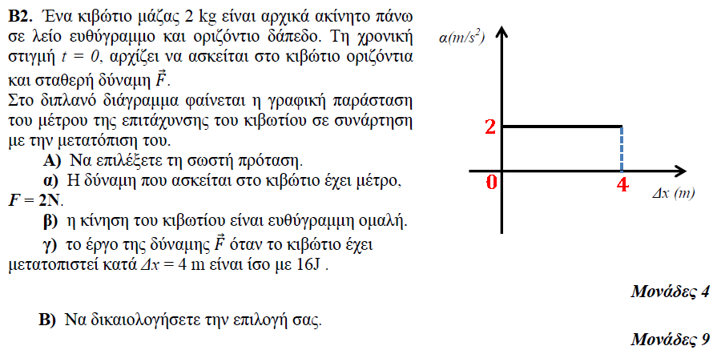

**➤ 8044 / B1** [****](https://drive.google.com/file/d/1AsV-gEEeizDwUbc2JC8evlI_ty8EQmrN/view?usp=sharing)

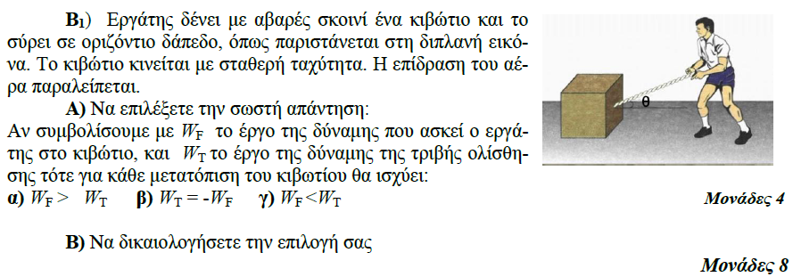

**➤ 8045 / B2** [****](https://drive.google.com/file/d/1zKcQzNbz6doQaXZQIaypdDsDT-SYbYYH/view?usp=sharing)

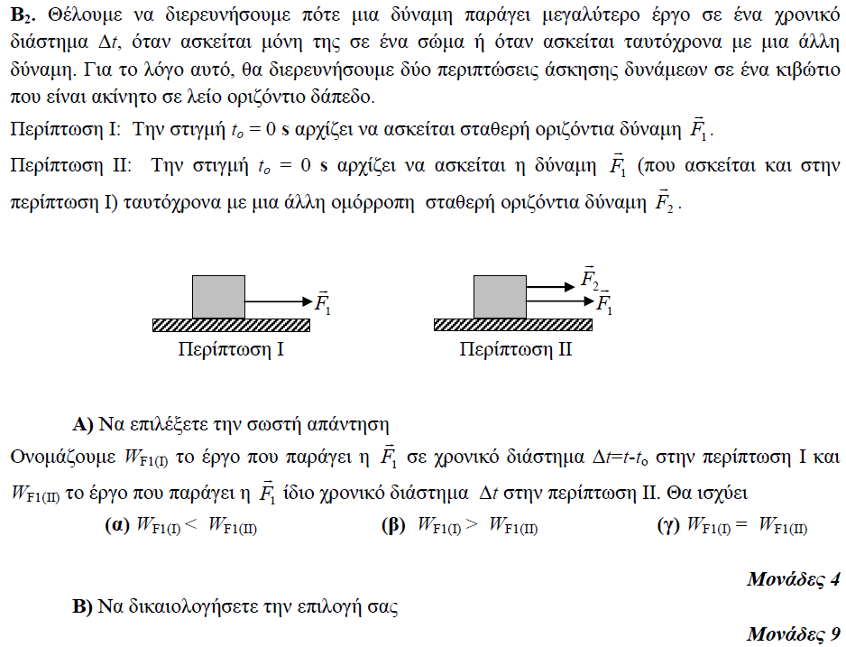

**➤ 8047 / B1** [****](https://drive.google.com/file/d/1MUv1_2w1HQI4oa01Zll2ejwj3ECQTeXf/view?usp=sharing)

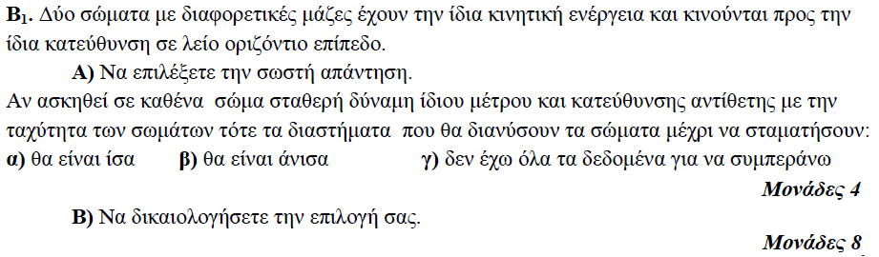

**➤ 11929 / B2** [****](https://drive.google.com/file/d/1t1syJJnNYLI7TupT4HF-rb0_0YO9Ogmo/view?usp=sharing)

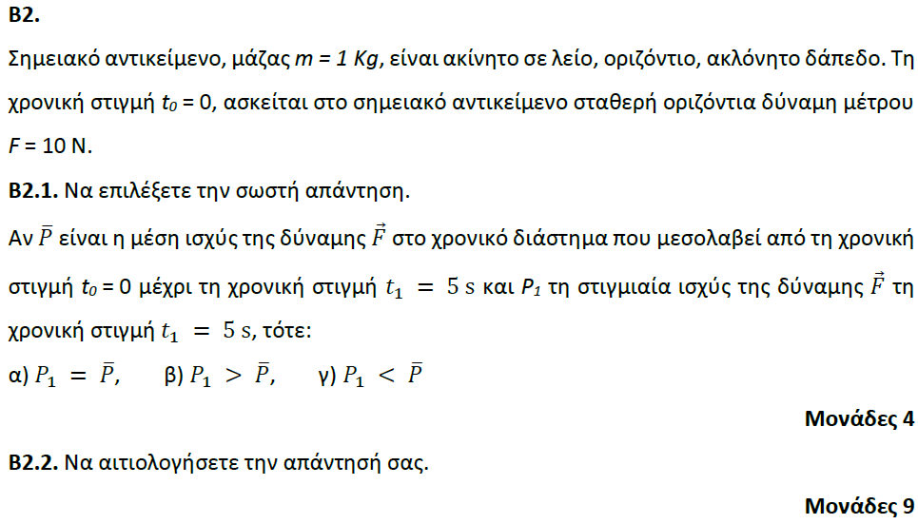

**➤ 13102 / B2** [****](https://drive.google.com/file/d/1LnVkQ1jN1doL0-fe2OORc62V5KqVyHyZ/view?usp=sharing)

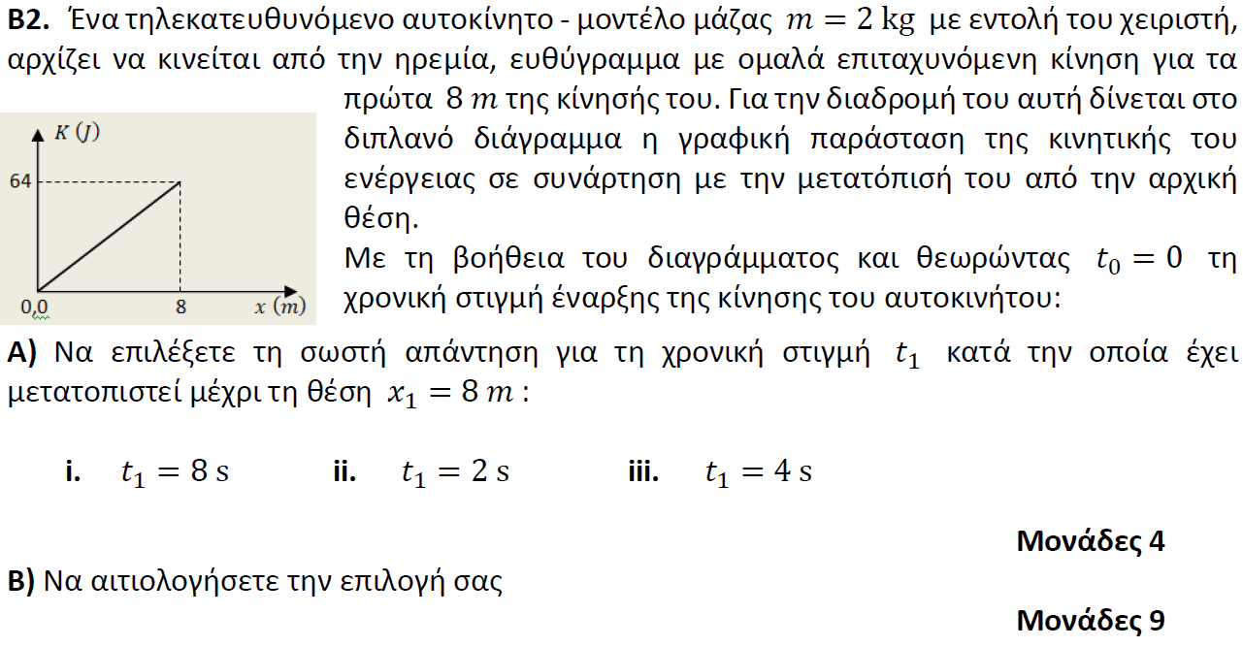

**➤ 13104 / B1** [****](https://drive.google.com/file/d/1SXR5TjVDcx_HTGJLITmj-VUUgLyqDDSx/view?usp=sharing)

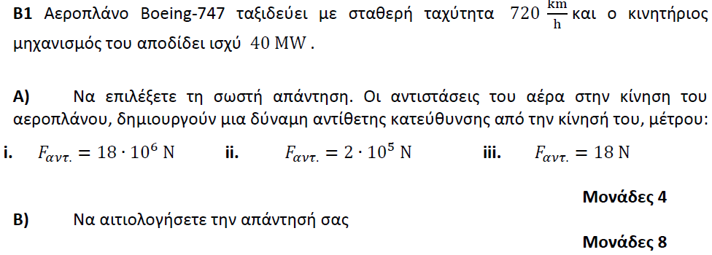

**➤ 13107 / B2** [****](https://drive.google.com/file/d/1mG-_i41Bl2EnQu3e4hKkl-JfFILtOYBI/view?usp=sharing)

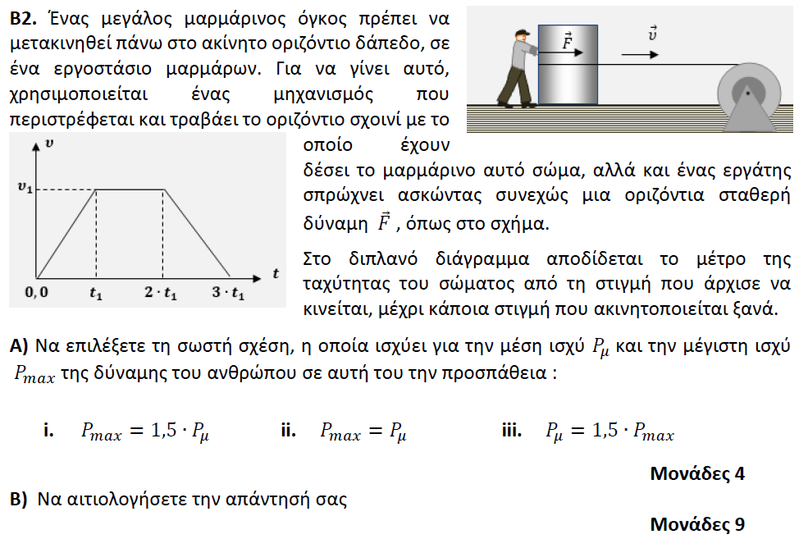

**➤ 13273 / B2** [****](https://drive.google.com/file/d/1rIqWW0Y7Tt7iIkIFFPswGD8KMnTM22gZ/view?usp=sharing)

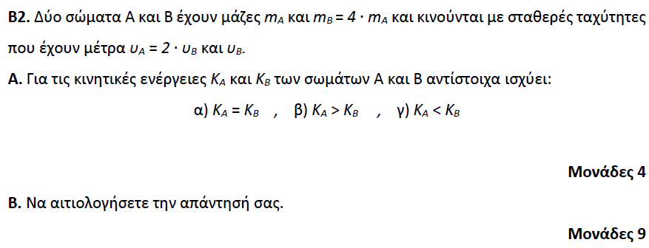

**➤ 13345 / B2** [****](https://drive.google.com/file/d/1jGnvvq8odBm1Kyfdz7tW-aUTTUtnwWDN/view?usp=sharing)

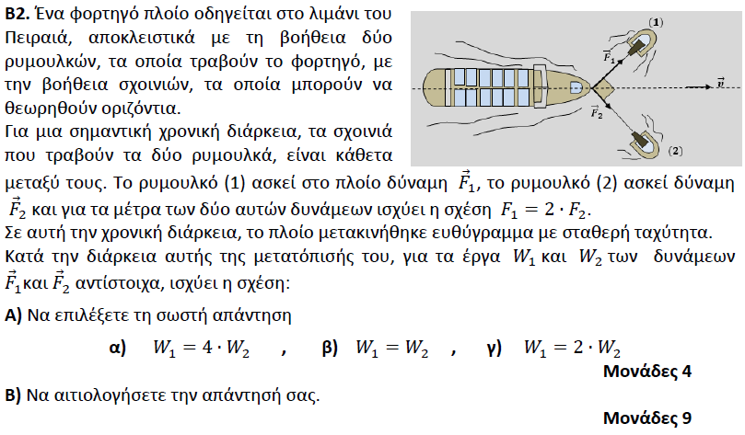

**➤ 13348 / B2** [****](https://drive.google.com/file/d/1cfKEt6HqdQkOFBcnsJ4hovLI_gFmZUYa/view?usp=sharing)

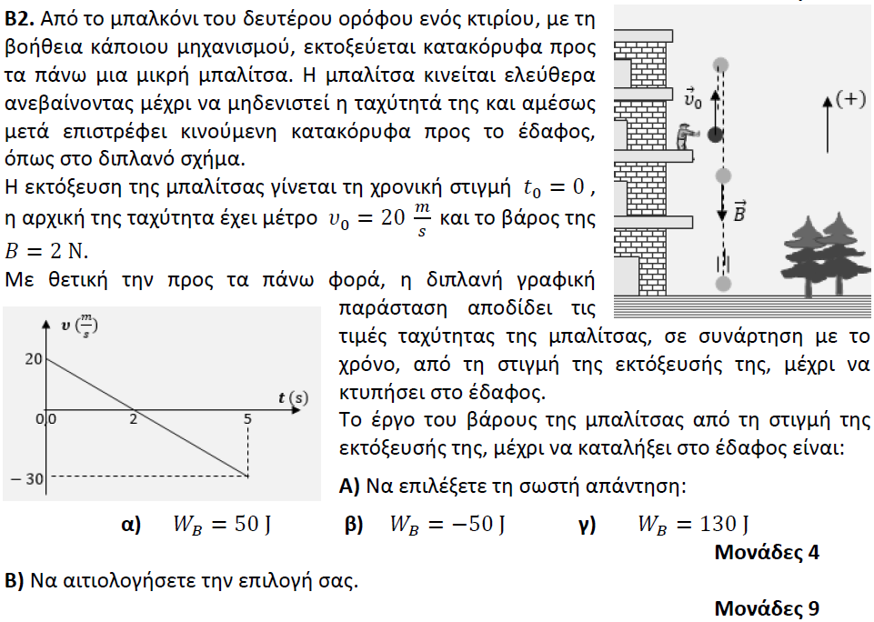

**➤ 13467 / B2** [****](https://drive.google.com/file/d/1IZDu0Us4ulCqQRU1MPWjw66vS0QEsPTS/view?usp=sharing)

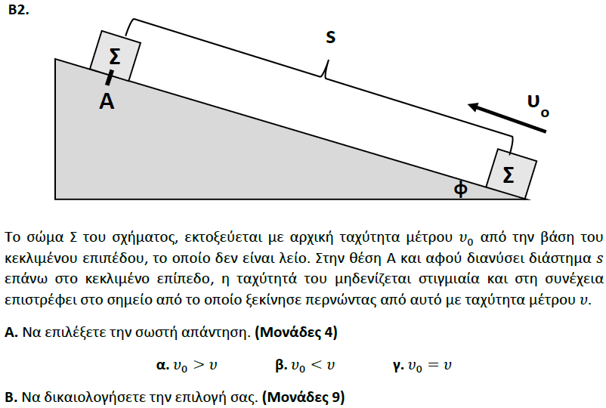

**➤ 13509 / B2** [****](https://drive.google.com/file/d/1pU_F-IkjsPSxjwHkTyT1YKTtXL5lkhWw/view?usp=sharing)

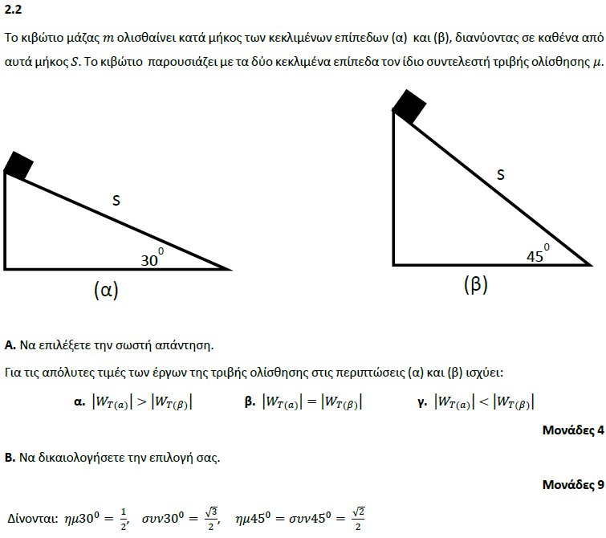

**➤ 13512 / B2** [****](https://drive.google.com/file/d/1GdaQDg6z7ApqbdH3QdBJFhAaCIchwIKq/view?usp=sharing)

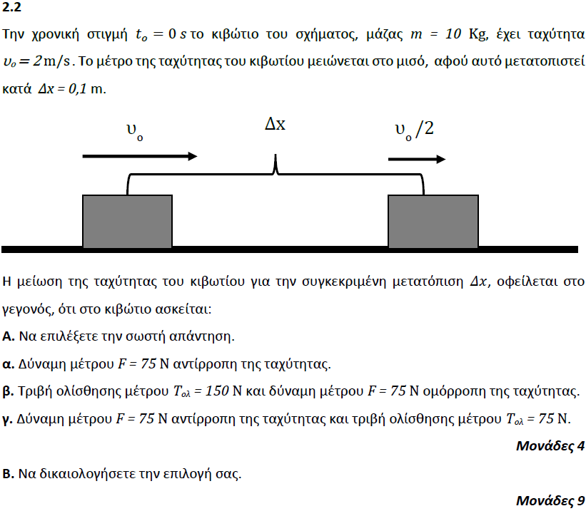

**➤ 13513 / B2** [****](https://drive.google.com/file/d/1ZnHkg0aVpVea0MseksgxggGOdvpBYh0K/view?usp=sharing)

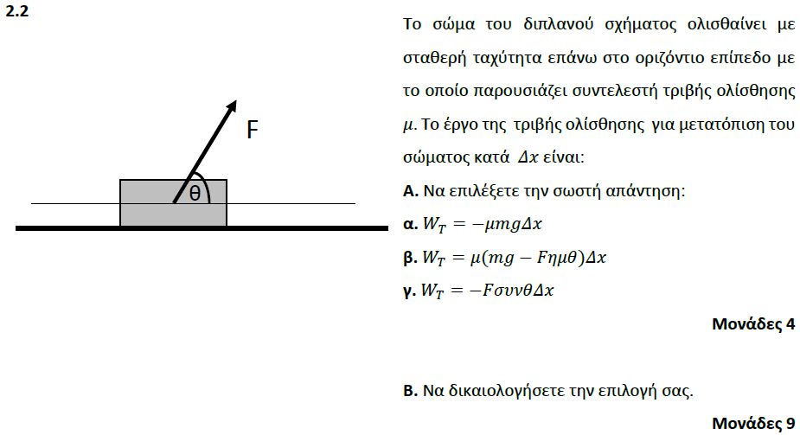

**➤ 13545 / B2** [****](https://drive.google.com/file/d/1GE1tz6-2kZ23oBNfhbCA5SMDXAqZYxGj/view?usp=sharing)

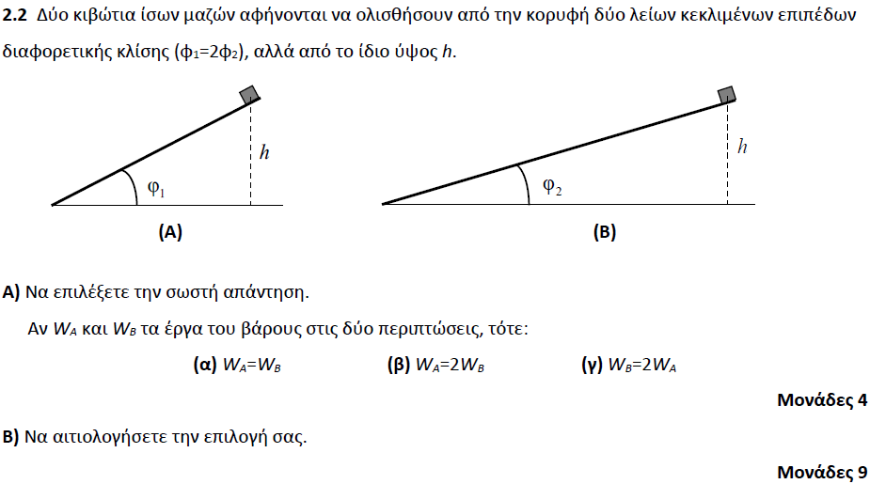

**➤ 13547 / B1** [****](https://drive.google.com/file/d/1BqN9EgtDxXpls-pdaWt-cHZFDcnzjxgq/view?usp=sharing)

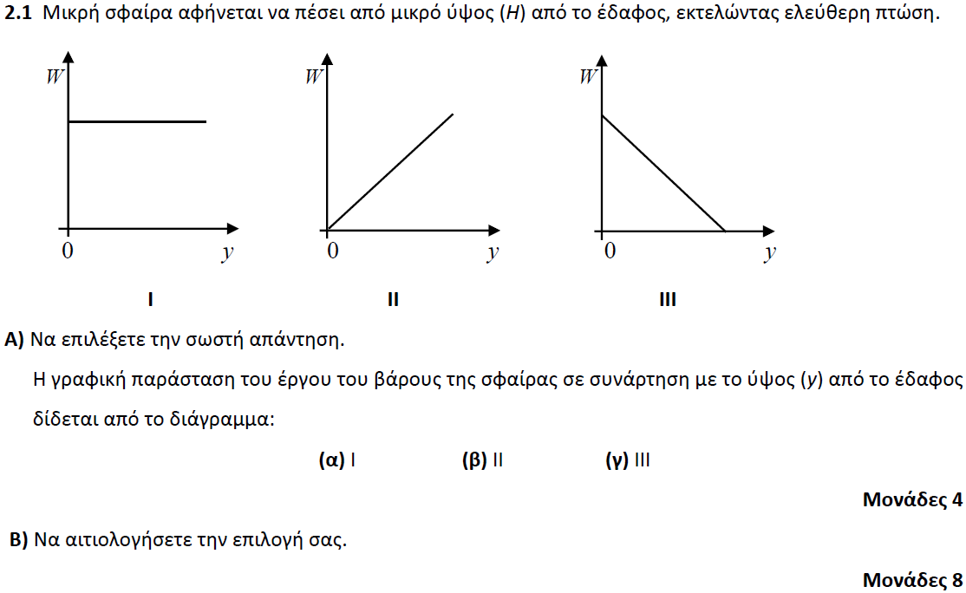

**➤ 13549 / B1** [****](https://drive.google.com/file/d/1keiHDF7NsX6A8crqckOKXuyUsRrSCgnn/view?usp=sharing)

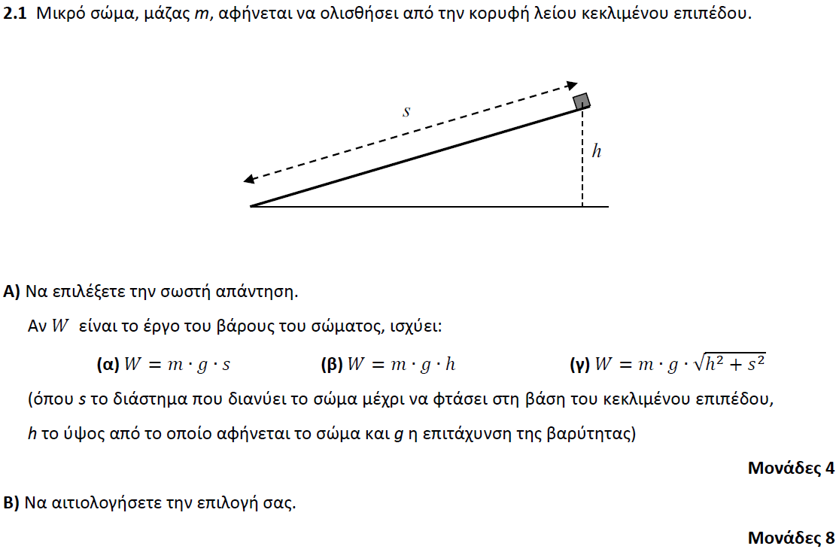

**➤ 13550 / B2** [****](https://drive.google.com/file/d/1gWYj6aNpj7JrZsmz6_bgCi9kABA213J4/view?usp=sharing)

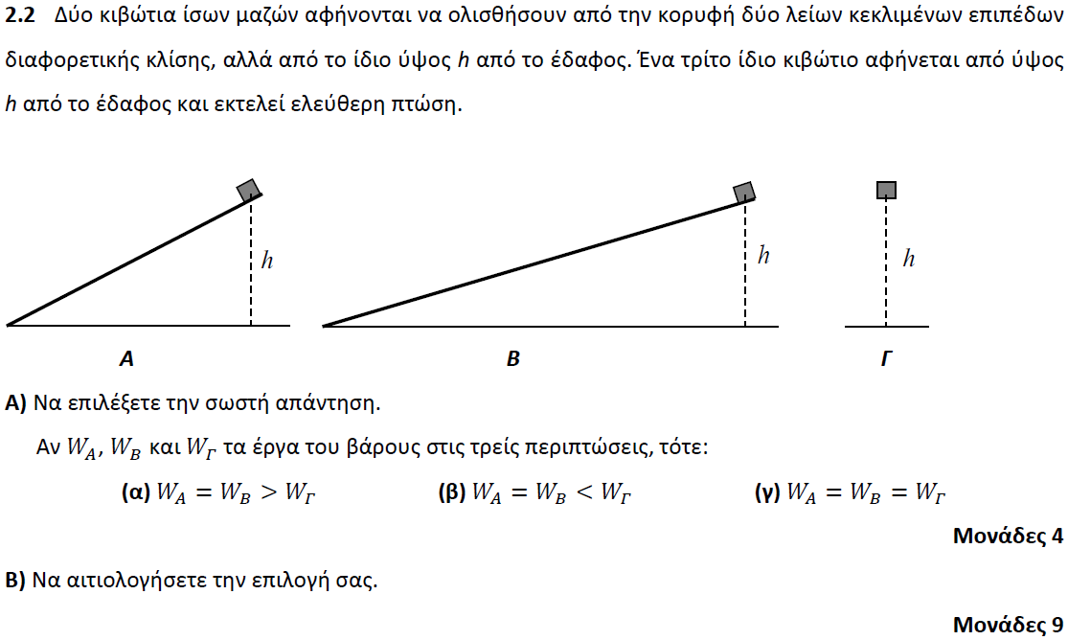

**➤ 13556 / B1** [****](https://drive.google.com/file/d/1UxCRz77U6ajqlLC2EsDztHJtv6iY-wdL/view?usp=sharing)

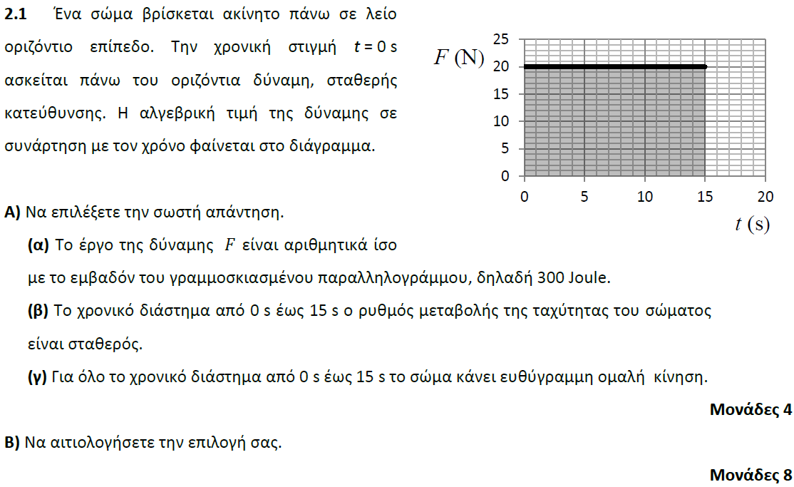

**➤ 13556 / B2** [****](https://drive.google.com/file/d/1UxCRz77U6ajqlLC2EsDztHJtv6iY-wdL/view?usp=sharing)

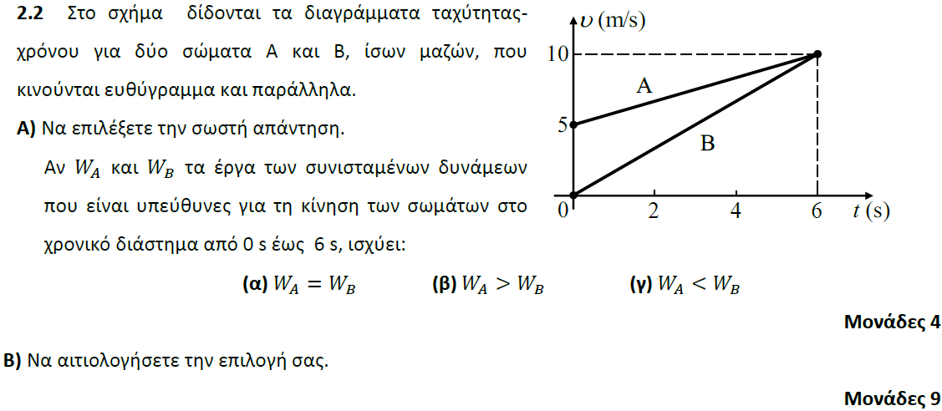

**➤ 13567 / B1** [****](https://drive.google.com/file/d/1PZoc9E8FbR39y-PUzgP9F0SUlfOms7R6/view?usp=sharing)

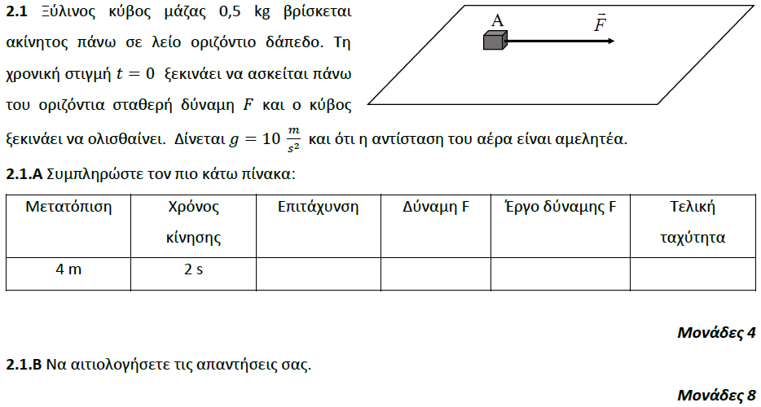

**➤ 13567 / B2** [****](https://drive.google.com/file/d/1PZoc9E8FbR39y-PUzgP9F0SUlfOms7R6/view?usp=sharing)

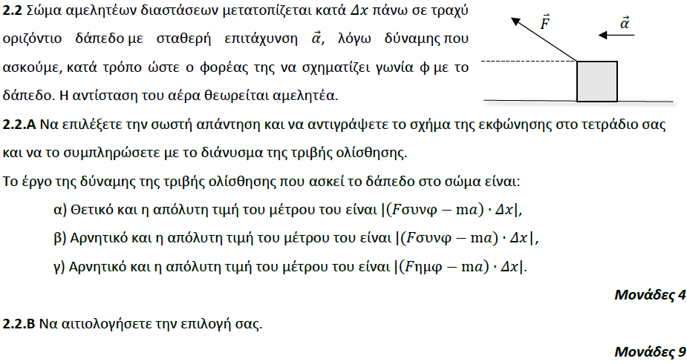

**➤ 13569 / B1** [****](https://drive.google.com/file/d/1yABd_BwYIuNrJZc1vGIUm7j5hO0X2UUn/view?usp=sharing)

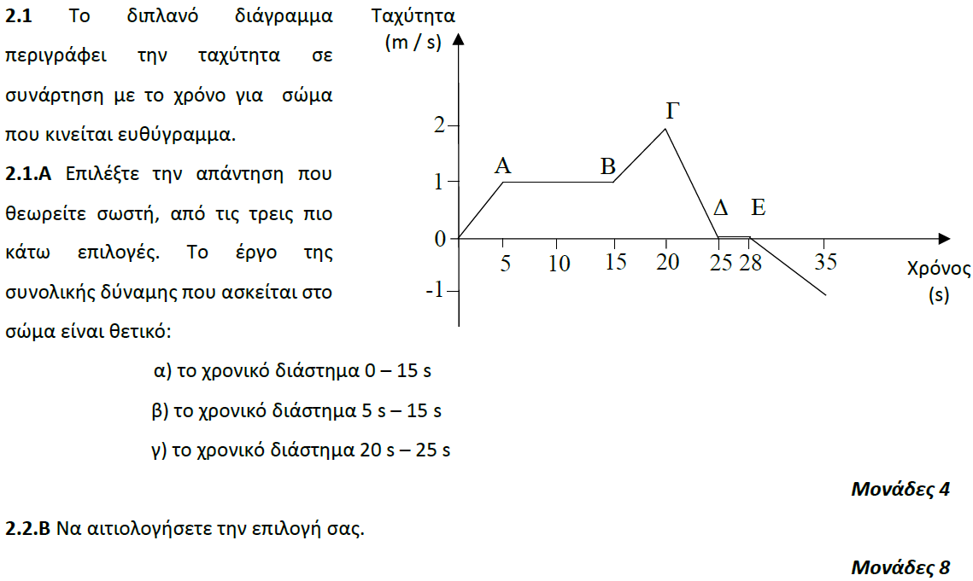

**➤ 13574 / B2** [****](https://drive.google.com/file/d/1uBBBim2Tofa6E1dqODDzvMpaKuh42vZQ/view?usp=sharing)

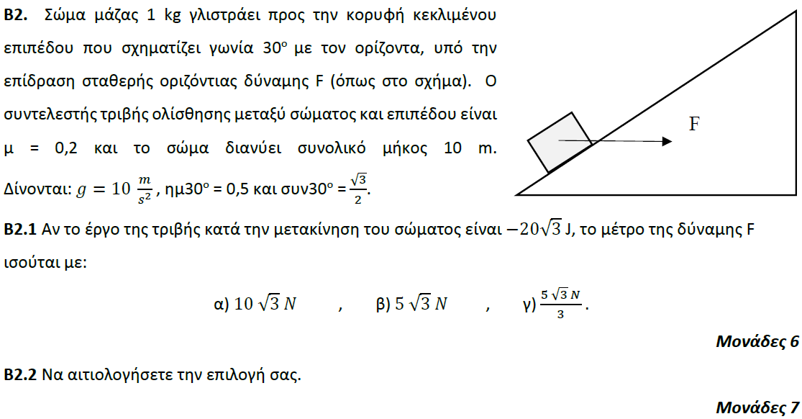

**➤ 13615 / B1** [****](https://drive.google.com/file/d/1P3mHvrTbQEdJ3YR5Zx93s4l1-6mJnXLr/view?usp=sharing)

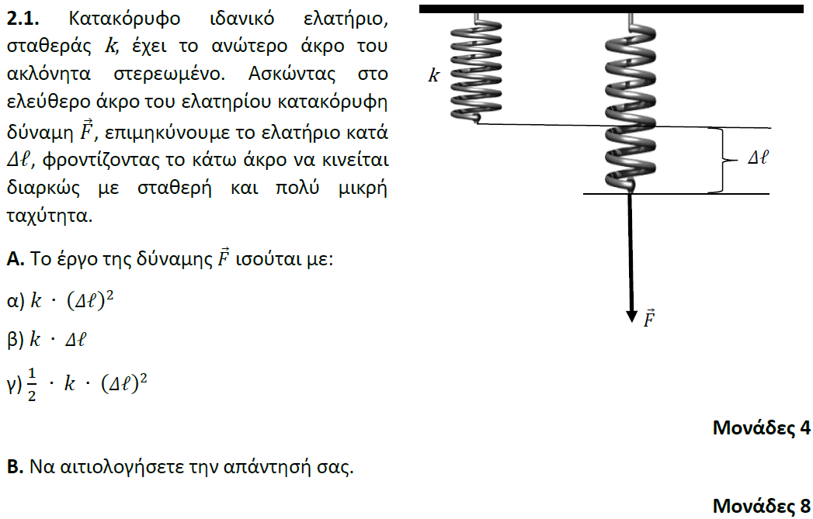

**➤ 13623 / B2** [****](https://drive.google.com/file/d/1LmHv3ALKcsIWnzU0qidypjLTF20ovLPK/view?usp=sharing)

