**WITH AUDIO**►:  [**Click to open/close audio player**](https://linguapress.com/advanced/gandhi.htm#mplay) then hit the **► play** button

***Mahatma Gandhi was surely one of the half dozen or so most important and influential figures of the twentieth century – a man whose legacy remains strong many decades after his death, and will be remembered for many years to come.***

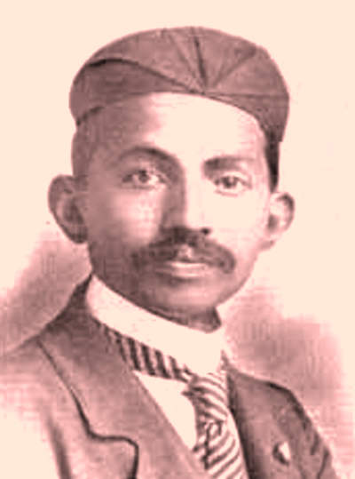Gandhi as a young lawyer, in 1902

When the epic film of Gandhi's life first came out in 1983, America’s *Newsweek* magazine commented: "There are very few movies that absolutely must be seen. Sir Richard Attenborough’s GANDHI is one of them." The magazine then went on to **devote** six full pages to the film and its background, unprecedented **coverage** for a film.

The film, which won no fewer than eight Oscars, traced the life of Mahatma Gandhi, who was one of the most amazing men of his age. Gandhi was assassinated in 1948, at the age of 78 — and it is with this event that the film begins. We see the**bald bespectacled** white-robed old man that the world recognises as Gandhi, before suddenly getting taken back to the 1890s, to South Africa, where a certain Mr. Mohandas K. Gandhi was working as a young **lawyer**.

M.K. Gandhi was a perfect example of a successful son of the British Empire, as it was at the time. He had been born into a well-to-do Hindu **merchant** family on October 2 1869 in the town of Porbander in the Indian state of Gujarat.   At the age of 18, on his father's advice, he went to study law in England, returning to India three years later as a qualified lawyer.

Following his student years in London, he dressed like an educated Englishman, and behaved like one too. Back in India he was recruited by a shipping company, and in 1893 he went to work in the company's offices in Durban, South Africa.

A few weeks after reaching South Africa, he was sent by train from Durban to the capital city Pretoria to **settle** a dispute for his client. South Africa at the time was controlled by the Boers, **Afrikaans**-speaking Whites, who believed in racial segregation, and it was during this trip that he first came face to face with the country's race laws. The young London-trained lawyer was sitting in the first class **compartment** of a train, as was appropriate for anyone of his status, when suddenly an angry White told him to get back to the third class compartment where he belonged. Gandhi's passive refusal to do so led to his being thrown off the train.

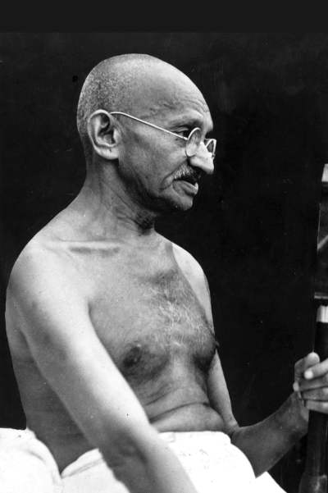 Gandhi in 1948

 This, according to Gandhi, was the incident which changed his life. Having experienced the way that Indians and other people of colour were discriminated against in South Africa, Gandhi decided to set up a movement to fight without violence for the rights of Indians and against injustice. From then on, the **well-off** young lawyer from India would use his skills to work against the racial discrimination which existed at the time in South Africa (just as it did in many other parts of the world). Having initially journeyed to South Africa for a short business mission, he ended up spending 21 years in the country, **spearheading** non-violent campaigns against racial segregation, injustice and discrimination. It was a hard fight, during which Gandhi was beaten up, almost assassinated, and sent to prison four times; but in the end his perseverence and popularity **prevailed**, and in 1914 Jan Smuts, Prime Minister of the Union of South Africa, signed the *Indian Relief****Act*,** effectively ending discrimination... for the time being.

By then, Gandhi had returned to India where he was already an almost mythical figure.  In the thirty-four years which followed, Gandhi successfully led his country to Independence from British colonial rule, opposing the British with his policy of non-violent passive resistance. This was the period in his life when he was most influential. Winston Churchill – one of the other "great men" of the 20th century –**could not stand** Gandhi, and described him as a***seditious****fakir*. Gandhi represented a force that Churchill could not stop. While Churchill could fight and win against **tyrants** on the battlefield, Gandhi opposed force with passivity, and violence with peace, and Churchill did not know how to deal with this. What could he do against a man who could lie down on the ground when confronted by police on horseback, or could lead people on a two hundred mile march, in non-violent protest against a government monopoly over salt? Churchill had no answer to this man who inspired massive demonstrations of non violent peasants against the armed power of **the British Raj** in India.   Were he alive today, Churchill would surely not be happy to see Gandhi's statue *(photo top of page)* among the twelve that stand in Parliament Square, London, just 150 metres from his own.

During his lifetime, Mahatma Gandhi was an inspiration for Indians of all religions, and the man who held India together during the final years of the British Empire. Since then, his legacy -  his principles of non-violence and *satyagraha*, meaning "pursuit of truth" - have been an inspiration for other  non-violent activists worldwide, including [**Martin Luther King**](https://linguapress.com/advanced/martin-luther-king.htm),  Nelson Mandela, and even Greta Thunberg.

**Notes**

**Gandhi, the film.** The film, directed by Richard Attenborough (the older brother of the environmentalist David Attenborough) starred **Ben Kingsley**, whose resemblance to Gandhi was remarkable. Kingsley, who was half Indian by descent, was a stage actor with the Royal Shakespeare Company before being catapulted into the limelight with the success of his role as Gandhi

**WORDS**

**legacy:** contribution to life, example **- decade:**period of ten years - **devote:**occupy**-  coverage :** attention from the media**- bald :**without hair -**bespectacled:**wearing glasses**- lawyer:**legal expert**,** attorney**- compartment:**section**- well-off**: rich - **merchant:**trader, businessman -**settle:**conclude, bring to an end **- Afrikaans:** a variety of Dutch **- to spearhead:**to lead **- to prevail:** to win, be victorious **- Act:**Law - **could not stand:** could not tolerate - **seditious:**revolutionary**-  tyrant:** monster, oppressor **- the British Raj** - British imperial power