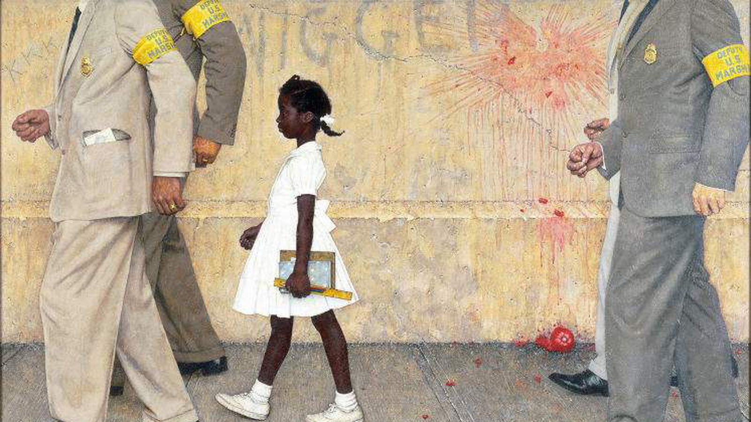

***The Problem We All Live With*** is a 1964 painting by [Norman Rockwell](https://en.wikipedia.org/wiki/Norman_Rockwell). It is considered an iconic image of the [Civil Rights Movement](https://en.wikipedia.org/wiki/Civil_Rights_Movement) in the [United States](https://en.wikipedia.org/wiki/United_States).[[2]](https://en.wikipedia.org/wiki/The_Problem_We_All_Live_With#cite_note-Solomon-2) It depicts [Ruby Bridges](https://en.wikipedia.org/wiki/Ruby_Bridges), a six-year-old [African American](https://en.wikipedia.org/wiki/African_Americans) girl, on her way to [William Frantz Elementary School](https://en.wikipedia.org/wiki/William_Frantz_Elementary_School), an all-white public school, on November 14, 1960, during the [New Orleans school desegregation crisis](https://en.wikipedia.org/wiki/New_Orleans_school_desegregation_crisis). Because of threats of violence against her, she is escorted by four [deputy U.S. marshals](https://en.wikipedia.org/wiki/United_States_Marshals_Service); the painting is framed such that the marshals' heads are cropped at the shoulders. On the wall behind her is written the racial slur "[nigger](https://en.wikipedia.org/wiki/Nigger)" and the letters "[KKK](https://en.wikipedia.org/wiki/Ku_Klux_Klan)"; a smashed and splattered tomato thrown against the wall is also visible. The white protesters are not visible, as the viewer is looking at the scene from their point of view.[[3]](https://en.wikipedia.org/wiki/The_Problem_We_All_Live_With#cite_note-Underside_of_Innocence-3) The painting is oil on canvas and measures 36 inches (91 cm) high by 58 inches (150 cm) wide.[[5]](https://en.wikipedia.org/wiki/The_Problem_We_All_Live_With#cite_note-NRM-5)

**Ruby Bridges became a civil rights icon when she was 6.**