**UNIT 4 - Vincent Van Gogh**

**How to talk about art pp.36-37**

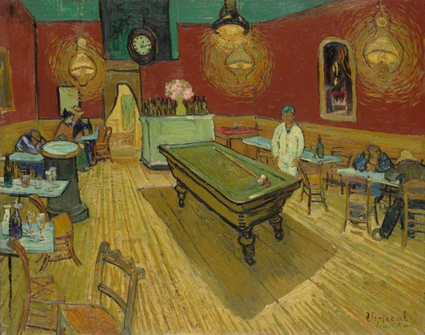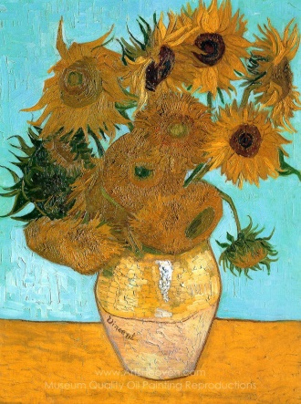**A B**

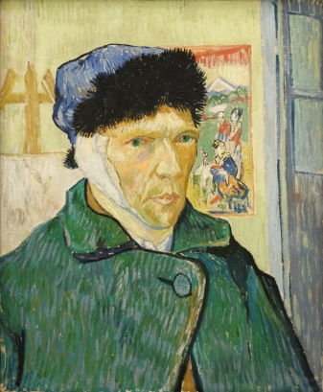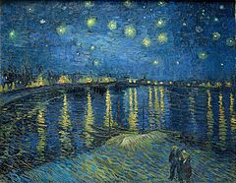

**C D**

**The painting depicts a scene in …**

**The theme of… is reflected in the painting**

**The background illustrates the 3-dimentional perspective of...**

**A portrait represents a person from the face up to the shoulders**

**A landscape is the portrayal of a scene in the open space/in nature**

**Still life is called the representation of lifeless objects**

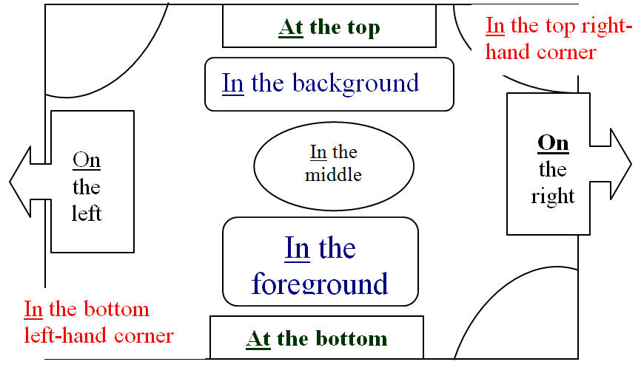

**Unit 4- Vincent Van Gogh**

**Glossary**

|  |  |  |
| --- | --- | --- |
| **Lexical item** | **Synonym/Definition** | **Greek translation** |
| **Activities 1-5, pp. 36-39** | | |
| **lyrics** | the words of a poem or song, verse | στίχοι |
| **stanza** | a group of lines forming the basic recurring metrical unit in a poem | στροφή ποιήματος |
| **to flame** | to suddenly become hot and red with emotion | καίγομαι, φουντώνω |
| **to blaze** | to burn fiercely or brightly/to light up | φλέγομαι, λαμποκοπώ |
| **to swirl** | to whirl, to twirl | στροβιλίζομαι, περιστρέφομαι |
| **haze** | a very fine cloud of something such as vapour or smoke in the air | ομίχλη, θολούρα |
| **to reflect** | a. throw back (heat, light, or sound) without absorbing it,  b. (of a mirror or shiny surface) show an image of,  c. embody or represent (something) in a faithful or appropriate way,  d. think deeply or carefully about | α. αντανακλώ,  β. καθρεφτίζω,  γ. απεικονίζω, εκπροσωπώ,  δ. στοχάζομαι |
| **china blue** | a pale greyish blue | πορσελάνινο μπλε |
| **hue** | shade of colour | απόχρωση |
| **amber** | here: a honey-yellow colour typical of amber | κεχριμπάρι |
| **grain** | a. wheat or any other cultivated cereal used as food, b. the seeds of wheat or other cultivated cereal, c. a small hard particle of a substance such as salt or sand | α. δημητριακά, β. σπόρος,  γ. κόκκος |
| **weathered** | weather-beaten | ανεμοδαρμένος |
| **to soothe** | to make smb feel calmer or less worried | καταπραΰνω, ηρεμώ, μετριάζω |
| **to suffer** | a. to experience or be subjected to (something bad or unpleasant),  b. **from:** to be affected by or subject to (an illness or ailment) | α. υποφέρω, β. πάσχω |
| **sanity** | having a healthy mind | πνευματική/ψυχική υγεία, λογική |
| **frameless** | without frame or a solid structure | χωρίς πλαίσιο, χωρίς κορνίζα |
| **ragged\*** | a. of surface: uneven, irregular  b. of clothes: torn, worn out | α. μη ομαλός  β. κουρελιασμένος |
| **rugged\*** | a. of ground: rocky  b. of features: rough | α. τραχύς  β. ανθεκτικός |
| **thorn** | a sharp-pointed woody projection on the stem of a plant (e.g. a rose thorn) | αγκάθι |
| **breeze** | a gentle wind | ελαφρύ αεράκι, αύρα |
| **daffodil** | a bulbous European plant which typically bears bright yellow flowers with a long trumpet-shaped centre (corona) | ασφόδελος, νάρκισσος |
| **linen** | a. cloth woven from flax, b. articles such as sheets or clothes made, or originally made, of linen | α. λινό, β. ασπρόρουχα, σεντόνια |
| **to sketch** | draw without many details | σχεδιάζω, ιχνογραφώ |
| **to paint** | depict (someone or something) or produce (a picture) with paint | ζωγραφίζω, βάφω |
| **to draw** | to produce (a picture or diagram) by making lines and marks on paper with a pencil, pen, etc. | σχεδιάζω |
| **palette** | a thin board or slab on which an artist lays and mixes colours | παλέτα |
| **brushes** | an implement with a handle and a block of bristles, hair, or wire | πινέλα |
| **mental disorder** | an illness or condition that disrupts normal mental function | διανοητική διαταραχή |
| **to commit suicide** | to take one’s life, to kill oneself | αυτοκτονώ |
| **in sight (of)** | visible, easily seen, in view | ορατός, εμφανής |
| **dutiful** | conscientiously or obediently fulfilling one's duty, responsible | υπάκουος, με αίσθηση καθήκοντος |
| **Activity 6, p.40** | | |
| **absinthe** | a strong alcoholic drink that is green and has a bitter taste | αψέντι |
| **solitary** | here: single; only | μοναδικός |
| **vantage point** | a position or standpoint from which something is viewed or considered | σκοπιά, προοπτική, σημείο υπεροχής/πλεονεκτικής θέσης |
| **peasant** | a poor agricultural labourer of low social status, a farmer | χωρικός, χωριάτης |
| **to depict** | portray, represent | απεικονίζω |
| **modest** | self-effacing, unpretentious | σεμνός, λιτός |
| **to sustain** | to strengthen or support physically or mentally | συντηρώ |
| **stark** | apparent and obvious | λιτός, απέριττος |
| **legacy** | a. property you gain after smb dies,  b. sth that remains from an earlier time | α. κληρονομιά,  β. κληροδότημα |
| **sentimental** | emotional | συναισθηματικός |
| **compassionate** | sympathetic | συμπονετικός |
| **sincerity** | honesty, truthfulness | ειλικρίνεια |
| **harvest** | the time of year when crops are cut and collected from the fields | θερισμός, συγκομιδή |
| **deliberate** | intentional, conscious, on purpose | σκόπιμος |
| **approach** | attitude, viewpoint, line of action | προσέγγιση |
| **spatial** | relating to or occupying space | χωροταξικός |
| **crop** | the total amount collected of a plant such as a grain, fruit, or vegetable | καλλιέργεια, σοδειά |
| **to reveal** | to divulge, to disclose | αποκαλύπτω |
| **to attain** | to achieve, to obtain, to gain | αποκτώ |
| **grandeur** | splendour and impressiveness, especially of appearance or style, magnificence | μεγαλοπρέπεια |
| **sprig** | a small stem bearing leaves or flowers, taken from a plant, a twig, a small branch | κλαδί, κλωνάρι |
| **almond blossom** | the flower of the tree that yields almonds | άνθος αμυγδαλιάς |
| **oil on canvas** | painting with oil colours on a strong cloth specially made for it | ελαιογραφία σε καμβά |
| **translucent** | opaque | ημιδιαφανής |
| **bloom** | flower (also used as verb: *to bloom*) | άνθος |
| **to recall** | a. to remember  b. to bring back in mind the memory of | α. θυμάμαι  β. θυμίζω |
| **scarlet** | οf a brilliant red colour, wine red | βαθύ κόκκινο, πορφυρό |
| **to pay tribute to** | to praise someone or something publicly | αποτίνω φόρο τιμής |
| **to inspire** | to fill (someone) with the urge or ability to do or feel something, especially to do something creative, to stimulate, to incite | εμπνέω |
| **untypically** | unusually, uncommonly, atypically, uncharacteristically | μη αναμενόμενα, καθόλου αντιπροσωπευτικά |
| **brushstroke** | a mark made by a paintbrush drawn across a surface | πινελιά |
| **stipple** | a mark (on a surface) with numerous small dots or specks | κουκκίδα, ζωγραφική με κουκκίδες |
| **Activity 7, pp. 41-45** | | |
| **pastor** | priest | ιερέας |
| **to bring up** | to raise children | αναθρέφω παιδιά |
| **appealing** | attractive, luring | ελκυστικός |
| **to be drawn** | to be attracted to | έλκομαι, «με τραβά» |
| **to a certain extent** | up to a point | ως ένα βαθμό |
| **introspective** | inward-looking, self-analysing, introvert | ενδοσκοπικός, συνεσταλμένος |
| **to cherish** | to take pleasure in sth, to appreciate,  to hold dear | απολαμβάνω, λατρεύω |
| **amply** | abundantly, sufficiently, adequately | επαρκώς |
| **to document** | to record information in an official form | τεκμηριώνω, καταγράφω |
| **vast** | huge, very large, extensive, great, immense | τεράστιος |
| **insight** | an accurate and deep understanding, awareness | διορατικότητα, οξυδέρκεια |
| **keen mind** | sharp, eager | οξύ πνεύμα, μυαλό |
| **to take up** | to start an activity | ξεκινώ μια δραστηριότητα |
| **in earnest** | seriously, fervently, passionately | με ζήλο, στα σοβαρά |
| **divergence** | difference, deviation | απόκλιση |
| **looseness** | the state of not being firmly fixed in place | χαλαρότητα |
| **to favour** | to support, to give an advantage | ευνοώ, δείχνω προτίμηση για κάτι |
| **to set apart from** | to differentiate from | διακρίνω, διαχωρίζω |
| **to lack** | to be short of, to be deficient in | έχω έλλειψη ή ανεπάρκεια σε κάτι |
| **social engagement** | social involvement and interaction | κοινωνικότητα |
| **to blend in(to)** | to be an unobtrusive or harmonious part of a greater whole by being similar in appearance or behaviour | αναμειγνύομαι, καμουφλάρομαι, εναρμονίζομαι |
| **beholder** | a person who sees or observes | θεατής, παρατηρητής |
| **to make one’s mark on** | to influence, to affect | επηρεάζω, αφήνω το αποτύπωμα μου πάνω σε |
| **to be regarded as** | to be considered (to be) | θεωρούμαι |
| **unstable** | unbalanced | ασταθής |
| **volatile** | likely to change emotional state suddenly | εκρηκτικός, ευέξαπτος, ασταθής |
| **tortured** | tormented | βασανισμένος |
| **to undermine** | to make sth or smb weaker/less effective | υπονομεύω, υποσκάπτω |
| **to found** | to set up, to establish | ιδρύω |
| **ultimately** | eventually, in the end | τελικά |
| **to pursue** | α.tofollow, to chaseβ. if you pursue a plan, activity, or situation, you try to do it or achieve it, usually over a long period of time | α. ακολουθώ, καταδιώκω  β. επιδιώκω, |
| **portion** | segment, part | μερίδα, μέρος |
| **to alternate** | to vary, to swap | εναλλάσσω |
| **fits of madness** | seizures of irregular behaviour | παροξυσμοί/κρίσεις τρέλας |
| **lucidity** | to think clearly or express yourself clearly | διαύγεια σκέψης, έκφρασης |
| **depression** | melancholy, misery, sadness, unhappiness | κατάθλιψη |
| **to aggravate** | to make worse, to exacerbate | επιδεινώνω/ομαι |
| **a fit of painting activity** | a period/time of obsession with painting | μια εμμονή καλλιτεχνικής δραστηριότητας |
| **physician** | a person qualified to practice medicine, a doctor | ιατρός |
| **to come to terms with** | to come to accept ; reconcile oneself to | συμβιβάζομαι |
| **approximately** | about, around | κατά προσέγγιση |
| **impassioned** | passionate | παθιασμένος |
| **vibration** | tremor, movement to and fro | δόνηση |
| **for** | because | επειδή, διότι |
| **to be absorbed in** | to be engrossed in | απορροφημένος |
| **spiritual essence** | the non-material substance of things | πνευματική ουσία |
| **enormous** | huge | τεράστιος, πελώριος |
| **to dedicate oneself to** | to devote one’s energy and actions to | αφοσιώνομαι |
| **recognition** | acknowledgement ,appreciation | αναγνώριση |
| **to rank among** | to receive a place of acclaim among | κατατάσσομαι ανάμεσα |
| **thus** | whereby | συνεπώς, κατ’ αυτόν τον τρόπο |
| **to** **preserve** | to conserve, to safeguard | διατηρώ, συντηρώ, διαφυλάττω |
| **on the contrary** | saying or showing the opposite | αντιθέτως |
| **Activity 8, pp. 46-47** | | |
| **to long for** | to crave for, to desire, to yearn | επιθυμώ βαθιά, διακαώς |
| **meadow** | field, pasture | λιβάδι, αγρός με λουλούδια |
| **hedge** | a fence or row of bushes or shrubs | φράχτης με θάμνους |
| **hawthorn** | a thorny shrub or tree | λευκάγκαθα |
| **elm tree** | a tall deciduous tree | φτελιά |
| **dusk** | the darker stage of twilight | σούρουπο |
| **tidings** | news, information | τα νέα, οι ειδήσεις |
| **disillusioned** | disheartened, disappointed | απογοητευμένος |
| **to endow with** | to provide with a quality, ability, or asset | προικίζω |
| **to penetrate** | to pierce | διαπερνώ |
| **to stifle** | to make (someone) unable to breathe properly; suffocate; restrain | πνίγω, ασφυκτιώ, καταπνίγω |
| **moors** | uncultivated land | χερσότοποs |
| **immaculate** | perfect, spotless | άμεμπτος, αψεγάδιαστος |
| **yoke** | harness | ζυγός |
| **to throw off** | to get rid of | αποτινάσσω, ξεφορτώνομαι |
| **to quit** | to give up, to stop, to abandon, to leave | τα παρατώ, σταματώ |
| **to regain** | to recover, to win sth back | ανακτώ |
| **vague** | unclear, fuzzy, indistinct | ασαφής, θολός |
| **ray** | beam, a streak of light | ακτίνα |
| **to flicker** | to glimmer, alternately flaring up and dying down | τρεμοπαίζω |
| **to supplant** | replace | αντικαθιστώ |

**[Artistic movement](https://www.thefreedictionary.com/artistic+movement)**- a group of artists who agree on general principles

Click on the **links** below to visit the site and learn more about art movements

Or

Go to **<https://simplicable.com/new/art-styles>**

**[Impressionism](https://www.thefreedictionary.com/impressionism)** -   
a school of late 19th century French painters who pictured appearances   
by strokes of unmixed colors to give the impression of reflected light

**[Pop Art](https://www.thefreedictionary.com/pop+art)** - a school of art that emerged in the United Kingdom in the 1950s and became prevalent in the United States and the United Kingdom in the 1960s; it imitated the techniques of   
commercial art (as the soup cans of Andy Warhol) and the styles   
of popular culture and the mass media

**[Pointillism](https://www.thefreedictionary.com/pointillism)** - a school of painters who used a technique of painting with tiny dots of pure colors   
that would blend in the viewer's eye; developed by Georges Seurat   
and his followers late in 19th century France

**[Art deco](https://www.thefreedictionary.com/art+deco)**, **[deco](https://www.thefreedictionary.com/deco)** - a style of design that was popular in the 1920s and 1930s; marked by stylized forms  
 and geometric designs adapted to mass production

**[Art nouveau](https://www.thefreedictionary.com/art+nouveau)** - a French school of art and architecture popular in the 1890s; characterized by   
stylized natural forms and sinuous outlines of such objects as leaves and vines and flowers

**[Cubism](https://www.thefreedictionary.com/cubism)** -   
an artistic movement in France beginning in 1907 that featured surfaces   
of geometrical planes

**[Dadaism](https://www.thefreedictionary.com/dadaism)**, **[dada](https://www.thefreedictionary.com/dada)** - a nihilistic art movement (especially in painting) that flourished in Europe early   
in the 20th century; based on irrationality and negation of the accepted laws of beauty

**[Expressionism](https://www.thefreedictionary.com/expressionism)** - an art movement early in the 20th century; the artist's subjective expression   
of inner experiences was emphasized;   
an inner feeling was expressed through a distorted rendition of reality

**[Fauvism](https://www.thefreedictionary.com/fauvism)** -   
an art movement launched in 1905 whose work was characterized by bright  
 and nonnatural colors and simple forms; influenced the expressionists

**[Futurism](https://www.thefreedictionary.com/futurism)** -  
 an artistic movement in Italy around 1910 that tried to express the energy   
and values of the machine age

**[Minimal art](https://www.thefreedictionary.com/minimal+art)**, **[minimalism](https://www.thefreedictionary.com/minimalism)**, **[reductivism](https://www.thefreedictionary.com/reductivism)** - an art movement in sculpture and painting that began in the 1950s and emphasized  
 extreme simplification of form and color

**[Naturalism](https://www.thefreedictionary.com/naturalism)**, **[realism](https://www.thefreedictionary.com/realism)**-  
an artistic movement in 19th century France; artists and writers   
strove for detailed realistic and factual description

[**Surrealism**](https://www.thefreedictionary.com/surrealism) - a 20th century movement of artists and writers (developing out of dadaism) who   
used fantastic images and incongruous juxtapositions in order to represent   
unconscious thoughts and dreams

**[Symbolism](https://www.thefreedictionary.com/symbolism)** -   
an artistic movement in the late 19th century that tried to express   
abstract or mystical ideas throughthe symbolic use of images

**Source: <https://www.thefreedictionary.com/Art+styles>**

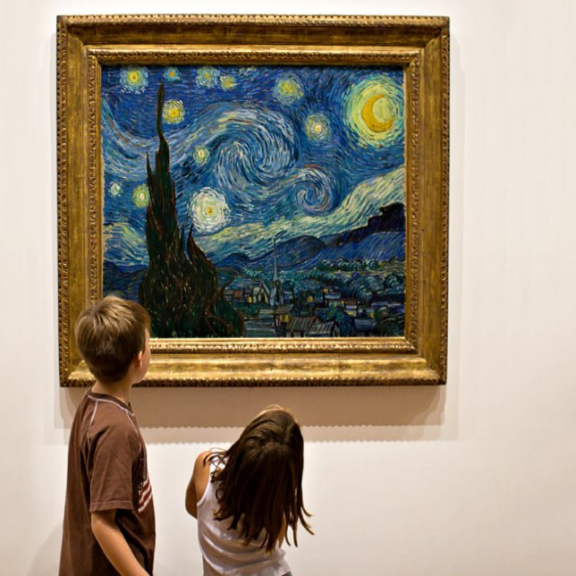

**Grammar**

**A. i) Present Tenses are used**

|  |  |
| --- | --- |
| ***Simple*** | ***Continuous*** |
| **1. to express habit** | **1. to express actions in progress now** |
| **2. for general truths & natural laws** | **2. for activities in progress around now** |
| **3. for permanent situations** | **3. for temporary situations** |
| **4. for schedules** | **4. for arrangements & future plans** |
| **5. for commentary and stories** | **5. for progressively changing situations** |

**ii) Past Tenses are used**

|  |  |
| --- | --- |
| ***Simple*** | ***Continuous*** |
| **1. to express complete actions in the past** | **1. to express actions in progress in the past** |
| **2. to express habit in the past** | **2. for progressively changing situations** |
| **3. to tell a story about the past** | **3. as a background to a story** |

**iii) Present Perfect Tenses are used**

|  |  |
| --- | --- |
| ***Simple*** | ***Continuous*** |
| **1. to express actions that are complete without referring to time of completion, or actions that are not complete yet** | **1. to express actions that started in the past and are still in progress, either stating a starting point of past reference or using a time phrase expressing duration** |
| **2. to express actions that started in the past and are still in progress, either stating a starting point of past reference or using a time phrase expressing duration** | **2. for activities that have just ended and their effects are still visible** |

**iv) Past Perfect Tenses are used**

|  |  |
| --- | --- |
| ***Simple*** | ***Continuous*** |
| **1. to express an action that was completed before another action in the past** | **1. to express an action that was in progress for a specific time before another action in the past** |

**v) FutureTenses are used**

|  |  |
| --- | --- |
| ***Simple*** | ***Continuous*** |
| **1. to express actions that will begin and end in the future** | **1. to express actions that will be in progress in the future, stating a specific point of future reference** |

**vi) Future Perfect Tenses are used**

|  |  |
| --- | --- |
| ***Simple*** | ***Continuous*** |
| **1. to express an action that will be completed before another action in the future** | **1. to express an action that will have begun and been in progress for a specific time before another action in the future, stating a point of reference in the future or a time phrase expressing duration** |

***Note:***

***Tip#1: Stative verbs are always used in simple verb forms unless they express actions***

***Tip#2: You use continuous verb forms with always if you are angry about someone’s behavior***

* **Watch Dan from BBC English explaining how to use the right tense to express future time: <https://youtu.be/RiwiaoBGRzA>**
* **Go to:** [**https://www.perfect-english-grammar.com/verb-tenses.html**](https://www.perfect-english-grammar.com/verb-tenses.html) **, download the infographics and expanations documents and practice doing the exercises on tenses online.**

**Β. Passive Voice**

**Ι. We use passive voice to give *emphasis on the subject of the sentence*, to *create a more impersonal/less assertive tone* and for *formality*.**

Examples:

**1. “**This world ***was never meant*** for one as beautiful as you.” (*This world not* another world)

**2.** “And when no hope ***was left*** in sight.” (*the passive moderates the assertiveness* of a personal opinion or consideration *on the part of the speaker-it works as a general statement*)

**3.** Van Gogh ***is regarded as*** a post-impressionist rather than an impressionist. (the passive indicates *formality* in the tone of the speaker)

# Online practice-Download the document with explanations on the use of Passive Voice and click on the links to do the exercises online:

# <https://www.perfect-english-grammar.com/passive.html>

**Writing**

**Watch the video** [**https://youtu.be/ubTJI_UphPk**](https://youtu.be/ubTJI_UphPk) **and write where Van Gogh will go after visiting the Museum and what he will do there.**

**Your story will be published in the school newspaper.**

**/*/**