**UNIT 3 – Renaissance Arts & Artists**

**How to talk about art pp.34-37**

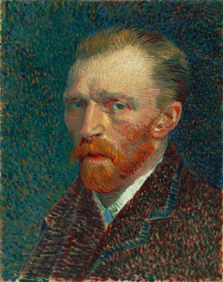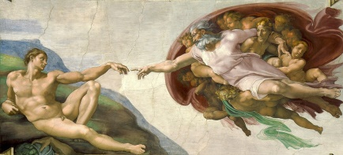

**A B**

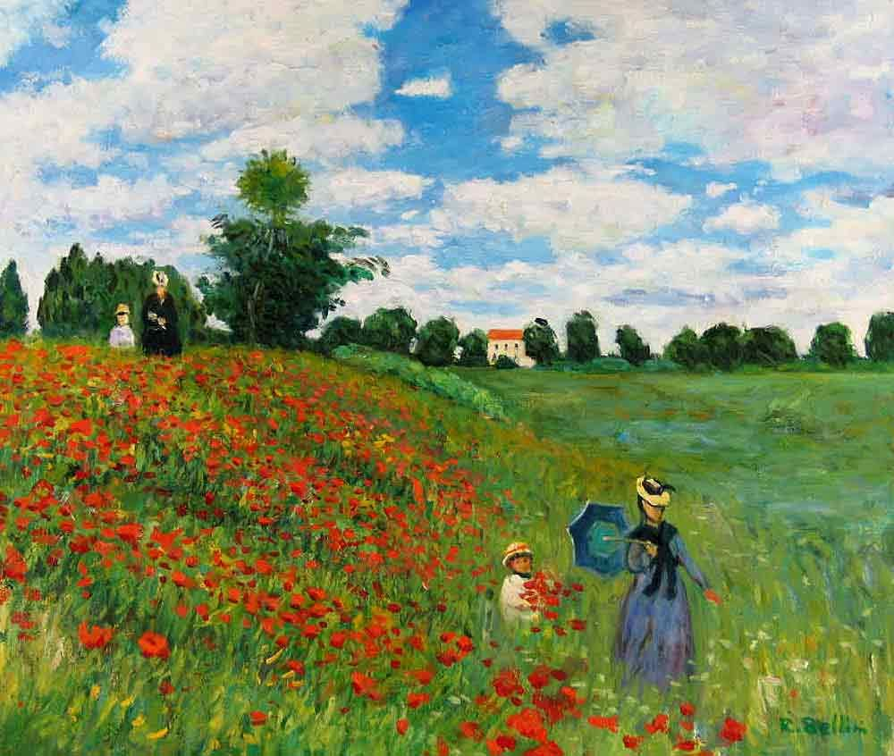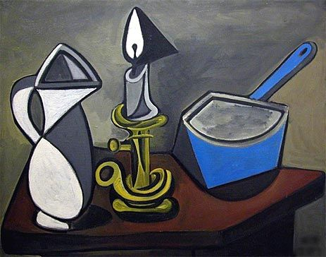**C D**

**The painting depicts a scene in …**

**The theme of… is reflected in the painting**

**The background illustrates the 3-dimentional perspective of...**

**A portrait represents a person from the face up to the shoulders**

**A landscape is the portrayal of a scene in the open space/in nature**

**Still life is called the representation of lifeless objects**

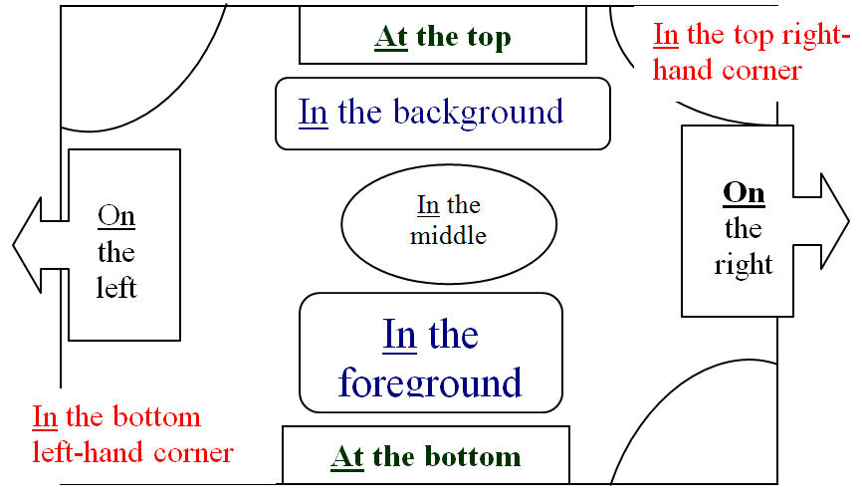

|  |  |  |
| --- | --- | --- |
| **Leonardo Da Vinci (Text a) pp.37-38** | | |
| **Lexical item** | **Synonym/Definition** | **Greek translation** |
| **the Italian Renaissance** | period in the European civilization immediately following the Middle Ages | Ιταλική Αναγέννηση |
| **art** | a term for the visual, auditory, or performing arts, expressing human expression and creativity | τέχνη |
| **artist** | someone who creates something innovative while at the same time employing technical expertise | καλλιτέχνης |
| **hugely influential** | having a great impact on | με τεράστια επίδραση |
| **immensely talented** | amazingly gifted | εξαιρετικά ταλαντούχος |
| **illegitimate son** | child out of wedlock | γιος εκτός γάμου |
| **to be apprenticed to** | to be trained in a skill near a master | κάνω την μαθητεία μου/ασκούμαι δίπλα σε (κάποιον δάσκαλο/τεχνίτη) |
| **spiritual** | religious, devotional | πνευματικός, θρησκευτικός |
| **to deteriorate** | to become progressively worse | χειροτερεύω |
| **to restore** | to re-establish, to return to a former condition | αποκαθιστώ |
| **intriguing** | interesting, fascinating | σαγηνευτικό |
| **portrait** | a representation of a person, especially one depicting only the face, head and shoulders | πορτραίτο/έργο που απεικονίζει κυρίως πρόσωπο |
| **to no avail** | in vain, without a visible result | μάταια |
| **a fleeting second** | lasting for a very short time | ένα φευγαλέο δευτερόλεπτο |
| **a faint smile** | slight, barely perceivable | ένα αχνό χαμόγελο |
| **to capture** | to catch (here: to depict) | αιχμαλωτίζω (εδώ: απεικονίζω) |
| **to encapsulate** | to enclose (here: to express) | ενσωματώνω (εδώ: περικλείω ως εκφραση) |
| **tremendous** | great, huge, enormous, immense | τεράστιος, τρομερός |
| **primarily** | mainly | πρωταρχικά (επιρ) |
| **eclectic** | a person who derives ideas, style or taste from a diverse range of sources | μικτός, ετερόκλητος |
| **to draw on** | to use something that you have gradually gained | αντλώ (π.χ.ιδέες) |
| **pioneering** | being ahead of one’s time | πρωτοπόρος |
| **beyond dispute** | certainly, without doubt | αδιαμφισβήτητα |

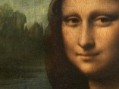Find out more about Leonardo Da Vinci:

1. Leonardo Da Vinci & his life in 3 minutes: <https://youtu.be/n-h32XpDYBw>

2. Leonardo Da Vinci’s biography: <https://youtu.be/Rm0qszPJnc8>

3. Leonardo Da Vinci’s Vitruvian Man: <https://youtu.be/aMsaFP3kgqQ>

4 Leonardo Da Vinci’s 7 most significant inventions: <https://youtu.be/PwOlIGGDVjE>

|  |  |  |
| --- | --- | --- |
| **Michelangelo (Text b) p.40** | | |
| **Lexical item** | **Synonym/Definition** | **Greek translation** |
| **sculptor** | an artist who makes sculptures | γλύπτης |
| **magistrate** | a civil officer who administers the law and conducts a court | δικαστής |
| **household** | a home (and its occupants regarded as a unit) | η οικία, το σπιτικό |
| **leading patron** | the person who gives substantial financial support | ο κύριος χρηματοδότης |
| **to expel** | to force someone to leave a place | αποβάλλω, εδώ: απελαύνω |
| **to summon** | to call or invite | καλώ, εδώ: προσκαλώ |
| **to commission** | to order the production of a work of art | αναθέτω |
| **to be regarded as** | to be thought to be | θεωρούμαι ως |
| **to be affected by** | to be influenced by | επηρεάζομαι |
| **vast** | enormous, immense, huge, colossal | τεράστιος |
| **altar wall** | the part of the Christian church where the table for communion services is kept | το τέμπλο ενός ιερού |
| **to contribute (to)** | to add something to | συνεισφέρω |
| **unmistakable** | very distinctive, certain | αλάθητος, εδώ: ολοφάνερος |

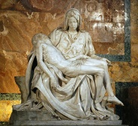Find out more about Michelangelo:

1. Michelangelo & his life (short biography): <https://youtu.be/RwgJfRSOgNQ>

2. Michelangelo, life and work: <https://youtu.be/Y89-ofD5Bew>

3. Michelangelo’s most admired works of art: <https://www.theartstory.org/artist/michelangelo/>

4. Michelangelo’s statue of ‘David’ and its many interpretations: <https://youtu.be/o9Kum_Jijdk>

5. Michelangelo’s depiction of Genesis on the ceiling of the Sistine Chapel: <https://youtu.be/PI0meIFA69M>

6. Michelangelo’s depiction of Last Judgement on the altar of the Sistine Chapel: <https://youtu.be/ofBvFQ_eCkA>

|  |  |  |
| --- | --- | --- |
| **Sandro Botticelli (Text c) p. 42** | | |
| **Lexical item** | **Synonym/Definition** | **Greek translation** |
| **tanner** | leather maker | βυρσοδέψης (αυτός που επεξεργάζεται το δέρμα) |
| **apprenticeship** | training, internship | μαθητεία, εξάσκηση, πρακτική |
| **goldsmith** | jewelry maker | χρυσοχόος |
| **to be recognized as** | to be acknowledged for | είμαι αναγνωρισμένος ως |
| **gifted** | talented | ταλαντούχος, προικισμένος |
| **to be dedicated to** | to be committed oneself to | είμαι αφοσιωμένος σε |
| **to evolve** | to develop gradually | εξελίσσομαι |
| **distinct** | well defined | ευδιάκριτος |
| **to be detached from** | be separated from | είμαι απομακρυσμένος από |
| **to tackle** | to deal with | καταπιάνομαι, ασχολούμαι |
| **unaccomplished** | not recognized | μη διακεκριμένος |
| **to attribute (to)** | to ascribe to | αποδίδω |
| **to lie forgotten** | to remain unrecognized | παραμένω ξεχασμένος, άγνωστος |
| **to earn respect** | to gain admiration, esteem | κερδίζω σεβασμό |
| **achievement** | accomplishment | επίτευγμα, κατόρθωμα |
| **contribution** | offering | συνεισφορά |
| **distinction** | difference (here:excellence) | διάκριση, εδώ: υπεροχή |
| **esteemed** | respected, admired | με υπόληψη |

Find out more about Sandro Botticelli:

1. Sandro Botticelli’s biography: <https://youtu.be/ea1--FrSZTw>

2. Sandro Botticelli’s full biography: <https://www.theartstory.org/artist/botticelli-sandro/life-and-legacy/>

3. Sandro Botticelli’s life and work: <https://youtu.be/PySzRJzlF08>

4. Sandro Botticelli’s paintings: <https://youtu.be/lX3Q44syO1E>

5. Sandro Botticelli’s painting ‘Birth Of Venus’: <https://youtu.be/L3J-JDa2knc>

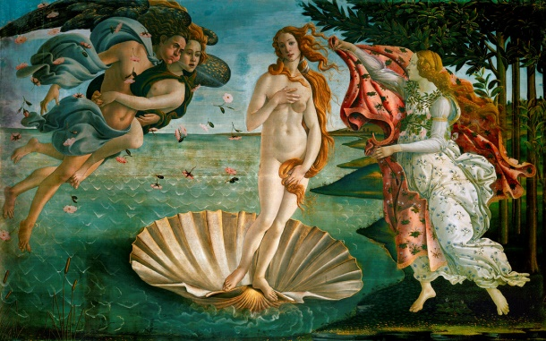

|  |  |  |
| --- | --- | --- |
| **Raphael (Text d) pp.43-44** | | |
| **Lexical item** | **Synonym/Definition** | **Greek translation** |
| **competent** | efficient, skillful | με ικανότητα, δεξιοτέχνης |
| **highly regarded** | greatly esteemed | με υπόληψη |
| **to house** | to provide accommodation | στεγάζω, φιλοξενώ |
| **court** | yard, court of justice, here: palace | αυλή, δικαστήριο, εδώ: παλάτι |
| **glittering** | glamorous | απαστράπτον |
| **privileged** | advantageous, under favorable circumstances | προνομιούχος |
| **to be fuelled** | to be supplied with power (here: to be triggered, to be caused, to be led) | πυροδοτούμαι, προκαλούμαι |
| **to be acknowledged for** | to be recognized | αναγνωρίζομαι ως |
| **magnificent** | splendid, impressive, grand, gorgeous, remarkable | μεγαλοπρεπής |
| **chamber** | a large room | αίθουσα |
| **remarkable** | worthy of attention, striking (here: magnificent) | αξιοπρόσεχτος, αξιοθαύμαστος |
| **untimely** | happening at an inappropriate time (here: too soon) | πρόωρος |
| **to attract a large crowd** | to be attended by a lot of people | προσελκύω πλήθος κόσμου |
| **to be referred to** | to be studied | γίνεται αντικείμενο σπουδής |
| **extensively** | widely | ευρεώς |
| **successive** | following one another or following others, consecutive | διαδοχικός, συνεχής, αλλεπάλληλος |

Find out more about Raphael:

1. Raphael’s biography: <https://www.italian-renaissance-art.com/Raphael-Biography.html>

2. Raphael’s painting School of Athens- a virtual tour: <https://youtu.be/Smd-q44ysoM>

3. Raphael’s School of Athens-Who’s who Part 1: <http://www.hellenicaworld.com/Greece/Science/en/SchoolAthens.html>

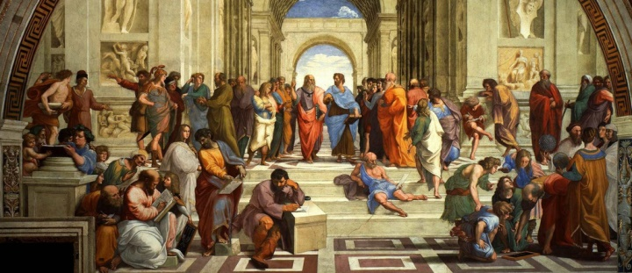4. Raphael’s School of Athens-Who’s who Part 2: <http://www.hellenicaworld.com/Greece/Science/en/SchoolAthens2.html>

|  |  |  |
| --- | --- | --- |
| **Andrea del Verrocchio (Text e) p.46** | | |
| **Lexical item** | **Synonym/Definition** | **Greek translation** |
| **tile and brick maker** | constructor of building materials from clay | κατασκευαστής  πλακιδίων και τούβλων |
| **to be trained at** | to practice a skill in a workshop in order to master it | εκπαιδεύομαι σε (μέρος) |
| **equestrian statue** | portraying a person on horseback | άγαλμα με έφιππο (απεικόνιση ατόμου πάνω σε άλογο) |
| **to heal** | to cure | θεραπεύω |
| **devotional** | used in religious worship | θρησκευτικός |
| **a youth** | a young man | νεαρός, νέος |
| **to resolve** | to decide, to find a solution | αποφασίζω |
| **to surpass** | to exceed, to be better than | ξεπερνώ, υπερέχω |
| **to be ranked second only to** | to be considered to be one of the two greatest | έρχομαι δεύτερος μετά από |
| **to set an example for** | to establish a role model, to influence | αποτελώ παράδειγμα προς μίμηση |

Find out more about Andrea del Verrocchio:

1. Andrea del Verrocchio’s life and work: <https://youtu.be/py3QdKJjQ_E>

2. Andrea del Verrocchio – 10 things you need to know: <https://www.thecollector.com/andrea-del-verrocchio/>

3. Andrea del Verrocchio’s sculptures: <http://www.andreadelverrocchio.com/sculptures/>

4. Andrea del Verrocchio’s paintings: <http://www.andreadelverrocchio.com/paintings/>

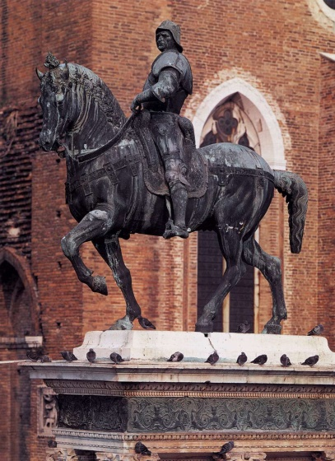

**Grammar pp.49, Passive Voice**

A. We use passive voice to give *emphasis on the subject of the sentence*, to *create a more impersonal/less assertive tone* and for *formality*.

Examples:

**1.** Renaissance is considered the era of the rebirth of arts and scientific thinking. (*Renaissance not* the Middle Ages)

**2.** Da Vinci has been regarded primarily as an artist. (*the passive moderates the assertiveness* of a personal opinion or consideration *on the part of the speaker*)

**3**. Raphael’s compositions were referred to extensively. (the passive indicates *formality* in the tone of the speaker)

B. Watch the following video and study the examples on p. 49:

**How to use the Passive Voice:** [**https://youtu.be/N7uvEllP5Jg**](https://youtu.be/N7uvEllP5Jg)

# Practice converting sentences from the Active into the Passive Voice:

[**https://www.ego4u.com/en/cram-up/grammar/passive/exercises?06**](https://www.ego4u.com/en/cram-up/grammar/passive/exercises?06)

# Online practice- Choose your level and test yourself in Passive Voice Use: <https://www.englisch-hilfen.de/en/exercises_list/passiv.htm>

**Writing p. 50:   
Write an article about an artist you admire**

Remember:

* Underline the key idea(s) in the rubric.
* Decide who the reader(s) will be, as this will define your register and language.
* Start with an interesting event/clue/award in the life of the artist you are going to write about. Your introduction should make the reader interested in further reading your story.
* Write two equally long paragraphs in the main body. The first paragraph should include facts about the artist’s life but don’t just write a list of events with dates. Choose the events that you feel the reader would be most intrigued by and omit details that are unimportant.
* In the second paragraph write about the artist’s accomplishments. Again, don’t just write a list of years when awards and titles were received by your artist. Choose the most significant achievements and leave out unnecessary details that may bore your reader. Tip: use the Present Perfect Tense if your artist is still alive*.*
* Use linking devices to link the ideas smoothly between the paragraphs as well as within them.
* In the conclusion you write why you admire the artist you have chosen. You need to elaborate on your opinion with supporting sentences and examples.
* Write a catchy title for your article.

Study the following model article:

***Dreaming potential***

Adele made her ascent to show business by becoming from a daydreamer the famous and successful singer she is today in the late 2000’s. Her genuine and truly captivating masterpieces have stolen millions of hearts, as she sings about true emotions, hopes and breakups which most people have been through and can identify themselves with.

*Adele Laurie Blue Adkins* was born on 5th May 1988 and was raised in London. Her childhood was very much alike many other young girls’ because Adele was not brought up in a rich family like other celebrities. Due to the fact that her father had left the family when she was still a small child, she was raised exclusively by her mother. Since she was 7, Adele always wanted to be older, until she finally became 18 years old. However, it was when she turned 25 that she realized most of her life had been spent wishing.

She started writing and performing her own songs while she was still very young. According to Adele, she was inspired by the Spice Girls, who definitely had a great impact on her future career. She has released eight albums so far, her most successful hits being “Rolling in the deep”, “Set fire to the rain” and “Hello”. Her singles stay on top for many weeks and her videos reach millions of views in a few days. She has also written, composed and recorded the song featuring in James Bond movie “Skyfall”, earning her a Golden Globe and an Oscar Award, and definitely making her a successful and inspiring person according to Time magazine.

Today, pop music industry is filled with skinny and Photoshop made celebrities, but Adele is fresh and real. She is a great example of how dreams come true when one really strives for them. She has also proved that a person need not be size-zero or pattern-like beautiful in order to gain success in life. She is the epitome of strength for many people all over the world as her successful career has proved that “curves” in a world filled with anorexic stars cannot prevent someone to reach remarkable achievements when they are endowed with great talent. Unlike many successful superstars, Adele has remained a humble person, which attracts even more followers.