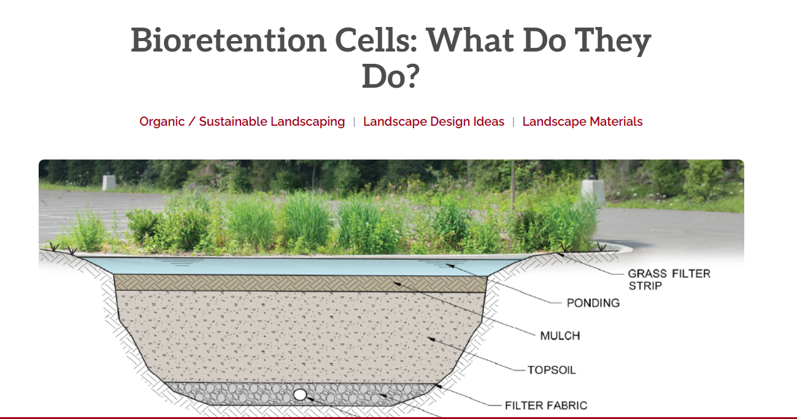
https://www.lyngsogarden.com/community-resources/bioretention-cells-what-do-they-do/

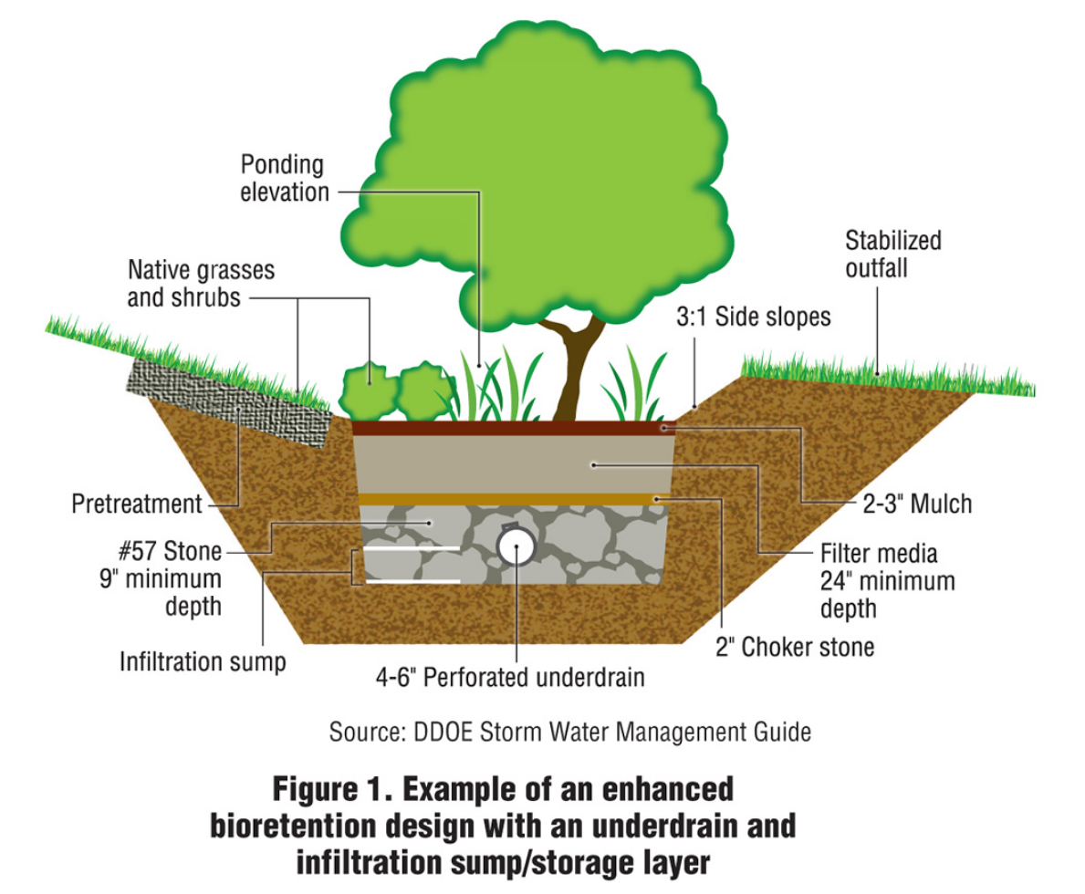
https://www.biocycle.net/green-infrastructure-incentives-in-nations-capital/

https://megamanual.geosyntec.com/npsmanual/bioretentionareasandraingardens.aspx
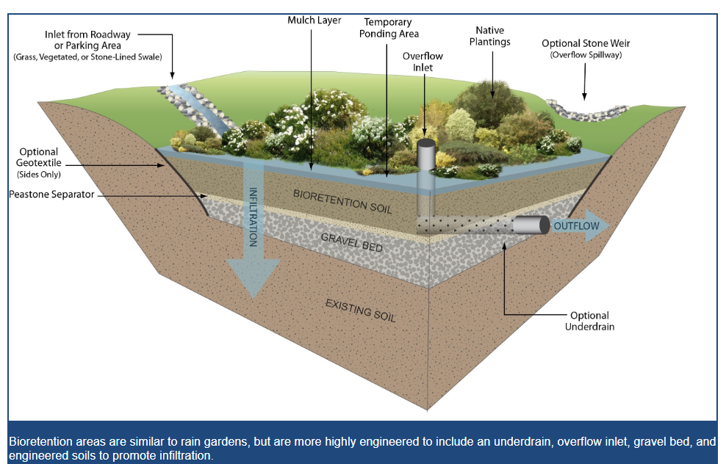

https://wiki.sustainabletechnologies.ca/wiki/Bioretention:_Streetscapes
φωτο!!

https://wiki.sustainabletechnologies.ca/wiki/Perennials:_List
ΛΙΣΤΑ ΦΥΤΩΝ- ποσοστά υγρασίας και αντοχή σε ξηρασία- φωτό

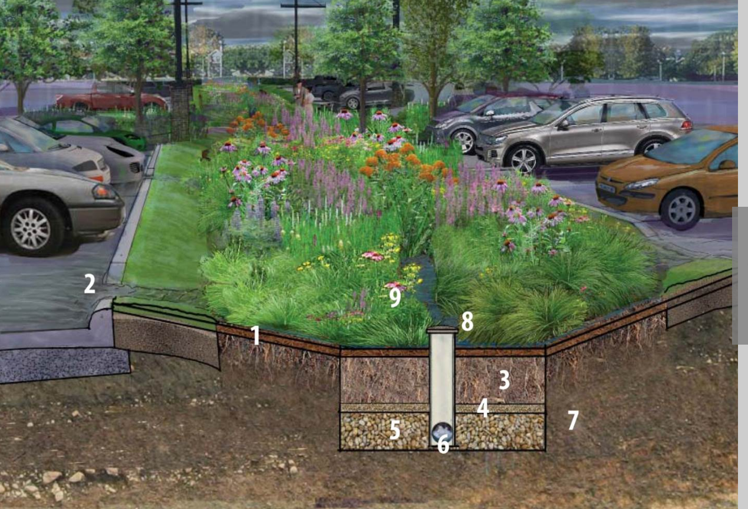

https://bluegrasslawn.com/bioretention-what-does-it-do-how-does-it-work
