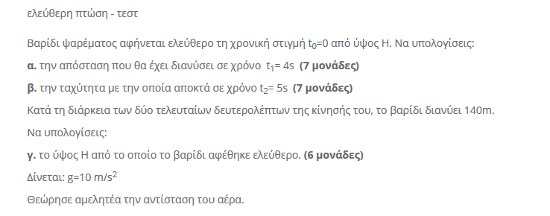



α. y= g t2= 5 t2

y=5⋅42=80m

β. υ=gt=10⋅5=50m/s

γ. yτελ=H= g t2= 5 t2 όπου t=tολ

y-2= g (t-2)2 = 5 (t-2)2= 5(t2-4t+4)= 5t2-20t+20

Δίνεται: H-y-2=140 => 5 t2 - (5t2-20t+20)=140 => 5 t2 - 5t2 + 20t-20=140 => 20t=160 => t=8s



Άρα: Η=5 t2=5⋅82=> H=320m



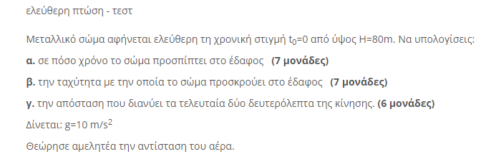



α. y= g t2= 5 t2  => 80=5 t2  => t2  =16 => t=4s

β. υ=gt=10⋅4=40m/s

γ. y4-y2= 5⋅42-5⋅22=80-20=60m

