**Worksheet 1**

**1. Look up the meaning of the following words/phrases from the video about Eleanor Roosevelt. You can use an online dictionary like wordreference.com.**

a. beacon:

b. economic depression:

c. spearhead:

d. blitz:

e. predecessors:

f. delegation:

g. ostracised:

h. chairperson:

**2. Answer the following questions:**

a. When and why was Eleanor Roosevelt chosen as a US delegate in the Human Rights committee?

b. How was she treated by her male counterparts?

c. Who was a big influence for Eleanor Roosevelt? What was an important observation that this person made?

**Worksheet 2**

**What similarities and differences can you find between Eleanor Roosevelt and Malala Yousafzai. Use the Venn Diagram below to note them down:**

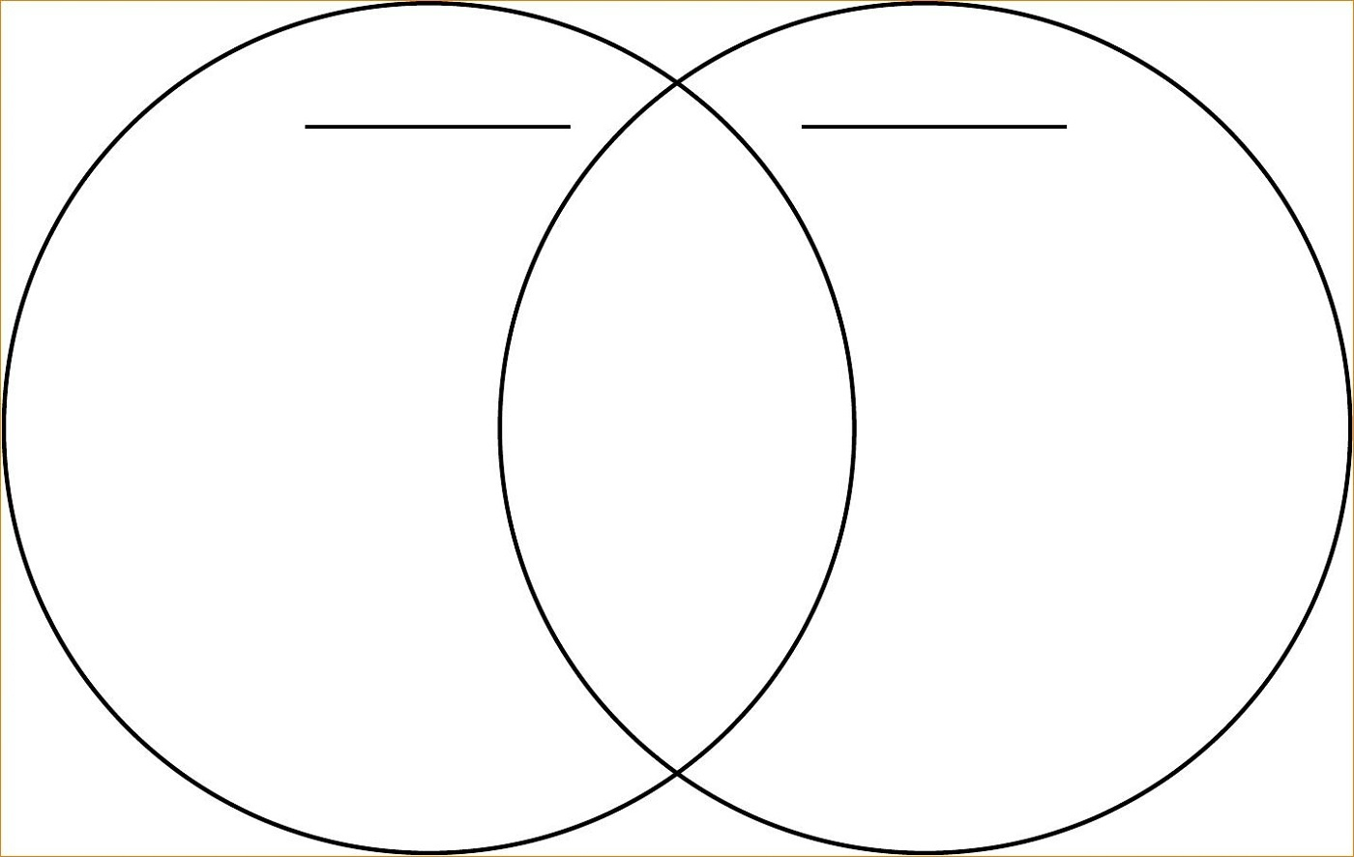

**Worksheet 3**

**Fill in the blanks with the words from the list below:**

***a. activism b. shortlist c. extremism d. resolve e. ardently f. silence g. advocate h. recipient***

***I. violation j. steadfast***

# Malala Yousafzai’s Courage

An assassination attempt was not enough to curtail the human-rights work of teenage activist Malala Yousafzai. In fact, her brush with death at the hands of the Taliban only served to strengthen her 1____________ and led to her recognition as a joint winner of the 2014 Nobel Peace Prize.

The 17-year-old Pakistani rose to prominence as a vocal 2_______________ for girls’ right to [education](https://www.educationworld.com/a_lesson/malala-yousafzai-pakistan-taliban-rights-discussion.shtml). The Taliban, who 3________________disagree with Yousafzai’s position, were fearful that her 4_____________ would inspire others to act. The group planned to 5___________ the teen, and while she rode a school bus, a Taliban gunman shot her in the head.

Yousafzai was flown to England, where she received emergency care and eventually recovered from her injuries. Rather than go into hiding, she remained 6_____________ in her attempts to provide Pakistani girls with the right to an education. In October 2013 she [visited the U.S.](https://www.cbsnews.com/news/malala-yousafzai-survivor-of-taliban-visits-us/) to share her story.

Her work, including her best-selling book I am Malala, landed her on the 7_____________ of Nobel candidates in 2013. Despite being the odds-on favorite to win the award, Yousafzai was edged out by Organization for the Prohibition of Chemical Weapons, a watchdog group that conducts investigations into the use of chemical weapons.

Yousafzai is the youngest 8______________of the prize since it was created in 1901, said [an article in The New York Times](https://www.nytimes.com/2014/10/11/world/europe/kailash-satyarthi-and-malala-yousafzai-are-awarded-nobel-peace-prize.html?_r=0). Yousafzai won the prize along with Kailash Satyarthi, an Indian veteran known for his efforts to end child labor and free children from sex trafficking.

"The Nobel Committee regards it as an important point for a Hindu and a Muslim, an Indian and a Pakistani, to join in a common struggle for education and against 9______________," said Thorbjorn Jagland, the committee's chairman. "Children must go to school and not be financially exploited. It is a prerequisite for peaceful global development that the rights of children and young people be respected. In conflict-ridden areas in particular, the 10_____________ of children’s rights leads to the continuation of violence from generation to generation."

In response to her award, Yousafzai expressed hope "that the leaders of Pakistan and India would come together on education and asked for them to jointly attend the award presentation in December," said an [article on NBCNews.com](https://www.nbcnews.com/news/world/peace-prize-winner-malala-thanks-dad-not-clipping-her-wings-n222746).

"I'm proud that I am the first Pakistani, and I am honored that I am the first young woman or the first young person to receive this award," she said in a press conference from Britain. "I am thankful to my father for not clipping my wings and for letting me to fly."

Malala said she was in chemistry class when she learned that she won the award, NBC News said.

"I was totally sure that I hadn't won it," she said, and added she was accepting the award on behalf of children everywhere. "When I found that I got the Nobel Peace Prize. I decided that I would not leave my school I would continue to learn."

educationworld.com

**Worksheet 4**

**Now make a timeline with the most important events in Malala’s life:**

**Worksheet 5**

**Get into groups. Watch the video about Malala’s most inspiring quotes. Choose one (the one that made an impression on you) and discuss which important values or which human rights you can associate with this quote. Give an example of a relevant human rights violation. Finally, propose actions for incorporating these human rights values into your daily lives.**

**Quote:**

**Human Rights/ Values:**

**Example of human right violation:**

**Actions to incorporate human rights values in your life:**

**Top 20 Malala Yousafzai quotes**

“I am stronger than fear.” — Malala Yousafzai ([00:00](https://www.youtube.com/watch?v=PFmVfkgTFI8&t=0s))

“One child, one teacher, one book, one pen can change the world.” — Malala Yousafzai ([00:07](https://www.youtube.com/watch?v=PFmVfkgTFI8&t=7s))

“Education is the best weapon through which we can fight poverty, ignorance and terrorism.” — Malala Yousafzai ([00:14](https://www.youtube.com/watch?v=PFmVfkgTFI8&t=14s))

“My father always says that heroism is in the Pashtun DNA.” — Malala Yousafzai ([00:21](https://www.youtube.com/watch?v=PFmVfkgTFI8&t=21s))

“We realize the importance of our voices only when we are silenced.” — Malala Yousafzai ([00:28](https://www.youtube.com/watch?v=PFmVfkgTFI8&t=28s))

“With guns you can kill terrorists, with education you can kill terrorism.” — Malala Yousafzai ([00:35](https://www.youtube.com/watch?v=PFmVfkgTFI8&t=35s))

“Education is neither Eastern nor Western, it is human.” — Malala Yousafzai ([00:42](https://www.youtube.com/watch?v=PFmVfkgTFI8&t=42s))

“I believe in the power of the voice of women.” — Malala Yousafzai ([00:49](https://www.youtube.com/watch?v=PFmVfkgTFI8&t=49s))

“Extremists have shown what frightens them most. A girl with a book.” — Malala Yousafzai ([00:56](https://www.youtube.com/watch?v=PFmVfkgTFI8&t=56s))

“I thought that words and books and pens were more powerful than guns.” — Malala Yousafzai ([01:03](https://www.youtube.com/watch?v=PFmVfkgTFI8&t=63s))

“Let us make our future now, and let us make our dreams tomorrow’s reality.” — Malala Yousafzai ([01:10](https://www.youtube.com/watch?v=PFmVfkgTFI8&t=70s))

“There should be no discrimination against languages people speak, skin colour, or religion.” — Malala Yousafzai ([01:17](https://www.youtube.com/watch?v=PFmVfkgTFI8&t=77s))

“I had two options One was to remain silent and wait to be killed and the second was to speak up and then be killed. I chose the second one. I decided to speak up.” — Malala Yousafzai ([01:24](https://www.youtube.com/watch?v=PFmVfkgTFI8&t=84s))

“A city without books, a city without a library is like a graveyard.” — Malala Yousafzai ([01:31](https://www.youtube.com/watch?v=PFmVfkgTFI8&t=91s))

“I truly believe the only way we can create global peace is through not only educating our minds, but our hearts and our souls.” — Malala Yousafzai ([01:38](https://www.youtube.com/watch?v=PFmVfkgTFI8&t=98s))

“We cannot all succeed when half of us are held back.” — Malala Yousafzai ([01:45](https://www.youtube.com/watch?v=PFmVfkgTFI8&t=105s))

“We are stronger than those who oppress us, who seek to silence us. We are stronger than the enemies of education. We are stronger than fear, hatred, violence and poverty.” — Malala Yousafzai ([01:52](https://www.youtube.com/watch?v=PFmVfkgTFI8&t=112s))

“I tell my story, not because its unique, but because its not, it is the story of many girls.” — Malala Yousafzai ([01:59](https://www.youtube.com/watch?v=PFmVfkgTFI8&t=119s))

“This is what my soul is telling me, be peaceful and love everyone.” — Malala Yousafzai ([02:06](https://www.youtube.com/watch?v=PFmVfkgTFI8&t=126s))

“They thought that the bullets would silence us, but they failed.” — Malala Yousafzai ([02:13](https://www.youtube.com/watch?v=PFmVfkgTFI8&t=133s))

**Worksheet 6**

**Produce a written text of 180-200 words.**

**TASK: Malala Yousafzai, a young girl from Pakistan, is slowly recovering after being attacked for**

**defending the right of girls to go to school.**

**Her plight has inspired people around the world who show support for Malala and her cause.**

**You decide to write a letter to Malala in which you:**

1. **express your support for Malala and her cause**
2. **argue for the right of all children to education and**
3. **discuss why education is so important for the future of our world.**

**Sign your letter.**

**Don’t forget**

* In the introduction you should state who you are and the reason you are writing (point a).
* In the main body include points b and c from the rubric.
* Start each paragraph with a suitable topic sentence which states the main idea of each paragraph. Then use supporting sentences to further explain it.
* Use suitable linking words and expressions to give your letter structure and help readers follow it.
* In the conclusion summarise the main points of your letter and thank the reader. Do not introduce any new ideas.

### Essay Plan for the Letter to Malala Yousafzai (With Useful Expressions and Linking Words)

#### ****Introduction (40-50 words)****

* Begin with a heartfelt greeting:  
  "Dear Malala, I am writing to express my deepest admiration for..."
* Mention the global impact of her story
* State the purpose (Thesis Statement):  
  "Through this letter, I wish to show my support for your cause, advocate for the right to education, and highlight why education is essential for our shared future."

#### ****Body Paragraph 1: Support for Malala and Her Cause (50-60 words)****

* Use expressions of admiration:  
  "I deeply admire your bravery in standing up for what is right, despite the challenges you have faced."
* Show solidarity:  
  "Your unwavering commitment to advocating for girls' education is truly inspiring."
* Linking words/expressions:
  + "Moreover,"
  + "In addition,"
  + "Your story serves as a powerful reminder that..."

#### ****Body Paragraph 2: The Right to Education for All Children (50-60 words)****

* State the universal importance of education:  
  "Education is a fundamental human right that no child should be denied."
* Argue the consequences of deprivation:  
  "Without access to education, children are trapped in cycles of poverty and inequality."
* Linking words/expressions:
  + "Furthermore,"
  + "It is essential to recognize that..."
  + "This is why it is crucial to ensure..."

#### ****Body Paragraph 3: Importance of Education for the Future (50-60 words)****

* Emphasize its broader impact:  
  "Education empowers individuals with the tools to innovate, solve problems, and contribute meaningfully to society."
* Highlight long-term benefits:  
  "By investing in education, we pave the way for a more peaceful and prosperous world."
* Linking words/expressions:
  + "In this way,"
  + "As a result,"
  + "Undoubtedly, education is the key to..."

#### ****Conclusion (40-50 words)****

* Reiterate support and hope:  
  "I fully support your mission and admire your courage to continue advocating for this noble cause."
* Call to action:  
  "Let us all work together to ensure that every child, regardless of their gender or background, has access to education."