THEMES

Two of the major themes in the novel, as they appear in the title as well, are
Pride (Περηφάνεια) and Prejudice (Προκατάληψη)

Read the definitions of the words pride and prejudice provided by "Oxford" and "Collins" dictionaries.

Pride a. a feeling of deep pleasure or satisfaction derived from one's own
achievements
b. the quality of having an excessively high opinion of oneself or one's importance

Prejudice a. preconceived opinion that is not based on reason or actual experience
b. dislike, hostility or unjust behaviour deriving from preconceived and
unfounded opinions

“It is a truth universally acknowledged, that a single man in possession of a good fortune, must be in want of a wife.“
Narrator, Volume I: Chapter 1

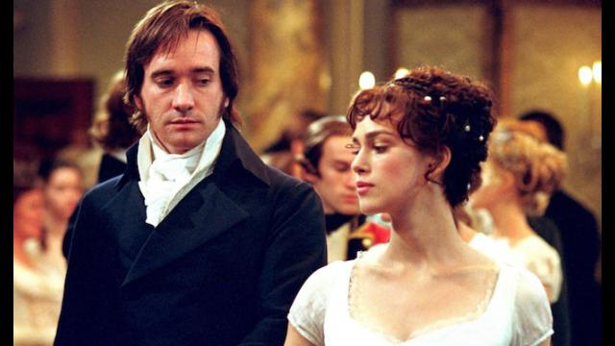
Question 1:
Read the following extracts from the novel and decide which of these two characters (Darcy and Elizabeth) behave with pride and/or prejudice.

…...........................................................................................................................................

Extract 1: Mr Darcy, Volume III: Chapter 1

"I have been a selfish being all my life, in practice, though not in principle. As a child I was taught what was right, but I was not taught to correct my temper. I was given good principles, but left to follow them in pride and conceit. Unfortunately an only son (for many years an only child), I was spoilt by my parents, who, though good themselves (my father, particularly, all that was benevolent and amiable), allowed, encouraged, almost taught me to be selfish and overbearing; to care for none beyond my own family circle; to think meanly of all the rest of the world; to wish at least to think meanly of their sense and worth compared with my own. Such I was, from eight to eight and twenty; and such I might still have been but for you, dearest, loveliest Elizabeth! What do I not owe you! You taught me a lesson, hard indeed at first, but most advantageous. By you, I was properly humbled. I came to you without a doubt of my reception. You showed me how insufficient were all my pretensions to please a woman worthy of being pleased "

Answer the questions:

- Has Darcy acknowledged that his class prejudice had clouded his judgment about Elizabeth?How is this revealed in the text?

..........................................................................................................................

- Has his upbringing affected his behaviour?

........................................................................................................................

- Explain how the above words reveal Darcy's journey to self-discovery.
Do you think that achieving a level of self-awareness leads to one’s future happiness?

.........................................................................................................................

Extract 2: "Elizabeth, Volume II: Chapter 13

"How despicably I have acted! I, who have prided myself on my discernment! I, who have valued myself on my abilities! who have often disdained the generous candour of my sister, and gratified my vanity in useless or blameable mistrust! How humiliating is this discovery! Yet, how just a humiliation! Had I been in love, I could not have been more wretchedly blind! But vanity, not love, has been my folly. Pleased with the preference of one, and offended by the neglect of the other, on the very beginning of our acquaintance, I have courted prepossession and ignorance, and driven reason away, where either were concerned. Till this moment I never knew myself.

- Which words show that Elizabeth has shown narrow-mindedness?

…...............................................................................................................................

- Has she recognised her faults? How has her judgment been affected by her pride and prejudice?

…................................................................................................................................

- Do you think she feels humiliated when admitting her feelings to Darcy?

….................................................................................................................................

Read the summary of the novel and the notes

Watch the movie clips
and

Do the following quiz:

1. Complete the quotation: “It is a truth universally acknowledged, that a single man in possession of a good fortune, must be in want of a ___.”
- a. house
- b. title
- c. wife
- d. dog

2. The Bennet family lives in the village of
- a. Pemberley
- b. Longbourn
- c. Rosings
- d. London

3. Mr. Bingley, when he attends the ball in Meryton, seems to be quite taken with
- a. Elizabeth
- b. Jane
- c. Lydia
- d. Charlotte Lucas

4. What does it mean that Mr. Bennet’s property is “entailed”?
- a. Lady Catherine de Bourgh gave it to him.
- b. It can only be inherited by a male.
- c. It comes from his wife’s family.
- d. He rents from Sir William Lucas.

5. To which Bennet daughter does Mr. Collins propose marriage?
- a. Elizabeth
- b. Jane
- c. Mary
- d. Lydia

6. Lady Catherine de Bourgh is Darcy’s
- a. Aunt
- b. Sister
- c. Mother
- d. First wife

7. When Darcy first proposes to Elizabeth, he spends most of the proposal dwelling on
- a. Her beauty
- b. How socially unsuitable a match she is for him
- c. How much he adores her family
- d. How much money he will lavish on her

8. When Darcy proposes for the first time, Elizabeth
- a. Tells him that she is engaged to Wickham
- b. Asks him for more time
- c. Turns him down
- d. Faints

9. Elizabeth’s feelings toward Darcy begin to change when he
- a. Sends her a letter explaining his actions
- b. Fights a duel with Wickham
- c. Sends money to Jane
- d. Marries Miss Bingley

10. Darcy’s estate is called
- a. Rosings
- b. London
- c. Pemberley
- d. Brighton

11. What socially disastrous romantic decision does Lydia make?
- a. She elopes with Wickham.
- b. She marries Bingley.
- c. She rejects Mr. Collins’s proposal.
- d. She runs away to France with a lover.

12. Who pays off Wickham, convincing him to marry Lydia?
- a. Bingley
- b. Darcy
- c. Mr. Gardiner
- d. Mr. Collins

13. When he returns to Netherfield, Mr. Bingley
- a. Has just married Miss Darcy
- b. Pursues the priesthood
- c. Begins courting Elizabeth
- d. Resumes courting Jane

14. What does Lady Catherine forbid Elizabeth to do?
- a. Marry Bingley
- b. Visit Rosings
- c. Marry Darcy
- d. See Wickham

15. The novel ends with
- a. Darcy marrying Elizabeth, and Bingley marrying Miss Darcy
- b. Darcy marrying Elizabeth, and Wickham marrying Jane
- c. Bingley marrying Jane, and Elizabeth marrying Wickham
- d. Bingley marrying Jane, and Darcy marrying Elizabeth



