INTERESTING FACTS ABOUT PRIDE AND PREJUDICE

Pride and Prejudice was published in 1813 and is one of six novels written by England’s favourite author, Jane Austen. Adapted hundreds of times in film, TV and literature, the story of Elizabeth Bennet and Mr Darcy is a timeless classic – but it doesn’t mean there aren’t still some surprising facts to discover about this enchanting tale.

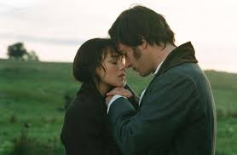
1. Its original title was ‘First Impressions’. One publisher rejected Pride and Prejudice without even reading it. Austen finished the book, then titled First Impressions, when she was 21 years old. In 1797, her father sent it to the publisher Thomas Cadell. He asked how much it would cost him to publish the book and what Cadell would pay for copyright. In response, Cadell scrawled “Declined by Return of Post” on the letter and sent it back with insulting speed. The novel languished for 14 years until, flush with the success of Sense and Sensibility, Austen revised the manuscript. It was published in 1813 when she was 37 years old. The novel was first finished in 1797 but was not published for another 16 years!

2. Pride and Prejudice was published anonymously.
Austen didn’t put her name on her novels, and would only say they were “By a Lady.” The title page of Pride and Prejudice said, “by the author of Sense and Sensibility.” It wasn’t until after her death that her brother revealed her name to the public.

3. It is rumoured that the character of Mr Darcy was based on Austen’s love interest, Thomas Lefroy, an Irish lawyer who she had a brief friendship with over the winter of 1795/1796.

4. Like her characters, Jane Austen was rejected for not being rich enough. At age 20, she had a flirtation with a young man named Thomas Lefroy. Like a scene out of one of her novels, she flirted scandalously with him at a ball. But Austen’s social status wasn’t high enough and Lefroy’s family separated the two lovebirds. Lefroy was soon engaged to a woman with a large fortune. Austen wrote her sister: “At length the day is come on which I am to flirt my last with Tom Lefroy … My tears flow as I write this, at this melancholy idea."

5. Like Elizabeth and Jane Bennet, Jane Austen was close to her sister. In Pride and Prejudice, the relationship between the two sisters is central to the novel. In real life, Jane was very close to her sister Cassandra. They wrote each other almost every day when they were apart and would voluntarily share a bedroom, even when they could sleep separately. When Jane died, Cassandra wrote her niece: “She was the sun of my life, the gilder of every pleasure, the soother of every sorrow.” It’s no wonder that close sisters appear in so many of Austen’s novels.

6. Like many of Austen’s early works, Pride and Prejudice was originally told in letters. This was a common style at the time, and Sense and Sensibility was similarly reworked to a third person narrative – however, many of the letters remain in the final edit.

7. The novel got its name from Fanny Burney’s Cecilia, one of Austen’s favourite novels which uses the phrase three times.

8. At first glance, the title appears to refer to Mr Darcy’s pride, and Elizabeth’s prejudice against him – however, closer inspection reveals that both characters possess both qualities, with Elizabeth’s pride being hurt by Darcy’s rejection and Darcy being prejudice against Elizabeth because of her social class. The novel reveals the characters growing together to amend their pride and remove their prejudices of each other and the world in which they live.
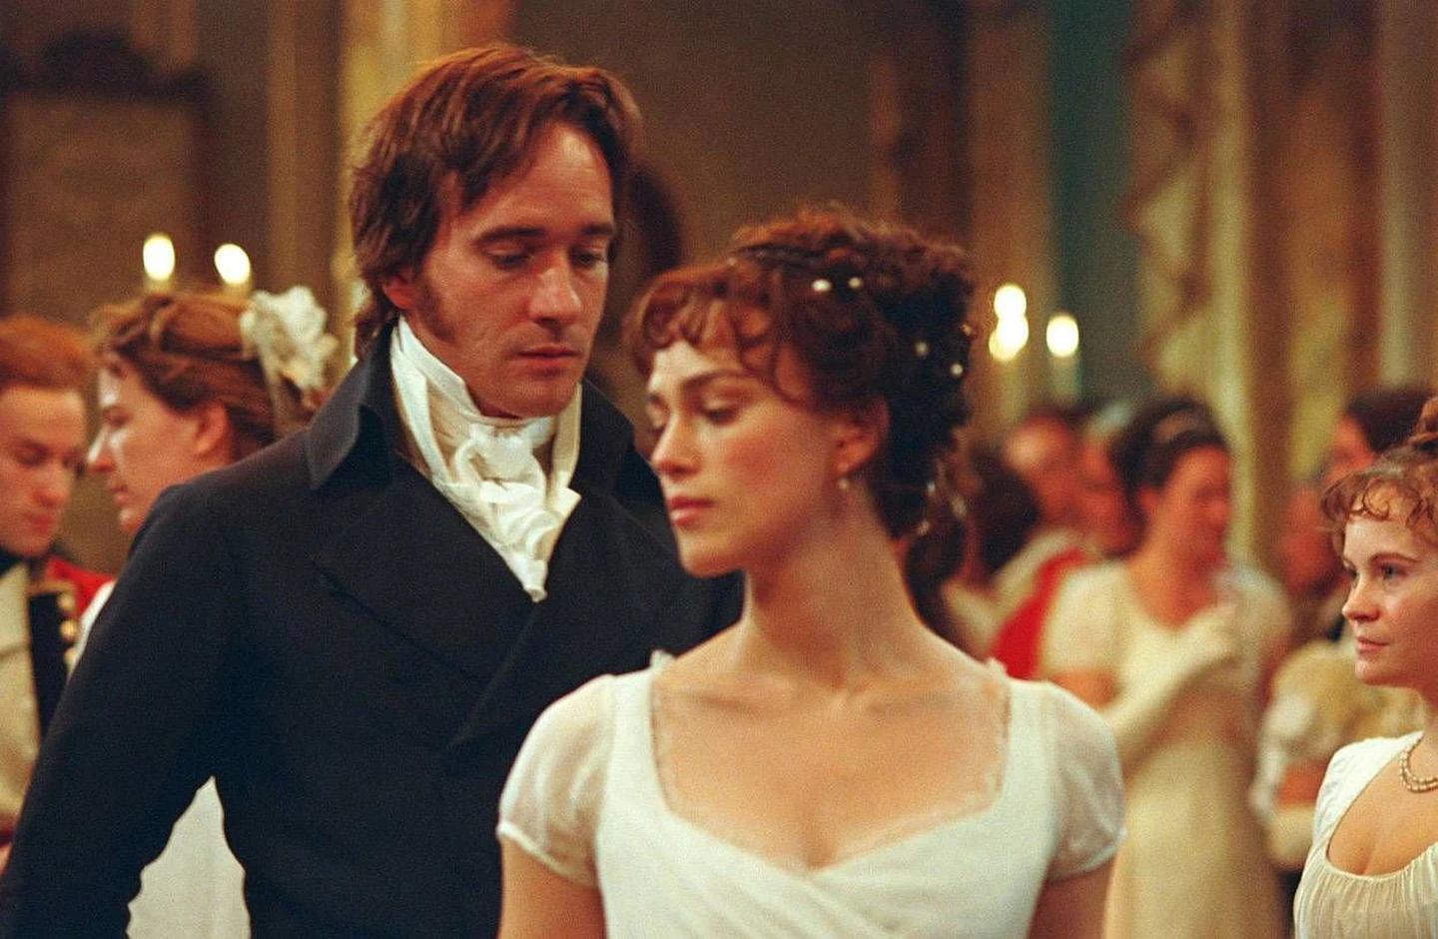

9. Elizabeth’s friend Charlotte Lucas demonstrates the practical, legal side of marriage. At 27, she is already considered ‘past it’ by society’s standards, and her marriage to Mr Collins is one of practicality and financial security. Her opinion on marriage – and her actions – show the reality of marriage for women in the early 1800s: not everyone has the luxury of waiting for a Darcy.

10. Jane Austen sold her copyright to Pride and Prejudice for 110 pounds—but wanted 150.
Austen sold the copyright for Pride and Prejudice to her publishers for 110 pounds, even though she said in a letter that she wanted 150 pounds. She chose this one-time payment, forfeiting any risk or reward connected to the future of the book. It was a bad gamble" The book was a bestseller, and was on its third printing by 1817. It has been in print ever since.

11. Mr Darcy’s first name is Fitzwilliam – which doesn’t roll off the tongue quite as easily!

12. Pride and Prejudice was the family favourite – Austen often read excerpts for feedback, and her close family and friends loved this novel as much as the public do.

13. Mr. Darcy would be the equivalent of a Rockefeller or a Vanderbilt.
The characters in Pride and Prejudice constantly exclaim over Mr. Darcy’s 10,000 pounds a year, but how rich is that exactly? In 2013, The Telegraph calculated that a decent estimate might be 12 million pounds, or $18.7 million U.S. dollars a year. It’s no wonder Mrs. Bennet gushed about Elizabeth’s engagement—"How rich and how great you will be!

14. Lydia Bennet elopes to the Las Vegas of her day.
In the book, the Bennet family is almost ruined when Lydia elopes with the soldier George Wickham to Scotland. “I am going to Gretna Green,” Lydia writes to her friend, “and if you cannot guess with who, I shall think you a simpleton.” Unlike England, Scotland allowed people under 21 to get married without parental consent, and without the same legal and religious bureaucracy. Gretna Green was the first town over the Scottish border. There, a young couple could be joined with “marriage by declaration,” which often occurred in a blacksmith shop.

15. Pride and Prejudice has been adapted hundreds of times.
The adaptations of Pride and Prejudice seem endless (and sometimes bbizarre). There have been at least 11 film and TV versions of the book, including the 1995 BBC miniseries starring Colin Firth as a memorable Darcy. Other (looser) adaptations include Bridget Jones's Diary (2001), Pride and Prejudice and Zombies (2016), the Bollywood movie Bride and Prejudice (2004), the mystery novel Death Comes to Pemberley, and the 2012-2013 web series The Lizzie Bennet Diaries.
