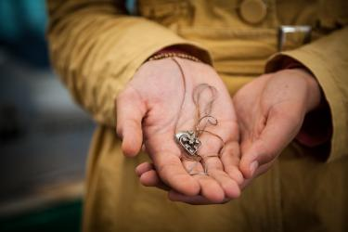
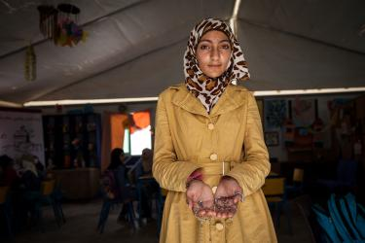
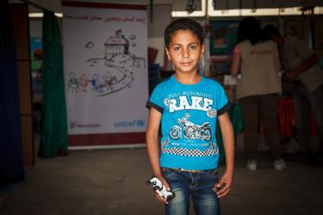
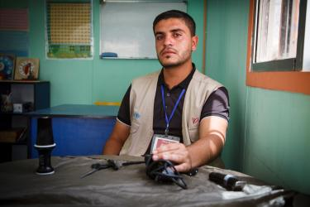
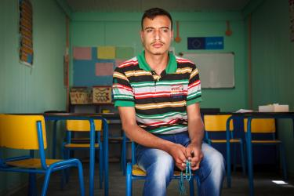
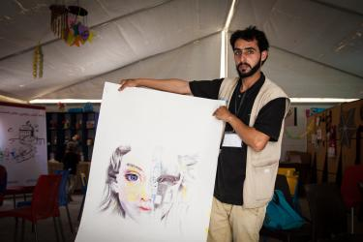
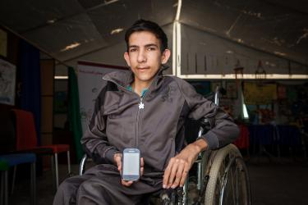
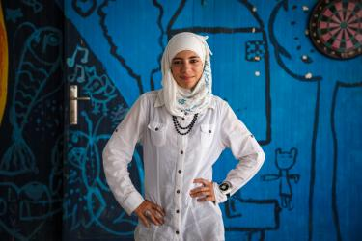
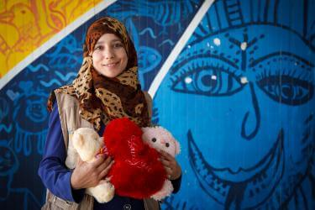
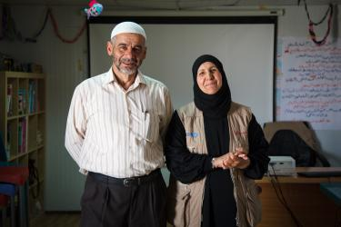
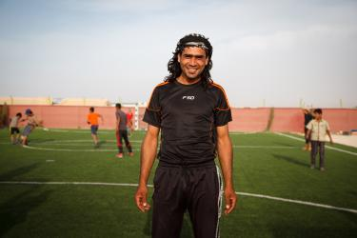
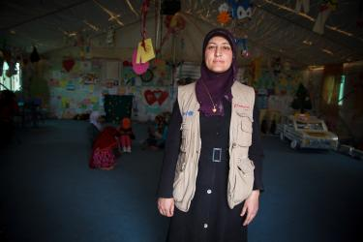
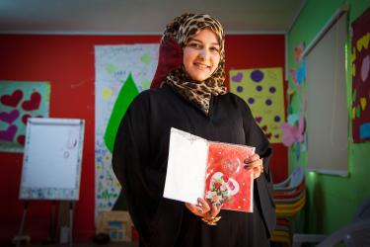
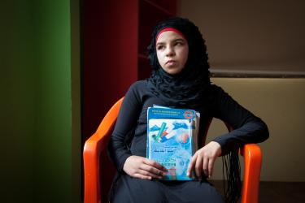
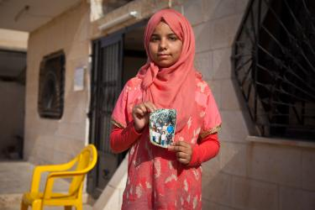
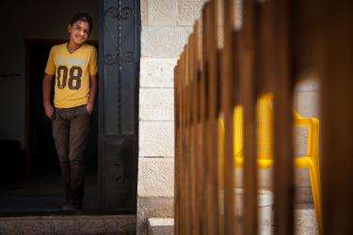
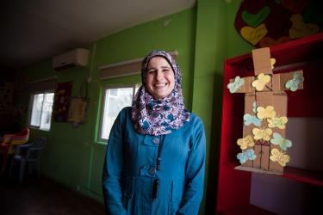
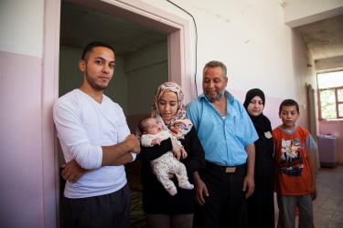
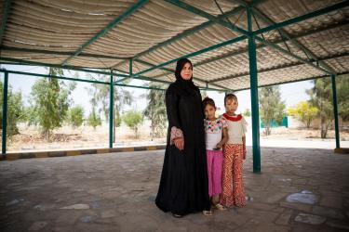

We asked refugees: What did you bring with you?
Retrieved from:https://www.mercycorps.org
MARCH 12, 2014

After eight years of war, millions of Syrians are still living far from home with no idea when they'll be able to return. Nearly one in four refugees worldwide is from Syria. Refugee life is their new reality, filled with heartbreak and challenges.
While some fled to refugee camps, most live in host communities in Syria's neighboring countries. Many had to run from their houses with only the few personal items they could carry.
These items have become bittersweet symbols of home and hope — they connect them to the life they've loved and ache to regain one day.
To shed light on the personal experiences in the midst of this crisis, we visited Syrians participating in our programs in Jordan and asked: What is the most important thing you brought with you?

Sajida — Zaatari Camp
Sajida, 14, and her family left their home in Daraa, Syria for the safety of Jordan in 2013. Before she left, she and her close friends exchanged necklaces.
“At the beginning of the war we didn’t know what was going to happen, we thought we might get separated so we gave each other gifts to remember one another by.” All of the other girls have remained in Syria. This necklace is from her best friend, Batool.

Muhanad — Zaatari Camp
Muhanad, 7, and his family have lived in Jordan since 2013. He's holding a birthday gift from his grandfather. The robot toy reminds him of his grandfather, "who is now in heaven," he tells me.

Muhammad — Zaatari Camp
Muhammad, 25, is from Daraa, Syria where he used to teach kindergarten. His hobby was giving his friends haircuts and shaves. The barber equipment he brought with him is a reminder of the dear people he used to spend time with while he cut their hair.
He’s stopped his hobby now — the last person he gave a haircut to, his best friend, was killed in the conflict. Since moving to the camp, Muhammad has married and had a baby. He now teaches students with disabilities in this Mercy Corps resource room.

Alaa — Zaatari Camp
Alaa, 18, and his family have been living in Zaatari since 2012, when the camp first opened, after fleeing Daraa. Alaa is holding prayer beads, a gift from his best friend before he left Syria.

Muhammad — Zaatari Camp
Muhammad, 21, is originally from Damascus, Syria. This painting reminds him of a friend, Salee, who lived in Muhammad’s neighborhood in Syria and was killed in the conflict.
The left side represents her childhood in Syria before the war. The right side represents her childhood after the conflict. “This memory is important to me because it shows this sweet girl's happy childhood before the war and her childhood turning to stone after the war began.” Muhammad now teaches art to students in Mercy Corps’ activity programs.

Muhammad — Zaatari Camp
Muhammad, 18, says that the numbers on his phone are the most important thing that he brought with him from Syria. The numbers allow him to communicate with his friends and family who stayed behind.

Basma — Azraq Camp
Basma, 15, and her family left Homs, Syria for Jordan in 2014. She proudly wears the watch her aunt gave her for her birthday — and as a parting gift as she fled to Lebanon.

Haneen — Azraq Camp
Haneen, 20, and her husband arrived in Azraq in 2014 from Syria. She brought with her wedding gifts from her husband and a teddy bear from her father, who stayed in Syria.

Um Shadee and Abu Shadee — Azraq Camp
Um Shadee, 50, and her family fled Homs, Syria in 2014. They left so quickly that they brought nothing with them but the clothes on their backs. She tells me that the most important thing she brought with her is her husband, Abu Shadee. Two of their seven children are with them now, but the other five are married and remained in Syria.

Faysal — Azraq Camp
Faysal, 30, and his family arrived at Azraq camp in 2014 from Damascus. He's wearing his Shmagh (head scarf), which he holds onto dearly. His good friend who died in the Syrian conflict gave it to him.

Reema — Azraq Camp
Reema and her family fled Damascus for Jordan in 2014. Reema sold all of her gold before the journey, except the gold heart necklace her mother gave her when she gave birth to her first son, Adnan.

Sumaya — Mafraq, Jordan
Sumaya, 19, and her family have been living in Jordan as refugees since 2012. “This card was part of my birthday present from my best friend. I only brought the card with me. Two days after my birthday my friend was killed. Whenever I’m sad or feeling angry I open the musical card and I feel like there is still hope.”

Halaa — Mafraq, Jordan
Halaa, 14, and her family have been refugees since 2014. “These were my father’s notebooks for his carpentry business. He was illiterate; he trusted only me and my older sister to keep track of the business records. He wouldn’t let anyone else touch the notebooks, not even my brother. The notebooks are the only material items we have as memories of my father.”

Manar — Mafraq, Jordan
Manar and her family arrived in Jordan in 2013, from Homs, Syria.
She has two brothers in Syria. One of them didn’t have papers to allow him to cross the border into Jordan and the other was caught working, which is illegal for refugees. “When they were bombing in Homs, we were so afraid. These photos are from when I was little. Manar managed to bring her photos across, which remind her of her family.

Abd Al Kareem — Mafraq, Jordan
Abd Al Kareem and his family arrived in Jordan in 2013.
He’s wearing the clothes he was wearing when he crossed the border from Syria to Jordan. He fled the war with only the clothes on his back. “The clothes remind me of Syria, that’s why they are important to me.”

Nisreen — Mafraq, Jordan
Nisreen, 30, her husband and four kids, ages 6-11, fled to Jordan in 2013 after her husband was injured in the war. Nisreen says that the most important thing she brought with her from Syria is her smile and her positive attitude.
“When I left Syria, I thought that I would never smile again or have this positive attitude again because all of the rest of my family went to Lebanon. But when I met the Jordanians, especially my neighbors, and came to the center to meet all of the other volunteers and instructors, I felt as if I were at home and everyone was my family, and then I found my smile and spirit.”

Judge Khalid — Mafraq, Jordan
Judge Khalid, 48, and his family arrived in Jordan in 2012 from Homs, Syria.
Khalid and his family fled bombings so quickly, they had no time to bring any material things with them. The most important thing Khalid brought with him is his family.

Salsabeel — Sahal Huron, Jordan
Salsabeel, 30, her three children, and her husband fled Syria after their home was destroyed.
After their home was destroyed, they had nothing left to bring with them. Salsabeel’s children — her two girls and her son Hamza, 3, are everything she has now.

