**A BRIEF BIOGRAPHY OF JANE AUSTEN**

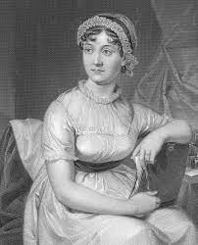

*By Tim Lambert*

Jane Austen was a great woman novelist of the early 19th century. Jane was born on 16 December 1775 in Steventon Rectory. She was the second daughter of The Reverend George Austen and his wife Cassandra. Apart from her older sister, also called Cassandra Jane also had 6 brothers.

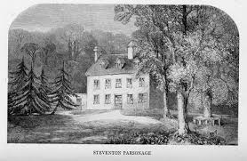

In 1783 Jane and her sister were sent to boarding school. While at school they both caught a fever (possibly typhus) and Jane nearly died. Jane Austen left school in 1786.

Even as a child Jane Austen loved writing and she wrote a lot of short stories .In the years 1796-97 Jane Austen wrote another novel she called First Impressions. It was later published as Pride and Prejudice.

In 1801 Jane Austen moved with her sister and parents to Bath. Jane Austen was a tall, slim woman. In 1802 she received a proposal of marriage from a man named Harris Bigg-Wither. At first Jane accepted but she quickly changed her mind. (There is a film on that topic: *Becoming Jane* starring Ann Hathaway-2007). Jane Austen never married. Her father George Austen died in 1805.

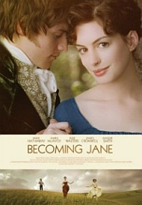

In 1807 Jane Austen moved to Southampton. She lived there until 1809. At that time Southampton was a flourishing port and town with a population of over 8,000. However in 1809 Jane Austen moved to the little village of Chawton in north Hampshire.

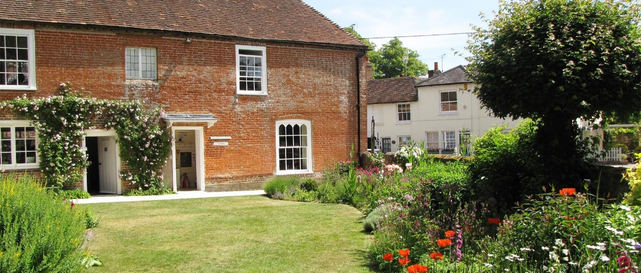

Then in 1811 Sense and Sensibility was published. Pride and Prejudice was published in 1813. Mansfield Park was published in 1814. Another book called Emma followed in 1816. Meanwhile Jane Austen wrote Persuasion but she died before it could be published. It was published posthumously in 1817.

Jane Austen died on 18 July 1817. Jane was only 41 years old. She was buried in Winchester Cathedral.

www.localhistories.org/austen

