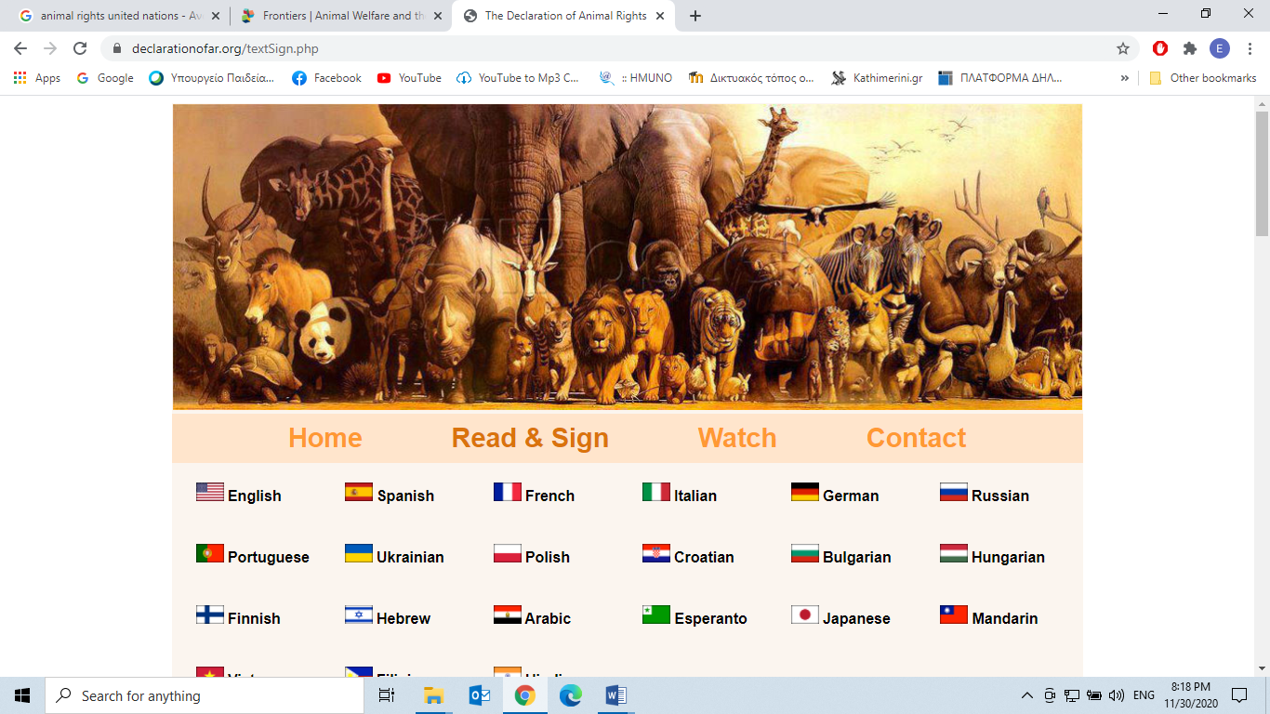

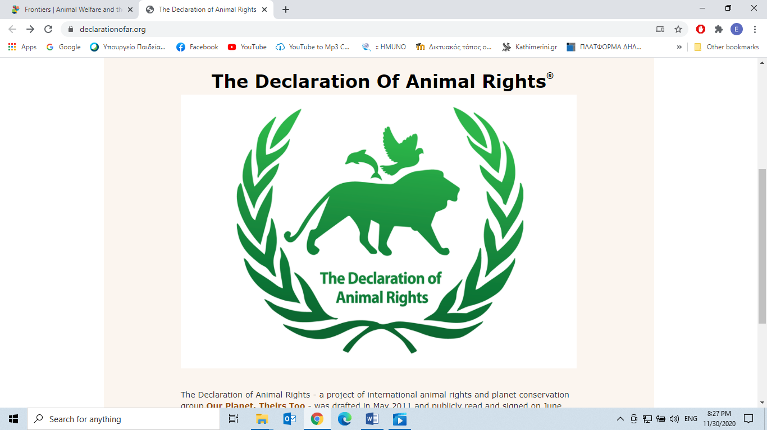

***The Declaration Of Animal Rights®***

The Declaration of Animal Rights - a project of international animal rights and planet conservation group Our Planet. Theirs Too - was drafted in May 2011 and publicly read and signed on June 3rd of the same year, on the 1st National Animal Rights Day in the US, in the city of New York.

The Declaration was copied onto a large scroll of paper, which since then has been traveling the world and collecting people's signatures, drawings and notes. It is now 300 meters (1,000 feet) long, with more than 20,000 signatures! Once it reaches 50,000 signatures, the scroll will be sent to the White House, the UN, The EU Parliament and other world leaders, in order to show them what we, the citizens of this world, think of our fellow animals and their rights. We will do this until The Declaration of Animal Rights is recognized all over the world, and the rights proclaimed in it are protected by global law!

You can read and sign The Declaration of Animal Rights here.

<https://declarationofar.org/>

© 2011-2020. All rights to The Declaration of Animal

***The Declaration Of Animal Rights***

WE HEREBY PROCLAIM THAT:

We hold these truths to be self-evident, that all beings are created equal, and have a right to Life, Liberty and the pursuit of their Happiness.

Therefore, all animals have the same natural right to exist, as any other living being.

All animals have the right to be free, to live their lives on their own terms, as intended by nature.

All animals have the right to eat, sleep, be physically and psychologically comfortable, be mobile, healthy, safe, and fulfill all their natural and essential needs. As such, all animals are to be free from hunger, thirst, and malnutrition; physical discomfort and exhaustion; confinement against their will, bad treatment, abusive or cruel actions; pain, injury and disease; fear and distress; and free to express their normal patterns of behavior.

All animals have the right to reproduce, live with their offspring, families, tribes or communities, and maintain a natural social life. They have the right to live in their natural environment, grow to a rhythm natural to their species, and maintain a life that corresponds to their natural longevity.

Animals are not the property or commodity of humans, and are not theirs to use for their benefit or sustenance. Therefore, they are to be free from slavery, exploitation, oppression, victimization, brutality, abuse, and any other treatment that disregards their safety, own free will and dignity. They should not be slaughtered for food, killed for their skins, experimented on, killed for religious purposes, used for forced labor, abused and killed for sport and entertainment, abused for commercial profit, hunted, persecuted or exterminated for human pleasure, need, or other ends.

Humans shall do whatever is within their means to protect all animals. Any animal who is dependent on a human, has the right to proper sustenance and care, and shall not be neglected, abandoned, or killed.

Animals who have died must be treated with respect and dignity, as humans are.

We call for the protection of these rights. They must be recognized and defended by law, as human rights are. Any act which compromises the wellbeing or survival of an animal or species, or jeopardizes, contradicts, or deprives an animal or species of the rights listed above, should be deemed a crime, and should be punished accordingly.

IN WITNESS THEREOF, this Declaration is hereby signed today, Sunday, June 5th 2011, The First National Animal Rights Day, in the City of New York, The United States of America.

(Original text written by Aylam Orian and anonymous, and edited by Aylam Orian and Zelda Penzel)

Taken from:

[**https://declarationofar.org/textSign.php**](https://declarationofar.org/textSign.php)

**Answer** **the Questions:**

1. Which of the above Animal Rights you feel most strongly about?

_______________________________________________________________________________________________________________________________________________________________________________________________________________________________________________________________

2. Which of these Rights do you find controversial and debatable?

­­­­_________________________________________________________________________________________________________________________________________________________________________________________________________________________________________________________________________________________________________________________________________________________________________________________________________________________________________