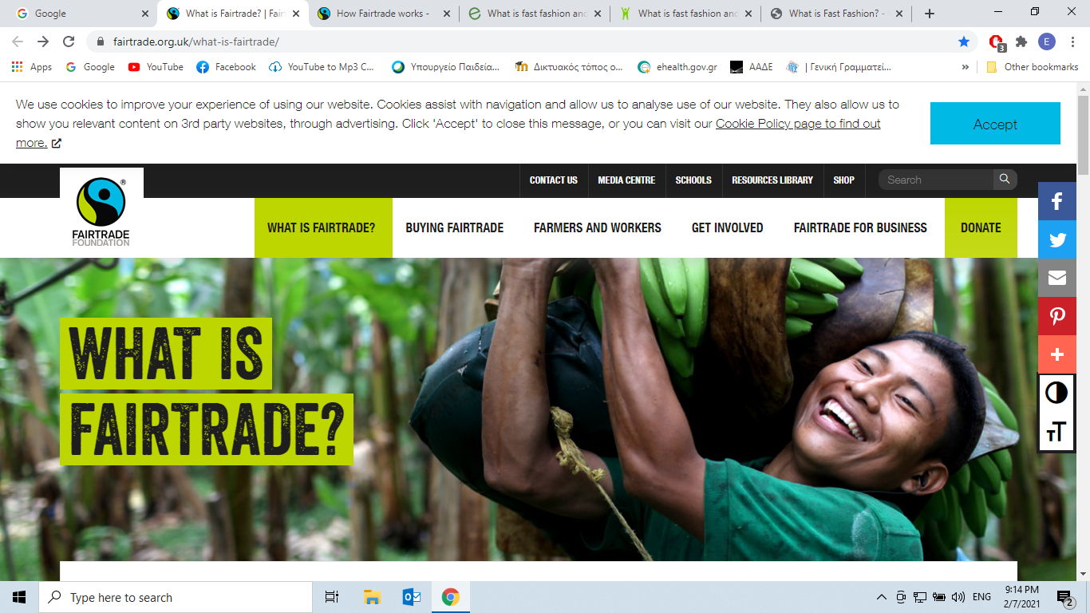

What’s Fairtrade? Fairtrade is about better prices, decent working conditions, local sustainability, and fair terms of trade for farmers and workers in the developing world.

By requiring companies to pay sustainable prices (which must never fall lower than the market price), Fairtrade tackles the injustices of conventional trade, which traditionally discriminates against the most vulnerable. It enables them to improve their position and have more control over their lives.

With Fairtrade you have the power to change the world every day. With simple shopping choices you can get farmers a better deal. And that means they can make their own decisions, control their future and lead the dignified life everyone deserves.

[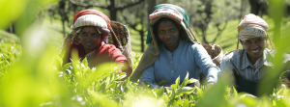](https://www.fairtrade.org.uk/what-is-fairtrade/what-fairtrade-does/)

[WHAT FAIRTRADE DOES](https://www.fairtrade.org.uk/what-is-fairtrade/what-fairtrade-does/)

Fairtrade is a simple way to make a difference to the lives of the people who grow the things we love. We do this by making trade fair.

[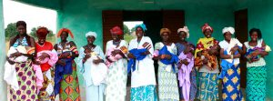](https://www.fairtrade.org.uk/what-is-fairtrade/facts-and-figures-about-fairtrade/)

[FACTS AND FIGURES ABOUT FAIRTRADE](https://www.fairtrade.org.uk/what-is-fairtrade/facts-and-figures-about-fairtrade/)

Ever wondered how many farmers and workers are involved with Fairtrade? Or how the Fairtrade Premium is used? Here’s a snapshot from our latest data.

[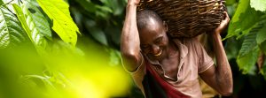](https://www.fairtrade.org.uk/what-is-fairtrade/where-fairtrade-works/)

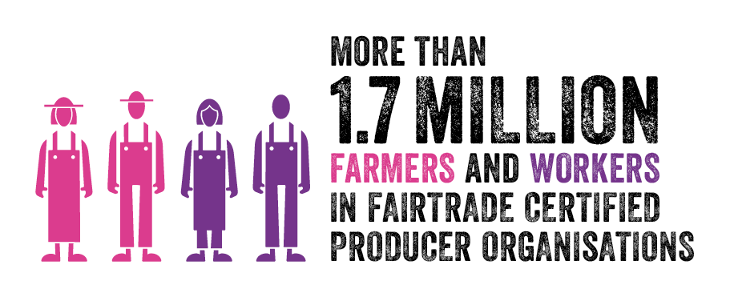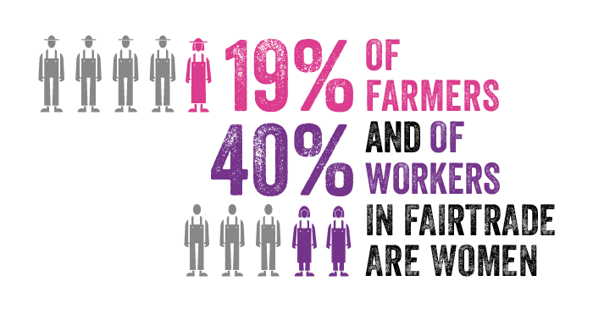

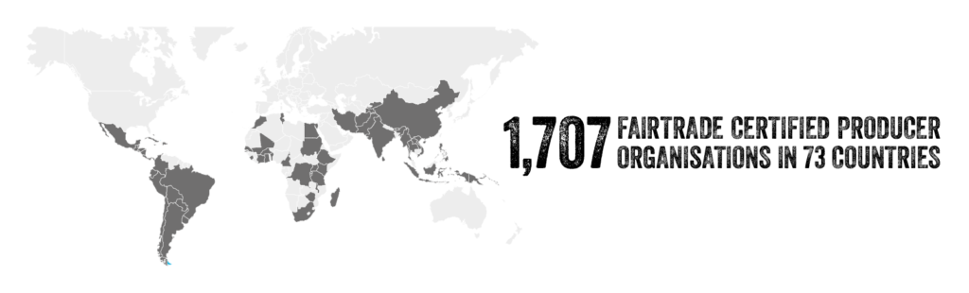

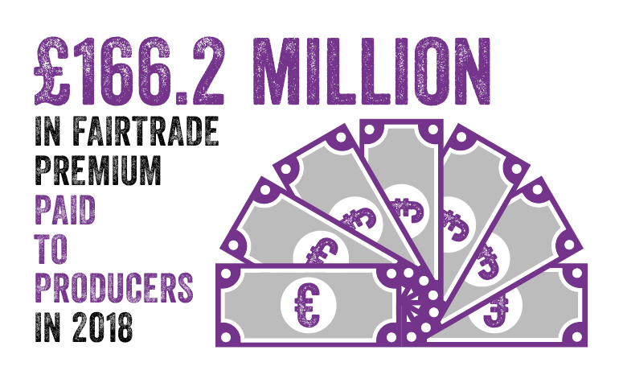 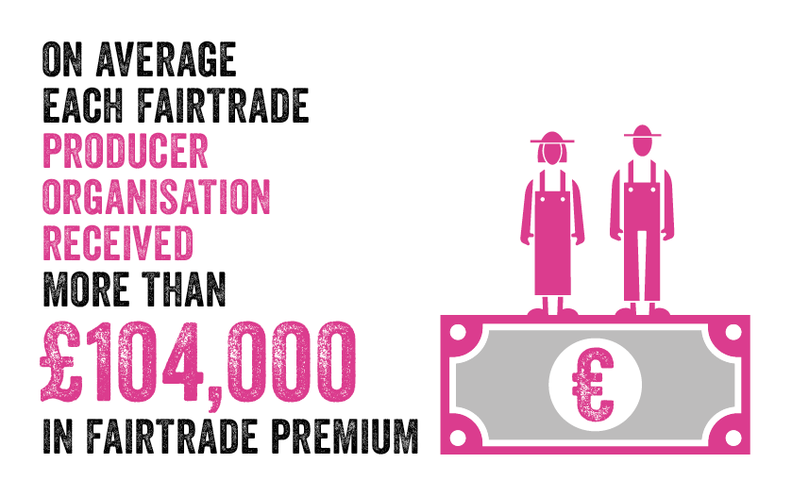

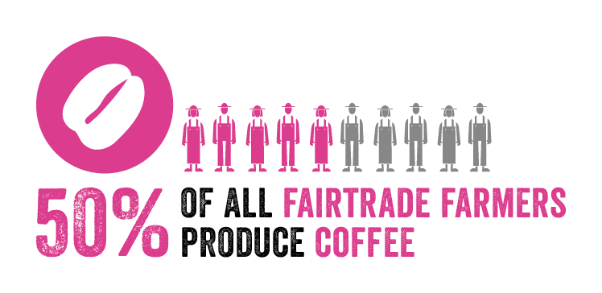 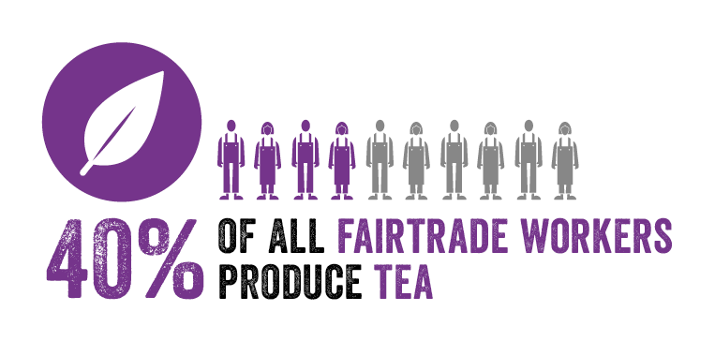

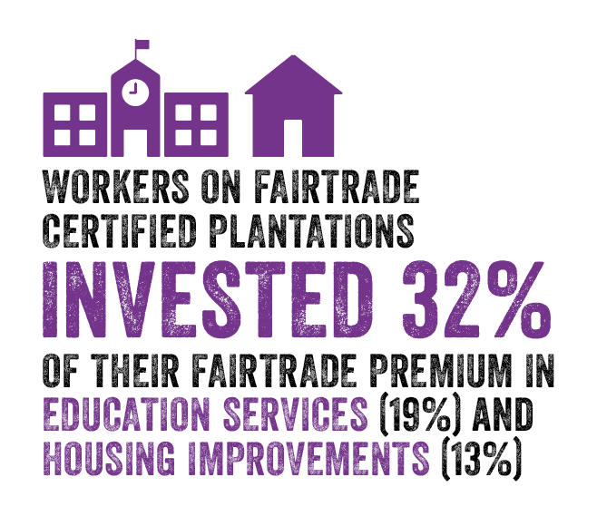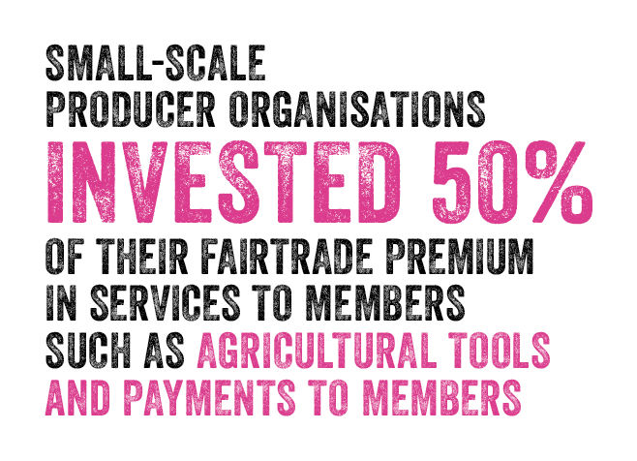

CONTACT[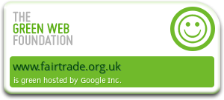](https://www.fairtrade.org.uk/media-centre/guidance-notices/fairtrades-website-is-powered-by-renewable-energy/)SIGN NEWSLETTER

There are over 1.66 million farmers and workers in 1,411 producer organisations across the Fairtrade system.

[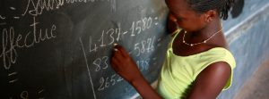](https://www.fairtrade.org.uk/what-is-fairtrade/who-we-are/)

[WHO WE ARE](https://www.fairtrade.org.uk/what-is-fairtrade/who-we-are/)

Fairtrade is a global movement with a strong and active presence in the UK, represented by the Fairtrade Foundation.

[](https://www.fairtrade.org.uk/what-is-fairtrade/the-impact-of-our-work/)

[THE IMPACT OF OUR WORK](https://www.fairtrade.org.uk/what-is-fairtrade/the-impact-of-our-work/)

We support small scale farmers and workers who are marginalised from trade in a variety of ways and carefully monitor the impact of Fairtrade on these communities.

[](https://www.fairtrade.org.uk/what-is-fairtrade/fairtrade-and-sustainability/)

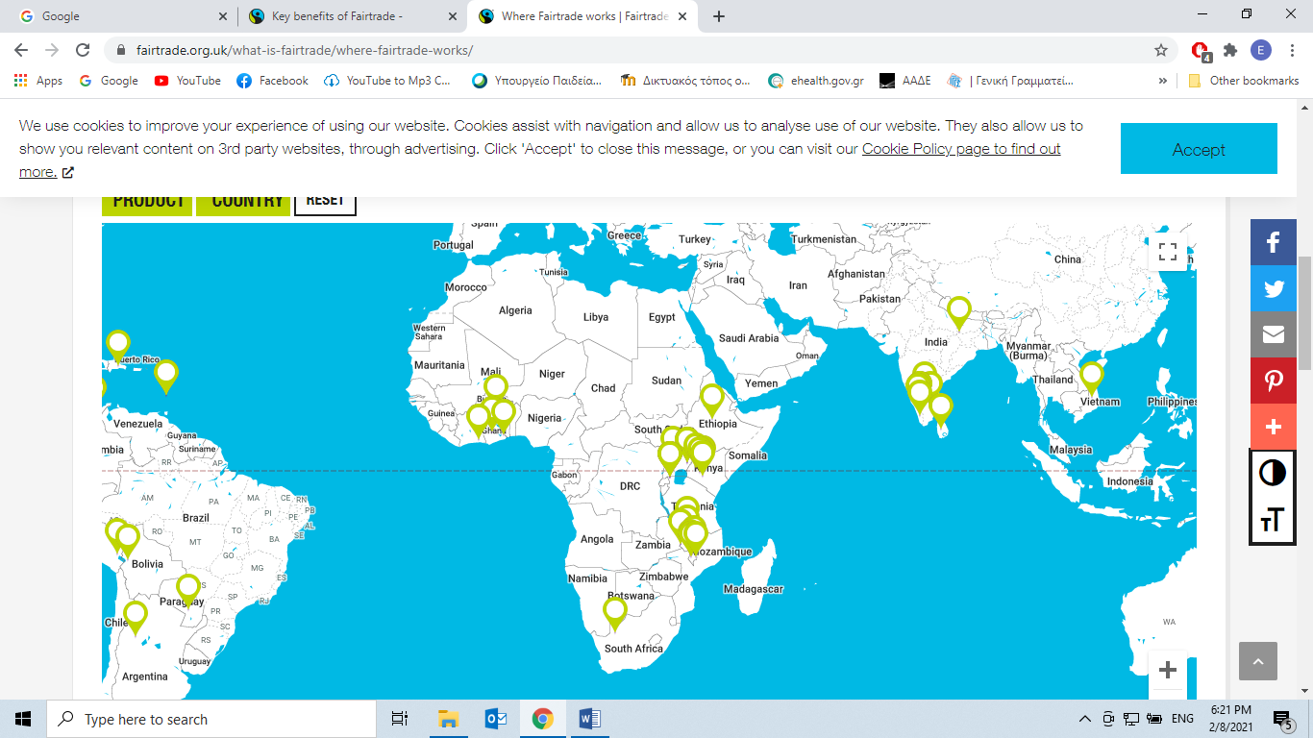

***Countries participating in the Fair Trade Project.***

***Answer the questions:***

1. **What is FairTrade? Give a brief definition.**

______________________________________________________________________________________________________________________________________

2. **How many countries are involved in the project? (give number) Have a look at Facts and Figures and consult the map. Name some countries**

_________________________________________________________________________________________________________________________________________________________________________________________________________

3. **The product that FairTrade farmers produce the most is :**

a. tea

b. bananas

c. coffee

4. **How do both farmers and consumers benefit from FairTrade?**

____________________________________________________________________________________________________________________________________________________________________________________________________________________________________________________________________________

5. **Where do farmers invest their money from FairTrade in?**

a. buying a house

b. paying loans

c. education

d. buying more land