**Retrieved from:**

**https://www.ethicalconsumer.org/fashion-clothing/what-fast-fashion-why-it-problem**

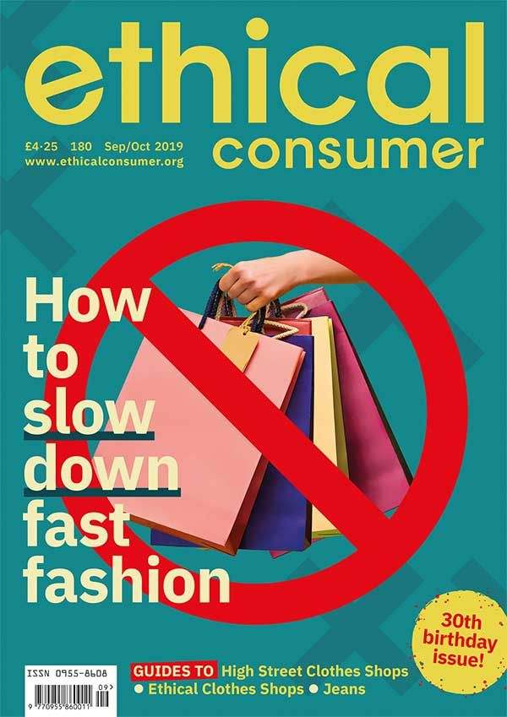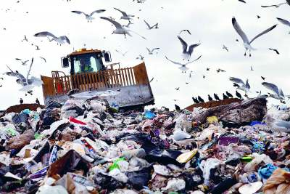

By

Alex Crumbie

Thursday 5th of September 2019

Alex Crumbie explores a mainstreaming of concern about the social and environmental impacts of the clothing industry.

Fast fashion is ‘fast’ in a number of senses: the rate of production is fast; the customer’s decision to purchase is fast; delivery is fast; and garments are worn fast, usually only a few times before being discarded. It is a model that is entirely unsustainable.

According to the [Fixing Fashion report](https://publications.parliament.uk/pa/cm201719/cmselect/cmenvaud/1952/1952.pdf), a **scathing**(*severely critical*) cross-party analysis published by the UK Parliament in 2019, the fast fashion business model is “encouraging over-consumption and **generating** (*producing*) excessive waste.”

Fast fashion has generally become the norm across the clothing sector, with most of the brands in this guide utilising elements of the fast fashion business model to varying degrees.

However, the worst offenders in the UK are some of the newer brands on the block, notably: [Boohoo](https://www.ethicalconsumer.org/company-profile/boohoocom-uk-ltd), [Pretty Little Thing](https://www.ethicalconsumer.org/company-profile/prettylittlethingcom-ltd), [Nasty Gal](https://www.ethicalconsumer.org/company-profile/nasty-gal-ltd) (all of which are owned by [Boohoo](https://www.ethicalconsumer.org/company-profile/boohoo-group-plc)), and [Missguided](https://www.ethicalconsumer.org/company-profile/missguided-ltd" \o "Missguided Ltd).

These brands market their clothes primarily to young people, especially young women, with promises of cut-price individuality, female empowerment and next-day delivery.

Fast Production

An essential aspect of the fast fashion business model is the offering of hundreds of new products, every week, or even every day. At the time of writing, Pretty Little Thing’s website listed an incredible 284 items under ‘New In Today’, while Missguided listed 639 under ‘New This Week.’

The short lead times necessary to deliver such vast quantities of new designs mean that [wash tests and wearer trials are usually not possible, which has implications for garment quality and durability](https://publications.parliament.uk/pa/cm201719/cmselect/cmenvaud/1952/1952.pdf). Furthermore, many of the [products are made with materials that cannot be recycled](https://publications.parliament.uk/pa/cm201719/cmselect/cmenvaud/1952/1952.pdf).

Fast Sale

Purchasing items of clothing is now easier than ever, facilitating mass overconsumption.

Fast fashion brands make heavy use of social media platforms, particularly Instagram, where users are able to purchase the clothes they see upon the bodies of models and ‘influencers’, those beautiful but relatable demi-gods of social media, in just a few swipes of the finger or thumb.

And low prices mean that buying an item requires little consideration. On top of that, even those without the money can have what they desire in the world of fast fashion with the wide availability of online credit, notably via the Swedish service, Klarna.

Delivery is also fast and relatively cheap, allowing customers to have what they desire the day after their desire first took hold. Boohoo, Pretty Little Thing, Missguided and ASOS all promote delivery services that offer a year of unlimited, next day delivery for under £10.

Fast Use

The garments produced in the world of fast fashion are generally of low quality, but many are thrown out before they have the chance to be worn out. While the [average person buys 60% more items of clothing than they did 15 years ago, that clothing is kept only half as long](https://www.mckinsey.com/~/media/McKinsey/Industries/Retail/Our%20Insights/The%20State%20of%20Fashion%202019%20A%20year%20of%20awakening/The-State-of-Fashion-2019-final.ashx).

WHAT'S THE DEFINITION OF FAST FASHION?

Fast fashion has three main components from the consumer’s perspective: it’s cheap, it’s trendy and it’s disposable. It makes purchasing clothes on impulse easy and affordable. Shoppers are encouraged to update their wardrobes regularly throughout the year to keep up with ever-changing trends.

From a business perspective, fashion’s growth depends on higher production and lower production costs. It surpasses the classic seasonal collection output by far. Instead of collections coming out four times per year, some fast fashion brands introduce new trends that mimic catwalk styles on the sales floor as often as several times per week.

Retrieved from:

<https://healthyhumanlife.com/blogs/news/what-is-fast-fashion>

Comment on the following:

1. Have a look at the two photos at the top of the articles. Compare and contrast. What seem to be the different messages conveyed to the reader?

_______________________________________________________________________________________________________________________________________________________________________________________________________________

2. Give a brief definition of fast fashion.

_______________________________________________________________________________________________________________________________________________________________________________________________________________

3. In what ways is fast fashion an entirely unsustainable model? (environmental impact)

______________________________________________________________________________________________________________________________________________________________________________________________________________________________________________________________________________________________________________________________________________________________________________________________________________________________

4. What is the impact of fast fashion on the consumer?

____________________________________________________________________________________________________________________________________________________________________________________________________________________________________________________________________________________