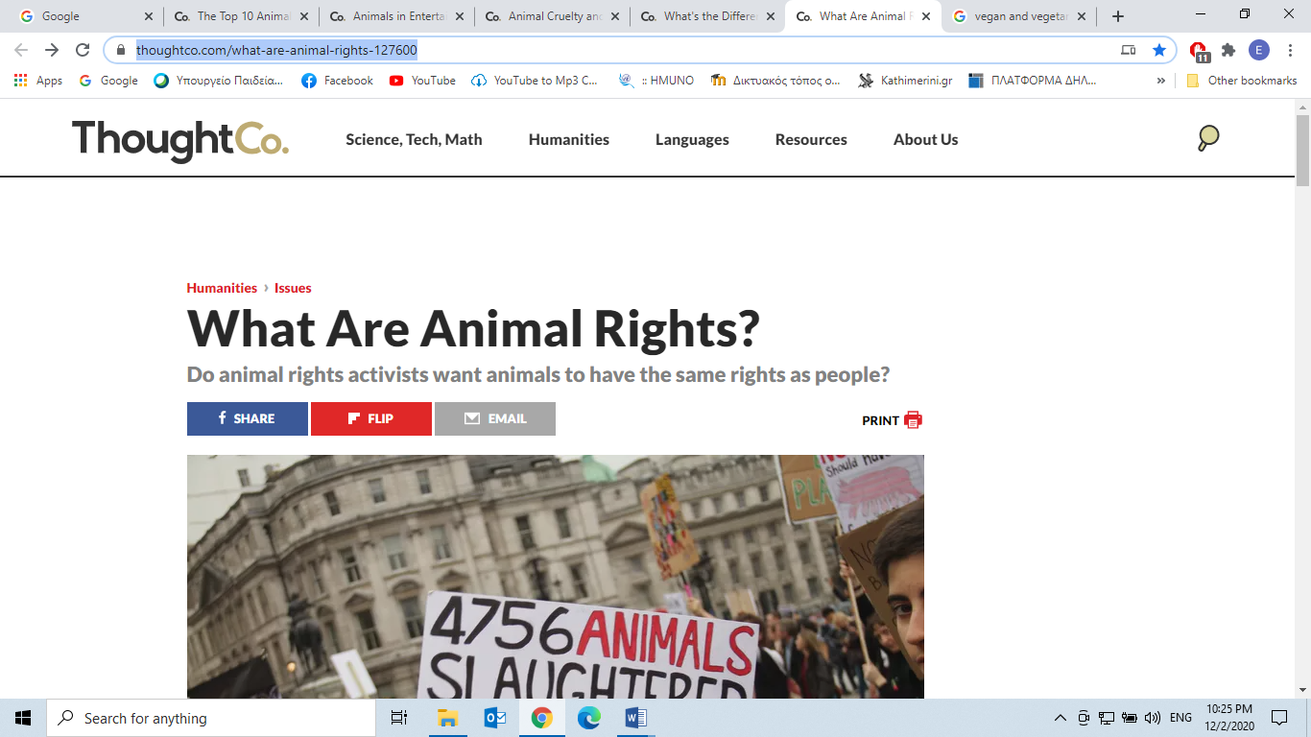

**From:** [**https://www.thoughtco.com/what-are-animal-rights-127600**](https://www.thoughtco.com/what-are-animal-rights-127600)

**What Are Animal Rights?**

**Do animal rights activists want animals to have the same rights as people?**

By

[Doris Lin](https://www.thoughtco.com/doris-lin-127487)

Updated January 08, 2018

Animal rights are the belief that animals have a right to be free of human use and exploitation, but there is a great deal of confusion about what that means. Animal rights are not about putting animals above humans or giving animals the same rights as humans. Also, animal rights are very different from animal welfare.

To most animal rights activists, animal rights are grounded in a rejection of **speciesism** (*the assumption of human superiority leading to the exploitation* *of animals*) and the knowledge that animals have sentience (the ability to suffer). (Learn more about the [basic tenets of animal rights](https://www.thoughtco.com/basic-tenets-of-animal-rights-127580).)

**Freedom from Human Use and Exploitation**

Humans use and exploit animals in myriad ways, including meat, [milk](https://www.thoughtco.com/milk-facts-whats-wrong-with-milk-127680), eggs, [animal experimentation](https://www.thoughtco.com/experimentation-on-animals-considered-in-senate-127848), fur, [hunting](https://www.thoughtco.com/is-hunting-ever-defensible-127868), and [circuses](https://www.thoughtco.com/how-circus-elephants-are-sometimes-abused-127647).

With the possible exception of animal experimentation, all of these uses of animals are frivolous. People don't need meat, eggs, milk, fur, hunting or circuses. The American Dietetic Association recognizes that people can be perfectly healthy as vegans.

Regarding animal experimentation, most would agree that testing of cosmetics and household products is unnecessary. A new furniture polish or lipstick seems a frivolous reason to the blind, maim, and kill hundreds or thousands of rabbits.

Many would also say that scientific experimentation on animals for the sake of science, with no immediate, obvious application to human health, is unnecessary because the suffering of the animals outweighs the satisfaction of human curiosity. This leaves only medical experiments. While animal experimentation may lead to human medical advancements, we cannot morally justify exploiting animals for experiments any more than experiments on mental patients or babies can be justified.

**Justifications for Animal Exploitation**

The most common justifications for animal use are:

* Animals are not intelligent (cannot think/reason).
* Animals are not as important as people.
* Animals have no duties.

Rights cannot be determined by the ability to think, or we'd have to give intelligence tests to determine which humans deserve rights. This would mean that babies, the mentally disabled and the mentally ill would have no rights.

Importance is not a good criterion for rights holding because importance is highly subjective and individuals have their own interests that make each individual important to him/herself. One person may find that their own pets are more important to them than a stranger on the other side of the world, but that doesn't give them the right to kill and eat that stranger.

The President of United States might be more important than most people, but that doesn't give the president the right to kill people and mount their heads on the wall as trophies. One could also argue that a single blue whale is more important than any single human being because the species is endangered and every individual is needed to help the population recover.

Duties are also not good criteria for rights holding because individuals who are incapable of recognizing or performing duties, such as babies or people with profound disabilities, still have a right not be eaten or experimented on. Furthermore, animals are routinely killed for failing to follow human rules (e.g., the mouse who is killed in a mousetrap), so even if they have no duties, we punish them for failing to abide by our expectations.

Because there will always be some humans who don't fit the criteria used to justify animal exploitation, the only true distinction between humans and non-human animals are species, which is an arbitrary line to draw between which individuals do and don't have rights. There is no magical dividing line between humans and non-human animals.

**The Same Rights as Humans?**

There is a common misconception that [animal rights](https://www.thoughtco.com/top-arguments-against-animal-rights-127630) activists want nonhuman animals to have the same rights as people. No one wants cats to have the right to vote, or for dogs to have the right to bear arms. The issue is not whether animals should have the same rights as people, but whether we have a right to use and exploit them for our purposes, however, frivolous they might be.

**Animal Rights v. Animal Welfare**

Animal rights are [distinguishable from animal welfare](https://www.thoughtco.com/animal-rights-v-animal-welfare-127592). In general, the term "animal rights" is the belief that humans do not have a right to use animals for our own purposes. "Animal welfare" is the belief that humans do have a right to use animals as long as the animals are treated humanely. The animal rights position on [factory farming](https://www.thoughtco.com/factory-farming-faq-127724) would be that we do not have a right to [slaughter animals for food](https://www.thoughtco.com/overview-of-humane-slaughter-act-127557) no matter how well the animals are treated while they are alive, while the animal welfare position might want to see certain cruel practices eliminated.

*"Animal welfare" describes a broad spectrum of views, while animal rights are* *more absolute*. For example, some animal welfare advocates might want a ban on fur, while others might believe that fur is morally acceptable if the [animals are killed](https://www.thoughtco.com/how-many-animals-are-killed-each-year-127631) "humanely" and do not suffer for too long in a trap. "Animal welfare" may also be used to describe the specialists view that certain animals (e.g. dogs, cats, horses) are more deserving of protection than others (e.g. fish, chickens, cows).

Lin, Doris. "What Are Animal Rights?" ThoughtCo, Aug. 26, 2020, thoughtco.com/what-are-animal-rights-127600.

**Respond to Quotes: Provide *Your* View**

1. “While animal experimentation may lead to human medical advancements, we cannot morally justify exploiting animals for experiments any more than experiments on mental patients or babies can be justified.”

What is your opinion on that? (30-50 words)

__________________________________________________________________________________________________________________________________________________________________________________________________________________________________________________________________________________________________________________________________________

2. a)What is the difference between the term “*Animal Rights*” and “*Animal Welfare*”?

____________________________________________________________________________________________________________________________________________________________________________________________________________________________

b) If you had to choose, would you be an Animal Rights activist or in favour of Animal Welfare-*pro Animal Welfare?* Give reasons.

_________________________________________________________________________________________________________________________________________________________________________________________________________________________________________________________________________________________________________________________________________________________________________________________________