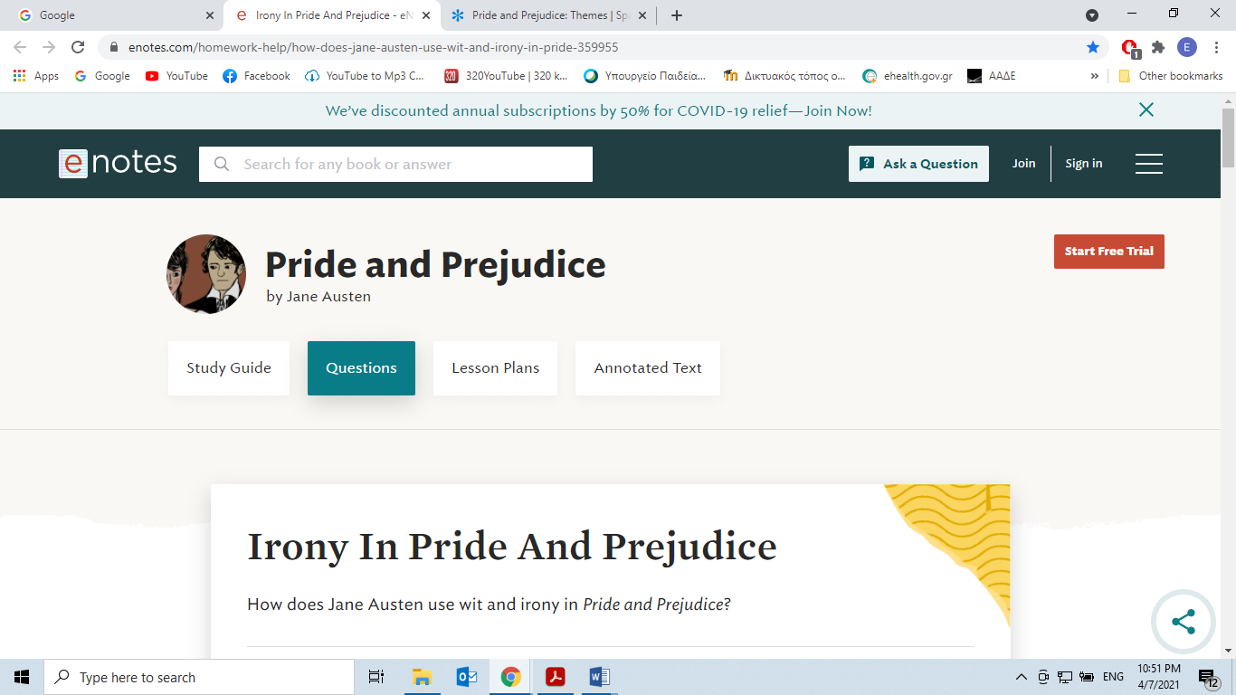

<https://www.enotes.com/homework-help/how-does-jane-austen-use-wit-and-irony-in-pride-359955>

**Irony In Pride And Prejudice**

How does Jane Austen use wit and irony in *Pride and Prejudice*?

Jane Austen uses wit and irony throughout *Pride and Prejudice* to create a comic tone around the serious subject of the marriage market. Ironic utterances like the novel's opening sentence and ironic plot twists keep the reader surprised and entertained.

*Irony*, which is when words or situations turn out the opposite of what is expected, permeates [*Pride and Prejudice*](https://www.enotes.com/topics/pride-and-prejudice).

The first sentence of the novel is frequently cited as the textbook’s example of verbal irony:

“It is a truth universally acknowledged, that a single man in possession of a good fortune, must be in want of a wife.”

What this really means is the opposite of what it says: that women universally wish to marry a man with money. This opening sentence sets the tone for the rest of this novel. In fact, the verbal irony of the first sentence is itself wittily and ironically upset by situational irony when [Elizabeth Bennet](https://www.enotes.com/topics/pride-and-prejudice/characters/elizabeth-bennet) turns down the wealthy [Mr. Darcy](https://www.enotes.com/topics/pride-and-prejudice/characters/mr-darcy)'s offer of marriage, blowing up at him in rage at his arrogant way of proposing to her and telling him he is the last man she would ever marry.

|  |
| --- |
| *“It is a truth universally acknowledged that a single man in possession of good fortune must be in want of a wife”.* |

This is a satirical line filled with irony. Its literal meaning is that a “rich single man should certainly be looking for a wife”. If we consider though Austen’s attitude about society’s expectations for women, we realize that this is not in fact her own personal idea but only a view fixed in the minds of the people of that period, which in fact criticises through her work. It could even bear the reverse meaning, that is “a single woman must be looking for a husband, especially a wealthy one”.