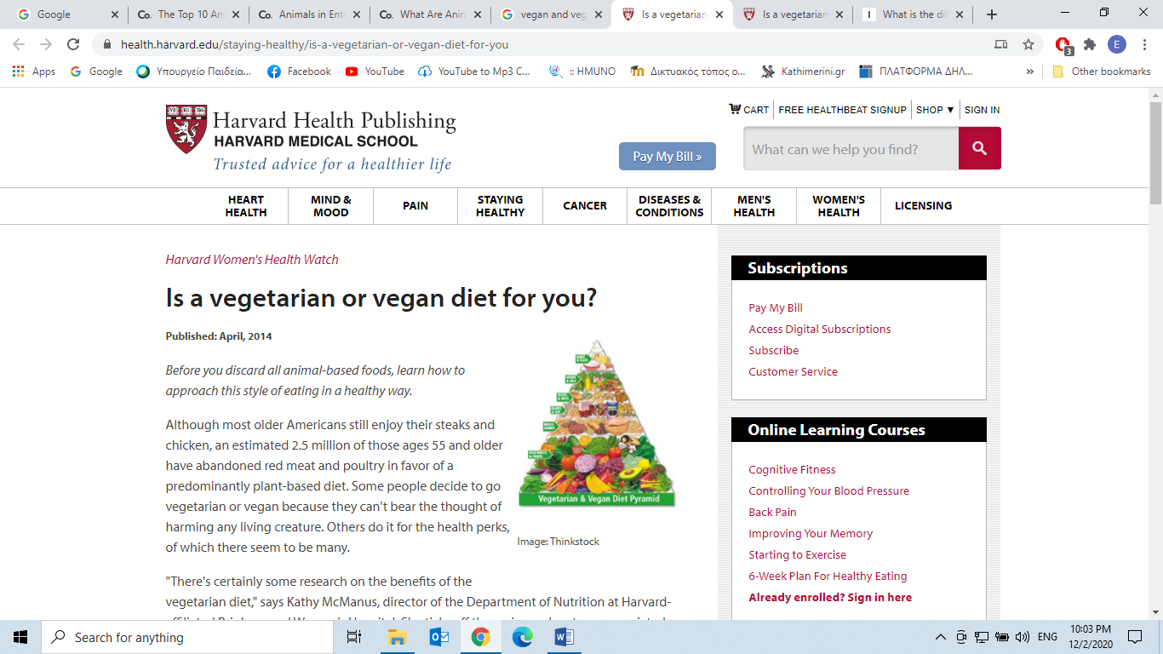

**Is a vegetarian or vegan diet for you?**

|  |
| --- |
| https://www.health.harvard.edu/media/content/images/W0514a-1.jpg  Image: Thinkstock |

**Published: April, 2014**

*Before you discard all animal-based foods, learn how to approach this style of eating in a healthy way.*

Although most older Americans still enjoy their steaks and chicken, an estimated 2.5 million of those ages 55 and older have abandoned red meat and **poultry** (*chicken and the like= πουλερικά*) in favor of a **predominantly** (*mainly*) plant-based diet. Some people decide to go vegetarian or vegan because they can't bear the thought of harming any living creature. Others do it for the **health perks** (*risks*), of which there seem to be many.

"There's certainly some research on the benefits of the vegetarian diet," says Kathy McManus, director of the Department of Nutrition at Harvard-affiliated Brigham and Women's Hospital. She ticks off the various advantages associated with this way of eating—*lower body mass index and blood pressure; reduced risks for heart disease, diabetes, and cancer; and longer life.*

If you're thinking about going vegetarian or vegan but are worried about making a big change in how you eat, know that there are many different layers to this way of eating. "**There are options** within a vegetarian diet if a woman wants to get her feet wet," McManus says. The most common approaches are these:

* **Semi-vegetarian**. You still eat animal products, but more selectively. Many semi-vegetarians eat chicken and fish but not red meat.
* **Pescatarian.** You avoid meat and poultry but still eat fish and seafood.
* **Lacto-ovo vegetarian**. You skip all meat, fish, and poultry but include dairy and eggs in your diet.
* **Vegan**. This solely plant-based diet is the strictest form of vegetarianism. You eat no animal products at all—not even eggs or dairy products.

**Watch your nutrition**

Vegetarian and vegan diets can be healthy, but they can lack certain nutrients. You may have to use a little creativity to ensure you get enough protein, calcium, iron, and vitamin B12.

Keep in mind that going vegetarian doesn't give you carte blanche to eat whatever you want—especially if you're trying to control your weight. Go heavy on fruits, vegetables, and whole grains but limit foods high in saturated fat, such as ice cream, whole milk, and cheese. And watch how much you eat at each meal. "People who are trying to lose weight can certainly do it on a vegetarian diet, but they have to limit portions," McManus says.

|  |  |
| --- | --- |
| **Vegetarian and vegan diets: Where to find the nutrients you need** | |
| **Nutrient** | **Examples of plant-based food sources** |
| **https://www.health.harvard.edu/media/content/images/W0514a-2.jpgCalcium** | Vegetarians: Low-fat or fat-free milk, yogurt, cheese  Vegetarians and vegans: Fortified soy milk or rice milk, fortified orange juice, tofu with added calcium, broccoli, beans, leafy green vegetables, almonds, almond butter, sesame seeds, soybeans |
| **https://www.health.harvard.edu/media/content/images/W0514a-3.jpgIron** | Vegetarians: Eggs, enriched breads and pasta |
| **https://www.health.harvard.edu/media/content/images/W0514a-3.jpgIron** | Vegetarians: Eggs, enriched breads and pasta  Vegetarians and vegans: Soy nuts, tofu, kale, spinach, beans, peanut butter |
| **https://www.health.harvard.edu/media/content/images/W0514a-4.jpgProtein** | Vegetarians: Eggs, milk and other dairy products  Vegetarians and vegans: Lentils, beans, quinoa, oatmeal, nuts |
| **https://www.health.harvard.edu/media/content/images/W0514a-5.jpgVitamin B12** | Vegetarians: Eggs, milk and other dairy products  Vegetarians and vegans: Fortified soy milk or orange juice, fortified cereals |

<https://www.health.harvard.edu/staying-healthy/is-a-vegetarian-or-vegan-diet-for-you>

***Respond to the following Questions:***

1. What is the difference between vegan and vegetarian?

____________________________________________________________________________________________________________________________________________________________________________________________________________________________________________________________________________

2. Do you think that going either vegan or vegetarian contributes to *ethical treatment* of animals and *caring about the environment* or is it just another trend being promoted by the marketing of food industry? (30-50 words)

________________________________________________________________________________________________________________________________________________________________________________________________________________________________________________________________________________________________________________________________________________________________________________________________________________________________________________________________________________________________________________________________________________________