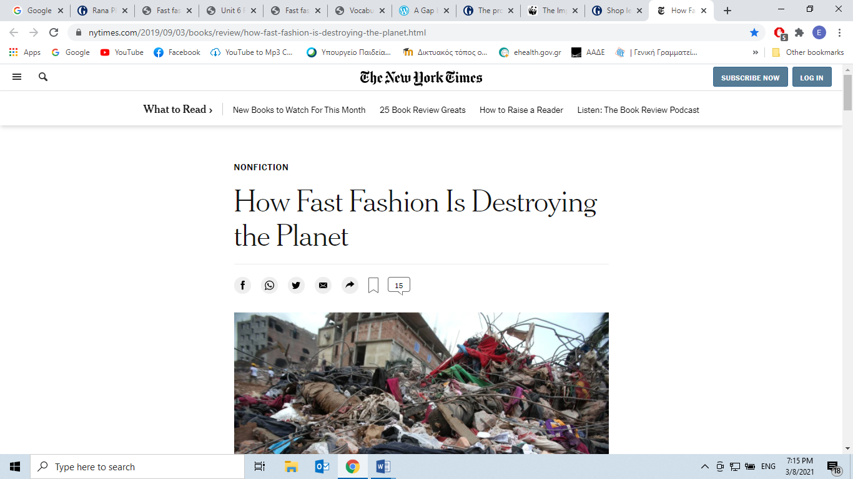

More than 60 percent of fabric fibers are now synthetics, derived from fossil fuels, so if and when our clothing ends up in a landfill (about 85 percent of textile waste in the United States goes to landfills or is incinerated), it will not decay.

Nor will the synthetic microfibers that end up in the sea, freshwater and elsewhere, including the deepest parts of the oceans and the highest glacier peaks. Future archaeologists may look at landfills taken over by nature and discover evidence of Zara.

And it is Zara and other brands like it that have helped plant flags on the farthest reaches of the planet. There are immigrant workers in Los Angeles today who are victims of wage theft and exploitation, not to mention the Bangladeshi, Chinese, Vietnamese and other laborers who face working conditions that are at best grim and at worst inhumane. Fashion is an industry that has depended on the *toil* (work extremely hard=μόχθος) of the powerless and the voiceless, and on keeping them that way.

<https://www.nytimes.com/2019/09/03/books/review/how-fast-fashion-is-destroying-the-planet.html>

***What can consumers do then? Just sit back and watch?***

The problem with fast fashion and how to fix it.

Zoe Morrison reports:

**Retrieved from:**

<https://www.theguardian.com/lifeandstyle/2014/aug/13/problem-with-fast-fashion-how-to-fix-it>

**Lessons from a month of slow fashion**

* Some people find not buying new clothes easy – I like it because I simply can’t be bothered to shop
* A limited wardrobe makes getting up in the morning quicker and can mean you get to wear your favourite clothes over and over again
* Clothes *wear out* (make useless by long or hard use) when worn repeatedly. I didn’t want to wear the same clothes too much as I didn’t want to wear them out and have another mending job on my hands
* Nobody really cares if you wear the same dress for days on end
* I was able to *emulate* (copy, reproduce, imitate) one of the latest fashions with stuff I already owned. (It did involve cutting and sewing though, which may not be for everyone)

**Easier alternatives**

For anyone who doesn’t have the time, or the will, to do the same, here are a few alternative suggestions for anyone who wants to join the slow fashion movement:

* Wear the same pair of shoes every day for a month
* Thin out your wardrobe and choose a set number of clothes to wear for the month – how low can you go? Do you need 20 items or could you cope with five, or even less?
* Get creative and *embellish* (decorate, enhance) just one unloved item of clothing, shoes or accessories. You could even make an accessory like a brooch with scraps you find around your home.
* Mend something that you would otherwise throw away or replace

***Shop less, mend more:***

*https://www.theguardian.com/lifeandstyle/2018/feb/10/shop-less-mend-more-making-more-sustainable-fashion-choices*

Reportedly topped only by oil, the fashion industry is contributing to major environmental destruction – mainly because consumers insist on buying so many clothes at such cheap prices.

***Alternatives do exist.*** The solution lies in buying less and choosing better quality items that are made as ethically as possible. But how to tell good brands from bad?

**Buy clothes made locally by ethical labels**

Step one is choosing brands that consider the planet and their workers. The desire to wear cheap new looks daily has led to offshore manufacturing in often *deplorable* (completely unacceptable) circumstances – buying local, well-made pieces can sidestep all that.

**Avoid fabrics made using petroleum and chemicals**

Think beyond where or how clothing is made, to exactly what each piece is made from. Where possible, skip petroleum-based synthetics such as polyester and nylon, which are actually plastics that take forever to break down once tossed. Each time such fabrics are washed, they shed thousands of [microfibres](https://storyofstuff.org/movies/story-of-microfibers/) that end up polluting rivers and oceans. ([Guppy Friend filter bags](http://guppyfriend.com/en/), developed in Berlin, are a solution to trapping microfibres in laundries.)

**Extend your wardrobe’s lifespan by mending**

Once clothing becomes tired and hole-ridden, don’t rush straight to the bin: try mending instead. Call a local clothing repairer or, better yet, join the [#visiblemending](https://www.instagram.com/explore/tags/visiblemending/) movement, which encourages entirely obvious and colourful hand-sewn repairs.

## **Reduce your consumption by hitting the op shops**

A guaranteed way to reduce the fashion industry’s impact is to avoid buying new stuff in the first place. Secondhand stores are the ultimate clothing recyclers – and *thrift shop* (second-hand store) fashion definitely doesn’t have to be *daggy* (scruffy, not stylish).

Switching to more ethical fashion options does take forethought, but the health of the planet and the safety of workers in developing nations depends on it.

Now, watch the video: *Is fast fashion destroying our environment?* AND do the task that appears in Liveworksheets.

<https://youtu.be/YOA0D0i5-fA?t=222>

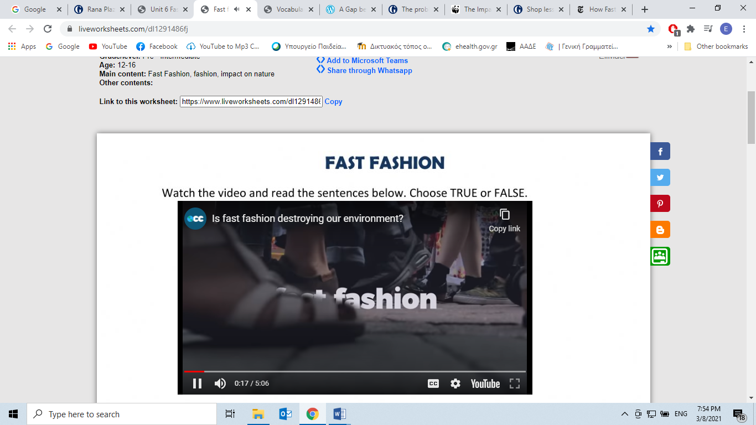

<https://www.liveworksheets.com/dl1291486fj>

WRITING PRODUCTION:

*How can you -as a consumer- contribute to reducing your environmental footprint? Which of the above practices will you be willing enough to adopt and why? Develop into an essay of 150-200 words.*

___________________________________________________________________________________________________________________________________________________________________________________________________________________________________________________________________________________________________________________________________________________________________________________________________________________________________________________________________________________________________________________________________________________________________________________________________________________________