***Module 5 Factory Farms Glossary and Background Information.***

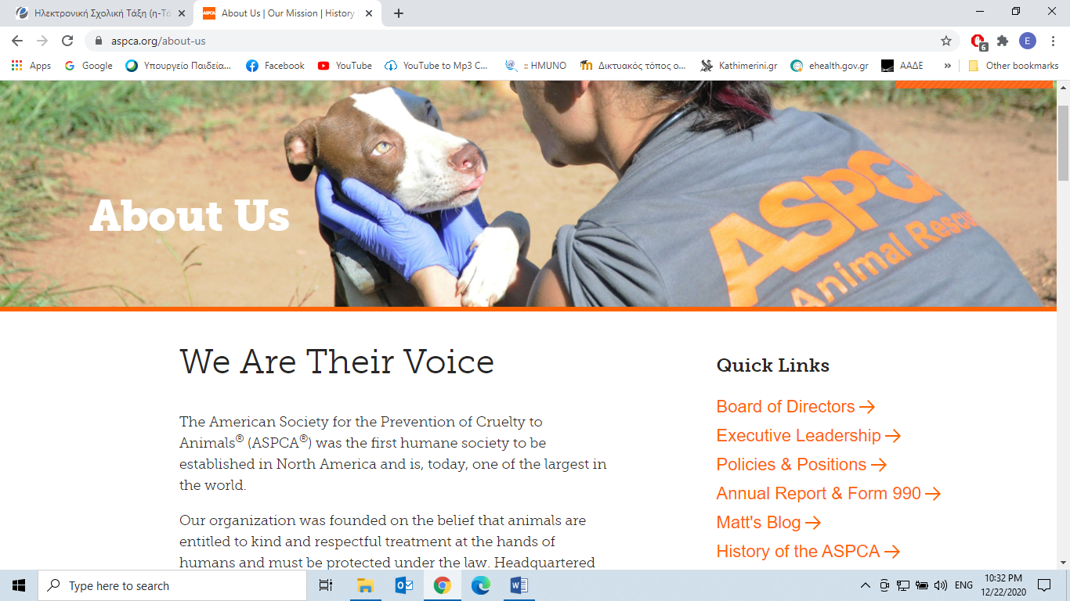

*Efficiency*=do things well, successfully, without waste

*Trumps*=do or produce something better

*Welfare*=well-being (ευημερία)

*At the expense of*=with the sacrifice of, at the price of, at the cost of

*Slaughter*=kill animals for food

*Plight*=a dangerous, difficult and unfortunate situation, predicament

*Egg-laying hens*=hens that produce eggs only

*Breed* =stock of a species=ράτσα, γένος

*Genetic manipulation*=genetic modification or engineering=γενετική τροποποίηση

**What is it?**

Direct manipulation of DNA to alter an organism’s characteristics (phenotype) in a particular way.

**How is this done?**

By deleting a whole region of DNA or introducing an additional copy of a gene. By extracting and combining DNA from another organism’s genome (γονιδίωμα).

For example: genetic manipulation can be applied from a virus to a sheep.

Plants with higher nutritional value can be produced in this way or they can tolerate exposure to herbicides.

For more on that visit: <https://www.yourgenome.org/>