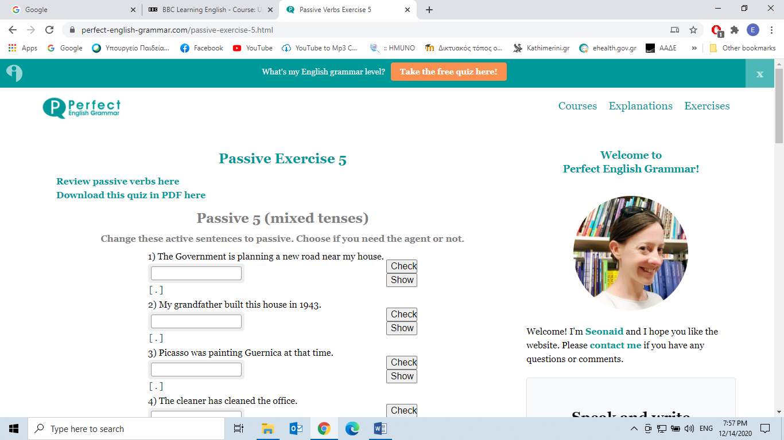

**https://www.perfect-english-grammar.com/passive-exercise-5.html**

**Passive 5 (mixed tenses)**

**Change these active sentences to passive. Choose if you need the agent or not.**

|  |  |
| --- | --- |
| 1) The Government is planning a new road near my house. | Check Show |
| 2) My grandfather built this house in 1943. | Check Show |
| 3) Picasso was painting Guernica at that time. | Check Show |
| 4) The cleaner has cleaned the office. | Check Show |
| 5) He had written three books before 1867. | Check Show |
| 6) John will tell you later. | Check Show |
| 7) By this time tomorrow we will have signed the deal. | Check Show |
| 8) Somebody should do the work. | Check Show |
| 9) The traffic might have delayed Jimmy. | Check Show |
| 10) People speak Portuguese in Brazil. | Check Show |
| 11) Everybody loves Mr Brown. | Check Show |
| 12) They are building a new stadium near the station. | Check Show |
| 13) The wolf ate the princess. | Check Show |
| 14) At six o'clock someone was telling a story. | Check Show |
| 15) Somebody has drunk all the milk! | Check Show |
| 16) I had cleaned all the windows before the storm. | Check Show |
| 17) A workman will repair the computer tomorrow. | Check Show |
| 18) By next year the students will have studied the passive. | Check Show |
| 19) James might cook dinner. | Check Show |
| 20) Somebody must have taken my wallet. | Check Show |

We respect your privacy. You can unsubscribe at any time.

Τέλος φόρμας