**Pride and Prejudice' Overview**

**Literature's Ultimate Romantic Comedy**

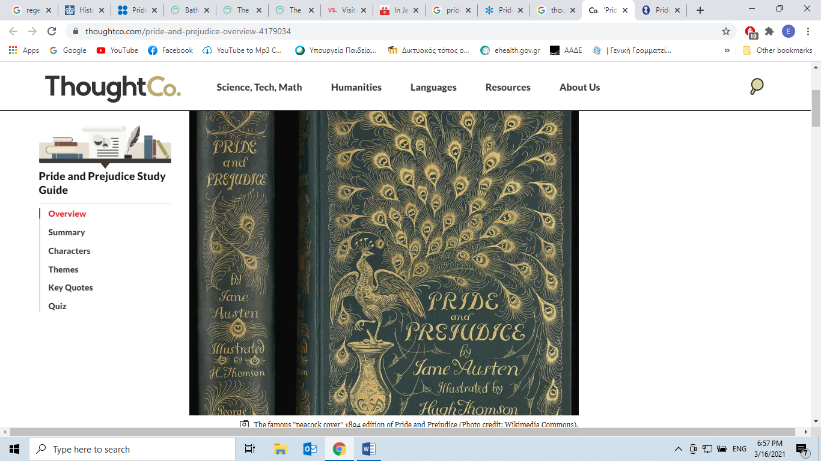

By

[Amanda Prahl](https://www.thoughtco.com/amanda-prahl-4172153)

Updated January 04, 2019

*Pride and Prejudice*is a novel by Jane Austen that satirizes issues of marriage and social class. It follows the relationship between the quick-to-judge Elizabeth Bennet and the haughty Mr. Darcy as both learn to mend their errors in judgment and look beyond markers of social status. First published in 1813, the bitingly funny romantic comedy has endured as both a popular favorite and [a literary classic](https://www.thoughtco.com/classic-novels-everyone-should-read-4153022).

**Fast Facts: Pride and Prejudice**

* **Author**: Jane Austen
* **Publisher**: Thomas Egerton, Whitehall
* **Year Published**: 1813
* **Genre**: Comedy of manners
* **Type of Work**: Novel
* **Original Language**: English
* **Themes**: Love, marriage, pride, social class, wealth, prejudice
* **Characters**: Elizabeth Bennet, Fitzwilliam Darcy, Jane Bennet, Charles Bingley, George Wickham, Lydia Bennet, William Collins
* **Notable Adaptations**: 1940 film, 1995 television miniseries (BBC), 2005 film
* **Fun Fact**: Researchers named a pheromone in male mice that attracts females “Darcin” after Mr. Darcy.

Plot Summary

*Pride and Prejudice* opens with the Bennet family's reaction to a bit of social news: the nearby Netherfield house has been leased to Mr. Bingley, a wealthy and single young man. Mrs. Bennet expresses the belief that Bingley will fall in love with one of her daughters. Her prediction proves true at the neighborhood ball, where Bingley and the sweet eldest Bennet daughter, Jane, fall in love at first sight. At the same ball, the strong-willed second daughter Elizabeth Bennet finds herself the object of disdain from Bingley’s arrogant, antisocial friend Darcy.

Caroline Bingley and Mr. Darcy convince Mr. Bingley of Jane’s disinterest and separate the couple. Elizabeth’s distaste for Darcy only grows when she befriends Wickham, a young militiaman who claims that Darcy ruined his livelihood out of spite. Darcy expresses interest in Elizabeth, but Elizabeth harshly rejects Darcy’s self-absorbed proposal of marriage.

The truth soon unravels. It is revealed that Wickham spent all the money Darcy’s father left him and then tried to seduce Darcy’s younger sister. During a trip with her aunt and uncle, Elizabeth visits Darcy’s [estate](https://www.thoughtco.com/definition-of-manor-1789184), Pemberley, where she begins to view Darcy in a better light. Her positive impression of Darcy grows when she learns that he has secretly used his own money to convince Wickham to marry, rather than abandon, her sister Lydia Bennet. Darcy's aunt, Lady Catherine, demands that Darcy marry her daughter, but her plan backfires and instead leads to Darcy and Elizabeth finding their romantic happiness alongside a reunited Jane and Bingley.

Major Characters

**Elizabeth Bennet**. The second of [the five Bennet daughters](https://www.thoughtco.com/pride-and-prejudice-characters-4178369), Elizabeth (“Lizzy”) is the story’s protagonist. Playful and intelligent, she prizes her ability to make judgments quickly. Her journey of self-discovery is at the heart of the story, as she learns how to discern the truth beneath first impressions.

**Fitzwilliam Darcy**. Mr. Darcy is a haughty and wealthy landowner who snubs Elizabeth when they first meet. He is proud of his [social status](https://www.thoughtco.com/what-is-social-class-and-why-does-it-matter-3026375) and is frustrated with his own attraction to Elizabeth but, like her, he learns to overcome his previous judgments to come to a truer perspective.

**Jane Bennet**. The sweet, pretty eldest Bennet daughter. She falls in love with Charles Bingley, Her kind, nonjudgmental nature leads her to overlook Caroline Bingley’s malice until it is almost too late.

**Charles Bingley**. Polite, open-hearted, and a little naïve, Bingley is a close friend of Darcy. He is easily influenced by Darcy’s opinions. He falls in love with Jane but is persuaded away from her, although he learns the truth in time to make amends.

**George Wickham**. An outwardly charming soldier, Wickham’s pleasant demeanor hides a selfish, manipulative core. Though he presents himself as a victim of Darcy’s pride, he is revealed to be the problem himself. He continues his bad behavior by seducing young Lydia Bennet.

Major Themes

**Love and Marriage**. [The novel focuses on](https://www.thoughtco.com/pride-and-prejudice-themes-literary-devices-4177651) the obstacles to, and the reasons for, romantic love. Most notably, it satirizes expectations about marriages of convenience and suggests that genuine compatibility and attraction—as well as honesty and respect—are the foundations of the best matches. Characters who try to subvert this thesis are the targets of the book’s biting satire.

**Pride**. In the novel, uncontrolled pride is one of the biggest obstacles to the characters’ happiness. In particular, pride based on notions of class and status is framed as ridiculous and unfounded in real values.

**Prejudice**. Making judgments about others can be useful, but not when those judgments are formed erroneously or quickly. The novel posits that overly confident prejudice must be overcome and tempered before the characters can reach happiness.

**Social Status**. Austen famously satirizes the manners and obsessions of class distinctions. While none of the characters are [socially mobile](https://www.thoughtco.com/social-mobility-3026591) in the modern sense, obsessions with status are presented as foolish and arrogant. Wealth and inheritance do matter, though, as evidenced by Mr. Collins’ presence as Mr. Bennet’s heir.

Literary Style

Austen’s writing is famous for one particular literary device: free indirect discourse. Free indirect discourse is the technique of writing thoughts that seem to come from an individual character's mind, without shifting into first-person narration or using action tags such as "she thought." This device gives readers access to inner thoughts and helps to solidify the characters’ unique voices.

The novel was written in the [Romantic period](https://www.thoughtco.com/the-romantic-period-739049) of literature, which was at its peak in the first half of the 19th century. The movement, which was a reaction against the onslaught of industrialism and rationalism, emphasized individuals and their emotions. Austen’s work fits into this framework to a degree, as it emphasizes decidedly non-industrial contexts and focuses primarily on the emotional lives of richly drawn individual characters.

About the Author

Born in 1775, Jane Austen is best known for her sharp observations of a small social circle: country gentry, with a few lower-tier military families in the mix. Her work prized the inner lives of women, featuring complicated characters who were flawed yet likable and whose internal conflicts were as important as their romantic entanglements. Austen shied away from over-sentimentality, preferring instead to mix heartfelt emotions with a helping of pointed wit.

**Cite this Article**

Prahl, Amanda. "'Pride and Prejudice' Overview." ThoughtCo, Aug. 28, 2020, thoughtco.com/pride-and-prejudice-overview-4179034.

