**TIPS FOR WRITING A GREAT NARRATIVE**

Set the scene and engage your audience early with well thought out characters and setting.

Introduce a problem or complication that causes an issue which gives your story purpose.

**Entertain us.** *Narratives* are the most popular of all styles of writing. If you can't entertain and engage us, your audience will quickly move on.

The single biggest challenge many students face when it comes to story writing is, coming up with i**nspiration** or **ideas** to get those creative juices flowing.  Some students will have more ideas than hours in the day and others will always struggle for both ideas and direction.

It is essential that you have a range of tools, strategies and resources at your disposal to ensure you get the most out of your writing time.  You can find some examples of these prompts at the bottom of this page.

[[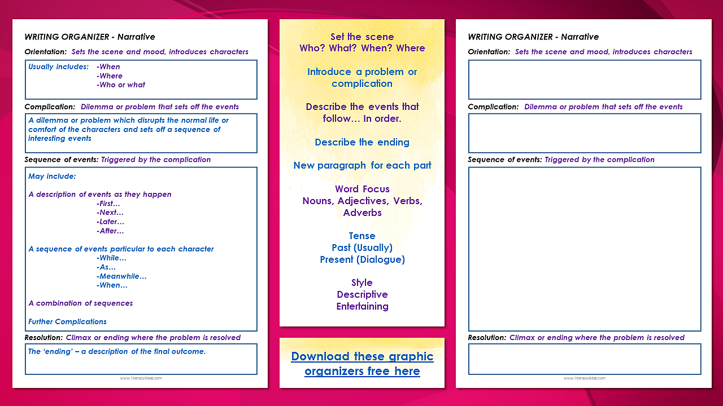](http://literacyideas.com/)](http://literacyideas.com/" \t "_blank)