**The horrors of war and conflict captured in one harrowing poem**

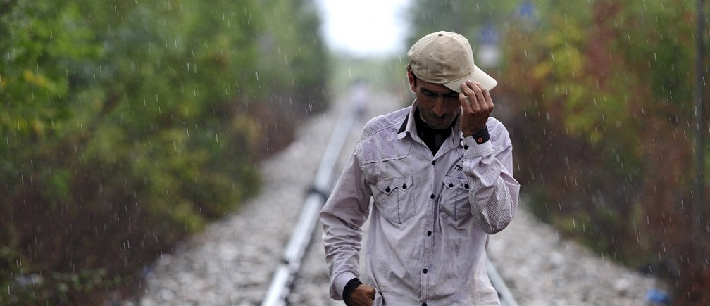

Image: REUTERS/Ognen Teofilovski

13 Sep 2016

Migration

[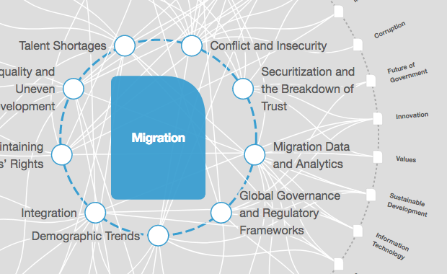](https://intelligence.weforum.org/topics/a1Gb0000000LGr8EAG?tab=publications)

[**Explore the latest strategic trends, research and analysis**](https://intelligence.weforum.org/topics/a1Gb0000000LGr8EAG?tab=publications)

The UN Refugee Agency has released a [powerful film](https://www.facebook.com/UNHCR/videos/10155411388398438/) that attempts to capture the terror of families who have been forced to flee their homes.

In the film, which was released on Facebook, celebrities including Cate Blanchett, Keira Knightley, Jesse Eisenberg and Chiwetel Ejiofor perform a poem entitled ‘What They Took With Them.’

The poem details the items refugees snatched in the final, panic-filled moments before they left their family homes, often while under fire from shells and bombs.

**Frenzy, chaos and terror**

Blanchett, a UN Refugee Agency Ambassador, described how the poem reflects the fear that drives families out of their homes. “The rhythm and words of the poem echo the frenzy and chaos and terror of suddenly being forced to leave your home, grabbing what little you can carry with you, and fleeing for safety.”

The UN Refugee Agency says there are more than 65 million people who have been forced to flee their homes. It’s the highest number of forcibly displaced people ever recorded.

**Essential items**

So what did those people take with them when they fled?

Passports and ID cards were important items to refugees hoping to build new lives in another country. In an age where information is power, smartphones and laptops were seen as vital to many fleeing families. Many were headed for dangerous journeys across the sea in flimsy boats. They took torches and laser pointers to attract the attention of rescuers.

Children grabbed their favourite toy. Parents took nappies and sunscreen for babies. One man took skin whitening cream because he did not want to look like a refugee wherever he ended up.

Many families took the keys to their homes, clinging to the hope that one day they may be able to return. Many never will.

Many of the images in the film were taken from the work of Photographer, Brian Sokol. His project [‘The Most Important Thing’](http://tracks.unhcr.org/2016/02/the-most-important-thing/) detailed the items that refugees from Angola described as their most cherished items during their time in exile.

The film is part of a campaign asking people around the world to support displaced people by signing the [#WithRefugees](https://twitter.com/search?q=%23withrefugees&src=typd&lang=en-gb) petition. The campaign is calling on governments to make sure all refugees have a safe place to live, access to education and the opportunity to work.

Retrieved from:

https://www.weforum.org/agenda/2016/09/what-do-refugees-take-with-them-celebrities-are-helping-the-un-tell-the-story/