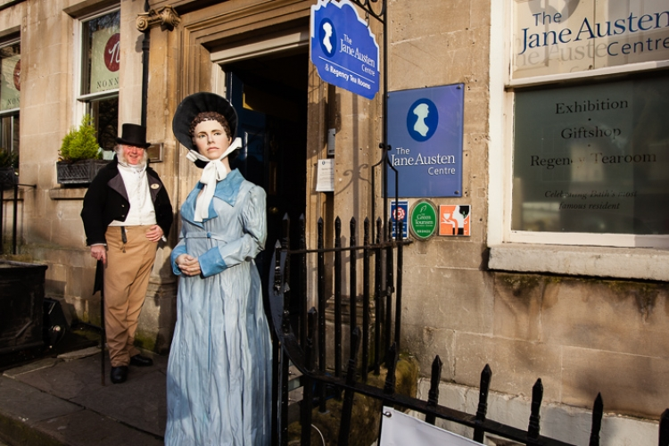

**Video Assignments on Jane Austen**

WATCH the VIDEOS and Fill in the gaps.

A. ***Professor Bradley Greenburg Illinois University – Course Hero***

*Pride and Prejudice* is one of the most 1.____________novels in all literature. It tackles social 2.____________such as class and 3._______________.

Through the protagonist Elizabeth Bennet readers have learned the importance to be 4. ____________to themselves.

The first title Jane Austen chose for the novel was 5.___________6.____________.

The novel takes place in England’s Regency Era. England was entering 7.___________ 8. _____________making it possible for 9._______________to accumulate massive wealth by trade and 10. _____________________.

It was 11. _____________for land and 12. ______________and nobility to marry beneath their social class.

The impact of the novel on the 13. _________________world is undeniable. It has sold million of copies. It has enjoyed film and TV 14. _______________and translated into 15. ______________of languages.

B. ***Jane Austen Centre in Bath***

In Jane Austen’s Centre the visitor can see the most 16. ____________representation of Jane Austen in a spectacular wax work.

The Centre prides itself on the Regency 17. __________Room, upstairs on the second floor, offering 18. ____________varieties of leaf tea, fresh coffee, delicious 19. __________teas and their famous “ Tea with Mr Darcy.”

There is an online gift shop that offers 20. _________________of Jane Austen. Every year in 21. _______________ the centre holds a Jane Austen Festival with 60 events during 22. _____________splendid days.

Visitors can dress up with Regency Era costumes in the Costume Area and introductory talks are given by qualified 23. ________________.

