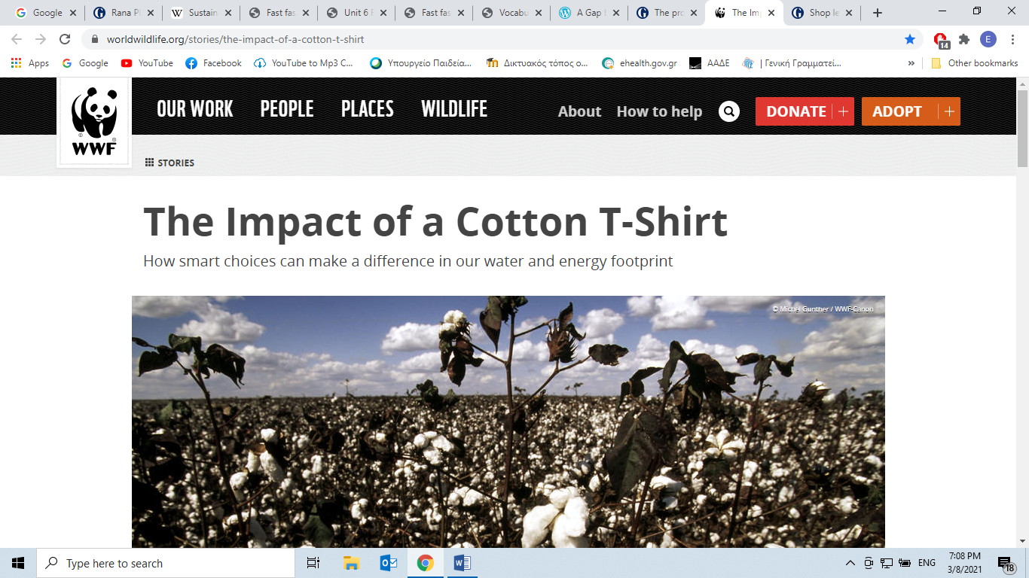

*https://www.worldwildlife.org/stories/the-impact-of-a-cotton-t-shirt*

Your favorite t-shirt is made from more than cotton and memories.

One key ingredient that doesn’t show up on your shirt’s label is water. Amazingly, it can take 2,700 liters to produce the cotton needed to make a single t-shirt.

This is the unseen or “virtual water” we consume every day. So, while it’s important to fix leaky taps and buy efficient washing machines, the water we use at home is only part of our total water footprint.

Take a refreshing cola or cold beer—only a fraction of the water involved actually goes into the bottle. Most of it is used to grow the sugarcane or barley these drinks are made from.

Your smart phone might not make you think of water, but from mining essential minerals to washing microchips, that little gadget has a substantial global water footprint.

The amount of [fresh water](https://worldwildlife.org/industries/fresh-water) available to meet the needs of people and nature is limited, but the demands grow year by year. We have to get smarter about how we use water.

**Using water better**

Seventy percent of all the water people use globally is dedicated to agriculture. That water is essential for the food we eat, as well as crops like [cotton](https://www.worldwildlife.org/industries/cotton).

WWF works with farmers and the businesses that buy their crops to develop [sustainable farming methods](https://www.worldwildlife.org/industries/sustainable-agriculture). This takes the strain off water supplies—not just for cotton, but for other “thirsty crops” like sugar cane and rice.

From farmers in Pakistan and India, to CEOs in the United States and South Africa, we’re helping people to use water more responsibly. With WWF’s support, the [Better Cotton Initiative](http://www.bettercotton.org/site.php) is working with farmers to grow cotton with less water.

In Pakistan, the Initiative has worked with 75,000 farmers who, as a result, have reduced their water use by 39%, and increased their income by 11%. They also used 47% less pesticide and 39% less chemical fertilizer.

That’s good for them, good for other communities downstream, good for the fish, birds and other creatures that depend on rivers and wetlands—and good for people like you who care about where your t-shirts come from.

Big global brands have embraced the scheme: [IKEA](http://www.ikea.com/ms/cs_CZ/pdf/WWF_IKEA_Fact_Sheet_Cotton_Nov2010.pdf), for example, plans to set an example by switching to 100% better Cotton by 2015.

**How You Can Make a Difference**

It takes a lot of energy to grow, manufacture and transport that cotton t-shirt—but did you know that the most energy goes into caring for it?

One load of washing uses 40 gallons of water. One load of drying uses 5 times more energy than washing. In fact, skipping the ironing and drying of your t-shirt, saves a third of its carbon footprint.

Whether it’s reducing waste, saving energy, or being a conscious consumer, small actions can make a big difference. Think about ways that you could save energy and water.

WWF is teaming up with National Geographic to help you learn more about these impacts so you can make each choice count. Stay tuned for more videos.

Now, watch the video by TedEd: *The life cycle of a t-shirt* by Angel Chang and do the activity as it appears in Liveworksheets.

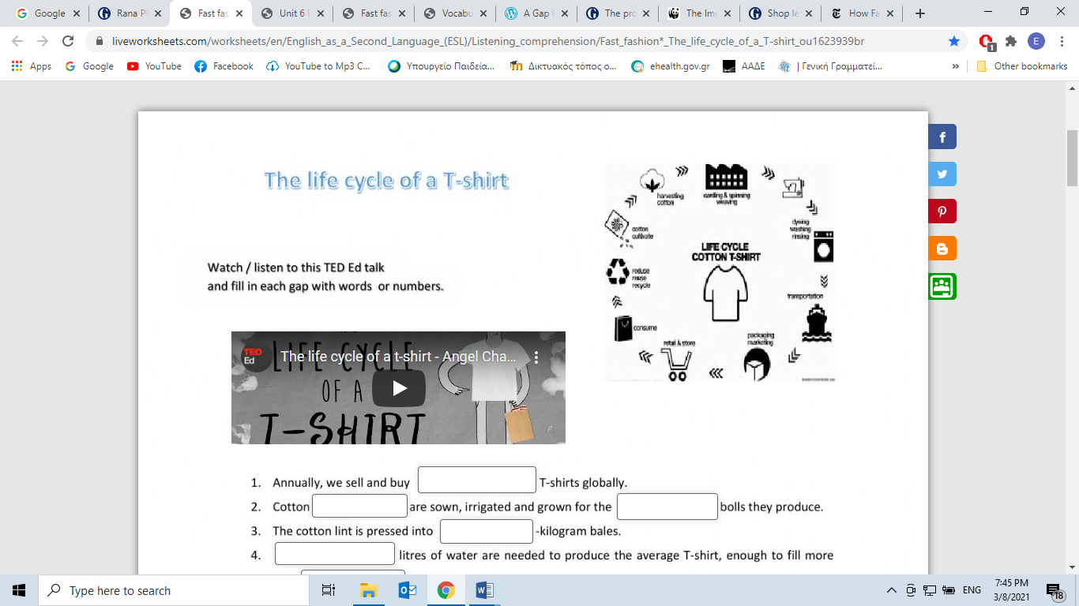

[https://www.liveworksheets.com/worksheets/en/English_as_a_Second_Language_(ESL)/Listening_comprehension/Fast_fashion*_The_life_cycle_of_a_T-shirt_ou1623939br](https://www.liveworksheets.com/worksheets/en/English_as_a_Second_Language_(ESL)/Listening_comprehension/Fast_fashion*_The_life_cycle_of_a_T-shirt_ou1623939br)

<https://youtu.be/BiSYoeqb_VY>