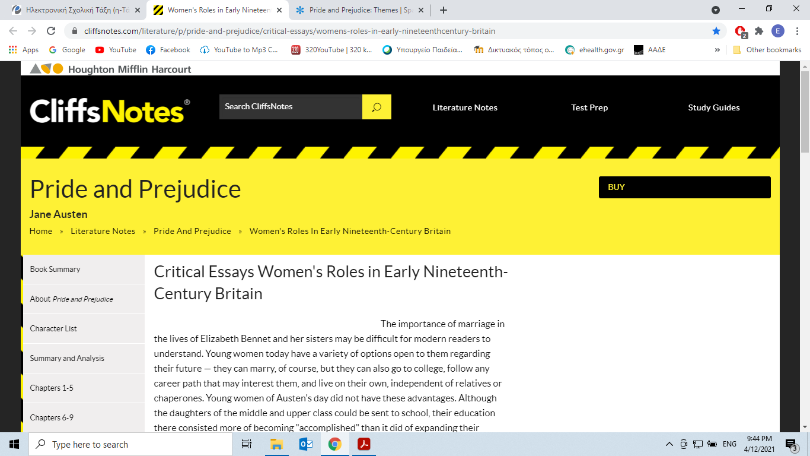

Critical Essays Women's Roles in Early Nineteenth-Century Britain

https://www.cliffsnotes.com/literature/p/pride-and-prejudice/critical-essays/womens-roles-in-early-nineteenthcentury-britain

The importance of marriage in the lives of Elizabeth Bennet and her sisters may be difficult for modern readers to understand. Young women today have a variety of options open to them regarding their future — they can marry, of course, but they can also go to college, follow any career path that may interest them, and live on their own, independent of relatives or chaperones (*person who accompanies and looks after another person=συνοδός).*

Young women of Austen's day did not have these advantages. Although the daughters of the middle and upper class could be sent to school, their education there consisted more of becoming "accomplished" than it did of expanding their academic knowledge. Additionally, women in early nineteenth-century Britain were not allowed in higher education, so private tutors, governesses, and private schools were the extent of structured education open to them. Naturally, a young woman like Elizabeth Bennet with a lively, inquisitive mind would have been able to further her education independently through reading. Elizabeth indicates as much to Lady Catherine, describing education for her and her sisters as being unstructured but accessible: "such of us as wished to learn, never wanted the means. We were always encouraged to read, and had all the masters that were necessary. Those who chose to be idle certainly might." In discussing a woman's accomplishments, Darcy also comments that a really commendable (*deserving praise=αξιέπαινος*) woman will improve "her mind by extensive reading."

A woman's formal education was limited because her job opportunities were limited — and vice versa. Society could not conceive of a woman entering a profession such as medicine or the law and therefore did not offer her the chance to do so. In fact, middle- and upper-class women had few avenues open to them for a secure future. If unmarried, they would remain dependent upon their relatives, living with or receiving a small income from their fathers, brothers, or other relations who could afford to support them. In Elizabeth's case, she is dependent upon her father while he is living and she is unmarried, but because of the entail (*a legal condition that property could only be* *passed to particular people, for example, only to an oldest son*) and the fact that she has no brothers, her situation could become quite desperate when he dies. She and her mother and sisters would be forced to rely upon the charity of their relatives, such as Mr. and Mrs. Phillips, Mr. and Mrs. Gardiner, and even Mr. Collins. Such a position would be extremely distasteful and humiliating.

Other options available to a gently bred young woman who needs to support herself would be to take a position as a governess or a lady's companion. Both jobs allowed a woman to earn a living without sacrificing her social position. However,the working conditions of these jobs were often unpleasant and degrading(*humiliating=ταπεινωτικό*). Governesses might be preyed upon (*hurt and deceive*) by the men in the family for which they worked, while lady's companions, such as Miss De Bourgh's companion, Mrs. Jenkinson, might be treated poorly by their employers and given menial (*not requiring much skill and lacking prestige=ταπεινός*) tasks to attend to. Any other form of employment a woman could take was considered unacceptable and would most likely irrevocably harm her social standing.

An unmarried woman's social standing would also be harmed by her living alone, outside of the sphere of her family's influence. If a single woman who had never been married was not living with her family, she should at least be living with a suitable chaperone. Therefore, when the Bennet daughters travel in *Pride and Prejudice*, they always stay in the company of a relative or a respectable married woman. Jane visits the Gardiners, Elizabeth stays with the now-married Charlotte, Elizabeth later travels with the Gardiners, and Lydia goes to Brighton as the guest of Mrs. Forster. When Lydia runs away with Wickham, however, her reputation and social standing are ruined by the fact that she lived with him alone and unwed for two weeks. Only marriage can save her from being rejected by her social sphere, and only marriage can save her family's reputation as well, unless they disowned her. Consequently, Darcy's efforts to find Wickham and Lydia and to buy Wickham's marriage to Lydia quite literally saves not only Lydia's reputation, but the whole Bennet family as well.

Answer the questions:

1. What options did women have regarding their education?

………………………………………………………………………………………………………………………………………………………………………………………………………………………………………………………………

2. What options did they have as regards employment?

………………………………………………………………………………………………………………………………………………………………………………………………………………………………………………………………

3. Could women live on their own? Talk about social restrictions.

…………………………………………………………………………………………………………………………………………………………………………………………………………………………