**17 Powerfully Inspiring Quotes from Ruth Bader Ginsburg**

**At 85 years of age, Ruth Bader Ginsburg (RBG) shows no signs of slowing down**

**BY**[**PETER ECONOMY**](https://www.inc.com/author/peter-economy)**, THE LEADERSHIP GUY@BIZZWRITER**

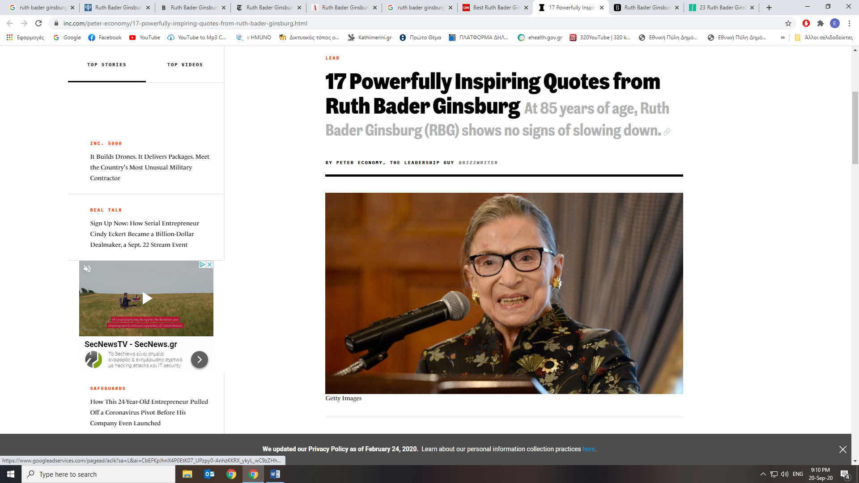

Ruth Bader Ginsburg became just the second female U.S. Supreme Court justice when she took the oath of office on August 10, 1993. She faced workplace discrimination in the 1960s despite graduating first in her class at Columbia Law School in 1959. Ginsburg has long been a forceful advocate of women's rights and gender equality, and she has earned the deep and abiding respect of her colleagues on the Court along with the American Public.

Rumors of Ginsburg's possible retirement from the bench have swirled for years as she fought off a variety of illnesses and injuries, including colon cancer, pancreatic cancer, fracturing three ribs after a fall in her office, and most recently, surgery to remove cancerous growths in her left lung. Despite these setbacks, Ruth Bader Ginsburg -- RBG for short -- has rejected the idea of stepping down from her position, perhaps inspired by Justice John Paul Stevens, who didn't retire until he was 90 years old.

Ginsburg is a powerful example of someone who lives her beliefs and isn't afraid to voice them. Here are 17 Ruth Bader Ginsburg quotes that will inspire your success in business and in life.

1. "Real change, enduring change, happens one step at a time."

2. "So often in life, things that you regard as an impediment turn out to be great, good fortune."

3. "Reacting in anger or annoyance will not advance one's ability to persuade."

4. "When a thoughtless or unkind word is spoken, best tune out."

5. "Fight for the things that you care about, but do it in a way that will lead others to join you."

6. "You can't have it all, all at once."

7. "I'm a very strong believer in listening and learning from others."

8. "In the course of a marriage, one accommodates the other"

9. "In every good marriage, it helps sometimes to be a little deaf."

10. "A gender line...helps to keep women not on a pedestal, but in a cage."

11. "If you want to be a true professional, do something outside yourself."

12. "Reading is the key that opens doors to many good things in life. Reading shaped my dreams, and more reading helped me make my dreams come true."

13. "Don't be distracted by emotions like anger, envy, resentment. These just zap energy and waste time."

14. "You can disagree without being disagreeable."

15. "If you have a caring life partner, you help the other person when that person needs it. I had a life partner who thought my work was as important as his, and I think that made all the difference for me."

16. "Women belong in all places where decisions are being made. It shouldn't be that women are the exception."

17. "I would like to be remembered as someone who used whatever talent she had to do her work to the very best of her ability."

JAN 12, 2019

*The opinions expressed here by Inc.com columnists are their own, not those of Inc.com.*

Taken from:

<https://www.inc.com/peter-economy/17-powerfully-inspiring-quotes-from-ruth-bader-ginsburg.html>

