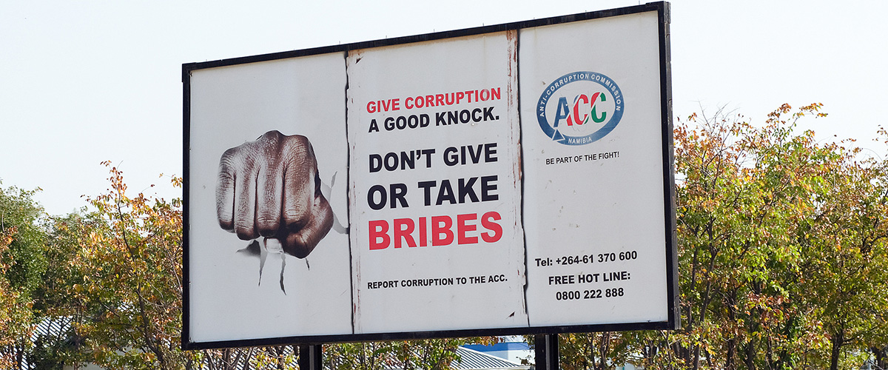

Anti-Corruption sign in Namibia. Photo: World Bank/Philip Schuler

**Background**

Corruption is a complex social, political and economic phenomenon that affects all countries. Corruption undermines democratic institutions, slows economic development and contributes to governmental instability.

Corruption attacks the foundation of democratic institutions by **distorting** (*give a misleading* *or false account*=διαστρεβλώνω) electoral processes, **perverting** (*twist/abuse/misuse/lead* *away from what is considered normal or acceptable*=διαστρέφω) the rule of law and creating bureaucratic **quagmires** (*hazardous situation)* whose only reason for existing is the soliciting of bribes. Economic development is **stunted** (*prevent from growing/developing*) because foreign direct investment is discouraged and small businesses within the country often find it impossible to overcome the "start-up costs" required because of corruption.

On 31 October 2003, the General Assembly adopted the United Nations Convention against Corruption and requested that the Secretary-General designate the United Nations Office on Drugs and Crime (UNODC) as secretariat for the Convention’s Conference of States Parties ([resolution 58/4](http://www.un.org/en/ga/search/view_doc.asp?symbol=A/RES/58/4)).

The Assembly also designated **9 December as International Anti-Corruption Day,** to raise awareness of corruption and of the role of the Convention in combating and preventing it.  The Convention entered into force in December 2005.

Governments, the private sector, non-governmental organizations, the media and citizens around the world are joining forces to fight this crime. The [United Nations Development Programme](http://www.undp.org/) (UNDP) and the [United Nations Office on Drugs and Crime](http://www.unodc.org/) (UNODC) are at the forefront of these efforts.

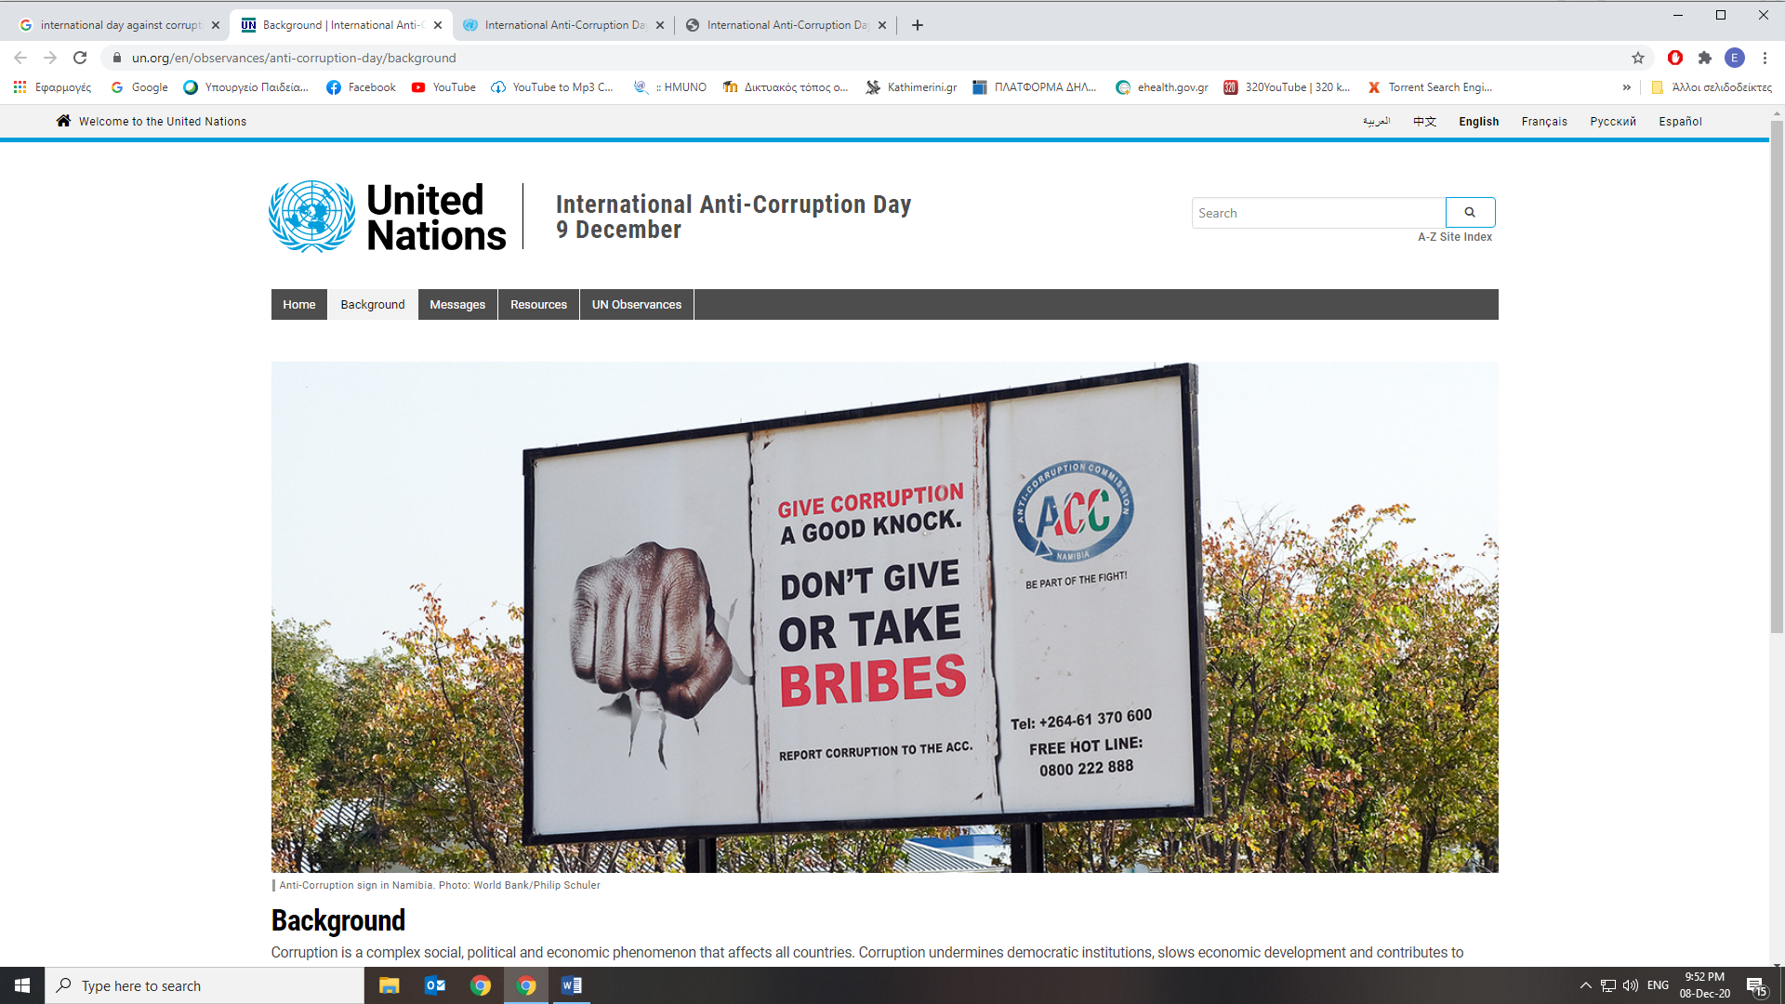

From:

<https://www.un.org/en/observances/anti-corruption-day/background>

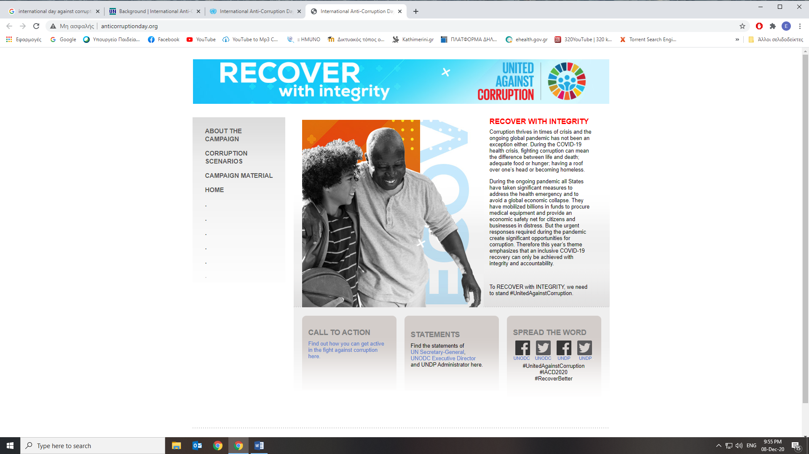

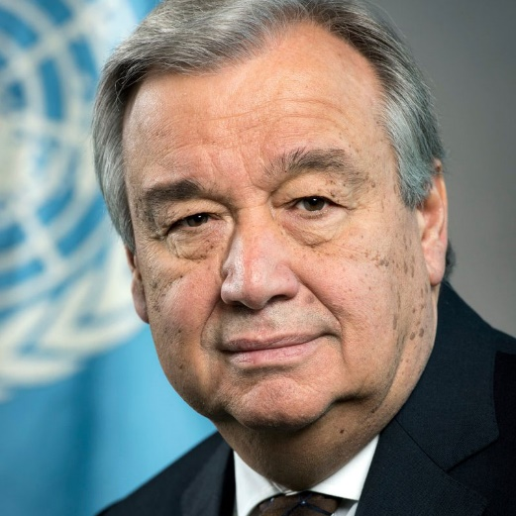

“Corruption is criminal, immoral and the ultimate betrayal of public trust. It is even more damaging in times of crisis – as the world is experiencing now with the COVID-19 pandemic. The response to the virus is creating new opportunities to exploit weak oversight and inadequate transparency, diverting funds away from people in their hour of greatest need.”

UN Secretary-General, António Guterres, [Statement on corruption in the context of COVID-19](https://www.un.org/en/coronavirus/statement-corruption-context-covid-19)

**Recover with integrity**

Corruption thrives in times of crisis and the ongoing global pandemic is no exception.

States all over the world have taken significant measures to address the health emergency and to avoid a global economic collapse. They **hastily** (*quickly*) mobilized billions in funds to **procure** (*obtain)* medical equipment and provide an economic safety net for citizens and businesses in distress. The urgent responses required, however, led some States to trade **compliance** (*obey/follow a wish/law*), oversight and accountability for achievement of rapid impact, thus creating significant opportunities for corruption.

“RECOVER with INTEGRITY” highlights that only by putting effective corruption **mitigation** (*reducing the severity*) measures in place will a better recovery be possible, while it also emphasizes that inclusive [COVID-19 recovery](https://www.un.org/en/coronavirus) can only be achieved with integrity.

[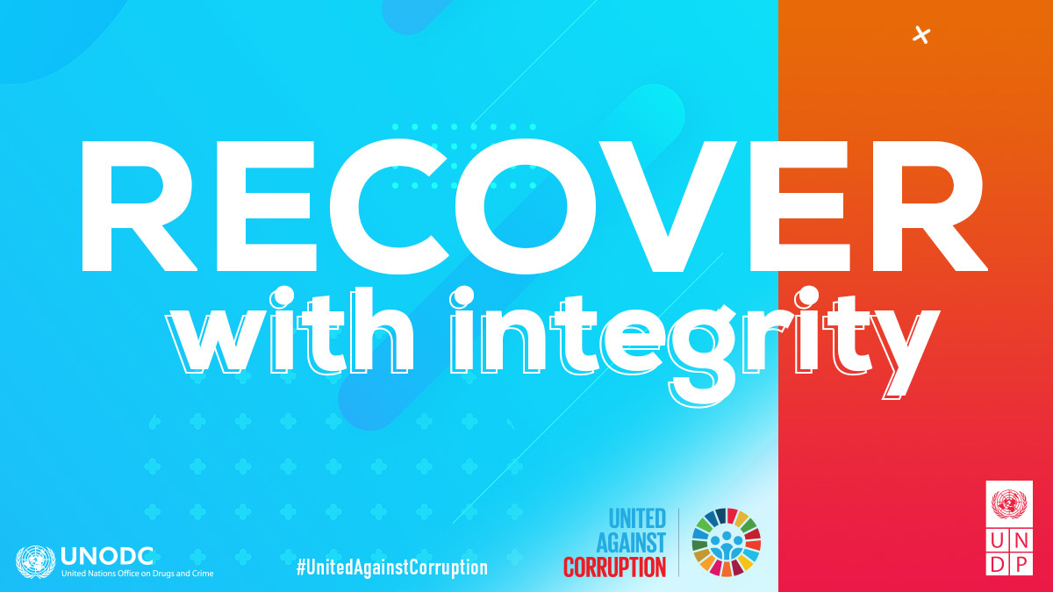](https://www.un.org/sites/un2.un.org/files/iacd2020-slogan_1200x656px-en.jpg)

Reducing the risks of mismanagement and corruption during the pandemic requires the involvement of strong anti-corruption bodies, better oversight over emergency support packages, more open and transparent public procurement and enhanced anti-corruption compliance by the private sector. In addition, countries also need to ensure support to and protection for whistleblowers and journalists uncovering corruption during the pandemic as well as bring their national anti-corruption frameworks in line with the [United Nations Convention Against Corruption](https://www.unodc.org/unodc/en/corruption/uncac.html) (UNCAC).

To RECOVER with INTEGRITY, we need to stand #UnitedAgainstCorruption.