**'Fahrenheit 451' Overview**

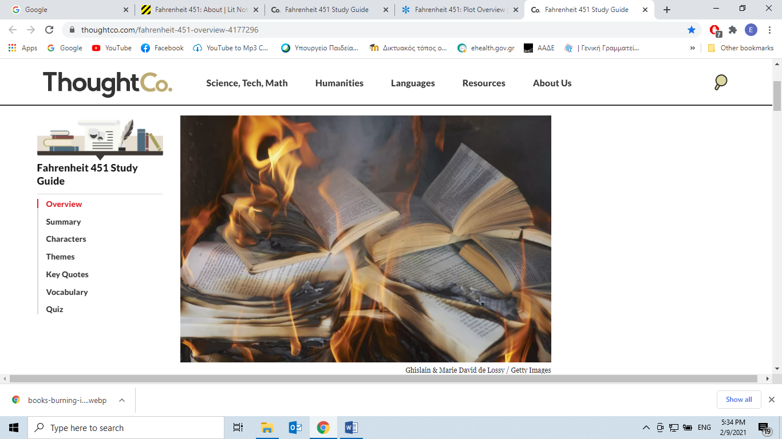

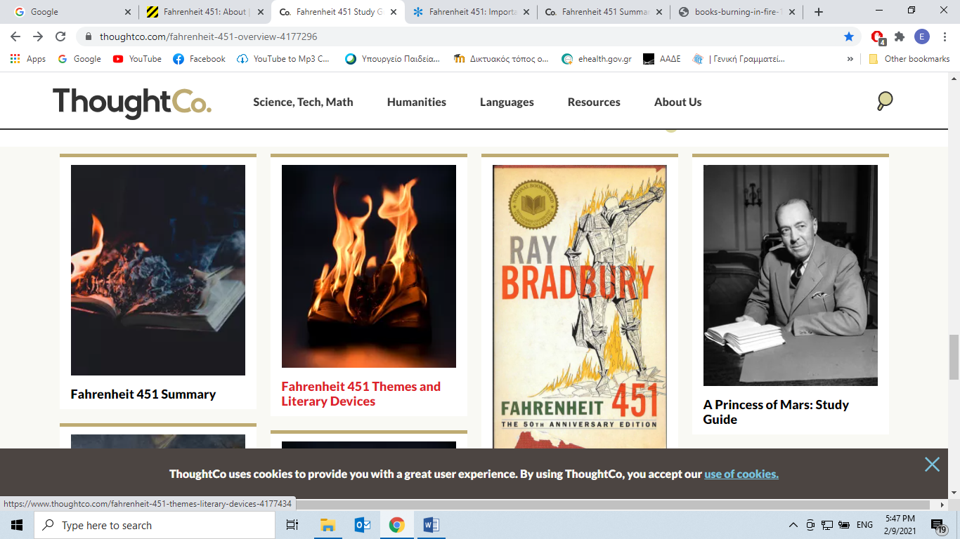

By

[Jeffrey Somers](https://www.thoughtco.com/jeffrey-somers-361693)

Updated January 04, 2019

*Fahrenheit 451*is a novel by Ray Bradbury. Published in 1953, the book takes place in a dystopian future world where the job of a firefighter is to burn books, rather than put out fires. The main character, Guy Montag, is one such fireman, who slowly begins to perceive the world around him as perverse and superficial even as it slides **inexorably** (*in a way that is impossible to stop or prevent*) towards a nuclear war. A commentary on the power of literacy and critical thought, *Fahrenheit 451* remains a **potent** (*powerful, strong, influential*) reminder of how quickly a society can fall apart.

**Fast Facts: Fahrenheit 451**

* **Author**: Ray Bradbury
* **Publisher**: Ballantine Books
* **Year Published**: 1953
* **Genre**: Science Fiction
* **Type of Work**: Novel
* **Original Language**: English
* **Themes**: Censorship, technology, conformity
* **Characters**: Guy Montag, Mildred Montag, Clarisse McClellan, Captain Beatty, Professor Faber, Granger
* **Notable Adaptations**: 1966 film by François Truffaut; 2018 HBO adaptation by Ramin Bahrani
* **Fun Fact**: Bradbury wrote *Fahrenheit 451* on rented typewriters at his local library, spending $9.80 to write the book.

Plot Summary

The protagonist, Guy Montag, is a fireman whose job is to burn hidden **caches** (*store, stock, supply*) of books, which are forbidden in this unspecified future society. At first, he goes about his job fairly mindlessly, but a conversation with a non-conforming teenager **spurs** (*urges, encourages*) him to question society. He develops a restless dissatisfaction that cannot be **quashed** (*suppress*).

Montag steals a Bible and smuggles it into his home. When he reveals the book (and the others he's stolen) to his wife Mildred, she panics at the thought of losing their income and thus the huge wall-sized televisions she watches constantly. Montag’s boss, Captain Beatty, gives him 24 hours to burn the book or face the consequences.

Montag eventually buries his book collection with help from Faber, a former professor. Soon, however, a call comes in for the Firemen to burn a new book cache—and the address is Montag’s house. Beatty insists that Montag do the burning; in response, Montag kills him and flees into the countryside. There, he meets a group of **drifters** (*wanderer, traveller*) who tell him of their mission to memorize books in order to eventually rebuild society. At the end of the book, there is a nuclear attack on the city, and Montag and the drifters head out to begin rebuilding.

Major Characters

**Guy Montag.** The protagonist of the story, Guy is a fireman who has been illegally **hoarding** (*collecting large amounts of sth*) and reading books. His blind faith in society **erodes** (*gradually destroy, wear away*) and opens his eyes to the decline of civilization. His efforts to resist conformity make him a criminal.

**Mildred Montag.**Guy’s wife. Mildred has retreated entirely into a fantasy world stoked television. Mildred is unable to comprehend Guy’s dissatisfaction and behaves in a childish, superficial manner throughout the story. Her behavior represents society at large.

**Clarisse McClellan.**A teenage girl who lives in Guy Montag’s neighborhood. She is curious and non-comformist, representing the nature of youth before the corrupting effects of society and materialism. She is the catalyst for Montag’s mental awakening.

**Captain Beatty.** Montag’s boss. Beatty is a former intellectual whose disappointment in books’ inability to truly solve problems has turned him into an anti-intellectual. Beatty tells Montag that books must be burned because they make people unhappy without offering real solutions.

**Professor Faber.**Once a professor of English, Faber is a **meek** (*quiet, gentle*), timid man who **deplores** (*condemn, abhor, despise, regret*) what society has become but lacks the bravery to do anything about it. Faber embodies Bradbury’s belief that knowledge without the willingness to use it is useless.

**Granger.** The leader of a group of drifters who have escaped society. Granger and the drifters preserve knowledge and wisdom by memorizing books. He explains to Montag that history is cyclical, and that a new age of wisdom will follow the current age of ignorance.

Major Themes

**Freedom of Thought vs. Censorship.** The novel is set in a society where the state forbids certain kinds of thought. Books contain the collected wisdom of humanity; denied access to them, people lack the mental skills to resist their government.

**The Dark Side of Technology.** Passive pastimes like watching TV are portrayed as harmful **purveyors** (*a person who sells sth*) of passive consumption. Technology in the book is consistently used to punish, oppress, and otherwise harm the characters.

**Obedience vs. Rebellion.** Humanity assists in its own oppression. As Captain Beatty explains, banning books didn’t require effort—people *chose* to ban books, because the knowledge in them made them think, which made them unhappy.

Literary Style

Bradbury uses rich language filled with metaphors, similes, and [figurative speech](https://www.thoughtco.com/fahrenheit-451-quotes-4175957) throughout the book. Even Montag, who has no formal education, thinks in terms of animal images and poetic, deeply beautiful symbols. Captain Beatty and Professor Faber frequently quote poets and great writers. Bradbury also uses animal imagery throughout to associate technology with dangerous predators.

About the Author

Born in 1920, Ray Bradbury was one of the most important writers of the 20th century, particularly in the science fiction genre. Bradbury framed technology and supernatural forces as dangerous and foreboding, which reflected the anxious, uneasy atmosphere of the newly atomic post-World War II world. Another piece by Bradbury, the [short story "There Will Come Soft Rains,"](https://www.thoughtco.com/analysis-there-will-come-soft-rains-2990477) is also reflective of this world.

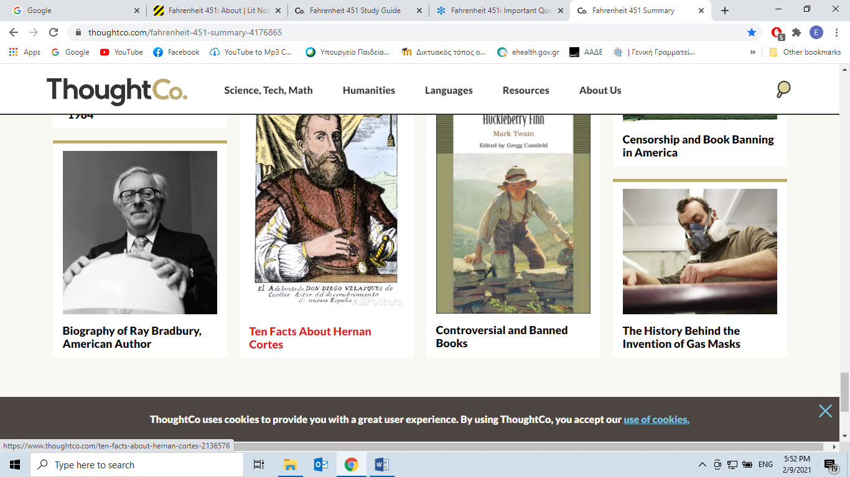

**Cite this Article**

Somers, Jeffrey. "'Fahrenheit 451' Overview." ThoughtCo, Aug. 28, 2020, thoughtco.com/fahrenheit-451-overview-4177296.

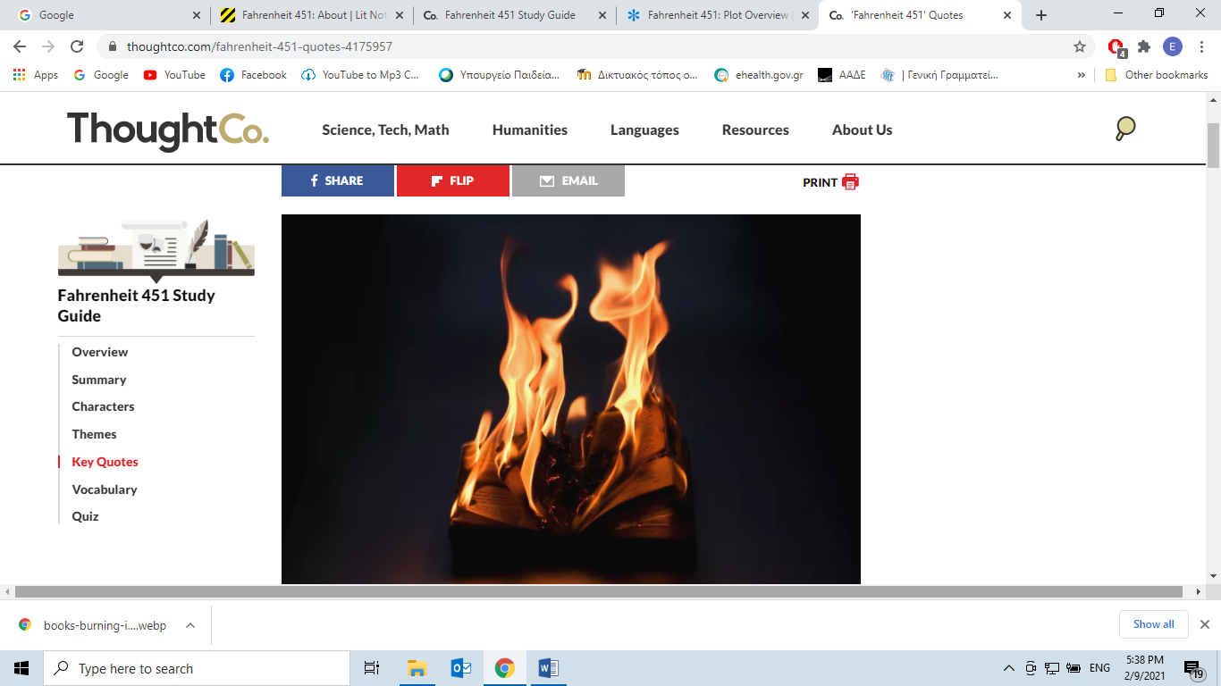 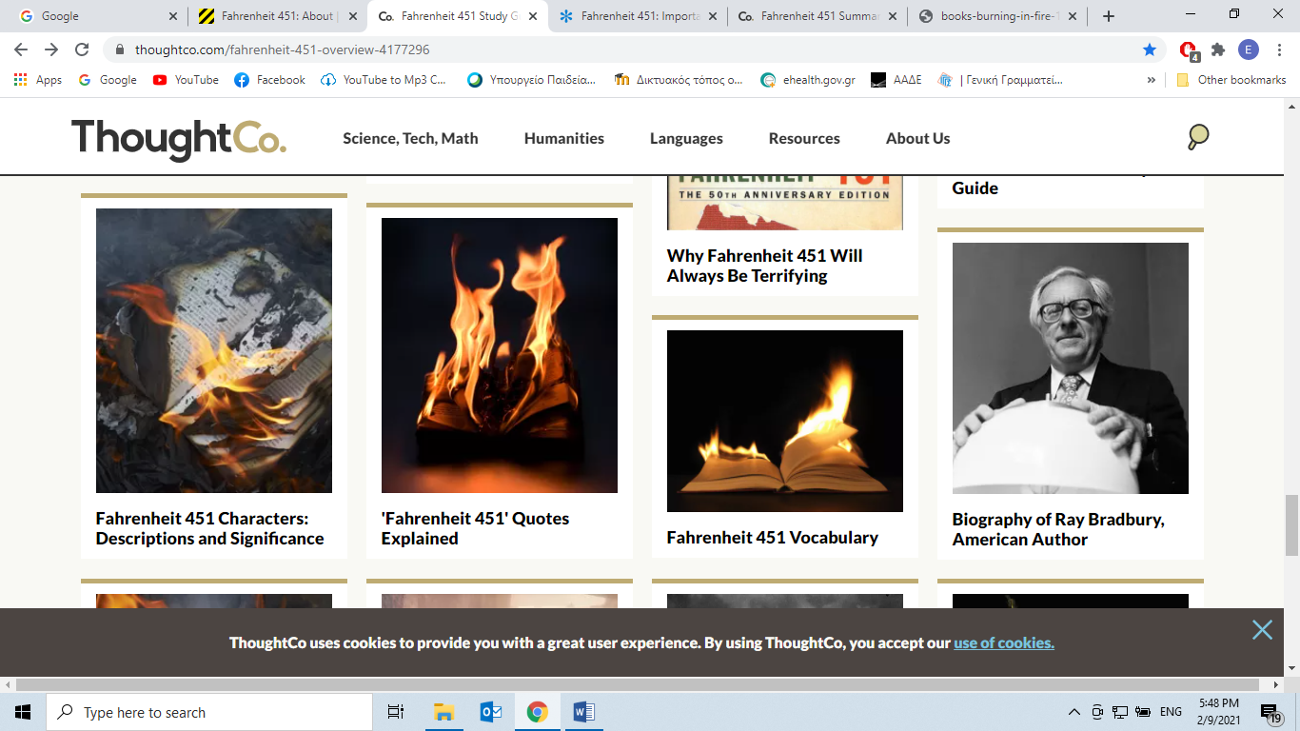

**Fahrenheit 451' Quotes Explained**

By

[Jeffrey Somers](https://www.thoughtco.com/jeffrey-somers-361693)

Updated August 30, 2019

When Ray Bradbury wrote *Fahrenheit 451* in 1953, television was gaining popularity for the first time, and Bradbury was concerned about its increasing influence in everyday people's lives. In *Fahrenheit 451*, the contrast between passive entertainment (television) and critical thought (books) is a central concern.

Many of the quotes in *Fahrenheit 451* emphasize Bradbury’s argument that passive entertainment is mind-numbing and even destructive, as well as his belief that worthwhile knowledge requires effort and patience. The following quotes represent some of the most significant ideas and arguments within the novel.

“It was a pleasure to burn. It was a special pleasure to see things eaten, to see things blackened and changed. With the brass nozzle in his fists, with this great python spitting its venomous kerosene upon the world, the blood pounded in his head, and his hands were the hands of some amazing conductor playing all the symphonies of blazing and burning to bring down the tatters and charcoal ruins of history.” (Part 1)

These are **the opening lines** of the novel. The passage describes Guy Montag's work as a Fireman, which in this dystopian world means that he burns books, rather than putting out fires. The quote contains details about Montag using his flamethrower to destroy a stock of illegal books, but the language the quote employs contains much more depth. These lines serve as a declaration of the central motif of the novel: the belief that humans prefer the easy, **gratifying** (*giving pleasure or satisfaction*) path over anything that requires effort.

Bradbury uses **lush** (*attractive, appealing*), sensual language to describe the act of destruction. Through the use of words like *pleasure* and *amazing*, burning books is depicted as fun and enjoyable. The act of burning is also described in terms of power, suggesting that Montag is reducing all of history to "tatters and charcoal" with his bare hands. Bradbury uses animal imagery ("the great python") to show that Montag is operating on a primitive and instinctive level: pleasure or pain, hunger or **satiation** (*satisfaction of appetite*).

“Coloured people don't like Little Black Sambo. Burn it. White people don't feel good about Uncle Tom's Cabin. Burn it. Someone's written a book on tobacco and cancer of the lungs? The cigarette people are weeping? Bum the book. Serenity, Montag. Peace, Montag. Take your fight outside. Better yet, into the incinerator.” (Part 1)

Captain Beatty makes this statement to Montag as a justification for book-burning. In the passage, Beatty argues that books cause trouble, and that by eliminating access to information, society will achieve serenity and peace.

**The statement underscores what Bradbury sees as the slippery slope leading to dystopia: intolerance of ideas that cause discomfort or unease.**

“I don't talk things. I talk the meaning of things. I sit here and know I'm alive.” (Part 2)

This statement, made by the character Faber, emphasizes the importance of critical thought. For Faber, considering the *meaning* of information—not just passively absorbing it—is what enables him to "know he's alive." Faber contrasts "*talking the meaning of things*" with simply "*talking things*," which in this passage refers to meaningless, superficial information-sharing or absorption devoid of any context or analysis. The loud, flashy, and virtually meaningless TV shows in the world of *Fahrenheit 451*, are a prime example of media that does nothing more than "talking things."

In this context, books themselves are merely objects, but they become powerful when readers use critical thought to explore the meaning of the information the books contain. Bradbury explicitly links the act of thinking and processing information with being alive. Consider this idea of aliveness in relation to Montag's wife Millie, who is constantly passively absorbing television and repeatedly attempts to end her own life.

“Books aren't people. You read and I look around, but there isn't anybody!” (Part 2)

Montag’s wife, Millie, rejects Montag’s efforts to force her to think. When Montag tries to read aloud to her, Millie reacts with increasing alarm and violence, at which point she makes the above statement.

Millie's statement **encapsulates** (*summarises*) what Bradbury sees as part of the problem of passive entertainment like television: it creates the illusion of community and activity. Millie feels that she is engaging with other people when she is watching television, but in fact she is simply sitting alone in her living room.

The quote is also an example of irony. Millie's complaint that books "aren't people" is supposed to contrast with the human contact she feels when watching television. In fact, however, books are the product of human minds expressing themselves, and when you read you are making a connection with that mind over time and space.

“Stuff your eyes with wonder. Live as if you'd drop dead in ten seconds. See the world. It's more fantastic than any dream made or paid for in factories. Ask for no guarantees, ask for no security, there never was such an animal.” (Part 3)

This statement is made by Granger, the leader of a group that memorizes books in order to pass the knowledge on to a future generation. Granger is speaking to Montag as they watch their city go up in flames. The first part of the statement implores the listener to see, experience, and learn about as much of the world as possible. He likens the mass-produced world of television to a factory of false fantasies, and argues that exploring the real world brings greater fulfillment and discovery than factory-made entertainment.

At the end of the passage, Granger **concedes** (*admit, agree*) that "there never was such an animal" as security—knowledge may very well bring discomfort and danger, but there is no other way to live.

**Cite this Article**

Somers, Jeffrey. "'Fahrenheit 451' Quotes Explained." ThoughtCo, Aug. 28, 2020, thoughtco.com/fahrenheit-451-quotes-4175957.