 

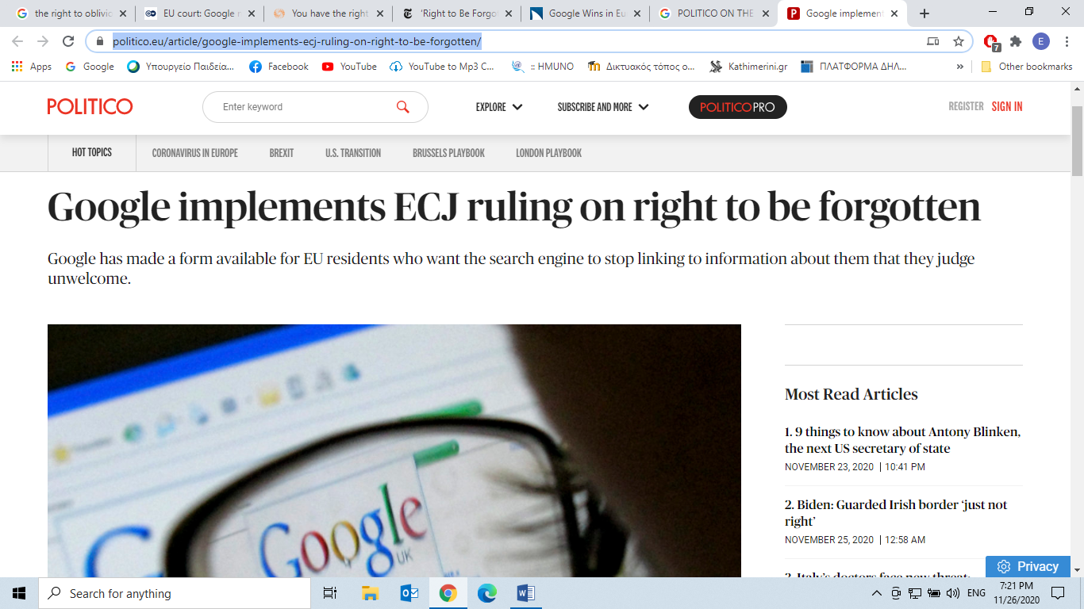

**Google implements** [**ECJ ruling**](https://europa.eu/european-union/about-eu/institutions-bodies/court-justice_en) **(European court of Justice) on right to be forgotten**

Google has made a form available for EU residents who want the search engine to stop linking to information about them that they judge unwelcome.

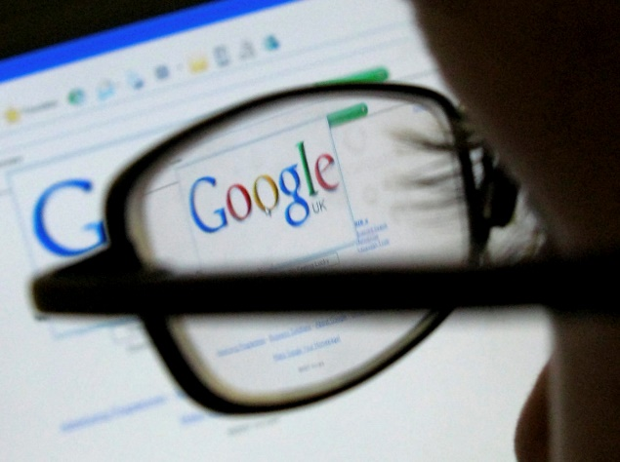

BY [NICHOLAS HIRST](https://www.politico.eu/author/nicholas-hirst/)

May 30, 2014 11:04 am

Individuals in the European Union can from today (30 May) ask Google to stop linking to information about them that they consider *to breach (break/violate)* their privacy, after the world’s largest search engine *implemented (come into force)* a ruling by the EU’s highest court from early May.

Google has published a form online allowing complainants to explain why they consider certain information to be “irrelevant, outdated, or otherwise inappropriate”. While the search engine says that it will assess each application individually, it has already warned that it will not remove links to information that it considers to be in the public interest, such as “financial scams, professional malpractice, criminal convictions” or the misconduct of government officials.

The form implements a [judgment](https://www.politico.eu/article/n-business3-nh/) handed down by the European Court of Justice on 13 May. The court ruled on a case brought by a Spanish citizen who complained that Google’s search engine linked his name to a 1998 announcement of an auction of his house to cover unpaid social security contributions.

The court, held that because Google “processed” data, it was subject to EU data protection rules. Data protection authorities or courts could consequently force Google to remove links to personal information, even if that material was legally published on the internet, the court ruled, agreeing with the European Commission and several national governments that intervened in the case.

A Google spokesperson said today: “The court’s ruling requires Google to make difficult judgments about an individual’s right to be forgotten and the public’s right to know. We’re creating an expert advisory committee to take a thorough look at these issues. We’ll also be working with data protection authorities and others as we implement this ruling.”

Taken from:

<https://www.politico.eu/article/google-implements-ecj-ruling-on-right-to-be-forgotten/>

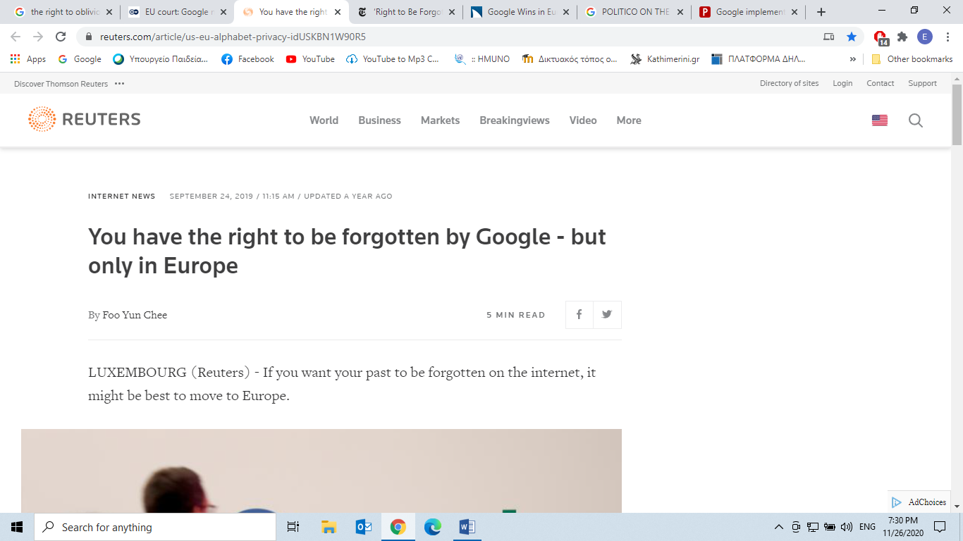

**You have the right to be forgotten by Google - but only in Europe**

By [Foo Yun Chee](https://www.reuters.com/journalists/foo-yun-chee)

5 MIN READ

LUXEMBOURG (Reuters) - If you want your past to be forgotten on the internet, it might be best to move to Europe.

Google [GOOGL.O](https://www.reuters.com/companies/GOOGL.O) will not have to apply Europe's "right to be forgotten" law globally, the continent's top court ruled on Tuesday in a landmark case that has *pitted (set against )* personal privacy rights against freedom of speech.

The victory for the U.S. tech titan means that, while it must remove links to sensitive personal data from its internet search results in Europe when required, it does not have to *scrap (delete)* them from searches elsewhere in the world.

The case has been viewed as a landmark test, in an age of an internet that knows no borders, of whether people can demand a blanket removal of information about themselves from searches without *stifling (prevent* *from happening/being expressed/restrain/suppress*) free speech and legitimate public interest.

It has also been seen by policymakers and companies around the world as a test of whether the European Union can extend its laws beyond its own territory. The ruling, which applies to all search engines, is rare positive news for big tech companies under intense official *scrutiny* (*close examination*) on both sides of the Atlantic over their dominant positions and gathering of vast amounts of data.

In its judgment, the Court of Justice of the European Union said the right to have personal data protected was not an absolute right.

“The balance between the right to privacy and the protection of personal data, on the one hand, and the freedom of information of internet users, on the other, is likely to vary significantly around the world,” it added.

Google welcomed the decision, saying: “It’s good to see that the court agreed with our arguments.”

The world’s predominant internet search engine has previously warned of the dangers of overreach (*do more than your authority* *allows/outwit/trick/cheat*) by Europe. In a blog post two years ago, it said there should be a balance between sensitive personal data and the public interest and no country should be able to impose rules on citizens of another.

The right to be forgotten was *enshrined (preserve so that it will be* *protected + respected/cherish as sacred*) by the same European court in 2014 when it ruled that people could ask search engines like Google to remove inadequate or irrelevant information from web results appearing under searches for their names.

Google, a unit of Alphabet Inc, says it has since received 845,501 requests to remove links, and removed 45 percent of the 3.3 million links it was asked to scrap.

Taken from:

[**https://www.reuters.com/article/us-eu-alphabet-privacy-idUSKBN1W90R5**](https://www.reuters.com/article/us-eu-alphabet-privacy-idUSKBN1W90R5)

**Answer the questions:**

1. Why this ruling of the European Court cannot apply to citizens globally?

________________________________________________________________________________________________________________________________________________________________________________________________________________________________________________________________________________________

2. Which cases are excluded from removal by Google?

________________________________________________________________________________________________________________________________________________________________________________________________________________________________________________________________________________________

3. In what sense to have private data protected, is not an absolute right?

________________________________________________________________________________________________________________________________________________________________________________________________________________________________________________________________________________________

4. Why does Google view this ruling as a victory?

________________________________________________________________________________________________________________________________________________________________________________________________________________________________________________________________________________________

**Now watch the relevant video:**

[**https://youtu.be/OnqyGkh7zIw**](https://youtu.be/OnqyGkh7zIw)