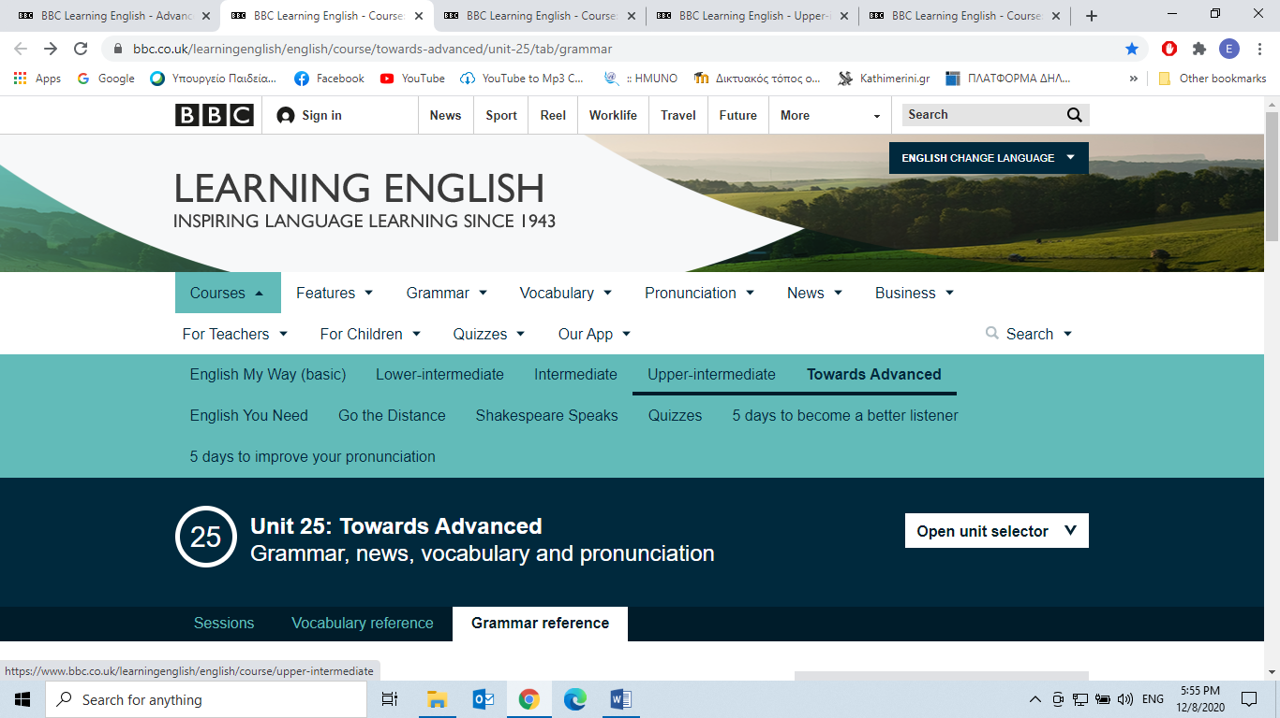

**From:**

**https://www.bbc.co.uk/learningenglish/english/course/towards-advanced/unit-25/tab/grammar**

**Grammar Reference**

**Session 1 - Masterclass**

**Inversion 1: After Negative or Limiting Adverbs**

Inversion happens in English for emphasis, dramatic purpose or formality. This type of inversion uses negative and limiting adverbs these are **a group of adverbs which limit the meaning of a verb or make it negative.** Examples are:  
never, hardly, no, rarely, seldom, little, barely, no sooner...than, in no way, under no circumstances, nowhere, not (+time), (only+ time). This is not a complete list.

To invert a sentence **move the adverbial to the beginning of the sentence and invert the subject and auxiliary verb:**

‘*I had never* met someone so interesting.’ becomes *‘Never had I*met someone so interesting.’  
'*He won't often* go to work.' becomes '*Not often will he* go to work'  
'*You should not* leave this room *for any reason*' becomes '*Under no circumstances should you* leave this room.'  
'*She hasn't seen* him *anywhere*.' becomes '*Nowhere* *has* *she* seen him'

Notice that **if the auxiliary verb is negative in the first sentence, it becomes affirmative in the inverted sentence and the 'not' moves to the front.**

In cases **where the tense does not use an auxiliary verb** in the affirmative, such as the present simple or the past simple, **one must be added**.

**Present Simple:***‘I rarely*go outside*.’*  becomes  *‘Rarely do I*go outside*.’  
'They don't ever*know what to do*'*becomes 'Never do they know what to do.'  
'*She* *almost never loses*' becomes '*Scarcely* *does* *she* lose.'

**Past Simple:**(Notice how the verb changes from past tense to infinitive)*‘She seldom worked*very hard*.’*becomes *‘Seldom did she*work very hard*.’  
'We never went*to the shopping centre.' becomes '*At no time did we*go to the shopping centre.'  
'*He didn't react at all*.' becomes '*In no way did he* react.'

**Some negative or limiting adverbials require you to complete a whole clause before the inversion takes place**.

*‘I didn’t know what to do until I saw what had happened.’*becomes *‘Not until I saw what had happened did I know what to do.’*

In this case, *‘Not until I saw what happened’* is the adverbial clause. **The inversion takes place after this, in the main clause**. This happens with 'Not +time' and 'Only + time'.

Not + until / before + clause  
Only + when / as / after / while / once + clause

Other examples are:  
  
'Only when they met again did he tell her'  
'Not before he admitted the truth did they let him go'  
'Not since Paris had they seen such a beautiful sunrise.'  
'Only now could he see how wonderful a car it was.'

**'Hardly' puts the inversion in the adverbial clause. It uses 'than' and 'when' to connect with the main clause.**

*‘Hardly had I got home*than the dog started barking.’ *'Hardly had he got into the bath*when the phone rang.’

**Little did they know** means **they didn't know.** The subject can be changed. Little can also be combined with nouns to show a lack of something, such as food or time.

*‘Little did they know*that he had stolen all of their money.’ (They didn't know he had stolen all of their money)  
*'Little did he know*that they would never meet again.' (He didn't know that they would never meet again.)  
*'Little time did they have* to explain.' (They didn't have time to explain)  
*'Little patience does she have*on a good day!' (She doesn't have any patience on a good day!)

* [**Practise Grammar**](https://www.bbc.co.uk/learningenglish/english/course/towards-advanced/unit-25)

**From:**

<https://www.bbc.co.uk/learningenglish/english/course/towards-advanced/unit-26/tab/grammar>

**Grammar Reference**

**Session 1 - Masterclass  
Inversion 2**

Inversion happens in English for emphasis, dramatic purpose or formality. In order to invert, the subject verb object order of a normal sentence is changed in some way.   
  
**1. Reduced Conditionals:**  
Conditionals are sentences in English which express the result or possible result of a real or imagined action. The usually start with if:

If you go to town, will you get me a cola? (1st conditional)  
If I were an animal, I would be a dog. (2nd conditional)  
If I had stayed longer, I would have learned a new language. (3rd conditional)  
In second and third conditionals we can **remove the if** and **invert the subject and auxiliary verb.** This is considered to be more formal and so more polite. In the case of the second conditional, if the verb is an action we use **were** and **the infinitive**.

**Were** **I** an animal, I would be a dog.  
**Were I to** **go**on holiday, I would go to Jamaica. (If I went on holiday...)  
**Had I** stayed longer, I would have learned a new language.

To invert a first conditional in this way, we need to use the word ‘should’. Should makes a first conditional more polite and more tentative. Then we remove the if and invert the subject and auxiliary verb as normal. So:

If you should go to town, will you get me a cola?  
**Should you** go to town, will you get me a cola?

**Negatives** in these forms **are not contracted**. So:  
  
**Should you not** go to town…  
**Were I not** a human…  
**Had I not** left so early…

**2. Adverbs of place or movement:**  
Adverbs of place or movement usually come after the verb in a clause.When an **adverb of place or movement** is put at the beginning of a clause, then **the whole verb phrase**, and **not just the auxiliary verb**, can be put before the subject. This is done for dramatic effect and is usually conveyed in a written style and even more so when introducing a new noun - such as in a story. So, for example:

The spy came through the window.   
Through the window **came** the spy (adverb of movement + **complete verb phrase** + subject)

300 men would stand in the pass.  
In the pass **would stand** 300 men. (adverb of place + **complete verb phrase** + subject)

This is common with shorter adverbs in speech, such as: here & there. If a pronoun is used instead of a noun, it must go before the verb.

There sat my father. There he sat.  
On ran the racers. On they ran.  
I opened the box and out jumped a puppy! I opened the box and out it jumped.

**3. Consequences of an adjective:**We can use **so** plus **an adjective**, then we **invert** the normal subject and auxiliary verb, and finally we use ‘**that**’ to emphasise how strongly something’s description affected us and what the consequence was. We can do the same thing with a noun using such.

So beautiful was she that I fell in love immediately (so + adjective + inversion + that + consequence)  
Such a beautiful woman was she that I fell in love immediately. (such + noun + inversion + that + consequence)

* [**Practise Grammar**](https://www.bbc.co.uk/learningenglish/english/course/towards-advanced/unit-26)

**From:**

<https://www.bbc.co.uk/learningenglish/english/course/upper-intermediate/unit-22/tab/grammar>

**Grammar Reference**

**Inversion**

We use adverbial inversion for drama, emphasis or formality.

Form: Move the adverb / adverbial phrase to the beginning of the sentence, and switch the subject and auxiliary:

Normal word order: **I had never seen such a wonder.**

Using inversion: **Never had I seen such a wonder.**

When we want to use inversion with sentences that have no auxiliary, we need to add it after the adverb and before the subject in the inverted sentence.

Normal word order: **I rarely smoke.** (no auxiliary)

Using inversion: **Rarely do I smoke.** (added **do** after adverb)

* [**Practise Grammar**](https://www.bbc.co.uk/learningenglish/english/course/upper-intermediate/unit-22)

From:

<https://www.perfect-english-grammar.com/inversion-exercise-1.html>

**Inversion Exercise 1**

**Change the normal sentence into one with inversion. For example: "We had hardly arrived when Julie burst into the house" becomes "Hardly had we arrived when Julie burst into the house".**

|  |  |
| --- | --- |
| 1) John had never been to such a fantastic restaurant.    [ . ] | Check Show |
| 2) I in no way want to be associated with this project.    [ . ] | Check Show |
| 3) They had no sooner eaten dinner than the ceiling crashed onto the dining table.    [ . ] | Check Show |
| 4) I had scarcely finished writing my essay when the examiner announced the end of the exam.    [ . ] | Check Show |
| 5) I seldom leave my house so early.    [ . ] | Check Show |
| 6) People rarely appreciate this musician's talent.    [ . ] | Check Show |
| 7) We would understand what had happened that night only later.    [ . ] | Check Show |
| 8) They had met such rude people nowhere before.    [ . ] | Check Show |
| 9) He understood little about the situation.    [ . ] | Check Show |
| 10) The children should on no account go on their own.    [ . ] | Check Show |

**From:**

**http://www.literarydevices.com/inversion/**

**Common Examples of Inversion**

We use inversion fairly frequently in everyday speech when wanting to place emphasis on a certain word. For example, if someone asked you how you felt and you were feeling particularly good, you might say, “Wonderful is the way I feel.” Here are some other examples of inversion a person might say:

* Shocked, I was.
* Tomorrow will come the decision.
* How amazing this is.

You can also often hear examples of inversion while watching sports and hearing the sportscasters talk about the athletes. For example:

* Fine swing he’s got, Woods.
* Looking a bit tired now, Federer.
* An excellent decision she made there.

The character Yoda in Star Wars often speaks in inversions, such as in the following quotes:

* “Powerful you have become, the dark side I sense in you.”
* “Patience you must have, my young padawan.”
* “Death is a natural part of life. Rejoice for those around you who transform into the Force. Mourn them do not. Miss them do not. Attachment leads to jealously. The shadow of greed, that is.”

♦

♦♦

**Significance of Inversion in Literature**

Just like in common speech, authors use inversion in their works to emphasize certain words. When the natural flow of language is manipulated, the reader takes more notice. It is also more common to find inversion in poetry than in [prose](http://www.literarydevices.com/prose/) because there the unnaturalness of inversion lends itself well to creating a poetic lilt. Poets might also choose to use inversion in order to create a [rhyme](http://www.literarydevices.com/rhyme/) or uphold a meter that would not work with the syntactically correct order of words.

**Examples of Inversion in Literature**

**Example #1**

Sometime too hot the eye of heaven shines,  
And often is his gold complexion dimmed,  
And every fair from fair sometime declines,  
By chance, or nature’s changing course untrimmed:

So long as men can breathe, or eyes can see,  
So long lives this, and this gives life to thee.

(“[Sonnet](http://www.literarydevices.com/sonnet/) 18” by Wiliam Shakespeare)

William Shakespeare used many examples of inversion in his plays and poetry, both anastrophe and anaclasis (an exchange of place of a short syllable with a preceding long one=. In this famous sonnet, Shakespeare changes around some of the word order to make lines more poetic and stylized. We see this in the first line of the excerpt, “Sometime too hot the eye of heaven shines.” In syntactically correct order, the line would read, “Sometimes the eye of heaven shines too hot.” By ending the line with “shines,” Shakespeare can create a rhyme with “declines.” The line also places the emphasis on the parallel between “too hot” and “shines.” There is also inversion in the final [couplet](http://www.literarydevices.com/couplet/) of the poem in the unusual phrasing, “So long lives this.” This creates a nice [repetition](http://www.literarydevices.com/repetition/) at the beginning of the two lines of the couplet with “so long” and [antimetabole](http://www.literarydevices.com/antimetabole/) (turning about=repeating a phrase in reverse order e.g. “Eat to live, not live to eat”) of “lives this” with “this gives life.”