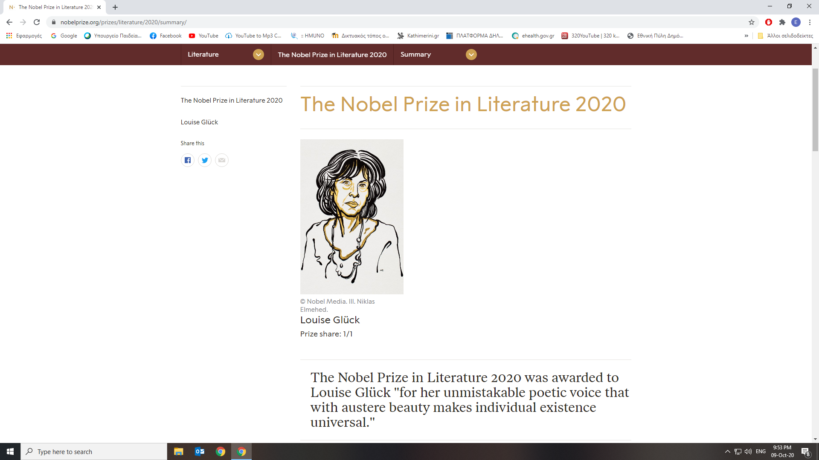

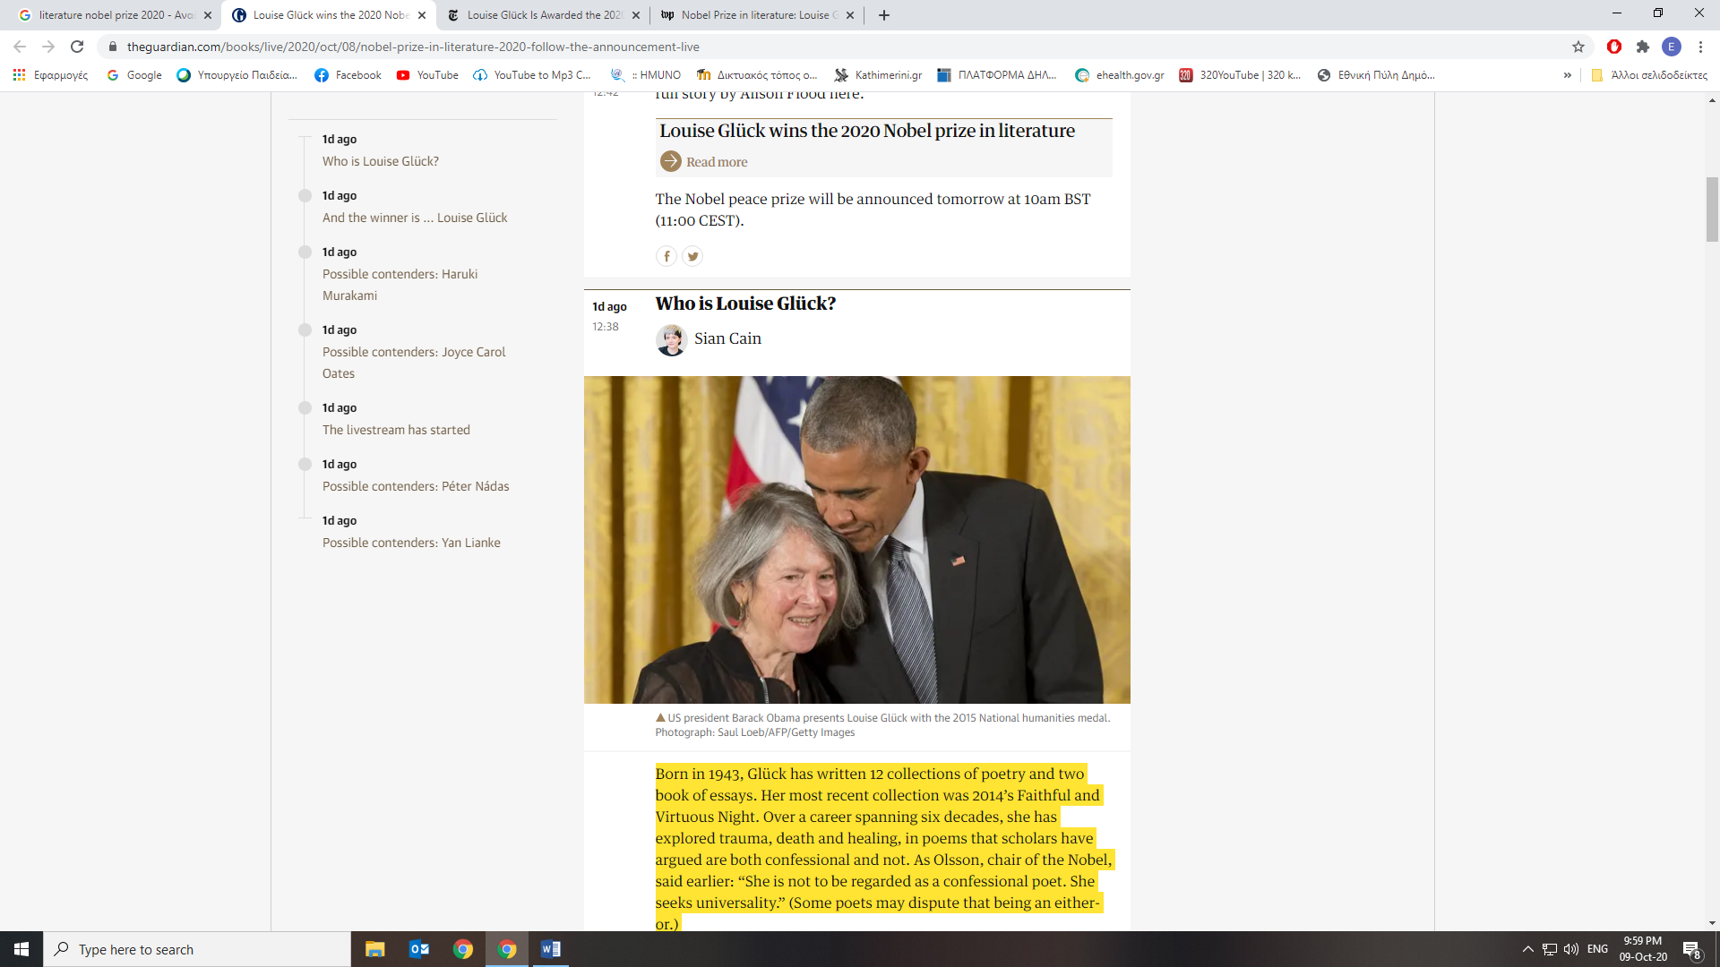

Born in 1943, Glück has written 12 collections of poetry and two book of essays. Her most recent collection was 2014’s Faithful and Virtuous Night. Over a career spanning six decades, she has explored trauma, death and healing, in poems that scholars have argued are both confessional and not. As Olsson, chair of the Nobel, said earlier: “She is not to be regarded as a confessional poet. She seeks universality.” (Some poets may dispute that being an either-or.)

Glück has written about developing anorexia as a teenager, which she later said was the result of her efforts to assert independence from her mother, as well as the death of her older sister, which happened before Glück was born. While in therapy, she elected to enrol in poetry workshops over a traditional college education and began to develop her voice. She published her first collection, Firstborn in 1968.

She won the Pulitzer prize for poetry in 1993 for her collection The Wild Iris. She was appointed the US poet laureate in 2003, and visited the White House to receive the National Humanities Medal from US president Barack Obama in 2016.

Taken from the Guardian

<https://www.theguardian.com/books/live/2020/oct/08/nobel-prize-in-literature-2020-follow-the-announcement-live>

**Louise Gluck Quotes**

[American](https://www.brainyquote.com/nationality/quotes-by-american-authors) - [Poet](https://www.brainyquote.com/profession/quotes-by-poets) Born: [April 22](https://www.brainyquote.com/birthdays/april_22), 1943

[It seems to me in the past it's been a good thing, as a writer, to have experiences I hadn't expected.](https://www.brainyquote.com/quotes/louise_gluck_665506)

[**Louise Gluck**](https://www.brainyquote.com/quotes/louise_gluck_665506)

[We have a disturbing cultural appetite for novelty, and it seems to me wrong each new laureate should dislodge the ideas of his or her predecessor, especially when they're still unfolding.](https://www.brainyquote.com/quotes/louise_gluck_665505)

[**Louise Gluck**](https://www.brainyquote.com/quotes/louise_gluck_665505)

[I don't live with earplugs. I don't like the spotlight - but I like overhearing conversations.](https://www.brainyquote.com/quotes/louise_gluck_665504)

[**Louise Gluck**](https://www.brainyquote.com/quotes/louise_gluck_665504)

[I have no concern with widening audience.](https://www.brainyquote.com/quotes/louise_gluck_665501)

[**Louise Gluck**](https://www.brainyquote.com/quotes/louise_gluck_665501)

[What I responded to, on the page, was the way a poem could liberate, by means of a word's setting, through subtleties of timing, of pacing, that word's full and surprising range of meaning. It seemed to me that simple language best suited this enterprise.](https://www.brainyquote.com/quotes/louise_gluck_665502)

[**Louise Gluck**](https://www.brainyquote.com/quotes/louise_gluck_665502)

[Toward his critics, the artist harbors a defensive ace: knowledge that the future will erase the present.](https://www.brainyquote.com/quotes/louise_gluck_665500)

**Taken from:**

<https://www.brainyquote.com/authors/louise-gluck-quotes>

From: <https://bookquoters.com/book/the-wild-iris>

“I don’t need your praise  
to survive. I was here first,  
before you were here, before  
you ever planted a garden.  
And I’ll be here when only the sun and moon  
are left, and the sea, and the wide field.  
  
I will constitute the field.”  
― Louise Glück, quote from The Wild Iris

“...whatever/ returns from oblivion/ returns to find a voice.”  
― Louise Glück, quote from The Wild Iris

“I watched the first shoots  
like wings tearing the soil, and it was my heart  
broken by the blight, the black spot so quickly  
multiplying in the rows. I doubt  
you have a heart, in our understanding of  
that term. You who do not discriminate  
between the dead and the living, who are, in consequence,  
immune to foreshadowing...”  
― Louise Glück, quote from The Wild Iris

“the powerful are always lied to since the weak are always driven to panic”  
― Louise Glück, quote from The Wild Iris

“End of Winter”  
  
Over the still world, a bird calls  
waking solitary among black boughs.  
  
You wanted to be born; I let you be born.  
When has my grief ever gotten  
in the way of your pleasure?  
  
Plunging ahead  
into the dark and light at the same time  
eager for sensation  
  
as though you were some new thing, wanting  
to express yourselves  
  
all brilliance, all vivacity  
never thinking  
this would cost you anything,  
never imagining the sound of my voice  
as anything but part of you—  
  
you won’t hear it in the other world,  
not clearly again,  
not in birdcall or human cry,  
  
not the clear sound, only  
persistent echoing  
in all sound that means good-bye, good-bye—  
  
the one continuous line  
that binds us to each other.”  
― Louise Glück, quote from The Wild Iris

“Remember that time you made the wish?  
  
I make a lot of wishes.  
  
The time I lied to you  
about the butterfly. I always wondered  
what you wished for.  
  
What do you think I wished for?  
  
I don't know. That I'd come back,  
that we'd somehow be together in the end.  
  
I wished for what I always wish for.  
I wished for another poem.”  
― Louise Glück, quote from The Wild Iris

**About the author**

**

***Louise Glück******Born place:****in New York City, The United States****Born date****April 22, 1943*

From:

<https://www.whatshouldireadnext.com/quotes/louise-gluck-tonight-i-saw-myself-in>

Other Quotes by "Louise Glück"

Tonight I saw myself in the dark window as the image of my father, whose life was spent like this, thinking of death, to the exclusion of other sensual matters, so in the end that life was easy to give up, since it contained nothing: even my mother's voice couldn't make him change or turn back as he believed that once you can't love another human being you have no place in the world.*—*[*Louise Glück*](https://www.whatshouldireadnext.com/quotes/authors/louise-gluck)

[Time passed, turning everything to ice. Under the ice, the future stirred. If you fell into it, you died. It was a time of waiting, of suspended action. I lived in the present, which was that part of the future you could see. The past floated above my head, like the sun and moon, visible but never reachable. It was a time governed by contradictions, as in I felt nothing and I was afraid.](https://www.whatshouldireadnext.com/quotes/louise-gluck-time-passed-turning-everything-to)*—*[*Louise Glück*](https://www.whatshouldireadnext.com/quotes/authors/louise-gluck)[*Averno*](https://www.whatshouldireadnext.com/isbn/0374107424)

[Watching you stare into space in the tidy rows of the vegetable garden, ostensibly working hard while actually doing the worst job possible, I think you are a small irritating purple thing and I would like to see you walk off the face of the earth because you are all that's wrong with my life and I need you and I claim you.](https://www.whatshouldireadnext.com/quotes/louise-gluck-watching-you-stare-into-space)*—*[*Louise Glück*](https://www.whatshouldireadnext.com/quotes/authors/louise-gluck)[*Meadowlands*](https://www.whatshouldireadnext.com/isbn/1862077622)

[Look at her, touching his cheek to make a truce, her fingers cool with spring rain; in thin grass, bursts of purple crocus— even here, even at the beginning of love, her hand leaving his face makes an image of departure and they think they are free to overlook this sadness.](https://www.whatshouldireadnext.com/quotes/louise-gluck-look-at-her-touching-his)*—*[*Louise Glück*](https://www.whatshouldireadnext.com/quotes/authors/louise-gluck)

[The books [poetry collections] may not sell, but neither are they given away or thrown away. They tend, more than other books, to fall apart in their owners’ hands. Not I suppose good news in a culture and economy built on obsolescence. But for a book to be loved this way and turned to this way for consolation and intense renewable excitement seems to me a marvel.](https://www.whatshouldireadnext.com/quotes/louise-gluck-the-books-poetry-collections-may)*—*[*Louise Glück*](https://www.whatshouldireadnext.com/quotes/authors/louise-gluck)

[Gretel in Darkness: This is the world we wanted. All who would have seen us dead are dead. I hear the witch's cry break in the moonlight through a sheet of sugar: God rewards. Her tongue shrivels into gas.... Now, far from women's arms And memory of women, in our father's hut we sleep, are never hungry. Why do I not forget? My father bars the door, bars harm from this house, and it is years. No one remembers. Even you, my brother, summer afternoons you look at me as though you meant to leave, as though it never happened. But I killed for you. I see armed firs, the spires of that gleaming kiln-- Nights I turn to you to hold me but you are not there. Am I alone? Spies hiss in the stillness, Hansel we are there still, and it is real, real, that black forest, and the fire in earnest.](https://www.whatshouldireadnext.com/quotes/louise-gluck-gretel-in-darkness-this-is)*—*[*Louise Glück*](https://www.whatshouldireadnext.com/quotes/authors/louise-gluck)