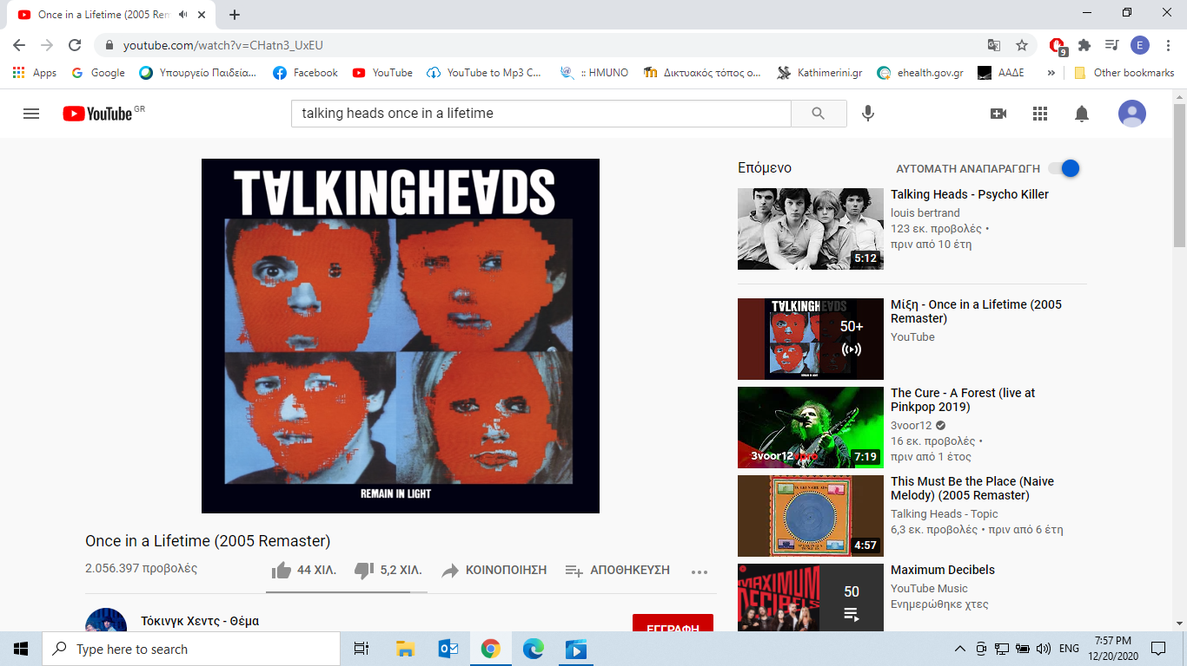

. We haven’t reaVerse 1]  
[And you may find yourself living in a shotgun shack  
And you may find yourself in another part of the world  
And you may find yourself behind the wheel of a large automobile  
And you may find yourself in a beautiful house, with a beautiful wife  
And you may ask yourself, "Well... how did I get here?"](https://genius.com/343245/Talking-heads-once-in-a-lifetime/And-you-may-find-yourself-living-in-a-shotgun-shack-and-you-may-find-yourself-in-another-part-of-the-world-and-you-may-find-yourself-behind-the-wheel-of-a-large-automobile-and-you-may-find-yourself-in-a-beautiful-house-with-a-beautiful-wife-and-you-may-ask-yourself-well-how-did-i-get-here)  
  
[Chorus]  
[Letting the days go by, let the water hold me down  
Letting the days go by, water flowing underground  
Into the blue again after the money's gone  
Once in a lifetime, water flowing underground](https://genius.com/343256/Talking-heads-once-in-a-lifetime/Letting-the-days-go-by-let-the-water-hold-me-down-letting-the-days-go-by-water-flowing-underground-into-the-blue-again-after-the-moneys-gone-once-in-a-lifetime-water-flowing-underground)  
  
[Verse 2]  
And you may ask yourself, "How do I work this?"  
[And you may ask yourself, "Where is that large automobile?"](https://genius.com/1174867/Talking-heads-once-in-a-lifetime/And-you-may-ask-yourself-where-is-that-large-automobile)  
[And you may tell yourself, "This is not my beautiful house"  
And you may tell yourself, "This is not my beautiful wife"](https://genius.com/343231/Talking-heads-once-in-a-lifetime/And-you-may-tell-yourself-this-is-not-my-beautiful-house-and-you-may-tell-yourself-this-is-not-my-beautiful-wife)  
  
[Chorus]  
[Letting the days go by, let the water hold me down  
Letting the days go by, water flowing underground  
Into the blue again after the money's gone  
Once in a lifetime, water flowing underground](https://genius.com/1174928/Talking-heads-once-in-a-lifetime/Letting-the-days-go-by-let-the-water-hold-me-down-letting-the-days-go-by-water-flowing-underground-into-the-blue-again-after-the-moneys-gone-once-in-a-lifetime-water-flowing-underground)

[Refrain]  
[Same as it ever was, same as it ever was  
Same as it ever was, same as it ever was  
Same as it ever was, same as it ever was  
Same as it ever was, same as it ever was](https://genius.com/1174794/Talking-heads-once-in-a-lifetime/Same-as-it-ever-was-same-as-it-ever-was-same-as-it-ever-was-same-as-it-ever-was-same-as-it-ever-was-same-as-it-ever-was-same-as-it-ever-was-same-as-it-ever-was)

[Verse 3]  
[Water dissolving and water removing](https://genius.com/8512641/Talking-heads-once-in-a-lifetime/Water-dissolving-and-water-removing)  
[There is water at the bottom of the ocean  
Under the water, carry the water  
Remove the water at the bottom of the ocean](https://genius.com/1174957/Talking-heads-once-in-a-lifetime/There-is-water-at-the-bottom-of-the-ocean-under-the-water-carry-the-water-remove-the-water-at-the-bottom-of-the-ocean)  
[Water dissolving and water removing](https://genius.com/8512641/Talking-heads-once-in-a-lifetime/Water-dissolving-and-water-removing)  
  
[Chorus]  
Letting the days go by, let the water hold me down  
Letting the days go by, water flowing underground  
Into the blue again, into the silent water  
Under the rocks and stones, there is water underground  
Letting the days go by, let the water hold me down  
Letting the days go by, water flowing underground  
[Into the blue again after the money's gone  
Once in a lifetime, water flowing underground](https://genius.com/1174945/Talking-heads-once-in-a-lifetime/Into-the-blue-again-after-the-moneys-gone-once-in-a-lifetime-water-flowing-underground)  
  
[Verse 4]  
[You may ask yourself, "What is that beautiful house?"  
You may ask yourself, "Where does that highway go to?"  
And you may ask yourself, "Am I right? Am I wrong?"  
And you may say to yourself, "My God! What have I done?"](https://genius.com/1174888/Talking-heads-once-in-a-lifetime/You-may-ask-yourself-what-is-that-beautiful-house-you-may-ask-yourself-where-does-that-highway-go-to-and-you-may-ask-yourself-am-i-right-am-i-wrong-and-you-may-say-to-yourself-my-god-what-have-i-done)  
  
[Chorus]  
[Letting the days go by, let the water hold me down  
Letting the days go by, water flowing underground  
Into the blue again, into the silent water  
Under the rocks and stones, there is water underground  
Letting the days go by, let the water hold me down  
Letting the days go by, water flowing underground  
Into the blue again after the money's gone  
Once in a lifetime, water flowing underground](https://genius.com/8635749/Talking-heads-once-in-a-lifetime/Letting-the-days-go-by-let-the-water-hold-me-down-letting-the-days-go-by-water-flowing-underground-into-the-blue-again-into-the-silent-water-under-the-rocks-and-stones-there-is-water-underground-letting-the-days-go-by-let-the-water-hold-me-down-letting-the-days-go-by-water-flowing-underground-into-the-blue-again-after-the-moneys-gone-once-in-a-lifetime-water-flowing-underground)

[Outro]  
[Same as it ever was, same as it ever was](https://genius.com/20670157/Talking-heads-once-in-a-lifetime/Same-as-it-ever-was-same-as-it-ever-was)  
Same as it ever was [and look where my hand was  
Time isn't holding up, time isn't after us](https://genius.com/2159387/Talking-heads-once-in-a-lifetime/And-look-where-my-hand-was-time-isnt-holding-up-time-isnt-after-us)  
Same as it ever was, same as it ever was  
Same as it ever was, same as it ever was  
Same as it ever was, same as it ever was  
Letting the days go by, same as it ever was  
[Here a twister comes, here comes the twister](https://genius.com/19259426/Talking-heads-once-in-a-lifetime/Here-a-twister-comes-here-comes-the-twister)  
Same as it ever was, same as it ever was (Letting the days go by)  
Same as it ever was, same as it ever was (Letting the days go by)  
Once in a lifetime, let the water hold me down  
[Letting the days go by](https://genius.com/8081466/Talking-heads-once-in-a-lifetime/Letting-the-days-go-by), water flowing underground

As the frontman of the group,David Byrne, said:

“*This song is about being unafraid of the passage of time*.”

**Taken from:**

https://genius.com/Talking-heads-once-in-a-lifetime-lyrics#about

https://genius.com/Talking-heads-once-in-a-lifetime-lyricshhttps://genius.com/Talking-heads-once-in-a-lifetime-lyricsttps://genius.com/Talking-heads-once-in-a-lifehttps://genius.com/Talking-heads-once-in-a-lifetime-lyricstime-lyricsAbout

3 Contributors

In this song, producer Brian