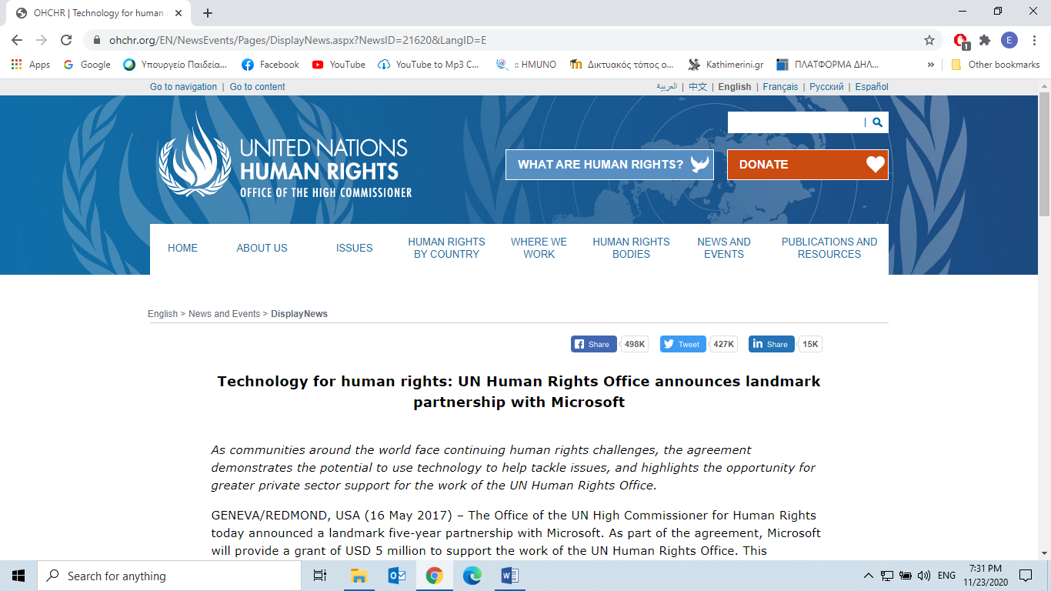

**Technology for human rights: UN Human Rights Office announces landmark partnership with Microsoft**

*As communities around the world face continuing human rights challenges, the agreement demonstrates the potential to use technology to help tackle issues, and highlights the opportunity for greater private sector support for the work of the UN Human Rights Office.*

GENEVA/REDMOND, USA (16 May 2017) – The Office of the UN High Commissioner for Human Rights today announced a landmark five-year partnership with Microsoft. As part of the agreement, Microsoft will provide a grant of USD 5 million to support the work of the UN Human Rights Office. This represents an unprecedented level of support from a private sector organization.

A particular area of focus for the partnership will be the development and use of advanced technology designed to better predict, analyze and respond to critical human rights situations, which currently appear not only to be proliferating in many parts of the world – including areas previously viewed as stable – but also growing in complexity.

The new partnership builds on a long-standing relationship between the UN Human Rights Office and Microsoft that is based on *two shared ideas*. The first is a commitment to ensuring technology plays a positive role in helping to promote and protect human rights. The second is *a recognition of the need for the private sector to play a bigger part in helping to advance the cause of human rights globally.*

“As a global company that sees the problems of the world, we believe that we have a responsibility to help to solve them,” said Brad Smith, President of Microsoft. “We have an *untapped* (not yet exploited or used) opportunity to use the power of technology to collect data, analyze that data, and equip the United Nations to advance human rights around the world.”

**Technology for Human Rights**

While in some cases technology may contribute to human rights challenges, it also has an important role to play in tackling abuses. The grant from Microsoft will help establish technology that has a positive impact, for example by developing and deploying new technology solutions specifically designed to advance the mission of the UN Human Rights Office and protect human rights.

One example is *Rights View* - an information ‘dashboard’ that will allow UN human rights staff to *aggregate* (form or group into) large quantities of internal and external data on specific countries and types of rights violations in real time. It will help to facilitate analysis, ensure early warning of emerging critical issues and provide data to guide responses. This tool, powered by cloud computing and big data analysis, is just one example of the potential for technology to be a force for good.

**Business and Human Rights**

Microsoft will also work with the UN Human Rights Office to raise awareness of the role that companies can and should play in driving respect for human rights and to promote more responsible business conduct across the world. Microsoft will work closely with the Office to help promote broader adoption and implementation of the United Nations Guiding Principles on Business and Human Rights. The UN Guiding Principles provide a global standard for preventing and addressing the risk of adverse (harmful, unfavourable) impacts on human rights linked to business activity.

Microsoft will also provide support for human rights advocacy and outreach campaigns through concrete support for the work of the UN Human Rights Office in key areas like freedom of expression, data protection and privacy, and inclusion. This includes direct support for the development and promotion of corporate principles for tackling LGBTI discrimination in the workplace in line with international human rights standards.

“This could be a truly ground-breaking agreement,” said UN High Commissioner for Human Rights Zeid Ra’ad Al Hussein. “We live in a rapidly evolving age, where technology can either be used to solve human rights problems or misused to erode human rights. Similarly, companies can *infringe* (violate, break, breach) people’s rights, or they can be a major progressive force.”

“The private sector has an essential role to play in advancing human rights, and this partnership with Microsoft demonstrates how we can join forces in a constructive way,” Zeid said. “I hope this is just the beginning of something much bigger: that it helps stimulate a broad movement by the private sector to stand up for human rights. Increased support from major companies in the technology sector and other fields can clearly make a critical difference.”

Now, answer the questions:

1. Microsoft and UN Human Rights Office share two ideas. Which are these? And why are these two ideas important?

________________________________________________________________________________________________________________________________________________________________________________________________________________________________________________________________

2. How can technology address Human Rights challenges?

________________________________________________________________________________________________________________________________________________________________________________________________________________________________________________________________

**Taken from:**

<https://www.ohchr.org/EN/NewsEvents/Pages/DisplayNews.aspx?NewsID=21620&LangID=E>

|  |
| --- |
| What are human rights?  UN Photo/John Isaac  Human rights are rights we have simply because we exist as human beings - they are not granted by any state. These universal rights are ***inherent (*existing as a permanent characteristic= έμφυτος)** to us all, regardless of nationality, sex, national or ethnic origin, color, religion, language, or any other status. They range from the most fundamental - the right to life - to those that make life worth living, such as the rights to food, education, work, health, and liberty.  The **Universal Declaration of Human Rights (UDHR),** adopted by the UN General Assembly in 1948, was the first legal document to set out the fundamental human rights to be universally protected. The UDHR, which [turned 70](https://www.ohchr.org/EN/NewsEvents/Pages/DisplayNews.aspx?NewsID=23856&LangID=E) in 2018, continues to be the foundation of all international human rights law. Its [30 articles](https://www.standup4humanrights.org/en/declaration.html) provide the principles and building blocks of current and future human rights conventions, treaties and other legal instruments.  The UDHR, together with the 2 covenants - the International *Covenant* (Agreement/ contract) for Civil and Political Rights, and the International Covenant for Economic, Social and Cultural Rights - make up the [International Bill of Rights](https://www.ohchr.org/Documents/Publications/FactSheet2Rev.1en.pdf).  Universal and *inalienable* (unable to be removed)  The principle of **universality** of human rights is the cornerstone of international human rights law. This means that we are all equally entitled to our human rights. This principle, as first emphasized in the UDHR, is repeated in many international human rights conventions, declarations, and resolutions.  Human rights are **inalienable**. They should not be taken away, except in specific situations and according to due process. For example, the right to liberty may be restricted if a person is found guilty of a crime by a court of law.  Indivisible and interdependent  UNICEF/ HQ04-0734/Jim HolmesAll human rights are **indivisible and interdependent**.  This means that one set of rights cannot be enjoyed fully without the other. For example, making progress in civil and political rights makes it easier to exercise economic, social and cultural rights. Similarly, violating economic, social and cultural rights can negatively affect many other rights.  Equal and non-discriminatory  UNICEF photo  Article 1 of the UDHR states: "All human beings are born free and equal in dignity and rights." Freedom from discrimination, set out in Article 2, is what ensures this equality.  Non-discrimination cuts across all international human rights law. This principle is present in all major human rights treaties. It also provides the central theme of 2 core instruments: the International Convention on the Elimination of All Forms of Racial Discrimination, and the Convention on the Elimination of All Forms of Discrimination against Women.  Both rights and obligations  All States have *ratified* (make an agreement official) at least 1 of the 9 [core human rights treaties](https://www.ohchr.org/EN/ProfessionalInterest/Pages/CoreInstruments.aspx), as well as 1 of the 9 optional protocols. 80% of States have ratified 4 or more. This means that States have obligations and duties under international law to respect, protect and fulfill human rights.   * The obligation to **respect**means that States must refrain from interfering with or curtailing the enjoyment of human rights. * The obligation to **protect**requires States to protect individuals and groups against human rights abuses. * The obligation to **fulfill** means that States must take positive action to facilitate the enjoyment of basic human rights.   Meanwhile, as individuals, while we are entitled to our human rights - but, we should also respect and [stand up](https://standup4humanrights.org/en/) for the human rights of others.  From:  https://www.ohchr.org/EN/Issues/Pages/WhatareHumanRights.aspx |
| Fill in the gaps with ONE word: |

Today, technology touches nearly every 1.__________ of our daily lives, affecting our activities 2. __________on and offline. In many ways, tech **empowers us to exercise our rights more 3.____________** by providing new opportunities to build connections and share ideas beyond our immediate community. The internet has expanded the possibilities for work, education, 4.___________to healthcare, and more. But these same technologies can unfortunately serve to infringe our rights. They can be used to surveil and silence marginalized communities at a scale that was never 5.___________possible.

That is why organizations like [**Access Now**](https://www.accessnow.org/) are fighting to ensure that as technology advances, human rights protections 6._____________along with it, and fundamental rights like privacy and 7.___________expression are maintained in digital spaces.

Taken from:

<https://www.accessnow.org/digital-rights-101-understanding-how-technology-affects-human-rights-for-all/>

Now, watch a relevant video:

<https://youtu.be/EmriAVi-ibk?t=31>