**THE AGE OF DISCOVERY / GREAT EXPLORERS**

[**https://geology.com/world/world-map.shtml**](https://geology.com/world/world-map.shtml)

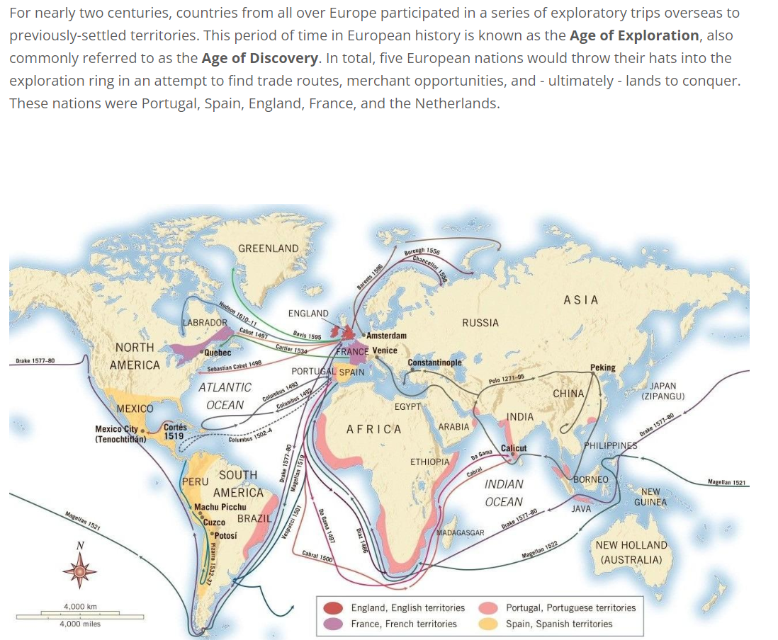

|  |  |  |  |
| --- | --- | --- | --- |
| **NAME** | **NATIONALITY** | **CENTURY** | **AREA** |
| Marco Polo | Italian | 13th/14th | China, Mongol Empire, India |
| João Côrte-Real | [Portuguese](https://en.wikipedia.org/wiki/Portuguese_people) | 15th | Azores, Newfoundland (Possible exploration of North America in 1473) |
| Christopher Columbus | Italian (Genoese) | 15th/16th | Bahamas, Caribbean, Central America, South America (Colombia and Venezuela) |
| Vasco da Gama | Portuguese | 15th/16th | sea route from Europe to India |
| Ferdinand Magellan | Portuguese | 15th/16th | 1st circumnavigation, Philippines, Strait of Malacca, Indian Ocean |
| Amerigo Vespucci | Italian | 15th/16th | Eastern South American coast, Caribbean |
| Hernán Cortés | Spanish | 16th | Mexico |
| Francisco de Orellana | Spanish | 16th | South America, Amazon River |
| James Cook | English | 18th | [Australasia](https://en.wikipedia.org/wiki/Australasia), [Oceania](https://en.wikipedia.org/wiki/Oceania) |
| [Francisco Pizarro](https://en.wikipedia.org/wiki/Francisco_Pizarro) | [Spanish](https://en.wikipedia.org/wiki/Spaniards) | 16th | [Hispaniola](https://en.wikipedia.org/wiki/Hispaniola), [Panama](https://en.wikipedia.org/wiki/Panama), [Peru](https://en.wikipedia.org/wiki/Peru) |