INDIRECT/REPORTED SPEECH

Χρησιμοποιώ πλάγιο λόγο για να μεταφέρω σε κάποιον τα λόγια που είπε ένα πρόσωπο σε ευθύ λόγο.

Kate: “I bought a new fridge last week.”

“I bought a new fridge last week.”, Kate said.

Kate said (that) she had bought a new fridge the previous week.

[Kate said to me…/Kate told me]

Στον πλάγιο λόγο αλλάζουν: οι αντωνυμίες, οι χρόνοι των ρημάτων, τα modal verbs και οι προσδιορισμοί τόπου και χρόνου.

**ΑΛΛΑΓΕΣ ΧΡΟΝΩΝ**

Γίνονται όταν το ρήμα εξάρτησης(say, tell, ask, mention, notice, promise, order)βρίσκεται σε παρελθοντικό χρόνο. Όταν το εισαγωγικό ρήμα βρίσκεται σε ενεστώτα οι ρηματικοί χρόνοι δεν αλλάζουν.

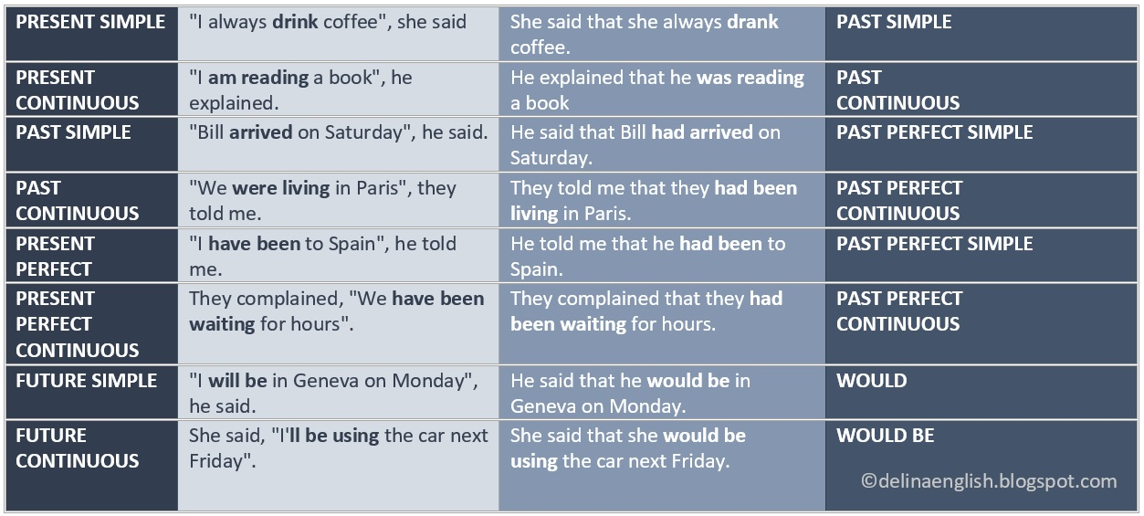

**ΑΛΛΑΓΕΣ ΣΕ ΕΚΦΡΑΣΕΙΣ ΧΡΟΝΟΥ ΚΑΙ ΤΟΠΟΥ**

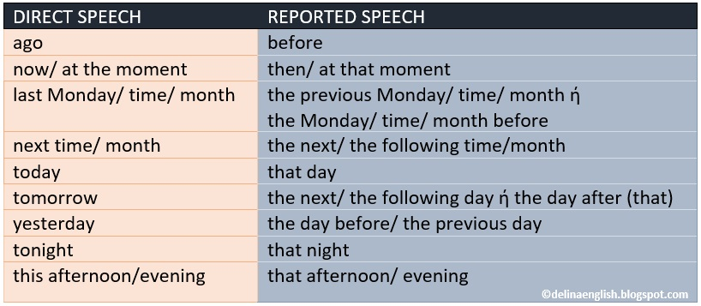

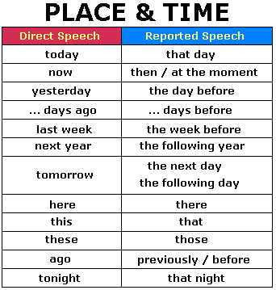

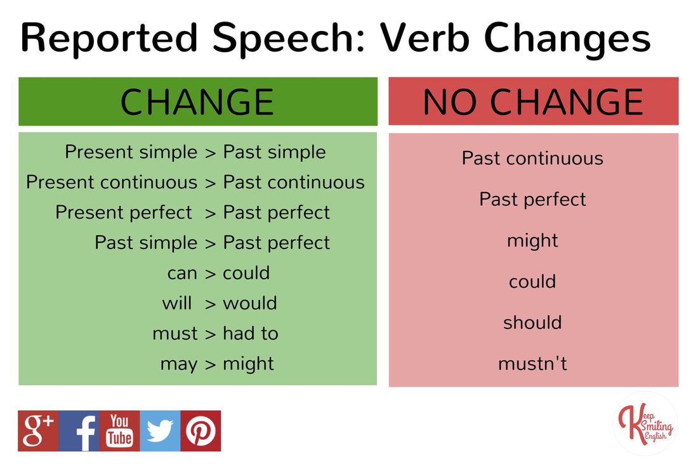

**ΑΛΛΑΓΕΣ ΣΕ MODAL VERBS**

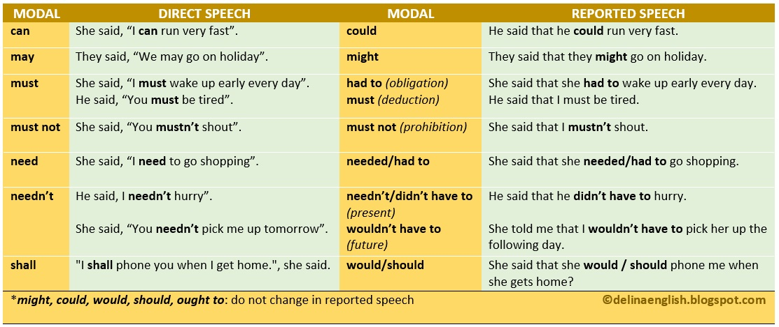

**INDIRECT REPORTED QUESTIONS**

Εισαγωγικά ρήματα:ask, wonder, want to know,etc

WH-QUESTIONS

Mark: “Where are you going tomorrow?”

Mark asked me where I was going the following day.

YES/NO QUESTIONS

Betty:” Have you seen my glasses?”

Betty asked me if/whether I had seen her glasses.

**REPORTING VERBS**

Agree/claim/demand/offer/promise/refuse+(not)to do

He offered to carry my suitcase.

Allow/advise/ask/beg/encourage/forbid/order/permit/remind/urge/

Want/warn

Mum warned me not to stay out late.

Accuse sb of/ admit to/apologize for/deny/boast about/complain about/thank sb for+(not) doing sth

She accused me of reading her mail.

Agree/admit/boast/claim/complain/deny/explain to sb/promise/remind sb/threaten

They all agreed that she was right.