ΘΕΜΑ 2β. ΛΕΞΙΚΟΓΡΑΜΜΑΤΙΚΗ
Part 1: Fill each gap in sentences 21-25 with the correct word from the box below (A-F). Use each word only once. There is one option you do not need.
A. | out | B. | up | C. | with | D. | on | E. | off | F. | down
- I'm really sorry, but I can't come tonight. We'll have to put _________our dinner plans for another time.
- When you're done _________ the game, just put it back on the shelf.
- My brother had to put me _________ for a few days when I was in London looking for a job.
- It took the firemen six hours to put _________ the fire.
- It’s cold outside, Anny! Don’t forget to put _________ your jacket.

Part 2: Fill each gap in sentences 26-30 with the correct word from the box below (G-L). Use each word only once. There is one option you do not need.
G. | carried | H. | got | I. | take | J. | throw | K. | runs | L. | buys

- The robbers _________ away in a stolen car, which the police found abandoned two hours later.
- Why did you _________away yesterday’s paper? I didn’t get a chance to read it!
- I’m afraid I got _________ away and spent too much money on clothes during my trip to Paris.
- There’s a new _________ away Chinese restaurant around the corner. We should try it one day.
- He’s really afraid of large dogs! Every time he sees one, he just _________ away!

ΘΕΜΑ 3. ΠΑΡΑΓΩΓΗ ΓΡΑΠΤΟΥ ΛΟΓΟΥ
Following a class discussion about addictions and their impact on people’s lives, your teacher has asked you to read the following text and write an article (120-150 words) for the English section of your school newspaper in order to
a) warn teenagers about the serious effects of this addiction, and
b) suggest ways to help addicted people deal with this problem.

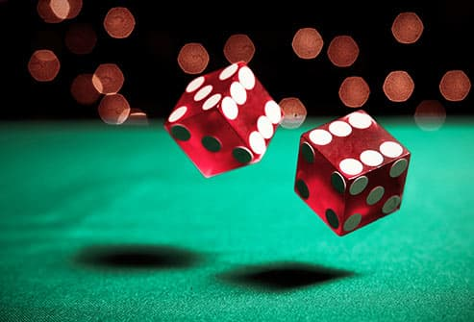
Gambling is when an individual risks something of value in the hope of getting something of even greater value. Gambling addiction is the uncontrollable urge to continue gambling despite the toll it takes on one’s life. It is addictive because it stimulates the brain’s reward system much like drugs or alcohol can. In fact, gambling addiction is the most common impulse control disorder worldwide.
There are many factors that can contribute to the development of a gambling addiction, including: desperation for money, the “high” that comes from the thrill of betting, and the intoxicating atmosphere of the gambling scene.

In the past, the psychiatric community generally regarded gambling as a compulsion rather than an addiction, i.e. a behavior primarily motivated by an intense urge rather than physical necessity. Similar to addictive substances, gambling addiction is associated with release of dopamine within the brain. Continuous use then causes the body to develop a tolerance, and the body needs more and more of the stimulating substance in order to receive the same rush.
Without a doubt, it’s an actual brain disease!

