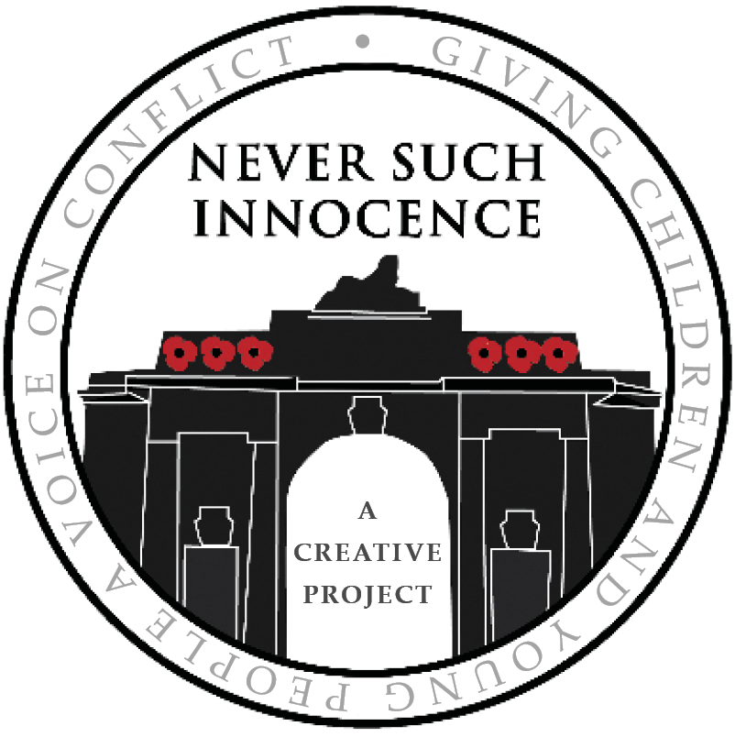

2024/25 Competition Rules

This year's question for reflection is ***How Can We Prevent Future Wars?***   
**Tell us what we can do as individuals, communities or nations. What can we learn from the past and what advice can we give to our leaders?**

Using poetry, art, speech and song, we would like you to answer this year’s question and have your voice heard.

**Entries are divided into the following four age categories*:**

Age 9-11; age 11-14; age 14-16; and age 16-18.

*The crossover of ages in these categories is to ensure children in the same school year have an equal opportunity. Categorisation is at the discretion of Never Such Innocence based on the information provided on the entry form.

Entries must draw on the competition question:***How Can We Prevent Future Wars?***

If you have any special educational needs you would like the judging panel to be aware of please make a note on your entry form.

All submissions are given a unique entry number to anonymise the judging process. We kindly request that only the title be written on the entry to ensure the submission may be identified and kept anonymous. All other details about the entrant should be confined to the entry form.

There is no entry fee.

Only one entry to each category per individual or group will be accepted; entrants may enter multiple categories (for example one poem and one piece of art may be entered by the same individual).

The judges’ decision is final and neither the judges nor Never Such Innocence staff will enter into any correspondence.

**The competition deadline is 28th February 2025**

Winners will be notified on, or before, 1st May 2025.

Entries from entrants aged 15 and under must be submitted by an adult (e.g. parent/guardian or teacher) on behalf of the entrant. The adult submitting the competition entry will be required to agree to the Never Such Innocence rules by way of a check-box on the online form or physical entry form.

The copyright of each entry remains with the author. However, by entering the competition, the author grants Never Such Innocence the right to publish and/or broadcast their work. All work entered into the competition may be broadcast with the entrant’s full name, age range, school and/or country.

The information you provide to Never Such Innocence is safe with us and we do not sell your data to third parties. Never Such Innocence will use and hold your data in accordance with the Privacy Policy which may be found [here](https://www.neversuchinnocence.com/privacy-policy).

* **Poems**  
  All poems must have a title and must not exceed 25 lines in length.
* Poems should consist of the contestant's own work and should not infringe any copyrights or any other rights of any third parties.
* Poetry written using AI will not be accepted.
* Poems may be written in any language.
* Poems should be either typed or legibly handwritten.
* If your poem is not in English, please include a written copy in your native language and a video or recording in your native language.

**Artwork**

* All artwork must have a title.
* We accept artwork in the form of sculptures and models; paintings and sketches; photography and digital mediums.
* Artwork should consist of the contestant's own work and should not infringe any copyrights or any other rights of any third parties.
* Artwork created using AI will not be accepted.
* Artwork may be produced in any medium such as water colours, pastels, charcoals, pencils, acrylic, crayons, paper cuttings, oil paints, photography or digital media.
* When submitting your entry, we ask that you share a high quality photograph or scan of your artwork; we may request to see the original works of art following the initial shortlisting.

**Song**

* Songs must be no longer than 4 minutes.
* Songs should consist of the contestant's own work and should not infringe any copyrights or any other rights of any third parties.
* Songs written using AI will not be accepted.
* Songs will be judged based on melody, composition, originality and lyrics (when applicable). The quality of production will not be considered.
* All writers will retain the rights to their original material - with the exception that a submission will grant a license in perpetuity to Never Such Innocence to exploit the song (meaning if you submit a song, we can play it…and if it makes any money, you will be paid accordingly)
* Songs may be written in any language.
* Songs should be either typed or legibly handwritten.
* Please include a recording (video or audio) of your song AND written lyrics.

**Speech**

* Speeches must be no longer than 5 minutes (maximum of 750 words).
* Speeches should consist of the contestant's own work and should not infringe any copyrights or any other rights of any third parties.
* Speeches written using AI will not be accepted.
* Speeches may be written in any language.
* Speeches should be either typed or legibly handwritten.
* Please include a recording (video or audio) of your speech AND written text.