**Tasks: I am Prepared to Die by Nelson Mandela**

Vis kompetansemål

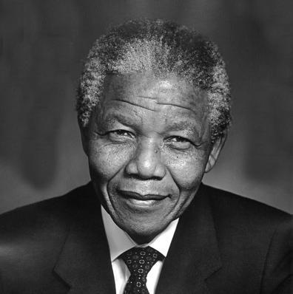

Nelson Mandela Bilde: unknown / [CC BY-NC-SA](https://creativecommons.org/licenses/by-nc-sa/4.0/deed.no)

**Understanding the speech:**

Work with a partner or in a group. Discuss the questions and write the answers in a shared document.

1. According to Mandela, what are the two main obstacles to economic advancement for Black South Africans?
2. Mandela discusses the lack of human dignity for Black people in South Africa. What examples are given in the speech?
3. Mandela states that "Poverty goes hand in hand with malnutrition and disease." What does he state are the secondary effects of poverty and the breakdown of family life?
4. Mention some of the rights that Mandela demands for Black South Africans.
5. Why would white people fear equal rights for all South African citizens?
6. Does Mandela believe that white supremacy would be replaced by black supremacy if Black South Africans were given the right to vote?
7. What does this speech tell you about what Mandela was like as a person?

**Analyse:**

Answer them as fully as possible.

1. What rhetorical devices are used in this speech? How do these devices contribute to conveying the message of the speech?

………………………………………………………………………………………………………………………………………………………………………………………………………………………………………………………………………

1. Originally, the final sentence in the speech was "This is an ideal for which I will die". Mandela's lawyers and supporters urged him to change it into "But if needs be, it is an ideal for which I am prepared to die." Why do you think they wanted him to change this, and what is the effect?

………………………………………………………………………………………………………………………………………………………………………………………………………………………………………………………………………

1. What do you think the impact of this speech was at the time it was delivered? Would it be received differently by Black South Africans than by white South Africans?

………………………………………………………………………………………………………………………………………………………………………………………………………………………………………………………………………

1. What is the message of the speech?

………………………………………………………………………………………………………………………………………………………………………………………………………………………………………………………………………

(https://ndla.no/subject:6e2e2319-cb8a-4dd2-b382-e30f001633bb/topic:94de9967-1492-479b-b0a8-6764a616b50d/topic:ccb4e84d-78e8-4a46-9f82-02650ff413a2/resource:1b04562c-ce4c-4502-b911-d3ef32beff64)