**Unit 6 - Leaders. Born or Made?**

1. What makes a good leader? Write down any **qualities** of good leaders that you can think of.

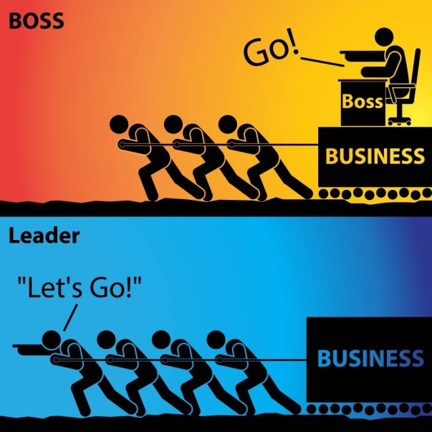

1. Think of examples of great leaders from the past or the present. Choose one you think is/was particularly gifted and say why.
2. Read the following descriptions. Can you guess the leaders’ names? Watch the video and check your answers.

<https://www.youtube.com/watch?v=1aHY8rfwfQQ>

1. A communist revolutionary and founder of the People’s Republic of China, who made it a world superpower.
2. Founding father and first president of the United States of America.
3. A Nobel Peace Prize winner, activist and revolutionary of the civil rights movement of Afro – Americans.
4. South African anti-aparheid revolutionary, political leader, and first democratically elected black President of South Africa.
5. Indian leader, famous for his non-violent resistance against the British rule in India.

**Reading – Biographies of two great leaders (p.83-84) - Glossary**

**Martin Luther King**

accomplish: (reach a goal) επιτυγχάνω

boycott: μποϊκοτάζ

civil rights movement: κίνημα για τα ατομικά δικαιώματα

combat: μάχη, μάχομαι (fight against)

discrimination: διάκριση

encompass: συμπεριλαμβάνω

federal law: ομοσπονδιακός νόμος

grassroots: (ordinary people) απλοί πολίτες

impact: αντίκτυπος, επίδραση (a powerful effect)

legislative: νομοθετικός

minister: ιερέας

posthumously: μετά θάνατον

Reconstruction era: εποχή της ανασυγκρότησης (1863-77: period in American history following the American Civil War, which focused mainly on civil rights)

riots: επεισόδια, ταραχές

secure: διασφαλίζω

segregation: διαχωρισμός

**Nelson Mandela**

amid: (in the middle of) εν μέσω

apartheid: political system in the past in South Africa in which people of different races are separated

coalition: συνασπισμός

colonial: αποικιακός

commission: επιτροπή

commit: δεσμεύομαι

constitution: σύνταγμα

dismantle: αποδομώ

foster: ενθαρρύνω

institutionalised: θεσμοθετημένος

legacy: κληρονομιά

negotiate: διαπραγματεύομαι

overthrow: ανατροπή

privilege: ευνοώ / πλεονέκτημα

promulgate: διακηρύσσω

reconciliation: συμφιλίωση

revolutionary: επαναστάτης

segregation: διαχωρισμός

tackle (a problem): αντιμετωπίζω (deal with)

**Vocabulary practice**

1. **Complete the table below.**

|  |  |  |
| --- | --- | --- |
| **Verb** | **Noun** | **Adjective** |
|  | leader |  |
|  | movement |  |
| secure |  |  |
|  |  | legislative |
|  | discrimination |  |
|  | recognition |  |
|  | (in)equality |  |
|  | opposition |  |
|  |  | revolutionary |
| elect |  |  |
|  | abuse |  |
|  | reconciliation |  |
| commit |  |  |

1. **Complete the following sentences with suitable words from the above table in the correct form.**
2. The professor is a ______________ expert in his field.
3. He made a ________________ to stay at the job for another year.
4. The national ______________ will take place on June 10th.
5. He ______________ his wife for many years before she went to the police.
6. The government has promised to introduce _______________ to limit fuel emissions from cars.
7. It took hours of negotiations to bring about a ________________ between the two sides.