Fast Fashion example

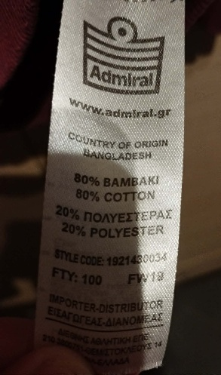
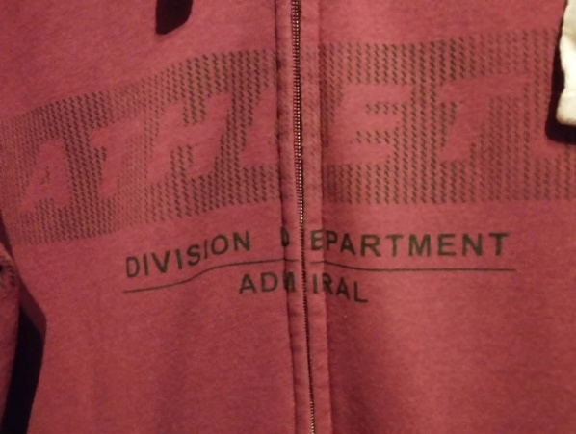
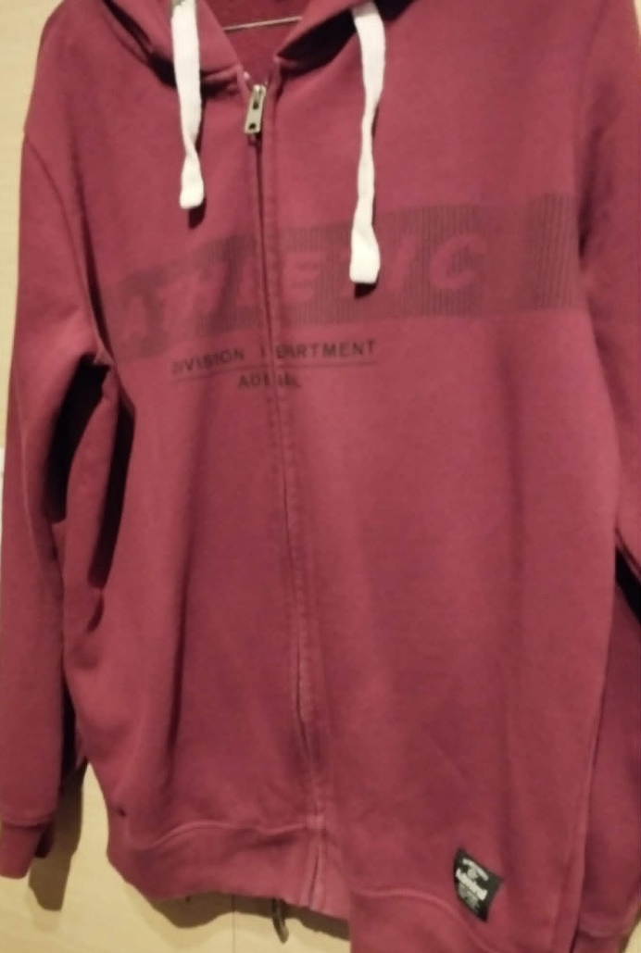
This shirt is made mostly of cotton which requires a lot of water and pesticides and it’s not friendly to the environment. The polyester also pollutes the clean water supply. It is dyed, and the dyes used are also harmful to the environment. It is made in Bangladesh, where there are no labor laws and workers are not paid well and work in dangerous conditions. Bangladesh also does not enforce environmental protection protocol to textile factories, making the pollution worse. The environmental and social cost of this garment is very high.
Red hoodie jacket with zipper, print and metal bands. 80% cotton and 20% polyester. Cost: 30 euros. Made in Bangladesh.

