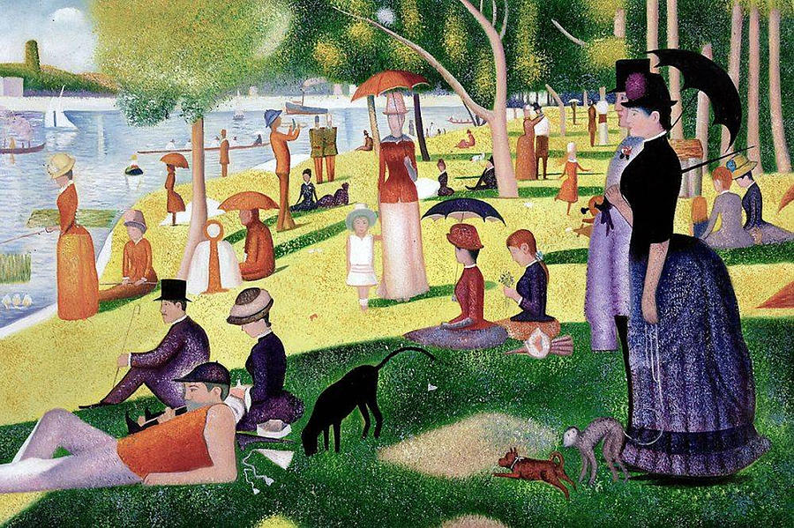
This painting belongs to the Impressionist school of painting. It is an example to the pointism technique. The painting is composed of dots of different colors that come together to create a picture. I find this painting fascinating because of this technique. I think it captures the day and atmosphere and creates a relaxing feeling.

Sunday Afternoon at the Grande Jatte by George Seurat 1886 Art Institute of Chicago
[Αναφέρετε εδώ την προέλευση.]


