UNIT 4 VINCENT VAN GOGH Student’s book p. 36 -37
1. | palette |  | παλέτα
2. | soul | spirit | ψυχή
3. | daffodil | 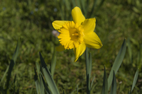 | νάρκισσος, ασφόδελος
4. | breeze (n) | a light and pleasant wind | ελαφρό αεράκι
5. | chill (n) | a feeling of cold | ψύχρα
6. | linen | strong cloth made from the fibres of the flax plant | λινό υφασμα
7. | sanity (n)  sane (adj)#insane | the state of having a healthy mind and not being mentally ill | πνευματική ψυχική υγεία
8. | to flame | - to burn (more) brightly  - if an emotion flames, you feel it suddenly and strongly | φλέγομαι, ανάβω
9. | to blaze | - to burn brightly and strongly  - to be brightly lit or full of colour | καίω. λάμπω, αστράφτω
10. | to swirl | to move quickly with a twisting, circular movement, or to make something do this | στριφογυρίζω  στροβιλιζομαι
11. | haze (n) | mist, foggy, dewy | ομίχλη, θολούρα, αχλύς
12. | hue (n) | (a degree of lightness, darkness, strength, etc. of) a colour, shade | απόχρωση
13. | amber | 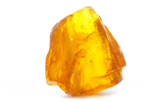  the yellowish-orange traffic light that shows between the green and the red to warn drivers that the lights are about to change. | κεχριμπάρι  χρυσοκίτρινο
14. | grain | 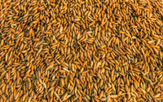  a seed or seeds from a plant especially a plant like a grass such as rice or wheat. | σιτηρά, δημητριακά
15. | weathered (adj.) | changed in colour or form over a period of time because of the effects of sun, wind, or other weather conditions | ταλαιπωρημένος σκαμμένος (μεταφορικά)
16. | to soothe | to make someone feel calm or less worried | καταπραύνω, ανακουφίζω, καθησυχάζω, παρηγορώ, ηρεμώ
17. | in sight | in someone’s view | που να είναι ορατό, να φαίνεται
18. | to be meant | to be intended | δεν ήταν για….(ελεύθερη μτφ.) δεν ήταν φτιαγμένος για
19. | hang-hung-hung |  | κρεμασμένος
20. | a frame  frameless (adj.) | a border that surrounds and supports a picture, door, or window  having no frame | κορνίζα, πλαίσιο  (χωρίς πλαίσιο, κορνίζα)
21. | ragged | untidy, dirty, and wearing old, torn clothes | κουρελιασμένος
22. | thorn |  | αγκάθι
23. | to crush | to press something very hard so that it is broken or its shape is destroyed | συνθλιβω, κάνω σκόνη
24. | virgin | pure and not spoiled, especially when describing something white | παρθένο

