**ΘΕΜΑ 1. ΚΑΤΑΝΟΗΣΗ ΓΡΑΠΤΟΥ ΛΟΓΟΥ**

**Read the text and choose the correct option (A, B or C) for items 1-10.**

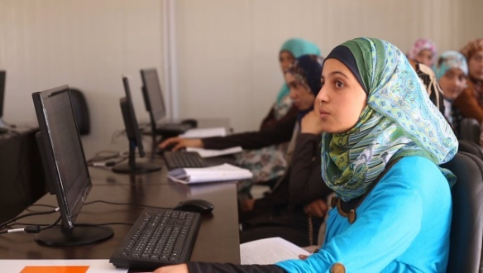Muzon, a passionate supporter ofSyrian girls’educationin Jordan’s refugee’s camps, has been regarded as Syria’s answer to Malala.When Muzon’s family escaped the war in Syria in 2013, they considered leaving her behind. The bright 14-year-old had been studying hard all year for her school exams and her aunt encouraged the family to let her stay and continue her education.

However, her father decided that the risks were too great and so the girl fled with him and her siblings across the border to Jordan’s Azraq refugee camp. “I knew she could make up for lost schooling, but if you lose your life there’s no way to make up for that” her father told me when I met the family in Jordan’s Azraq refugee camp.Education has always played a big part in Muzon’s life. Both of her parents were teachers back in Syria’s southern area of Dara’a, and her aunt and uncle were head teachers at local schools. “I didn’t need **them** to tell me that education is important. I always just felt it,” she explains. “Our house was built by an engineer. When I was sick I went to a doctor. Education is everything in life.”

Now 17, not only has she continued her studies in Jordan, but she has become a powerful and high-profile supporter for education among Syrian refugees, especially young women and girls. Her campaigning shares a number of similarities to that of Malala, Pakistan’s Nobel Prize-winning education campaigner, whom Muzon considers a personal friend. “She taught me that no matter what obstacles I face in life, they can be overcome.”The family’s main home in Izra was close to a military base. Unable to tolerate the fighting any longer, they made their way to Jordan and settled initially in Za’atari refugee camp.

(Words: 300)

|  |  |  |  |  |  |  |  |  |
| --- | --- | --- | --- | --- | --- | --- | --- | --- |
| **1.** The text talks about | | | | | | | | |
|  | **A.** | a young girl campaigning for female education. | **B.** | afamily’s everyday life in a refugee camp. | **C.** | | children in Pakistan who dropped out of school because of the war. | |
| **2.**A suitable title for the text could be | | | | | | | | |
|  | **A.** | Life in a refugee camp. | **B.** | Fighting for girl’s education. | **C.** | | Dropping out of school. | |
| **3.**Muzon’s father would never | | | | | | | | |
|  | **A.** | letMuzon livewith her aunt. | **B.** | risk leaving Muzon behind. | **C.** | | letMuzon continue school. | |
| **4.**Muzondid not | | | | | | | | |
|  | **A.** | pass her school exams. | **B.** | like taking school exams. | **C.** | | take her school exams. | |
| **5.**Muzon’s parents | | | | | | | | |
|  | **A.** | taught her the importance of education. | **B.** | were head teachers at local schools. | **C.** | | workedas educators in southern Syria. | |
| **6.**Muzon‘sparents | | | | | | | | |
|  | **A.** | built their house on their own. | **B.** | wanted her to study medicine. | **C.** | | wanted her to continue schooling. | |
| **7.**In the text, the underlined word “**them**” refers to | | | | | | | | |
|  | **A.** | Muzon’srelatives. | **B.** | Muzon’s headteachers. | | **C.** | | Muzon’sfriends. |
| **8.**Malala | | | | | | | | |
|  | **A.** | is a prize-winning author. | **B.** | lives in a camp inJordan. | | **C.** | | is an education campaigner. |
| **9.** Muzonbelieves that | | | | | | | | |
|  | **A.** | she can’t face life’s obstacles. | **B.** | obstacles in life do not matter. | | **C.** | | difficulties in life can be overcome. |
| **10.**The family decided to leave Syria because they | | | | | | | | |
|  | **A.** | wanted to find better jobs. | **B.** | couldn’t stand the attacks. | | **C.** | | wanted to live in Jordan. |

**ΘΕΜΑ 2α. ΛΕΞΙΚΟΓΡΑΜΜΑΤΙΚΗ**

**Match each underlined word in the sentences below (11-20) with a word from the box that has a similar meaning (A-J). Use each word only once.**

|  |  |  |  |  |  |  |  |  |  |
| --- | --- | --- | --- | --- | --- | --- | --- | --- | --- |
| **A.** | obstacles | **B.** | unable | **C.** | education | **D.** | campaigning | **E.** | important |
| **F.** | initially | **G.** | support | **H.** | powerful | **I.** | encourage | **J.** | tolerate |

|  |  |
| --- | --- |
|  | The town council agreed that it is of great significance to **help** local businesses by buying their products and contributing to the financial advancement of the region. |
|  | Instead of **fighting** against overtourism, local communities should think of ways to promote eco-tourism. |
|  | Zoe’s teaching methods were **originally** disapproved of by the school board, but they proved to be really successful when they were applied in a real classroom. |
|  | Despite their many disadvantages, social media have nevertheless made interaction immediate; this is why many people consider them a very **effective** method of communication. |
|  | We strongly**advise**our students to attend afternoon classes or take up hobbies that foster group work and interaction among all participants. |
|  | So many people are forced to leave their homes to escape war every day and the national community seems **powerless** to protect them. |
|  | I will not **accept**that sort of behaviour in my class! You should all treat your classmates and teachers with respect. |
|  | According to the Ministry of Education there has been a(n) **significant** increase in the number of female refugee girls attending school during the last decade. |
|  | Throughout my **schooling** I used to feel that homework was just a necessary evil. It took me a number of years to realise that homework actually helps children to develop a sense of self-discipline since they practise working alone without asking for help from their classmates and teachers. |
|  | Despite the many **difficulties** she had to face as a working mother, not only did she manage to prepare for the university entrance exams but also made it to the top. |