**VENUS AND CENTAUR (1485)**

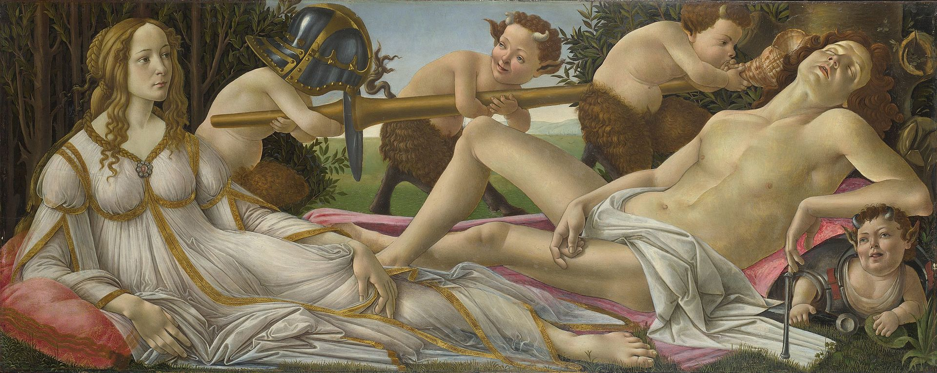

**DESCRIPTION AND SUBJECT OF “VENUS AND MARS”:**   


Venus watches Mars sleep while two infant satyrs play,[[9]](https://en.wikipedia.org/wiki/Venus_and_Mars_(Botticelli)" \l "cite_note-9) carrying his helmet (a [sallet](https://en.wikipedia.org/wiki/Sallet" \o "Sallet)) and [lance](https://en.wikipedia.org/wiki/Lance) as another rests inside his breastplate under his arm. A fourth blows a small [conch](https://en.wikipedia.org/wiki/Conch) shell in his ear in an effort, so far unsuccessful, to wake him. The clear implication is that the couple have been making love, and the male habit of falling asleep after sex was a regular subject for ribald jokes in the context of weddings in Renaissance Italy.[[10]](https://en.wikipedia.org/wiki/Venus_and_Mars_(Botticelli)#cite_note-10) The lance and conch can be read as sexual symbols.[[11]](https://en.wikipedia.org/wiki/Venus_and_Mars_(Botticelli)#cite_note-11)

The scene is set in a grove of [myrtle](https://en.wikipedia.org/wiki/Myrtaceae), traditionally associated with Venus and marriage, or possibly [laurel](https://en.wikipedia.org/wiki/Lauraceae), associated with [Lorenzo de' Medici](https://en.wikipedia.org/wiki/Lorenzo_de%27_Medici) (*il Magnifico*), or perhaps both plants.[[12]](https://en.wikipedia.org/wiki/Venus_and_Mars_(Botticelli)#cite_note-12) There is a limited view of the meadow beyond, leading to a distant walled city.[[3]](https://en.wikipedia.org/wiki/Venus_and_Mars_(Botticelli)#cite_note-Lightbown,_164-3)

In the foreground, a swarm of wasps hovers around Mars' head, possibly as a symbol that love is often accompanied by pain.[[13]](https://en.wikipedia.org/wiki/Venus_and_Mars_(Botticelli)#cite_note-P36-13) Another explanation, first suggested by [Ernst Gombrich](https://en.wikipedia.org/wiki/Ernst_Gombrich),[[14]](https://en.wikipedia.org/wiki/Venus_and_Mars_(Botticelli)" \l "cite_note-14) is that the wasps represent the Vespucci family that may have commissioned the painting.[[15]](https://en.wikipedia.org/wiki/Venus_and_Mars_(Botticelli)#cite_note-15) They had been neighbours of Botticelli since his childhood, and had commissioned his [*Saint Augustine in His Study*](https://en.wikipedia.org/wiki/Saint_Augustine_in_His_Study_(Botticelli,_Ognissanti)) for the Ognissanti church in 1480, probably in addition to other commissions. Their coat of arms included wasps, as their name means "little wasps" in Italian,[[16]](https://en.wikipedia.org/wiki/Venus_and_Mars_(Botticelli)#cite_note-16) and the wasps' nest, in a hollow in the tree in the top right corner, is exactly in the place in the panel where the [coat of arms](https://en.wikipedia.org/wiki/Coat_of_arms) of a patron was often painted.[[17]](https://en.wikipedia.org/wiki/Venus_and_Mars_(Botticelli)#cite_note-17)

The painting is thought originally to have been set into panelling as a *[spalliera](https://en.wikipedia.org/wiki/Spalliera" \o "Spalliera)*, or part of furniture such as a bed, the back of a *lettuccio*, a wooden sofa, or a similar piece.[[18]](https://en.wikipedia.org/wiki/Venus_and_Mars_(Botticelli)#cite_note-18)

Ronald Lightbown describes Mars as "Botticelli's most perfect male nude", though there are not really a large number of these; he was less interested in perfecting the anatomy of his figures than many of his Florentine contemporaries, but seems to have paid special attention to it here.[[19]](https://en.wikipedia.org/wiki/Venus_and_Mars_(Botticelli)#cite_note-19) The Venus here, unlike in the artist's *Birth of Venus*, is fully clothed, as she is in marital mode. This despite Venus being the wife of [Vulcan](https://en.wikipedia.org/wiki/Vulcan_(mythology)), making the relationship adulterous by normal human standards.[[20]](https://en.wikipedia.org/wiki/Venus_and_Mars_(Botticelli)" \l "cite_note-20) In Greek [Neoplatonism](https://en.wikipedia.org/wiki/Neoplatonism" \o "Neoplatonism), Harmony was the daughter of their union.[[21]](https://en.wikipedia.org/wiki/Venus_and_Mars_(Botticelli)#cite_note-21) Other late classical sources regarded [Cupid](https://en.wikipedia.org/wiki/Cupid) as a child of the union.

**THE CALUMNY OF APELLES (1494-1495)**

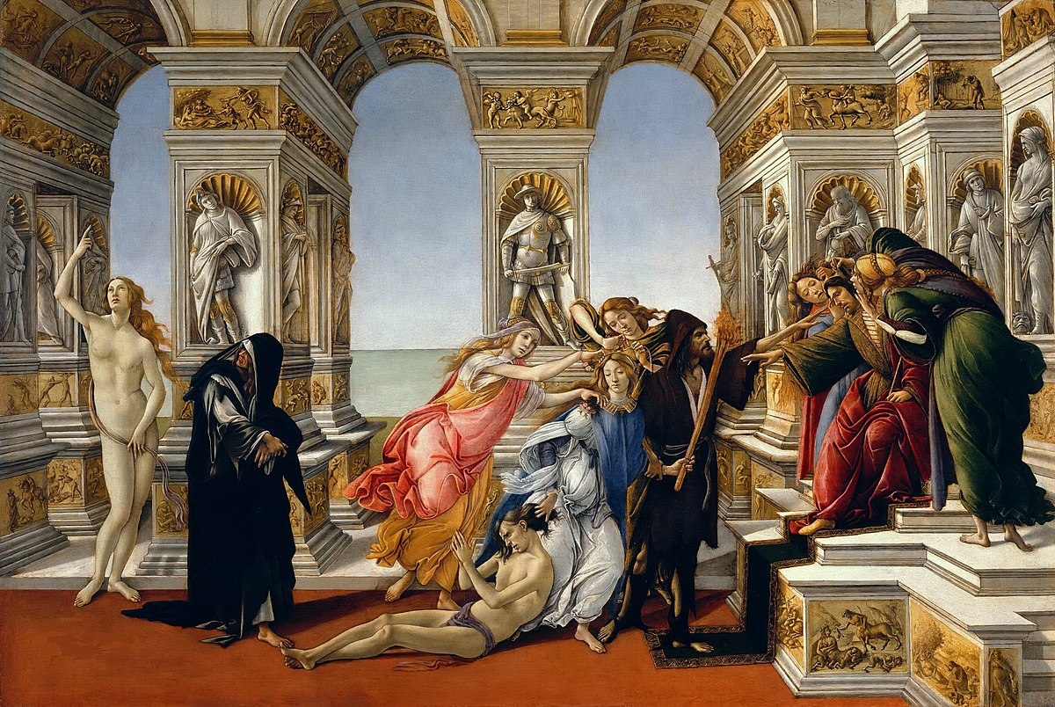  
Perfidy, the victim, Calumny, Fraud and Rancour

**DESCRIPTION AND SUBJECT OF “ THE CALUMNY OF APELLES”**

The figures are either [personifications](https://en.wikipedia.org/wiki/Personification) of vices or virtues, or in the case of the king and victim, of the roles of the powerful and the powerless. From left to right, they represent (with alternative names): Truth, nude and pointing upwards to Heaven; Repentance in black; Perfidy (Conspiracy) in red and yellow, over the innocent half-naked victim on the floor, who is being pulled forward by the hair by Calumny (Slander), in white and blue and holding a flaming torch. Fraud, behind, arranges Calumny's hair. Rancour (Envy), a bearded and hooded man in black, holds his hand towards the king's eyes to obscure their view. On the throne, the king has the [donkey](https://en.wikipedia.org/wiki/Donkey)'s ears of [King Midas](https://en.wikipedia.org/wiki/Midas#Ears_of_a_Donkey), and Ignorance on his far side and Suspicion on the near side grasp these as they speak into them. The king extends his hand towards Calumny, but his eyes look down so that he cannot see the scene.[[8]](https://en.wikipedia.org/wiki/Calumny_of_Apelles_(Botticelli)" \l "cite_note-8)

These identifications are clear from Lucian's description of a painting by Apelles, a Greek painter of the Hellenistic Period. Though Apelles' works have not survived, [Lucian](https://en.wikipedia.org/wiki/Lucian" \o "Lucian) recorded details of one in his *On Calumny*:

On the right of it sits [Midas](https://en.wikipedia.org/wiki/Midas" \o "Midas) with very large ears, extending his hand to Slander while she is still at some distance from him. Near him, on one side, stand two women—Ignorance and Suspicion. On the other side, Slander is coming up, a woman beautiful beyond measure, but full of malignant passion and excitement, evincing as she does fury and wrath by carrying in her left hand a blazing torch and with the other dragging by the hair a young man who stretches out his hands to heaven and calls the gods to witness his innocence. She is conducted by a pale ugly man who has a piercing eye and looks as if he had wasted away in long illness; he represents envy. There are two women in attendance to Slander, one is Fraud and the other Conspiracy. They are followed by a woman dressed in deep mourning, with black clothes all in tatters—she is Repentance. At all events, she is turning back with tears in her eyes and casting a stealthy glance, full of shame, at Truth, who is slowly approaching.[[9]](https://en.wikipedia.org/wiki/Calumny_of_Apelles_(Botticelli)" \l "cite_note-9)

[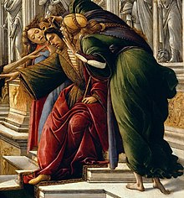](https://en.wikipedia.org/wiki/File:Sandro_Botticelli_021_(cropped3).jpg)

Ignorance, the king and Suspicion

Botticelli reproduced this quite closely, down to the donkey ears of the seated king, into which the women that flank him speak. A richly gowned Slander (or Calumny), with her hair being dressed by her attendants, is being led by her slender, robed companion. The victim she is dragging, nearly nude and with his ankles crossed as if to be crucified, raises his hands in prayer.[*[citation needed](https://en.wikipedia.org/wiki/Wikipedia:Citation_needed" \o "Wikipedia:Citation needed)*]

According to Lucian, the painting was made after Apelles had himself been slandered, denounced to [Ptolemy IV Philopator](https://en.wikipedia.org/wiki/Ptolemy_IV_Philopator) of Egypt by Antiphilos, a rival artist, of conspiring in around 219 BC with [Theodotus of Aetolia](https://en.wikipedia.org/wiki/Theodotus_of_Aetolia" \o "Theodotus of Aetolia) to hand Syrian cities such as [Tyre](https://en.wikipedia.org/wiki/Tyre,_Lebanon" \o "Tyre, Lebanon) to the rival [Seleucids](https://en.wikipedia.org/wiki/Seleucid).[[10]](https://en.wikipedia.org/wiki/Calumny_of_Apelles_(Botticelli)#cite_note-10) Ptolemy was on the verge of executing Apelles, when one of the rebel prisoners confirmed Apelles was innocent and the slanderer himself was given to Apelles as a slave, along with gold. Apelles then expressed his resentment of the peril in which he found himself in his painting.[[11]](https://en.wikipedia.org/wiki/Calumny_of_Apelles_(Botticelli)" \l "cite_note-11) A difficulty with Lucian's story is that, although Apelles' dates are far from certain, he is usually regarded as a contemporary of [Alexander the Great](https://en.wikipedia.org/wiki/Alexander_the_Great" \o "Alexander the Great), active about a century before the conspiracy.[[12]](https://en.wikipedia.org/wiki/Calumny_of_Apelles_(Botticelli)" \l "cite_note-12) Lucian lived about five centuries after Alexander's time.

**DESCRIPTION OF “NATIVITY” (1500-1501)**

The [Virgin Mary](https://en.wikipedia.org/wiki/Mary,_mother_of_Jesus) is shown kneeling before the [Christ Child](https://en.wikipedia.org/wiki/Christ_Child) in the centre, both are on a larger scale than the other figures. Joseph sits on the ground next to the child, perhaps asleep, with his face not visible. Behind the family are a ox and an ass. On either side of the main group an angel with an olive branch in their outstretched hand shows the child to respectively two shepherds and three men in long gowns, perhaps the [biblical Magi](https://en.wikipedia.org/wiki/Biblical_Magi" \o "Biblical Magi). These five are kneeling and crowned with olive branches. At the bottom of the work, three angels embrace three men also with olive on their head. Around them seven small devils are piercing themselves with lances and falling back into the underworld, "burying themselves".[[7]](https://en.wikipedia.org/wiki/The_Mystical_Nativity" \l "cite_note-7)[[8]](https://en.wikipedia.org/wiki/The_Mystical_Nativity#cite_note-8)

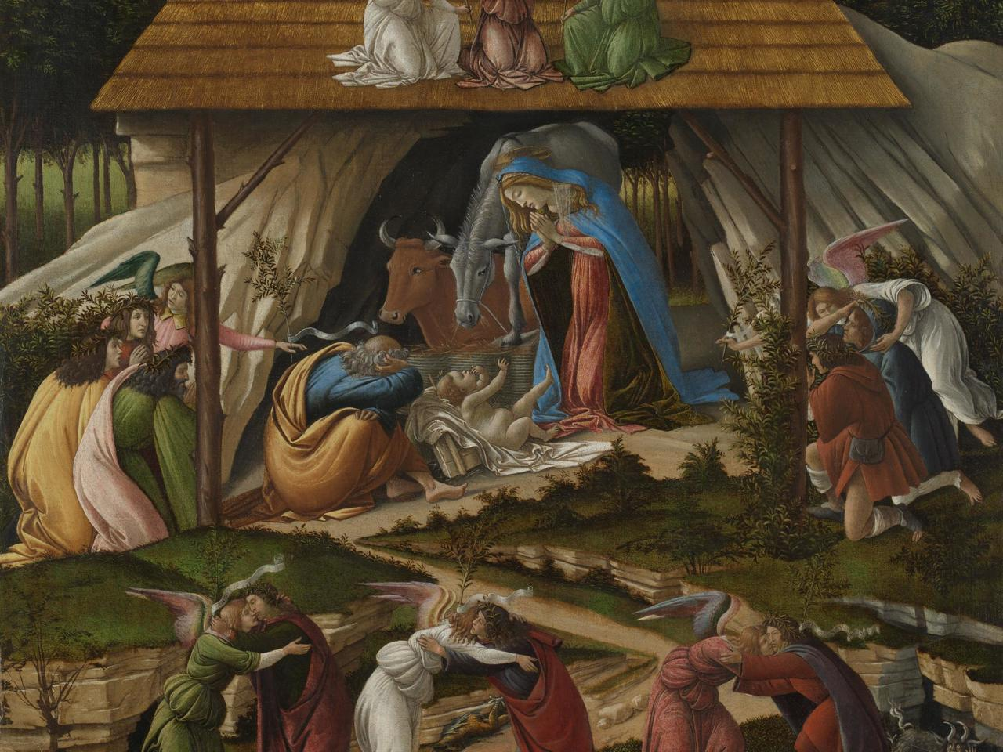

**CRUCIFIXION (1497)**

**CRUCIFIXION**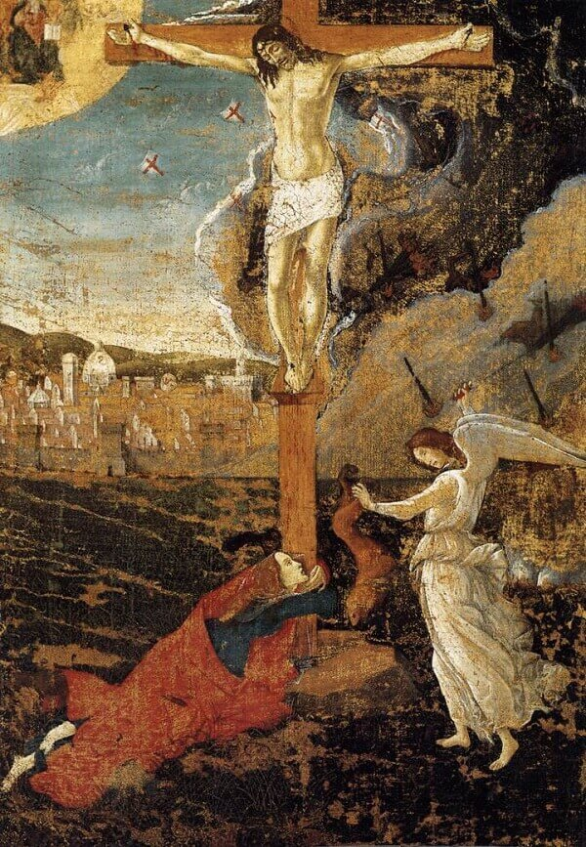

**THE LAST COMMUNION OF ST. JEROME (1494-1495)**

The painting represents the very moment in which Jerome, having gathered his companions from the monastery around him, is lying on a linen sheet and is asking one of his brothers to bring him the body of Christ….The epistle recalls that when Jerome saw the priest come closer, he asked his companions to help him get to his knees, while professing his faith in Christ whose body and blood are present in the wafer.” [[1]](https://en.wikipedia.org/wiki/The_Last_Communion_of_Saint_Jerome_(Botticelli)#cite_note-Testa-1): 306 No ancient author is known to have described this scene. [[1]](https://en.wikipedia.org/wiki/The_Last_Communion_of_Saint_Jerome_(Botticelli)" \l "cite_note-Testa-1): 306

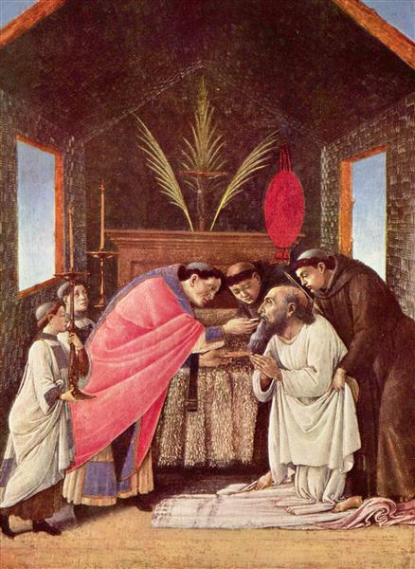

**PRIMAVERA**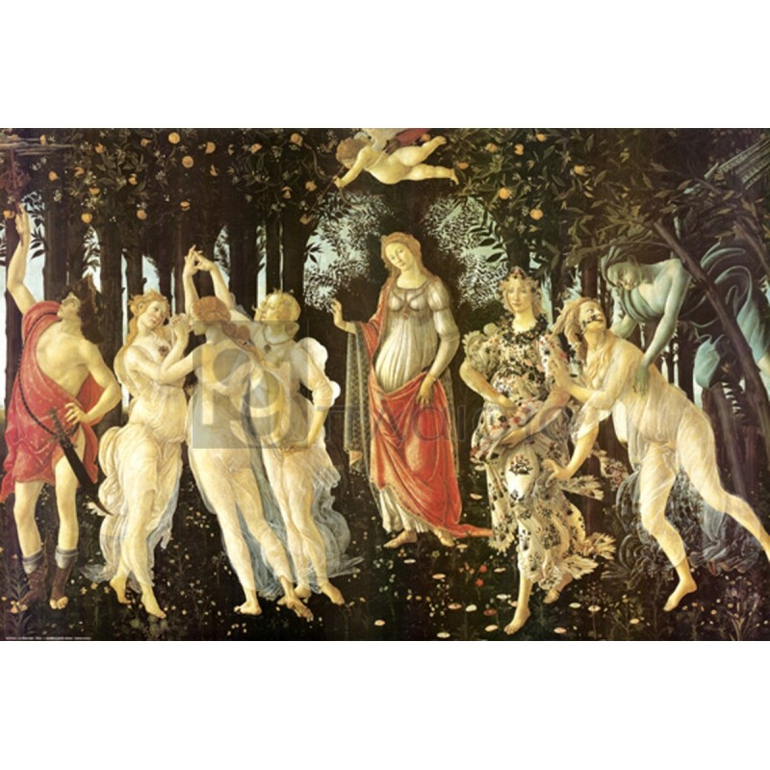

|  |  |
| --- | --- |
|  | **DESCRIPTION AND SUBJECT OF “LA PRIMAVERA” (late 1470s)**  **Venus**  The scene is set in the divine garden of *Venus*, the Goddess of Love, who is standing in the centre of the picture, set back a shade from the other figures. Close by, her companions, the *Three Graces*, are wearing diaphanous white and jewels in the colours of the Medici family. They are dancing, while next to them on the extreme left of the picture, *Mercury* - the winged messenger of the gods - is wearing a helmet and carrying a sword, enough to identify him as being on guard. He is also marked out by his winged shoes and his signature staff, with which he chases away threatening clouds. Overhead, Venus's blindfolded son *Amor*, aims his arrow at the *Three Graces*.  **Zephyrus**  Meanwhile, on the extreme right of the [painting](http://www.visual-arts-cork.com/fine-art-painting.htm), Botticelli has depicted two separate tales from classical mythology. Both concern *Zephyrus*, the god of the wind, who is featured with puffed cheeks and reaching for the nymph *Chloris*. In the first tale, *Zephyrus* falls for *Chloris* whom he forcefully takes as his wife. In the second tale, *Zephyrus* - as a mark of regret for his conduct - then transforms *Chloris* into *Flora* Goddess of Flowers and Spring. According to Ovid, he also gives her a wonderful garden, filled with flowers and plants, in which eternal spring reigns.  **Botanical Landscape**  The garden we see however, belongs to *Venus*, who raises her hand to welcome viewers into her kingdom. Her proprietorship is confirmed by the myrtle tree, behind her, which is one of her symbols. For reasons which are unclear, Botticelli painted a staggering 500 separate plant species in the picture, including some 190 different flowers. This one element alone has been the subject of decades of specialist cataloguing and research.  The figure of *Venus* (both in *La Primavera* and *The Birth of Venus*) may have been modelled on Simonetta Vespucci, the wife of Marco Vespucci. According to rumour, she was the mistress of Giuliano de' Medici, who himself is supposed to have been the model for *Mercury*. See also the *Portrait of Simonetta Vespucci*(1482, Musee Conde, Chantilly), by [Piero di Cosimo](http://www.visual-arts-cork.com/old-masters/piero-di-cosimo.htm) (1461-1521).  **Neoplatonic love :** According to one expert, *La Primavera* may be an illustration of Neo-platonic love. Thus, physical love symbolized by Zephyrus is renounced by the central member of the Graces, who turns her back on *Zephyrus* and *Amor/Cupid*, and gazes at *Mercury*. The winged messenger is himself looking out beyond the canvas at the painting *Pallas and the Centaur* (c.1482, Uffizi Gallery, Florence), which supposedly hung next to *Primavera*, and which portrays the victory of virtue over lust. If so, it must have been hung at a higher level than *Primavera*, as Mercury's gaze is directed towards the top corner of the garden. (Compare Botticelli's expressionist distortion of forms - the Florentine style - with the more naturalist contemporary painting *[Virgin of the Rocks](http://www.visual-arts-cork.com/famous-paintings/virgin-of-the-rocks.htm)* 1484-6, by Leonardo.) |

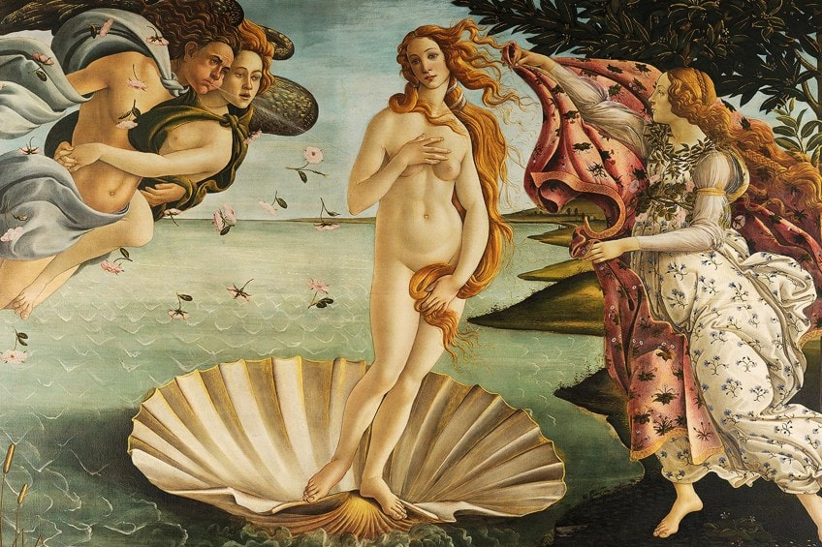

**DESCRIPTION AND SUBJECT OF “THE BIRTH OF VENUS” (mid 1480)**

**The [Hora of Spring](https://en.wikipedia.org/wiki/Horae" \o "Horae)**

**In the centre the newly born goddess Venus stands nude in a giant [scallop](https://en.wikipedia.org/wiki/Scallop" \o "Scallop) shell. The size of the shell is purely imaginary, and is also found in classical depictions of the subject.[[3]](https://en.wikipedia.org/wiki/The_Birth_of_Venus" \l "cite_note-3) At the left the [wind god](https://en.wikipedia.org/wiki/Anemoi" \o "Anemoi) Zephyr blows at her, with the wind shown by lines radiating from his mouth. He is in the air, and carries a young female, who is also blowing, but less forcefully. Both have wings. [Vasari](https://en.wikipedia.org/wiki/Vasari" \o "Vasari) was probably correct in identifying her as "[Aura](https://en.wikipedia.org/wiki/Aura_(mythology)" \o "Aura (mythology))", personification of a lighter breeze.[[4]](https://en.wikipedia.org/wiki/The_Birth_of_Venus" \l "cite_note-4) Their joint efforts are blowing Venus towards the shore, and blowing the hair and clothes of the other figures to the right.[[5]](https://en.wikipedia.org/wiki/The_Birth_of_Venus" \l "cite_note-5)**

**At the right a female figure who may be floating slightly above the ground holds out a rich cloak or dress to cover Venus when she reaches the shore, as she is about to do. She is one of the three [Horae](https://en.wikipedia.org/wiki/Horae" \o "Horae) or Hours, Greek minor goddesses of the seasons and of other divisions of time, and attendants of Venus. The floral decoration of her dress suggests she is the Hora of Spring.**[**[6]**](https://en.wikipedia.org/wiki/The_Birth_of_Venus#cite_note-6)

**Alternative identifications for the two secondary female figures involve those also found in the *Primavera*; the nymph held by Zephyr may be [Chloris](https://en.wikipedia.org/wiki/Chloris_(nymph)" \o "Chloris (nymph)), a flower nymph he married in some versions of her story, and the figure on land may be**[**Flora**](https://en.wikipedia.org/wiki/Flora_(deity))**.**[**[7]**](https://en.wikipedia.org/wiki/The_Birth_of_Venus#cite_note-7)**Flora is generally the Roman equivalent of the Greek Chloris; in the *Primavera* Chloris is transformed into the figure of Flora next to her, following**[**Ovid**](https://en.wikipedia.org/wiki/Ovid)**'s *[Fasti](https://en.wikipedia.org/wiki/Fasti_(poem)" \o "Fasti (poem))*,**[**[8]**](https://en.wikipedia.org/wiki/The_Birth_of_Venus#cite_note-8)**but it is hard to see that such a transformation is envisaged here. However, the roses blown along with the two flying figures would be appropriate for Chloris.**

**The subject is not strictly the "Birth of Venus", a title given to the painting only in the nineteenth century (though given as the subject by Vasari), but the next scene in her story, where she arrives on land, blown by the wind. The land probably represents either**[**Cythera**](https://en.wikipedia.org/wiki/Kythira)**or**[**Cyprus**](https://en.wikipedia.org/wiki/Cyprus)**, both Mediterranean islands regarded by the Greeks as territories of Venus.**[**[9]**](https://en.wikipedia.org/wiki/The_Birth_of_Venus#cite_note-9)

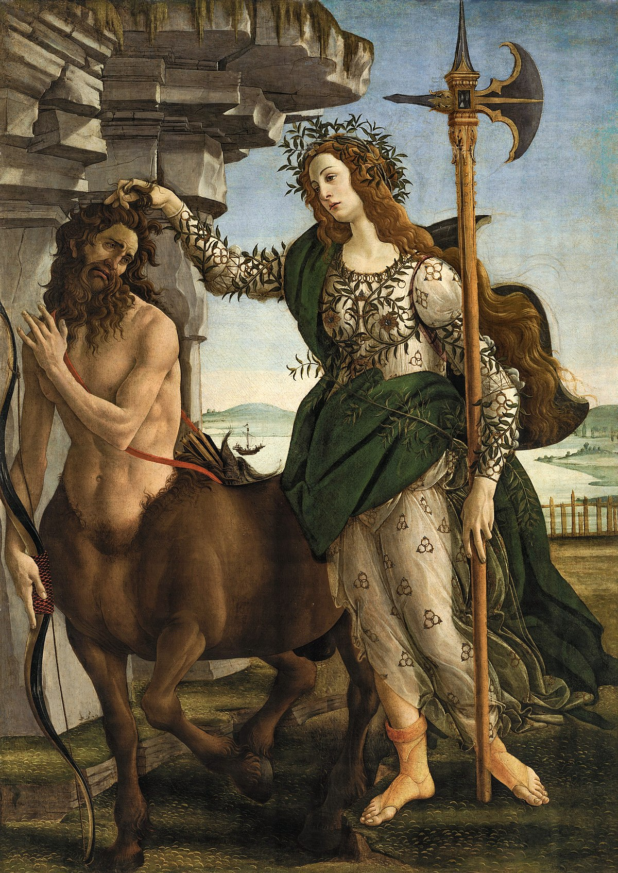

**INTERPRETATION OF “PALLAS AND THE CENTAUR” (1482)**

Pallas is a figure of reason, restraining the beast of our nature – also represented by the [centaur](https://en.wikipedia.org/wiki/Centaur) – by the hair and looking at it with no fear. This has been connected with [Sigmund Freud](https://en.wikipedia.org/wiki/Sigmund_Freud)’s theory of the unconscious,[[12]](https://en.wikipedia.org/wiki/Pallas_and_the_Centaur#cite_note-:3-12) and also to the [Renaissance Neo-Platonist](https://en.wikipedia.org/wiki/Renaissance_Neo-Platonist) [Marsilio Ficino](https://en.wikipedia.org/wiki/Marsilio_Ficino" \o "Marsilio Ficino)'s idea of the human soul as part animal and part human.[[2]](https://en.wikipedia.org/wiki/Pallas_and_the_Centaur#cite_note-Legouix,_113-2) It has been interpreted as an allegory on the peace after the [Pazzi](https://en.wikipedia.org/wiki/Pazzi" \o "Pazzi) wars.[[15]](https://en.wikipedia.org/wiki/Pallas_and_the_Centaur#cite_note-15)