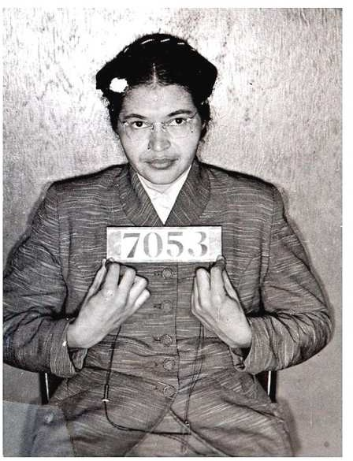
Civil rights icon Rosa Parks dies
Fill in the blanks with the appropriate word.
rights treated praised challenge civil laws symbol required movement effects revolution caught stood up fined

Rosa Parks, the icon of the American rights movement, has died aged 92. Her refusal to give up her seat to a white man on an Alabama bus in 1955 started a
in the US civil movement. She was one of the first people to America’s segregation laws.
Ms Parks passed away in her sleep at her home in Detroit. She suffered from the
of old age in recent years and was rarely seen in public. The mayor of Detroit
her courage and strength. He said she was a of the civil rights movement. He also said: “Just by a simple act of sitting down she for so many people.”
Ms Parks is called the mother of America's civil rights . In 1955, she was a 42-year-old department store worker in Montgomery, Alabama. She a bus and sat down. Soon after, a white man got on and had to stand. The law black passengers to make room for white passengers. Ms Parks refused to move, saying: “No. I'm tired of being like a second-class citizen.” She was arrested and
$10. This incident sparked the famous bus boycott that lasted 381 days. It also led to the end of segregation throughout America’s South.
breakingnewsenglish.com
Match the following synonyms from the article
- :icon
- movement
- started
- passed away
- praised
- caught
- soon
- room
- lasted
sparked
space
got on
resulted in
died
shortly
campaign
continued for
symbol
10. led to
hailed

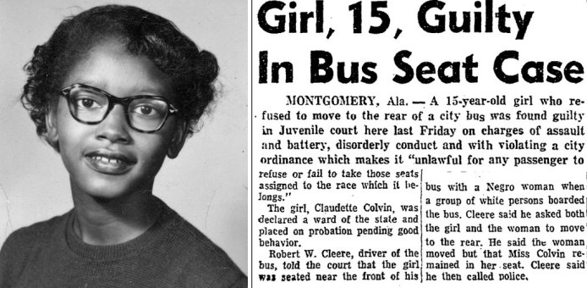

following statements Justify your response.  a. She was tried as an adult | True | False
b. She was a teenager at the time of her arrest. | True | False
c. Montgomery is in the state of New Jersey | True | False
d. She was the only one to not obey the request by the bus driver. | True | False
e. She asked a white man on a bus if she could sit on his seat. | True | False
f. U.S. law required black passengers to give their seats to white people. | True | False
g. The bus driver immediately called the police. | True | False
h. Claudette was sentenced to 6 months in prison. | True | False

