|  |  |  |  |  |  |
| --- | --- | --- | --- | --- | --- |
| |  |  | | --- | --- | |  |  | | |  |  | | --- | --- | |  |  | |

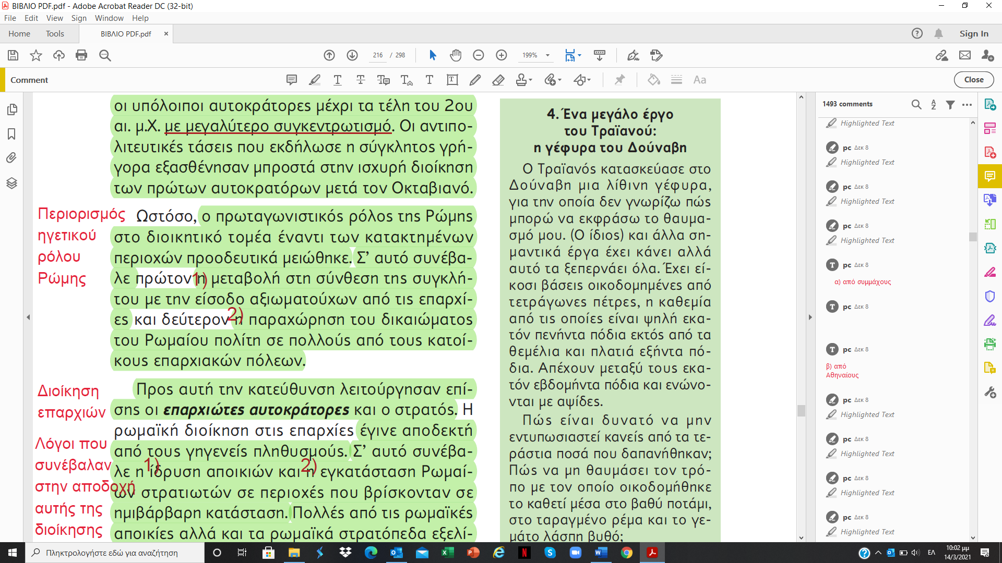

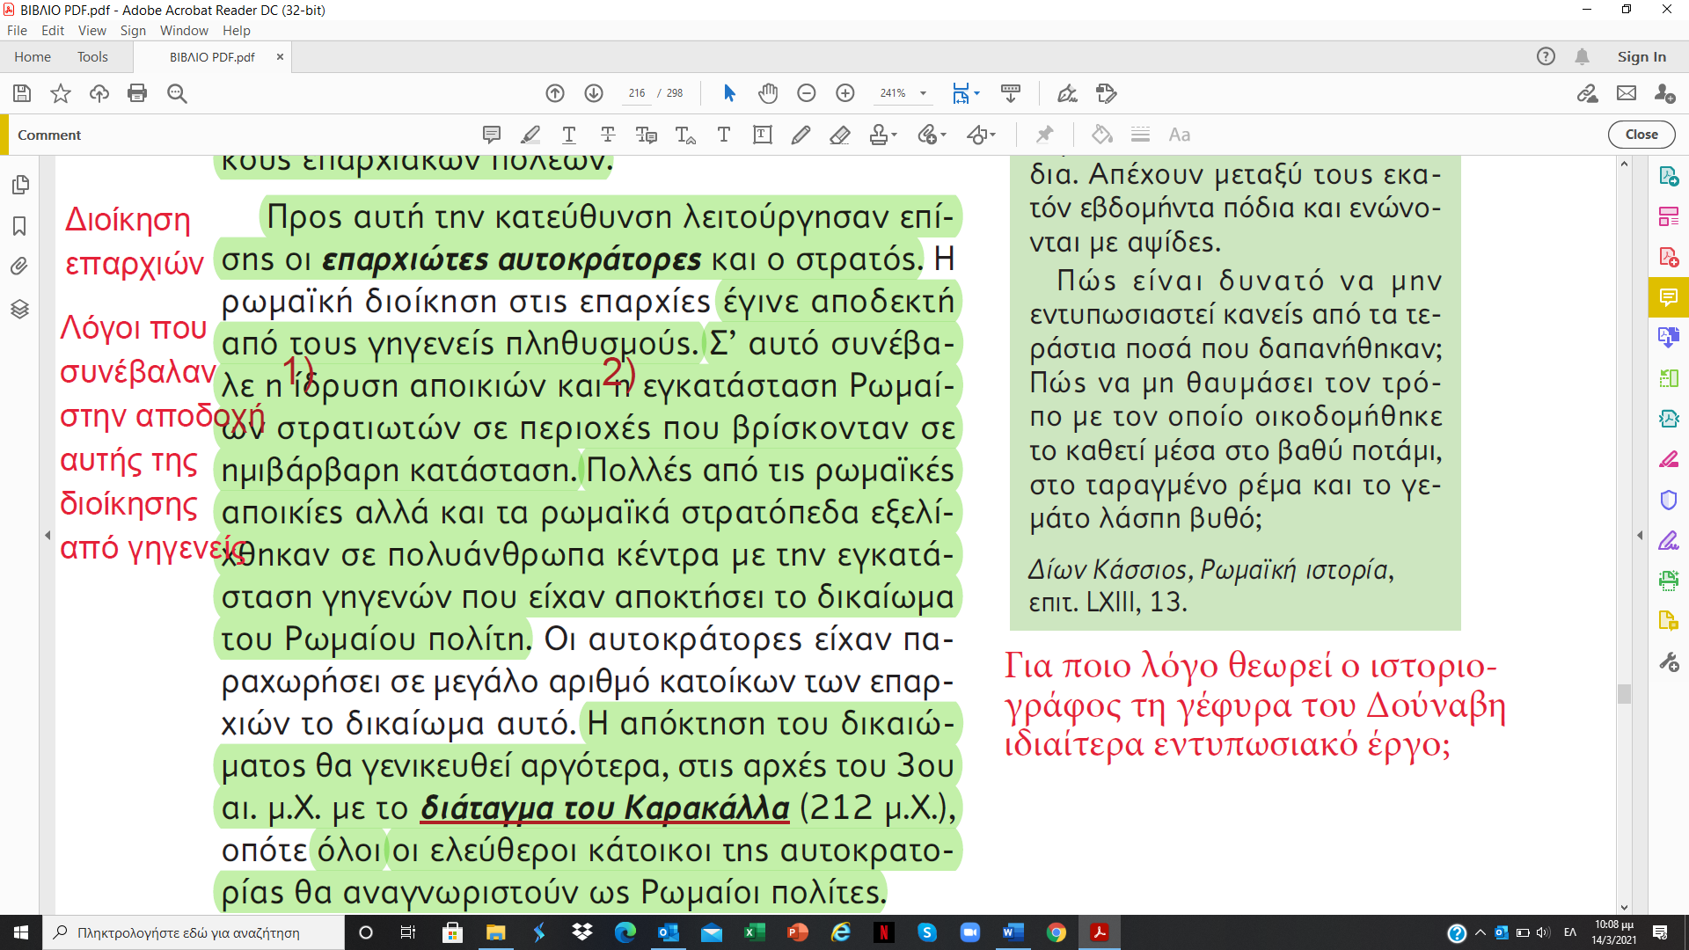

|  |  |
| --- | --- |
|  | Διοίκηση (κενά) |

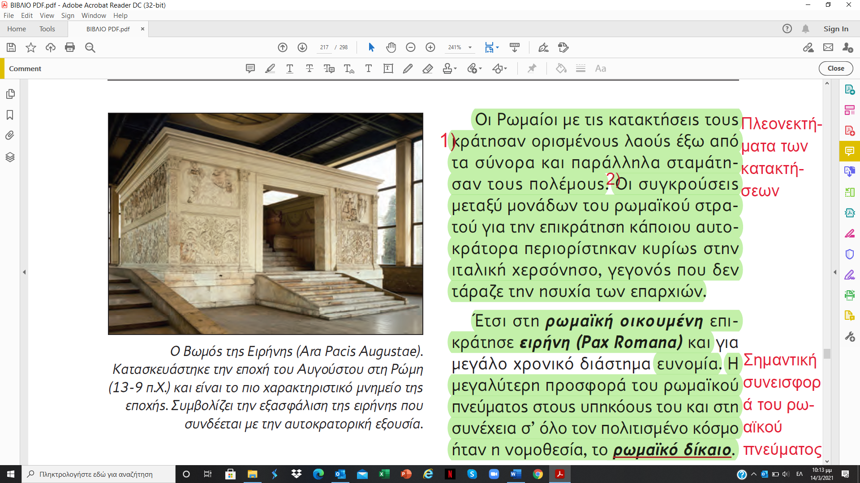

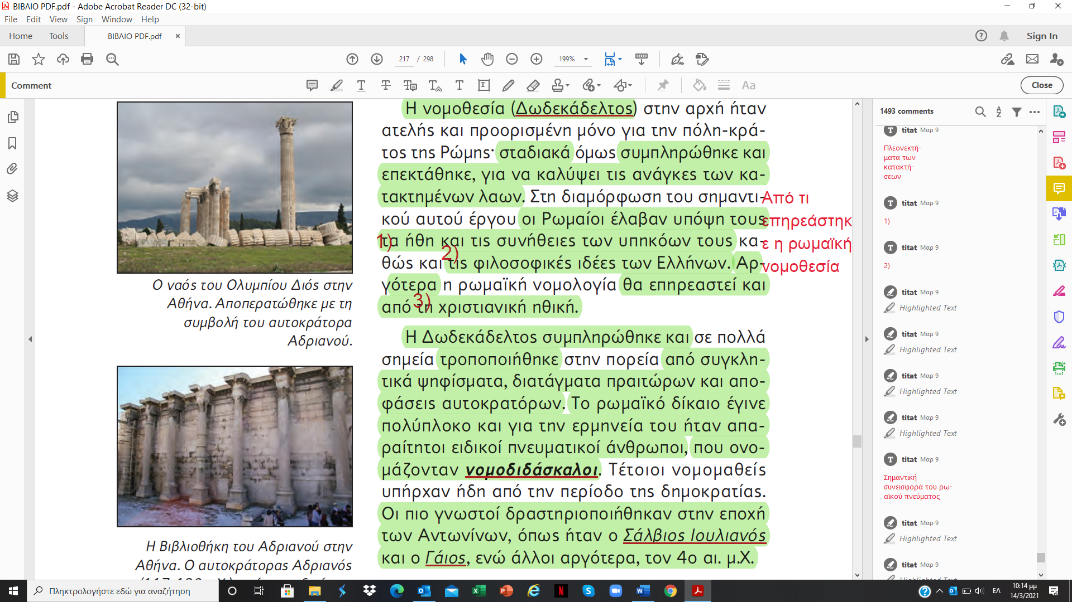

|  |  |  |
| --- | --- | --- |
|  | Νομοθεσία (κενά) | (σταυρόλεξο – επανάληψη) |

