forest fire flood hurricane earthquake avalanche tsunami drought volcanic eruption

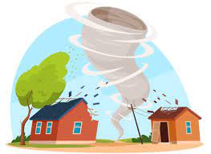 

1. ………………………………………………….. 2. …………………………………………………

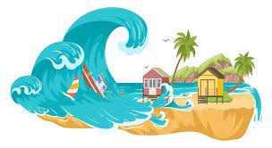 

3………………………………………………………… 4…………………………………………………………….

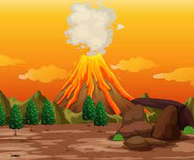 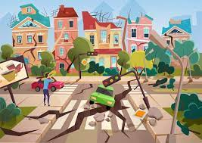

5………………………………………………………… 6………………………………………………………………

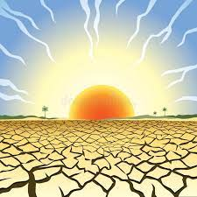 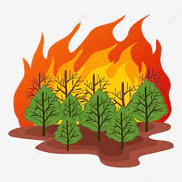

7……………………………………………………… 8…………………………………………………………