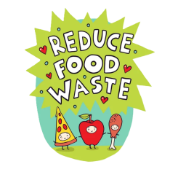
TASK ONE
Do you believe that the following statements are true or false?
- We waste about 1/3 of the food we produce.
- The most food waste happens at the consumer level in developing countries.
- Food waste only affects food availability and not the environment.
- Only meat waste has an environmental impact; fruits and vegetables don't matter.
- If food waste were reduced, more resources could be used to fight food insecurity.
- Food donations are illegal in most countries due to safety concerns.
TASK TWO
Read the following article and answer the questions:
Have you ever stopped to consider how much food you waste each day? Many of us might think that tossing out part of a sandwich or half an apple is insignificant. However, the truth is that food waste is a serious global issue with far-reaching consequences.
According to the United Nations, an estimated 1.3 billion tons of food—approximately one-third of all food produced globally—is wasted every year. While a significant portion of this is lost during production, processing, and distribution, a substantial amount is also thrown away in households, particularly in developed nations. For instance, in the United States, citizens discard around 150,000 tons of food daily, and in the UK, roughly 22% of the average family’s yearly groceries—items like fresh produce, bread, and dairy products—end up in the bin.
Why is this such a critical issue? While many of us take food for granted and throw away edible items without much thought, global hunger is on the rise. Current data shows that more than 800 million people go to bed hungry each night, and over 3 million children die annually due to malnutrition. Ironically, the food we waste could potentially feed more than 2 billion people. Beyond the humanitarian crisis, food waste also has severe environmental impacts. Enormous amounts of energy and water are used to grow, process, and transport food that ultimately never gets consumed. Furthermore, discarded food in landfills emits methane, a potent greenhouse gas that significantly contributes to climate change.
So, what can be done to tackle this issue? Governments and food industry leaders must take meaningful action, such as launching educational campaigns to raise public awareness about the importance of reducing food waste. However, individual responsibility also plays a crucial role. At home, we can make a difference by planning meals carefully, avoiding overbuying, and storing food properly to extend its shelf life. Leftovers can be repurposed or composted instead of being thrown away. Most importantly, we must recognize that food is not something to be casually discarded—it is a vital resource, and we all share the duty to treat it with respect.

A. Circle the correct answer:
1. What is an appropriate title for the previous article?
a. Sustainability at Home: Reducing Your Environmental Footprint
b. Wasted Potential: The Hidden Cost of Food Waste
c. Solving Hunger: Innovations in Global Food Distribution
d. The Modern Kitchen: Managing Meals and Minimizing Costs
2. What is one major reason food waste is a global issue?
a. It leads to an increase in food prices worldwide.
b. It reduces the demand for packaged goods.
c. It creates job shortages in the agricultural sector.
d. It contributes to global hunger and environmental damage.

3. What surprising contrast is highlighted in the article?
a. While millions go hungry, large amounts of edible food are wasted.
b. Farmers grow more organic food, yet people want fast food.
c. Supermarkets are full, but prices are still rising.
d. Developed countries waste less food than developing ones.
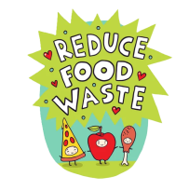
4. What is one action individuals can take to reduce food waste at home?
a. Avoid eating leftovers
b. Only buy canned and frozen items
c. Plan meals and store food properly
d. Shop daily instead of weekly
B. State whether the following statements are true (T), false (F) or Not Stated (NS)
STATEMENTS | TRUE | FALSE | NOT STATED
1. A small percentage of global food production is lost before it ever reaches consumers.
2. The text implies that modern food production methods are partly to blame for the high levels of food waste.
3. It is possible to feed billions of people with the amount of food that is currently being wasted globally.
4. The average family in the UK throws away more food than the average family in the US.
5. The author personally believes that composting is the best solution to food waste.
6. The environmental effects of food waste are more severe than the humanitarian consequences.

TASK THREE

Match the words in Column A with their correct meanings in Column B.
Column A | Column B
1. discard ___ | a. used for something different than its original purpose
2. significant ___ | b. to throw something away
3. malnutrition ___ | c. a site for the disposal of waste material which are buried  in the ground
4. methane ___ | d. a serious lack of proper nutrition, often due to not having
 | enough food.
5. landfill ___ | e. important or meaningful
6. consequences __ | f. all over the world
7. repurposed ___ | g. the results or effects of an action or condition
8. globally ___ | h. a harmful gas that contributes to global warming

TASK FOUR

Fill in the blanks using the correct words from the box below. Each word is used only once.

waste - hunger - resources - awareness - produce - campaign - composted - overbuying

1. Global __________ continues to rise, even though enough food is produced to feed the world.
2. One way to reduce food __________ is by planning meals ahead of time.
3. Families often throw away fruits and vegetables because of __________.
4. Educational programs can help raise public __________ about food waste.
5. Instead of tossing leftovers, they can be reused or __________ to benefit gardens.
6. Bread, dairy products, and fresh __________ are among the most commonly wasted items.
7. Wasting food also means wasting all the natural __________ used to grow and transport it.
8. The government launched a national __________ to encourage people to shop smarter and waste less.

TASK FIVE

Fill in the blanks with the verbs in the correct form.

1. If people __________ (throw) away less food every day, we could make better use of global resources.
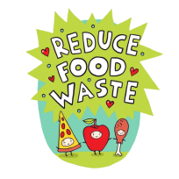
2. When food __________ (go) to a landfill, it releases methane, a harmful greenhouse gas.
3. If governments had launched awareness campaigns earlier, people __________ (understand) the issue better by now.
4. If you plan your meals in advance, you __________ (be) less likely to overbuy at the supermarket.
5. If I __________ (learn) about food waste sooner, I would have started reducing it years ago.
6. If more people take action, we __________ (see) a real drop in global food waste levels in the near future.

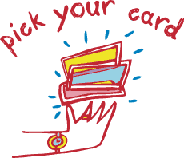
TASK SIX
What would you do in the following situations? Draw a card and tell the class.

TASK SEVEN

Prepare a mini campaign to raise awareness about food waste

1. Work in groups to design a campaign which will raise awareness about food waste. Choose one main idea or message you want to communicate. Your campaign design should include:

- a catchy slogan (eg. Think before you bin!)
- the main message / idea you want to convey
- the method you will use to deliver your idea (eg. poster, e-book, special event, etc.)
- possibly a social media idea
- why your idea will work / how will it help reduce food waste

2. Present your campaign in about 2 minutes. Make sure you:

- introduce yourselves
- present your idea clearly
- explain your creative choices
- persuade your classmates why it is effective and original

